Decision Log Entry 5 — Betsy Autonomous Procurement Agent | LO5 Managing

0. Context
Project: Betsy is a fully implemented autonomous procurement agent. The framework is chosen (DL1), the gates are designed (DL2), the architecture is built (DL3), the model is selected (DL4), and the full system runs end-to-end with a Streamlit dashboard and CLI interface.
Why this decision needs to be made now: Building the system is not the same as knowing it is working correctly over time. An autonomous agent that makes purchasing decisions on a 4-hour cycle can cause real financial harm if it silently drifts. Additionally, the assignment requires demonstrating success criteria: at least 2 stockout scenarios prevented, at least 1 invoice error caught, and a 95%+ autonomous approval rate.
Where this fits: DL1–DL4 cover analysis, design, and build. DL5 covers the managing phase — how Betsy is observed, measured, and improved after it is running.
1. Research Question
How do we know Betsy is making good decisions over time — and what do we observe, measure, and act on to keep the system aligned with what it was designed to do?
2. Current LO Stage
[ ] Analysing [ ] Advising [ ] Designing [ ] Realising [X] Managing
3. What Makes a Good Decision Here?
Criterion 1 | The system must provide a way to see, at a glance, whether it has been running as intended — cycles completed, gates fired, orders placed — without needing to read the raw database. Confirmed by opening the dashboard and being able to answer 'is Betsy working?' in under 30 seconds.
Criterion 2 | The three assignment success criteria must be measurable from the system's own data: (a) at least 2 stockout scenarios prevented, (b) at least 1 invoice error caught, (c) 95%+ autonomous approval rate. All three must be readable from the database or dashboard, not reconstructed from memory.
Criterion 3 | When something goes wrong, there must be enough information in the audit log to diagnose the problem without running the system again. Confirmed by being able to answer 'why did Betsy choose this supplier on this run?' from the audit log alone.
4. What I Decided
Three monitoring mechanisms were implemented: (1) a Streamlit dashboard with live KPIs and audit log, (2) a structured WHAT/WHY/NEXT audit log written by every node to the database, and (3) a notifications log file recording every HOTL and HITL alert as a permanent readable record.
One gap identified during this review: the 95%+ autonomous approval rate is not yet calculated as a dashboard KPI. The data exists in the database — it is a reporting gap, not a data gap.
5. Why This Decision

Research method — Lab + Field
Lab: ran multiple monitoring cycles and observed what the system actually produces. Field: evaluated that information against what Jenny would actually need to trust the system in daily operation.

Evidence — Dashboard KPI overview
The main KPI page showing 8 low-stock parts, 16 orders awaiting delivery, G1 as the last gate fired, and 232 decisions logged. The 'What Betsy Did Last Cycle' pipeline strip shows each of the 6 nodes with their status. Inventory Health table visible below.
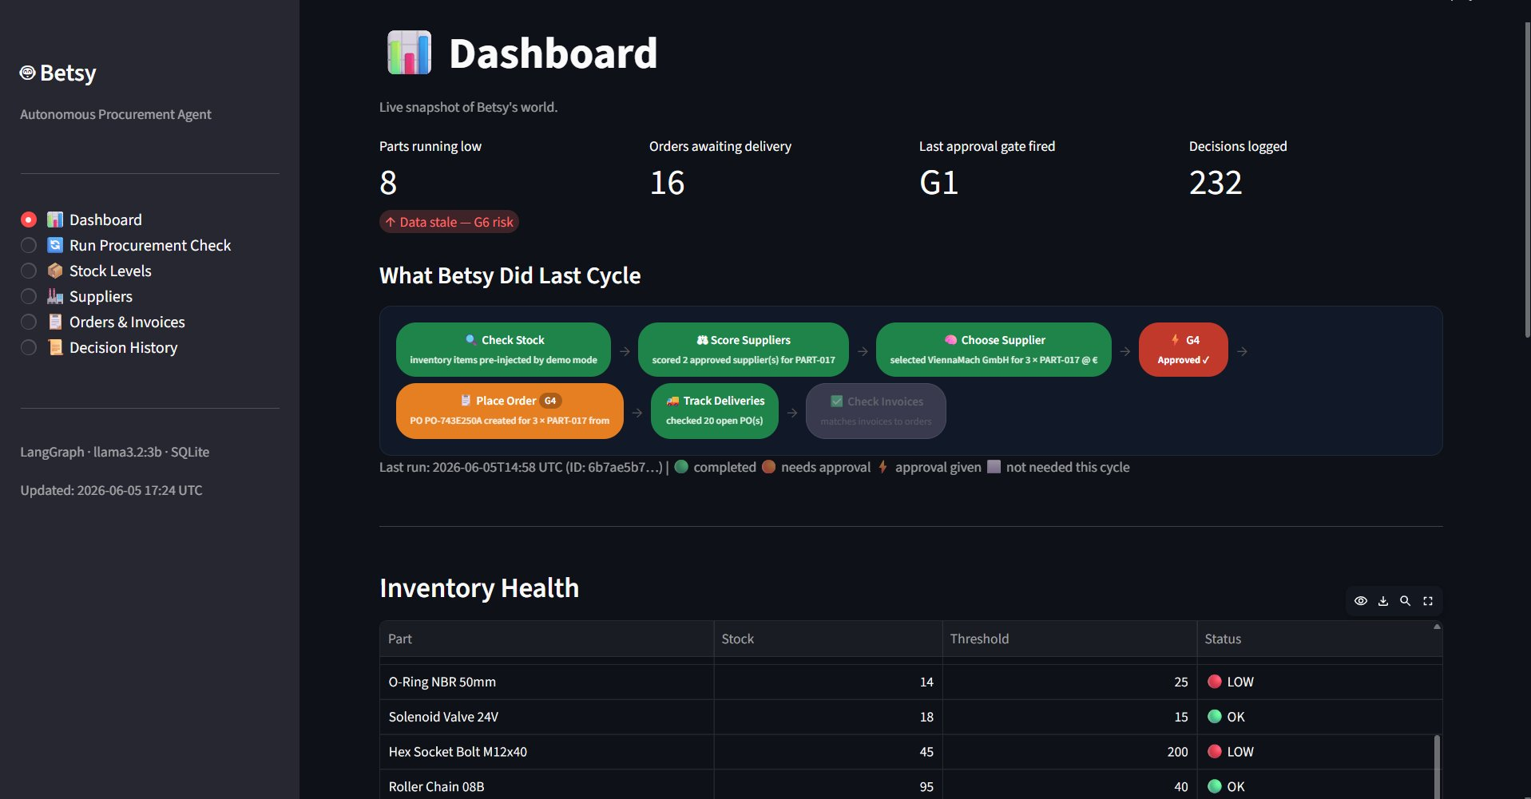
Dashboard main page — 8 parts running low, 16 orders awaiting delivery, last gate G1, 232 decisions logged. Last cycle pipeline: Check Stock → Score Suppliers → Choose Supplier → G4 Approved → Place Order → Track Deliveries.

Evidence — Decision History (audit log)
The Decision History page showing 234 logged entries with WHAT/WHY/NEXT reasoning in the readable log view, confirming the audit trail is accumulating correctly across runs.
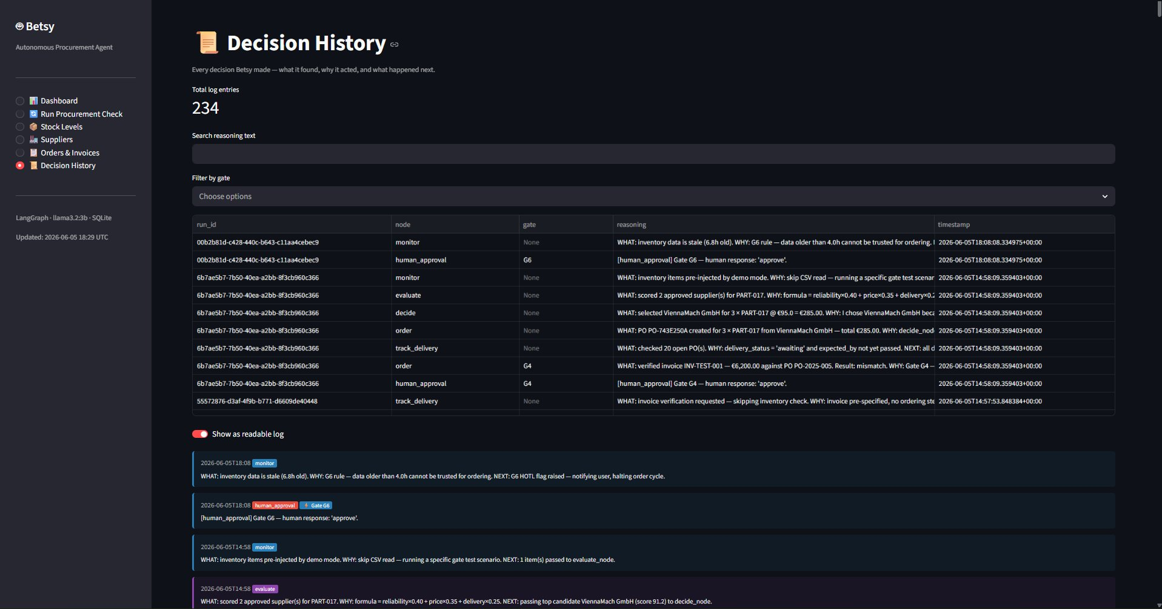
Decision History page — 234 total log entries. Table view shows run_id, node, gate, reasoning, timestamp. Readable log toggle shows WHAT/WHY/NEXT format entries from monitor, evaluate, decide, order nodes across multiple runs.

Evidence — Orders & Invoices with on-demand verify
The Purchase Orders dashboard showing open POs with delivery status and the pending invoices section with the Verify Now button — confirming on-demand invoice check is accessible without running a full cycle.
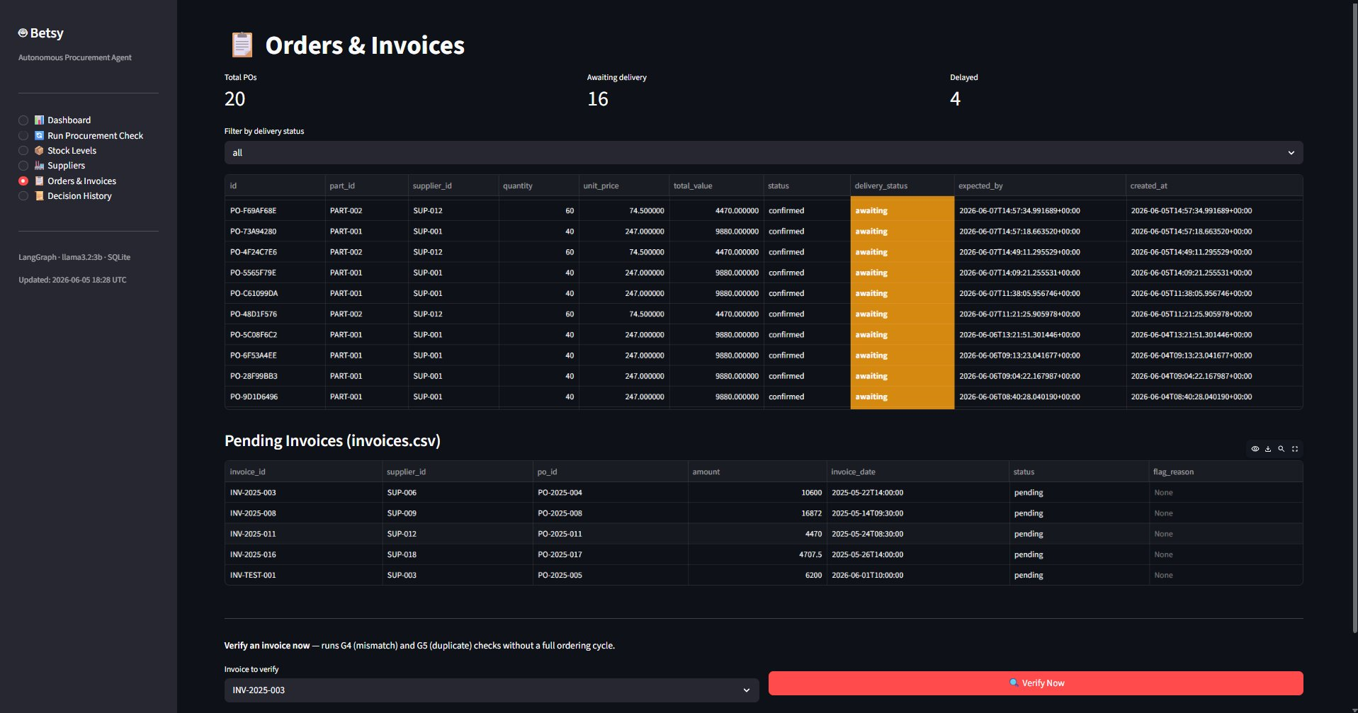
Orders & Invoices page — 20 total POs (16 awaiting, 4 delayed). Pending Invoices section shows 5 invoices including INV-TEST-001. Verify Now button triggers G4/G5 check without a full 4-hour ordering cycle.

Evidence — Dynamic reliability scoring
Terminal output showing AccuParts Corp starting at 85.0, dropping to 82.0 after a delayed delivery (track_delivery_node, −3.0 rule), then recovering to 84.0 after a clean invoice match (verify_node, +2.0 rule). Scores reflect actual delivery performance, not just the seeded CSV value.
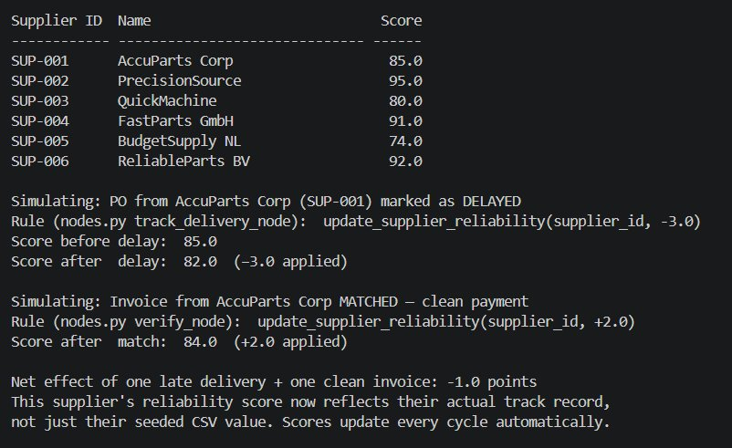
Dynamic reliability scoring — AccuParts Corp: 85.0 → 82.0 (DELAYED, -3.0 applied) → 84.0 (MATCHED invoice, +2.0 applied). Net effect: -1.0 from one late delivery + one clean invoice. Scores update every cycle automatically.

Evidence — Invoice-only routing code change
The actual _after_monitor function from betsy/graph.py showing the new invoice-only path. Before this change: verifying an invoice required running the full ordering cycle. After: if an invoice is provided but no low-stock items are found, the graph skips directly to Track Delivery → Verify. The Verify Now button on the dashboard triggers this path.
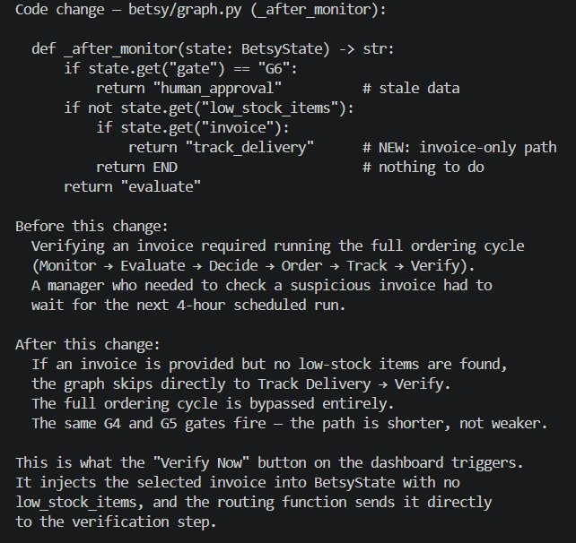
Invoice routing code change — _after_monitor function before/after. New invoice-only path skips full ordering cycle when invoice present but no low_stock_items. Same G4/G5 gates fire — path is shorter, not weaker. Verify Now button context explained.

What this means
The monitoring infrastructure that was built as part of the implementation is sufficient to observe system health and reconstruct any past decision. The main gap is reporting — the 95%+ autonomous approval rate needs to be surfaced explicitly as a dashboard KPI so the assignment success criterion can be demonstrated directly.
6. Does This Hold Up?
 | Criterion | Actual result vs. target
✅ | C1 — system health visible in under 30 seconds | Opening the dashboard and reading the four main KPIs takes under 10 seconds. 'Is Betsy working?' can be answered from the first page without navigating to the audit log or database.
🟡 | C2 — three success criteria measurable | Stockout prevention and invoice error catching are measurable from the database. The autonomous approval rate is calculable from the data but not yet shown as a dashboard KPI. Known gap — needs one additional metric added.
✅ | C3 — audit log sufficient for diagnosis | The WHAT/WHY/NEXT audit log contains enough information to diagnose any decision. Confirmed when a gate fired incorrectly in development (null price treated as zero for G3) — the log identified the root cause without rerunning the system.

What surprised me
The value of the audit log only became clear when something went wrong. During development, G3 fired on a run where it should not have — the price spike gate triggered because the previous price for a new supplier was null, and the calculation treated null as zero, making any price look like an infinite percentage increase. Without the WHAT/WHY/NEXT log recording exactly what data the Decide node saw, this bug would have been very hard to find. The log was designed for reporting and transparency — it turned out to be the most useful debugging tool in the project.
7. What This Unlocks — What Was Built As a Result of Managing
The monitoring mechanisms identified three problems during operation. All three were addressed with code changes:

Problem 1 — G3 false alarms on new suppliers (→ DL6)
G3 (price spike detection) was firing incorrectly when a supplier had no previous price recorded. The fix: a price_history table was added to store prices per cycle. G3 now uses a rolling average as its baseline. New suppliers with no history are excluded from the check rather than defaulting to zero. Full decision log: DL6_G3_Price_Redesign.

Problem 2 — Static reliability scores
The scoring formula used fixed reliability scores from the initial CSV. Scores never updated even when deliveries were late. The fix: track_delivery_node applies a reliability penalty (−3 points) when a PO is marked as delayed, and verify_node applies a bonus (+2 points) when an invoice matches cleanly.

Problem 3 — No on-demand invoice check
Verifying a suspicious invoice required running a full 4-hour procurement cycle. The fix: the graph routing was updated so that a state with an invoice but no low_stock_items skips directly to track_delivery and verify. A 'Verify Now' button was added to the dashboard.

Next LO stage
Portfolio compilation — DL1–DL6 complete. All five LO phases covered.

How I will know this worked
The system is working as a managed autonomous agent when: (a) at least two stockout prevention events are visible in the purchase order history, (b) at least one invoice discrepancy is recorded in the audit log as a G4 or G5 gate trigger, and (c) the managing phase has produced at least one documented design change based on what was observed — all three measurable from the database and decision logs.

