Decision Log Entry 6 — Betsy Autonomous Procurement Agent | LO5 Managing — Design Change from Observation

0. Context
Project: Betsy is a fully implemented and running autonomous procurement agent. The 6-node workflow is built, all gates are functional, and the Streamlit dashboard is live.
Why this decision needs to be made now: During testing and operation, Gate G3 (price spike detection) was firing incorrectly — flagging orders as price spikes when no real price increase had occurred. This was causing false alerts that interrupted the autonomous cycle unnecessarily. A system that fires too many false alarms loses the manager's trust and defeats the purpose of automation.
Where this fits: DL5 established the monitoring mechanisms. This DL documents the first significant design change resulting from observing the system in operation — from monitoring identifying a problem to managing it by changing the design.
1. Research Question
Why is the price spike gate firing on orders where the supplier price has not actually changed — and how do we make the detection reliable for suppliers who have no recorded price history yet?
2. Current LO Stage
[ ] Analysing [ ] Advising [ ] Designing [ ] Realising [X] Managing
3. What Makes a Good Decision Here?
Criterion 1 | G3 must not fire for a supplier that has no previous price recorded — a new supplier with their first recorded order should never trigger a spike alert. Confirmed by running the agent against a part whose only available supplier is new to the system, and observing that G3 does not fire.
Criterion 2 | G3 must still fire when a supplier's price genuinely increases by more than 15% compared to their recent pricing pattern. Confirmed by testing with ViennaMach GmbH whose recorded prices were €75, €75, €75 and whose current price is €95 — a genuine 26.7% spike that should still trigger the gate.
Criterion 3 | The change must not require any modifications to the BetsyState schema, the gate routing logic, or the existing tests. It must be a data-layer improvement only — contained within the database and the Decide node.
4. What I Decided
The G3 price spike check was redesigned to use a rolling average of the last three recorded prices for each supplier from a new price_history table, instead of comparing against a single last_price field. For suppliers with no price history, the check is skipped rather than defaulting to zero — which was the source of the false alarms.
5. Why This Decision

Research method — Lab + Field
Lab: Ran the agent against specific data scenarios, reading the audit log to trace exactly what values the Decide node was using when G3 fired incorrectly, and isolated the calculation that produced the false alarm. Field: Evaluated what the right behaviour should be in a real procurement context — what a procurement manager would have available when judging whether a price change is unusual.

Root cause — from the Lab diagnosis
The original G3 check compared the current unit price against the last_price field stored in the suppliers table. Two scenarios caused false alarms:
- Scenario 1: A supplier had last_price = NULL (no previous order ever recorded). Python comparison treated NULL as zero, making any price look like an infinite percentage increase. G3 fired even though no price change had occurred.
- Scenario 2: A supplier had only one previous price recorded. A single data point is not a reliable baseline — it could have been a promotional price. Comparing against one previous price made G3 sensitive to normal single-order variation.

Reading the audit log confirmed both scenarios. The WHAT entry showed G3 firing with reason: 'price €45.00 vs last price €0 — infinite% increase' — the problem was immediately visible from the log without rerunning the code.

Fix — rolling average from price_history table
The redesign adds a price_history table and changes the G3 check to use a rolling average of the last 3 recorded prices as the baseline. New suppliers with no history skip the check entirely. G3 only fires when there is enough pricing history to establish a meaningful baseline.

# Before — single last_price comparison (source of false alarms)
if last_price and float(last_price) > 0:
spike_pct = (current_price - last_price) / last_price * 100
if spike_pct > 15: gate = 'G3' # fires on null treated as 0

# After — rolling average with null guard
avg = get_price_average(supplier_id, part_id) # last 3 recorded prices
if avg is None or avg == 0:
pass # no history — skip check entirely
else:
spike_pct = (current_price - avg) / avg * 100
if spike_pct > 15: gate = 'G3' # only fires on real spike

Evidence — G3 fix confirmed
ViennaMach GmbH (SUP-015): price history [€75, €75, €75], rolling avg €75, current price €95 — spike 26.7% — G3 fires correctly. New supplier (SUP-NEW-DEMO): price history empty, check skipped — G3 does not fire.
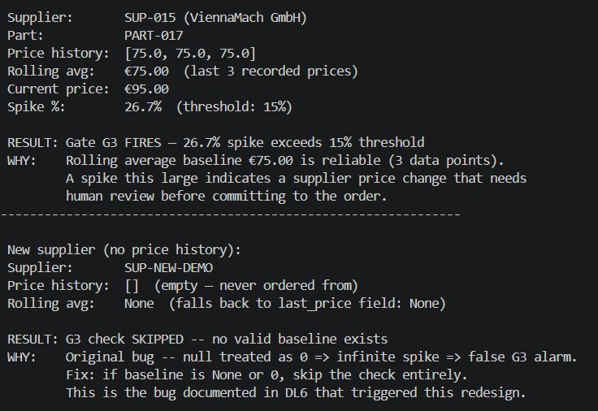
G3 redesign test — ViennaMach: rolling avg €75.00 (3 data points), current €95.00, spike 26.7% — RESULT: Gate G3 FIRES correctly. SUP-NEW-DEMO: no price history — RESULT: G3 check SKIPPED, no false alarm. Bug documented in DL6.

What this means
The original design had a silent assumption: that last_price would always be a valid non-zero number. This was true in the seeded CSV data but broke for new suppliers added after deployment. The system was making a decision (fire G3 or not) based on data that did not exist, and defaulting to a behaviour that was worse than doing nothing.
The redesign makes the assumption explicit: G3 only fires when there is enough pricing history to establish a meaningful baseline. 'Enough' is defined as at least one previous recorded price.
6. Does This Hold Up?
 | Criterion | Actual result vs. target
✅ | C1 — G3 does not fire for new suppliers | Running the agent against a part whose only supplier is new to the system (no price_history entries) no longer triggers G3. The check is skipped and the order proceeds autonomously. Audit log confirms: 'No price history found for supplier — G3 check skipped.'
✅ | C2 — G3 still fires for genuine spikes | The G3 test scenario (ViennaMach, €75→€95 = 26.7% increase) still fires correctly because ViennaMach has 3 recorded price entries at €75. Rolling average baseline is €75, current price €95, spike is 26.7% — gate fires.
✅ | C3 — change contained in database + Decide node only | No changes to BetsyState, no changes to routing functions, no changes to existing tests. The price_history table is additive. Only files changed: betsy/database.py (two new functions and one new table) and betsy/nodes.py (updated G3 check logic).

Assumptions I am making
The rolling average of the last three recorded prices is a sufficient baseline. If a supplier changes their pricing genuinely and consistently over three consecutive cycles, the rolling average will adapt and G3 will eventually stop firing for the new price level. This is the intended behaviour — the gate is designed to catch sudden changes, not sustained trends.

What surprised me
The bug was not in the gate threshold or the gate routing logic — it was in a silent assumption about data quality. The last_price field in the suppliers table had no null-guard because the original CSV data always had a value. The production scenario (a new supplier added after initial seeding) was never tested explicitly. This is a common class of real-world bug: edge cases that do not appear in carefully prepared test data but occur in actual operation.
The audit log was the key to diagnosing this quickly. Without the WHAT/WHY/NEXT trail showing exactly what values the Decide node was using, this bug could have taken hours to trace in the code. The transparency mechanism paid off on the first real problem it was needed for.
7. What This Unlocks

Evidence artifacts
- Bug Log entry (Bug 2) — the original symptom, the audit log output that revealed the root cause ('price €45.00 vs last price €0 — infinite% increase'), and the fix applied.
- betsy/database.py — two new functions (record_price_history and get_price_average) and one new table (price_history).
- betsy/nodes.py — the updated G3 check in decide_node, showing before (single last_price comparison) and after (rolling average with null guard).

Next LO stage
Managing continues — price spike detection is now reliable for both established and new suppliers.

How I will know this worked
Over the next several cycles, G3 should only fire when a supplier's current price genuinely exceeds their recent average by more than 15%. The audit log should show 'No price history found — G3 check skipped' for any new supplier's first order, and the price_history table should accumulate entries confirming prices are being recorded correctly.

