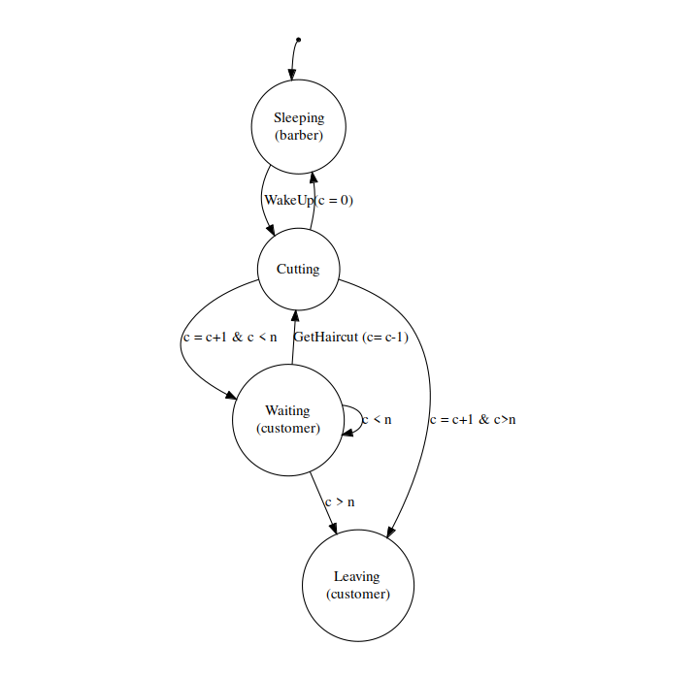
The number of chairs in waiting room is n, the number of customers arrived is c.
When a new customer arrives, c = c + 1. The barber keeps cutting hair for customers as while c > 0, c decreases as the customer gets haircut. The barber goes to sleep when c = 0. When a customer arrives, and c exceeds n, that new customer leaves.

Implementation on IMITATOR (barber_shop.imi)
Though I have successfully installed IMITATOR and used it locally to implement the model and define the 1st property, the testing for the other two properties is not yet completed.

The automaton consists of 4 locations: "sleeping," "cutting," “waiting” and "leaving."
- "sleeping" location: This location represents the initial state of the barber, where he is sleeping. When a customer arrives, the "arrive" synchronization is triggered, and the number of waiting customers "c" is set to 1, and the time since last customer arrival "x" is set to 0. Then, the system transitions to the "cutting" location.
- "cutting" location: This location represents the state where the barber is cutting hair. If there are no customers waiting (c=0), the "sleep" synchronization is triggered, and the barber goes back to sleep in the "sleeping" location. If there are customers waiting (0<c<=n), the "haircut" synchronization is triggered, and the next customer in line gets a haircut, and the number of waiting customers "c" is decreased by 1. The time since the last haircut "y" is set to 0, and the system transitions back to the "cutting" location.
- "waiting" location: This location represents the state where the customers are waiting for their turn in the waiting room. If a customer arrives, the "arrive" synchronization is triggered, and the number of waiting customers "c" is increased by 1, and the time since the last customer arrival "x" is set to 0.
If there are available chairs in the waiting room (c<=n) and the time since the last haircut "y" is greater than 0, the "stay_in_waiting" synchronization is triggered, and the customer stays in the waiting room.
If there are available chairs in the waiting room (c<=n) and the time since the last haircut "y" is 0, the "haircut" synchronization is triggered, and the next customer in line gets a haircut, and the number of waiting customers "c" is decreased by 1. The time since the last haircut "y" is set to 0, and the system transitions back to the "cutting" location.
If there are no available chairs in the waiting room (c>n), the "leave" synchronization is triggered, and time since last customer leaving "z" is set to 0, and the system transitions to the "leaving" location.
- "leaving" location: This location represents the state where a customer who couldn't find an available chair in the waiting room leaves the shop. There are no synchronizations in this location, and the simulation stops when all customers have left the shop.
The synclabs section defines the events that can synchronize the different locations. arrive, haircut, leave, stay_in_waiting and sleep are the events defined in this code. The automaton section of the code specifies the transitions that can occur between the different locations based on these events.

Express in temporal logic LTL and CTL for the properties:
1. If a customer is waiting, he will eventually be served.
G(Waiting -> F(Cutting))
AG(Waiting -> AF(Cutting))
2. The barber goes to sleep as soon as he has finished serving the last customer.
G(Cutting -> X Sleeping)
AG(Cutting -> AX Sleeping)
3. When the barber is sleeping, the waiting room is empty
G(Sleeping -> G (c = 0))
AG(Sleeping -> AG (c = 0))

Testing properties in IMITATOR: (imitator barber_shop.imi prop.imi)
1. If a customer is waiting, he will eventually be served:
The model satisfies this property with c=2, n=4 and c=3, n=2.
I defined this property in “prop1.imiprop” as:
property := #synth pattern(if stay_in_waiting then eventually haircut within t);
2. The barber goes to sleep as soon as he has finished serving the last customer.
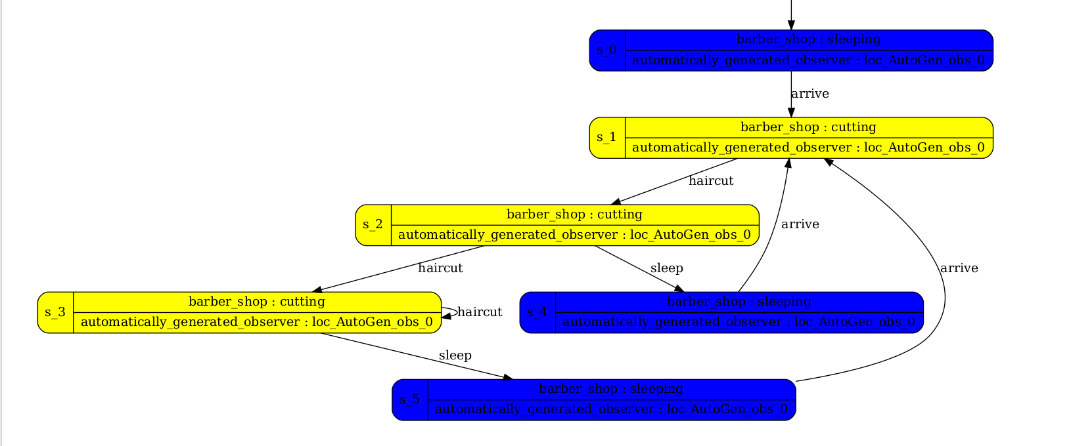Figure 1: Statespace of property 1
In the current model, the barber goes to sleep as soon as there are no customers waiting in the waiting room, regardless of whether or not he has finished serving the last customer. This means that if a customer arrives just as the last customer is being served, the barber will not go to sleep immediately after serving the last customer. Instead, the barber will wait for the new customer to be serviced, and only then will he go to sleep.
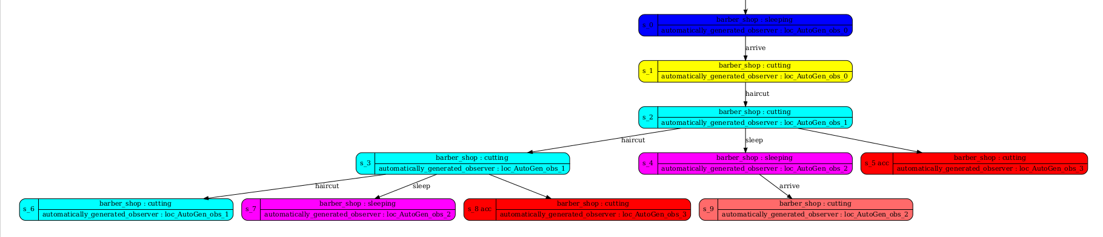Figure 2: Statespace of property 2
3. When the barber is sleeping, the waiting room is empty
The model satisfies the property "When the barber is sleeping, the waiting room is empty".
This property can be verified from the invariant condition of the "sleeping" location, which is True. This means that the property holds true whenever the system is in the "sleeping" state.
In the "sleeping" location, the system only transitions to the "cutting" location when a customer arrives. Thus, if the barber is sleeping and there are no waiting customers, the system will remain in the "sleeping" state.
From the "sleeping" location, the barber only transitions to the "cutting" location when there is at least one customer waiting. Therefore, if the barber is sleeping and there are no waiting customers, the system will stay in the "sleeping" state and the waiting room will remain empty.
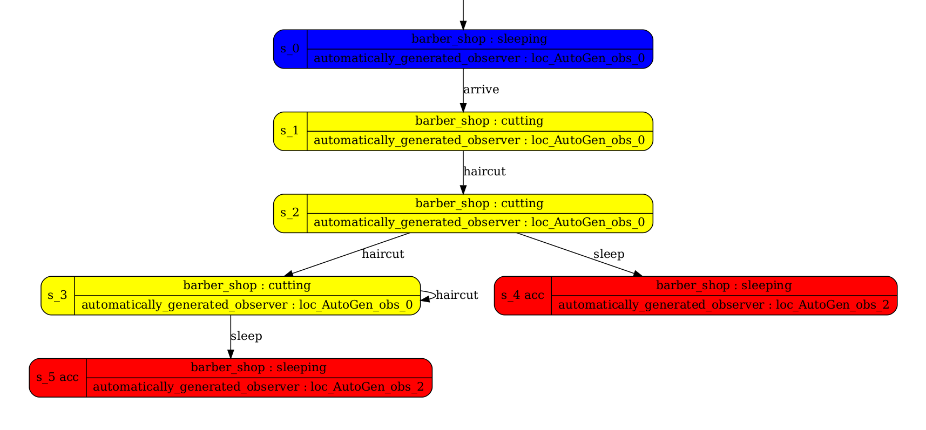Figure 3: Statespace of property 3

