#///////////////////////////////////////////////////////////////////////////////

# INSTITUTO TECNOLOGICO DE COSTA RICA

# Escuela de Ingenieria en Construccion

# Construction Engineering School

# https://www.tec.ac.cr

# Eng. MSc. Maikel Mendez Morales

# Email: maikel.mendez@gmail.com; mamendez@itcr.ac.cr

# https://orcid.org/0000-0003-1919-141X

# https://www.scopus.com/authid/detail.uri?authorId=51665581300

# https://scholar.google.com/citations?user=JnmSVFYAAAAJ&hl=en

# https://www.youtube.com/c/maikelmendez

# https://twitter.com/MaikelMendezM

# https://github.com/maikelonu

# Skype: maikel.mendez

#///////////////////////////////////////////////////////////////////////////////

1_Go to <https://www.overleaf.com> and create your own account

2_Create New Project/Upload Project

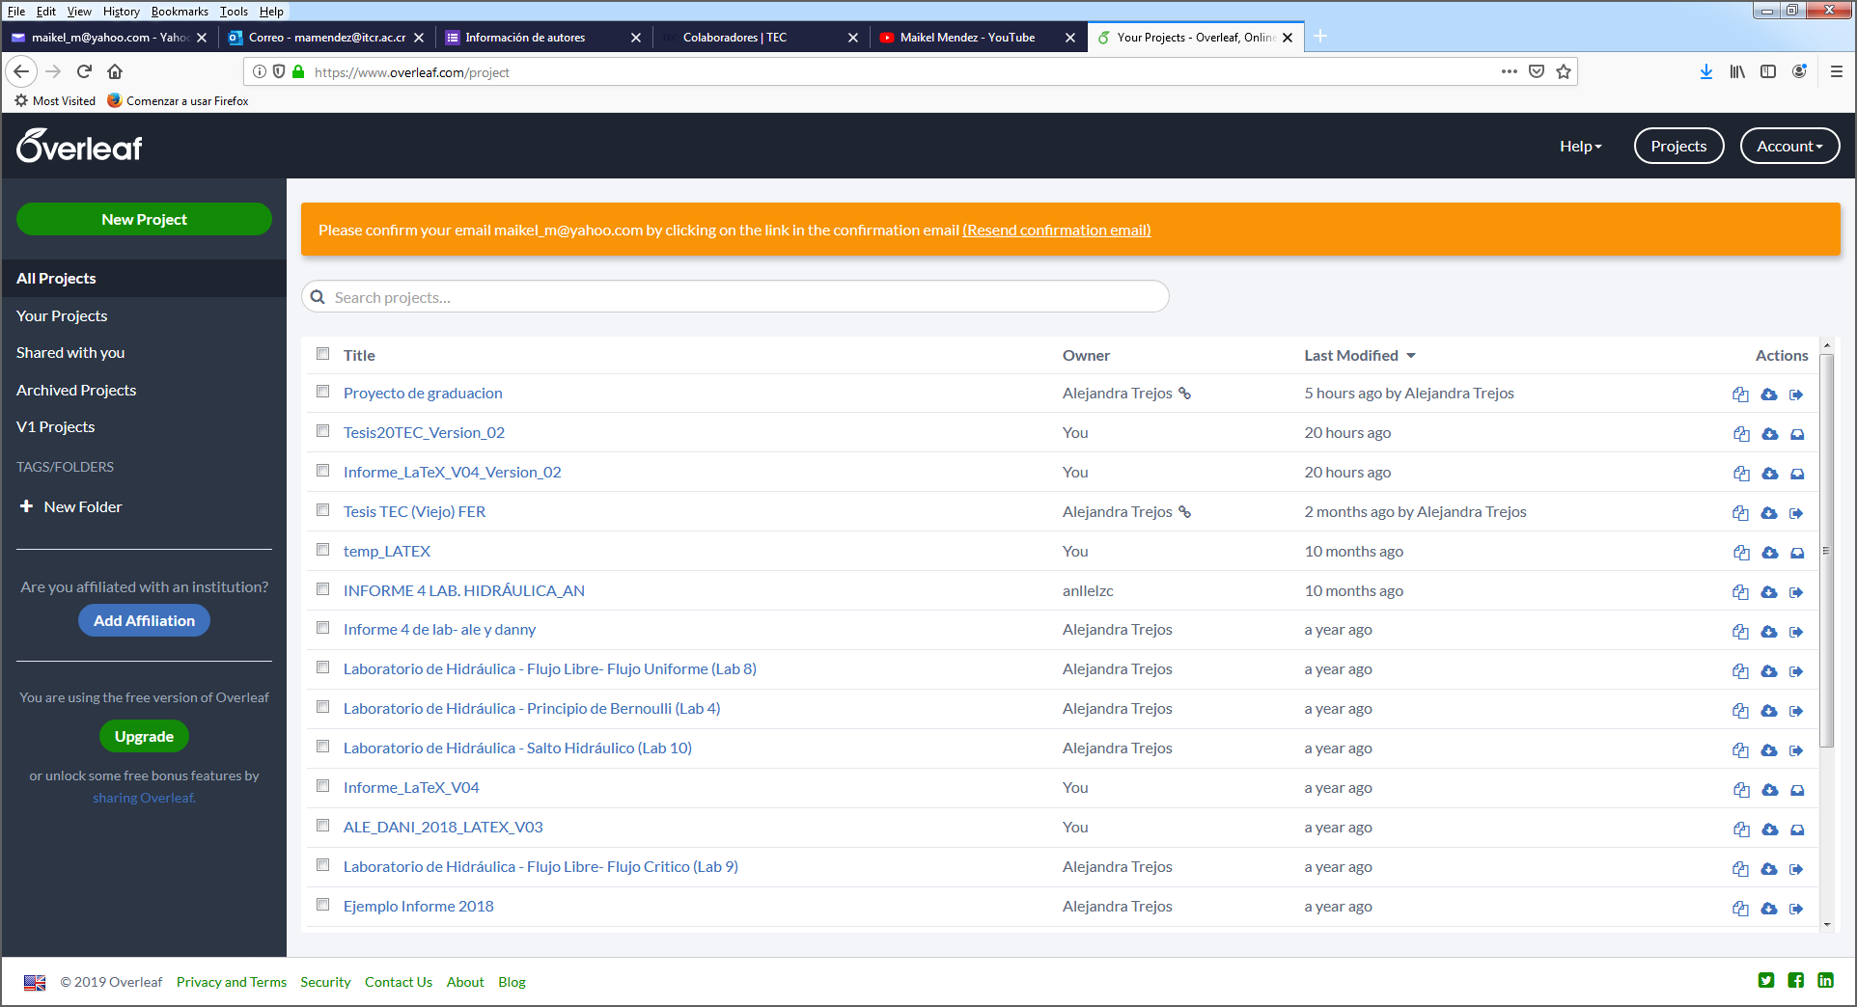

3_Upload LATEX_ICO_PG_2019.ZIP from:

<https://drive.google.com/drive/folders/1RgR77awrR6mCh6_glBQP65FScFO05vDK?usp=sharing>

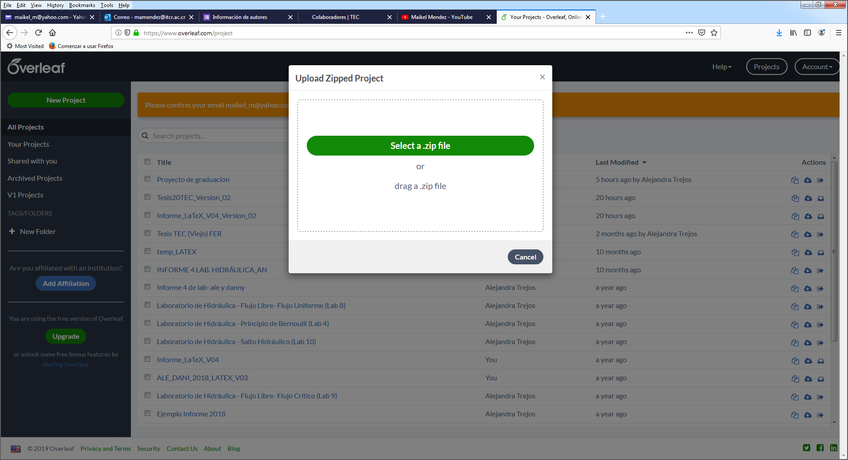

4_Start working!

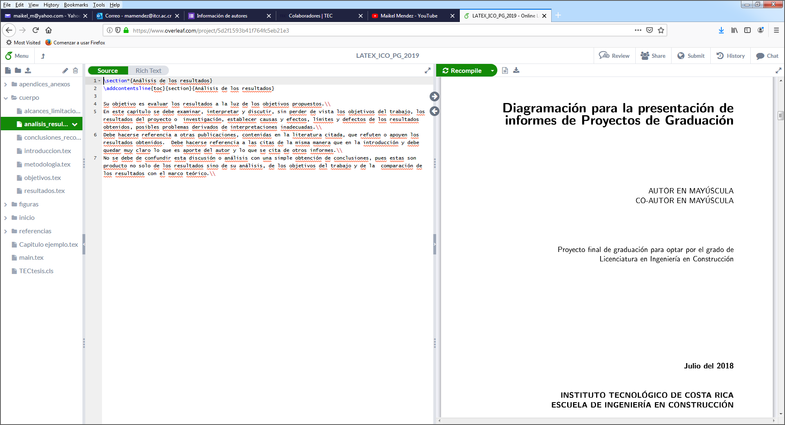

5_If you want to “install” LATEX **locally** on Windows, please refer to the following links:

<https://drive.google.com/drive/folders/1fcU0xTnbPNqV_jkbsjUiTtnIwrDJCCAo?usp=sharing>

and read: **Bienvenida.TXT** and **Instalación.TXT**.