**Answering the following Questions upon graphing data**

[1] *Can you count something interesting?*

Possibly, we could look at the amount of times the stock closed higher than open or closed lower than open.

[2] Can you find trends (e.g. high, low, increasing, decreasing, anomalies)?

Taking a select sample of one TICKER (AMGN), a graph containing 2000 – 2020 was plotted by yearly with the x depicting months against the open price. The initial data is cluttered and needs to be normalized to find any changes for our time series analysis.

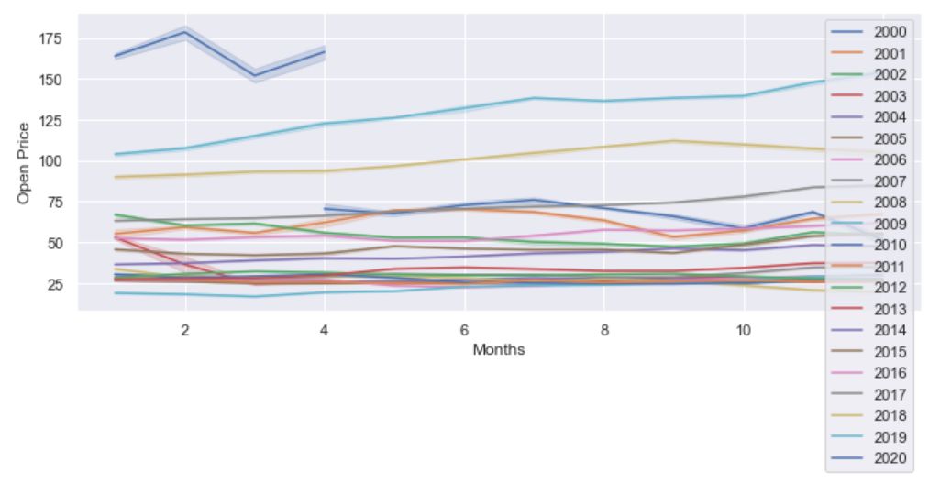

There are no immediate trends as illustrated using decompose model with statsmodel. Here are decomposition plots:

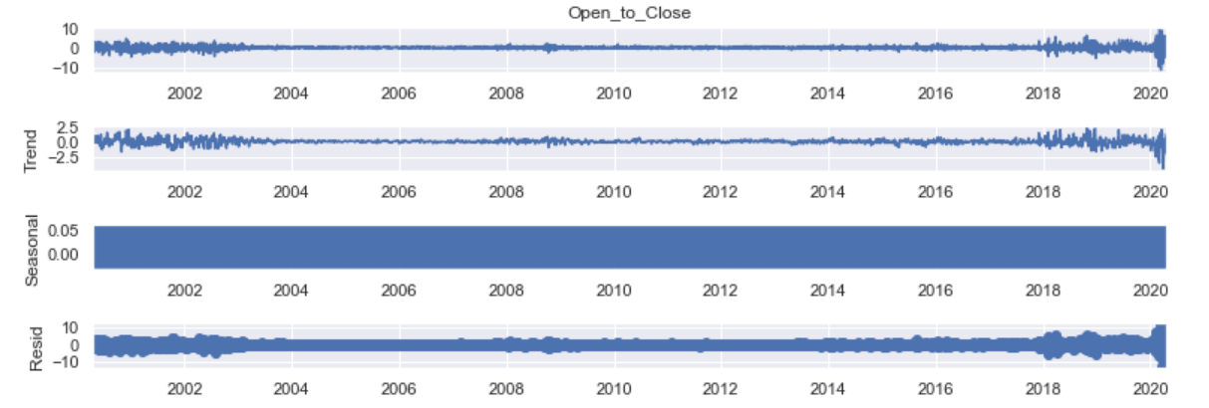

Further looking at how the decomposition model follows the whole picture of the graph:

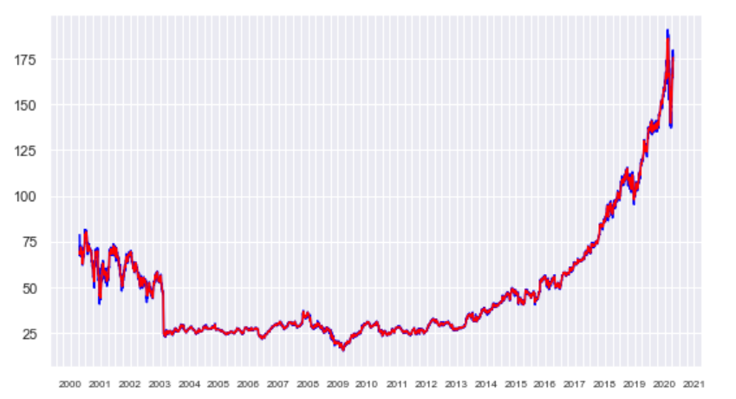

[3] *Developing hypothesis, you would like to investigate further?*

If the trend is so consistent, can intraday trading be a better alternative for biotech stocks?

Is analyzing AMGN just an outlier can you compare it to other stocks?

How about applying it to other sectors?

[4] *Is there a narrative or a way of presenting the insights using text and plots that tells a compelling story? What are some other trends/relationships you think will make the story more complete?*

Currently with the data, we can see that there is no seasonal pattern to trade with AMGN. Companies that do not fit the seasonal pattern allows the investor or analyst to ignore that aspect in their trading.