Kevin Mai’s Proposal for Predicting Biotechnology Stock Performance

Within the Healthcare Sector, there is a subcategory called Biotechnology. This area contains many companies responsible for new and innovative drugs, therapies, or biological technologies. Some investors speculate that a majority of bearish stock performance comes after a successful drug trial or proven invasive method. Other investors are doubtful with the awfully high rate of companies going into bankruptcy after failure of trials or unmet goals combined with burnt finances. There have been some strategies and technical analysis performed by investors proclaiming to achieve outstanding profits from 200% to 1000% in mere hours. But, is there a way to apply an algorithm to screen for tickers that match this sudden point of profit?

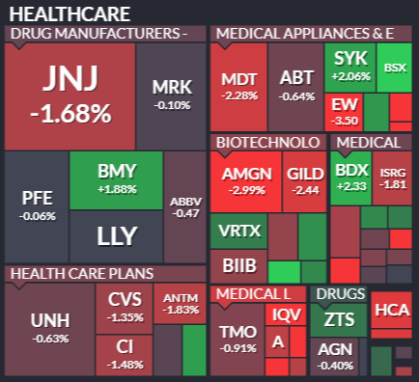

Retrieved from Finviz on March 31st 2020

With existing API’s, I hope to create a machine learning model that can predict a bearish trend, and in the best result, predict a certain target for the bearish mark. This project will demonstrate an expertise in data wrangling, time series analysis, as well as ML models with validation.