Demosaicing RTL from concept to validation.

Demosaicing is a function to convert to a RGB image from a image in the bayer pattern.
In an usual colored imaging sensor, the matrix of pixels have different filters to filter the colors. To get RGB, the imaging sensor doest not have 3 matrixes of RGB but a grid with RGB pixels interleaved like:
R G
G B
pattern, which is called bayer pattern.
The demosaic basically interpolates the pixels to get the RGB matrix.

There are plenty of algorithms for demosaic using interpolation, the one we are using is: HIGH-QUALITY LINEAR INTERPOLATION FOR DEMOSAICING OF BAYER-PATTERNED COLOR IMAGES
the paper is in the doc folder.
This algorithm computes RGB not interpolating only each channel individually but considering the value of the other channels.
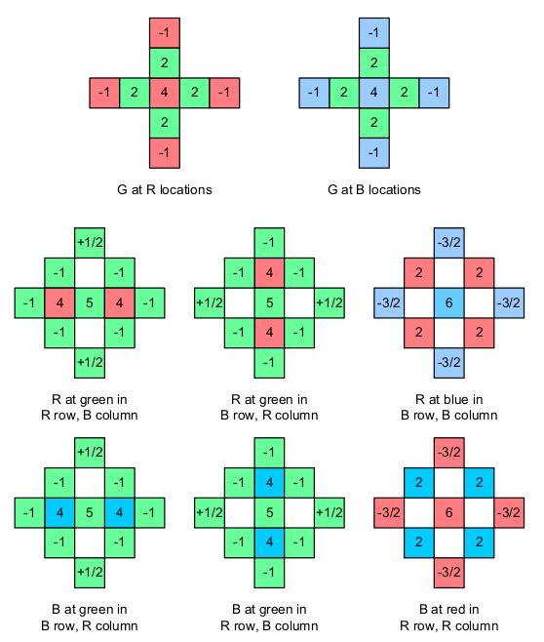

The coeficients are shown above and the shape is a 5x5 mask. In order to implement it in an FPGA, we will need to buffer 4 lines at least. Or row buffering like the image below.
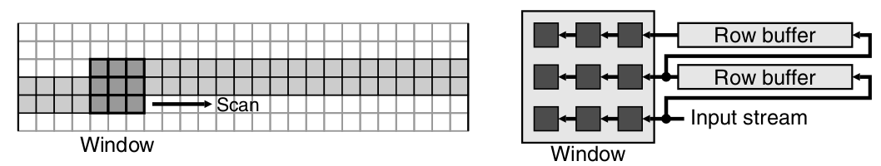
But this filter or window is 3x3 and we need 5x5. Also we have to think what to do in the border of the image, which could be handled in the router between the fifo and the convolution operation with the filter/coefficients.

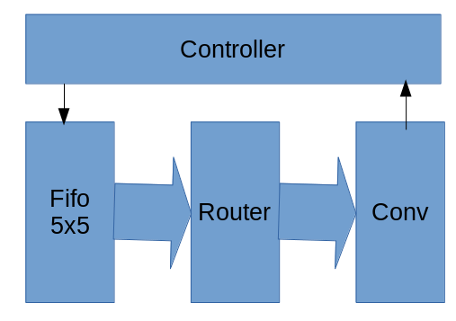
The basic algorithm structure:

Also the algorithm is implemented in octave using true RGB images plus some functionalities to write input vectors to the RTL design and later to compare the results. In the folder structure of this design.
The block diagram below show a general RTL development methodology where a Model generates the inputs to be used in the RTL

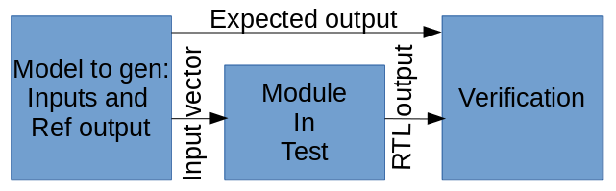

I coded generate_mosaic_image.m and sim_demosaicing_simple.m with the octave models to write intput vector files with the image to be demosaic and the model output to compare with the RTL design.

