We will be copying the data set in to HDFS which will be further loaded into HBase.

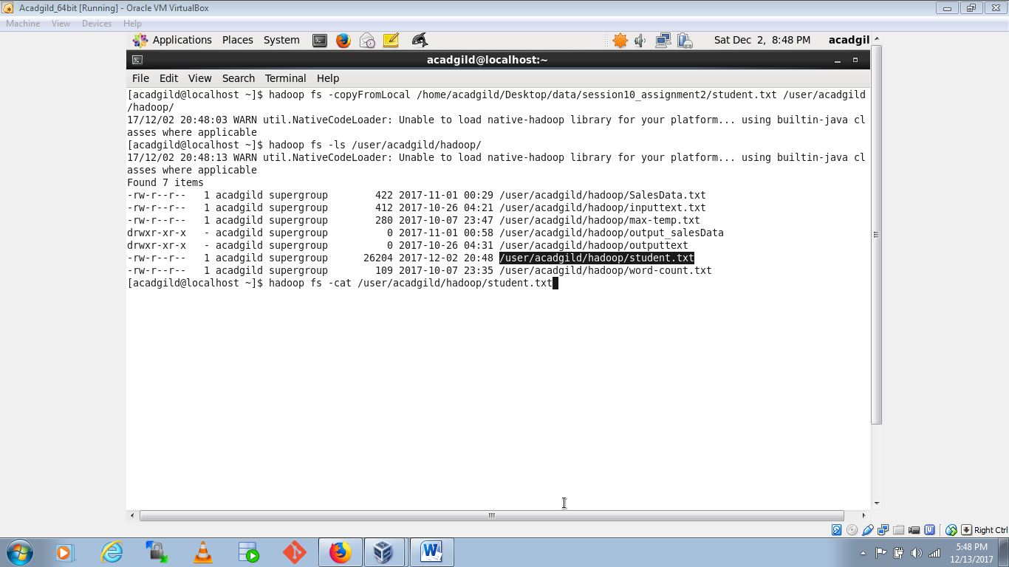

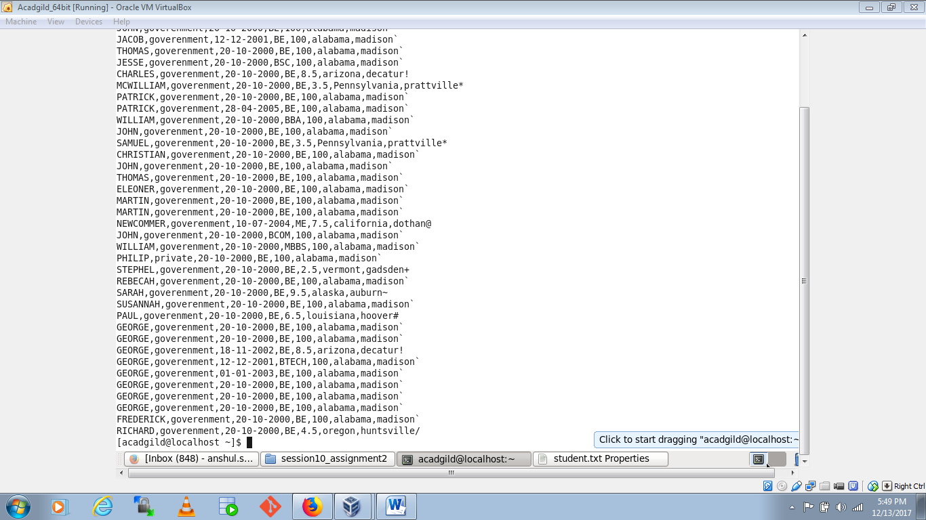

We will now start HBase shell and create a table.

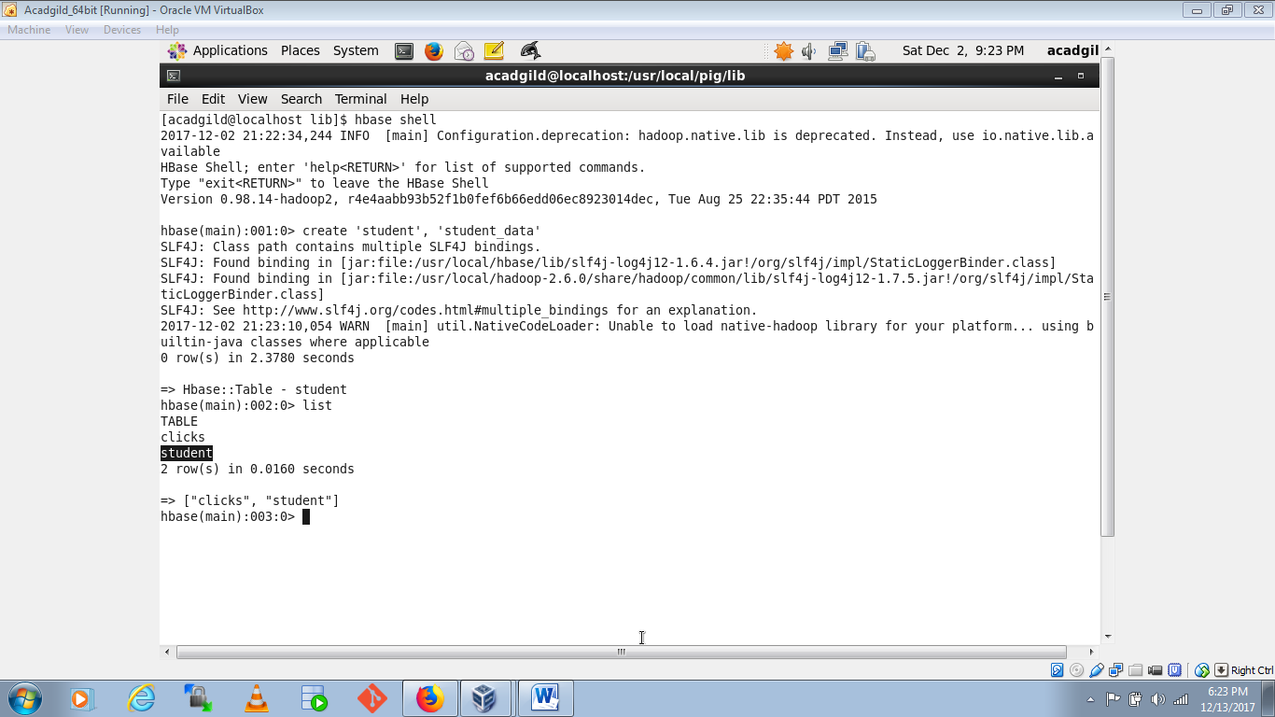

We can come out from HBase by typing exit and switch to PIG grunt shell.Once we are inside PIG mode we can load data from HDFS to Alias relation.

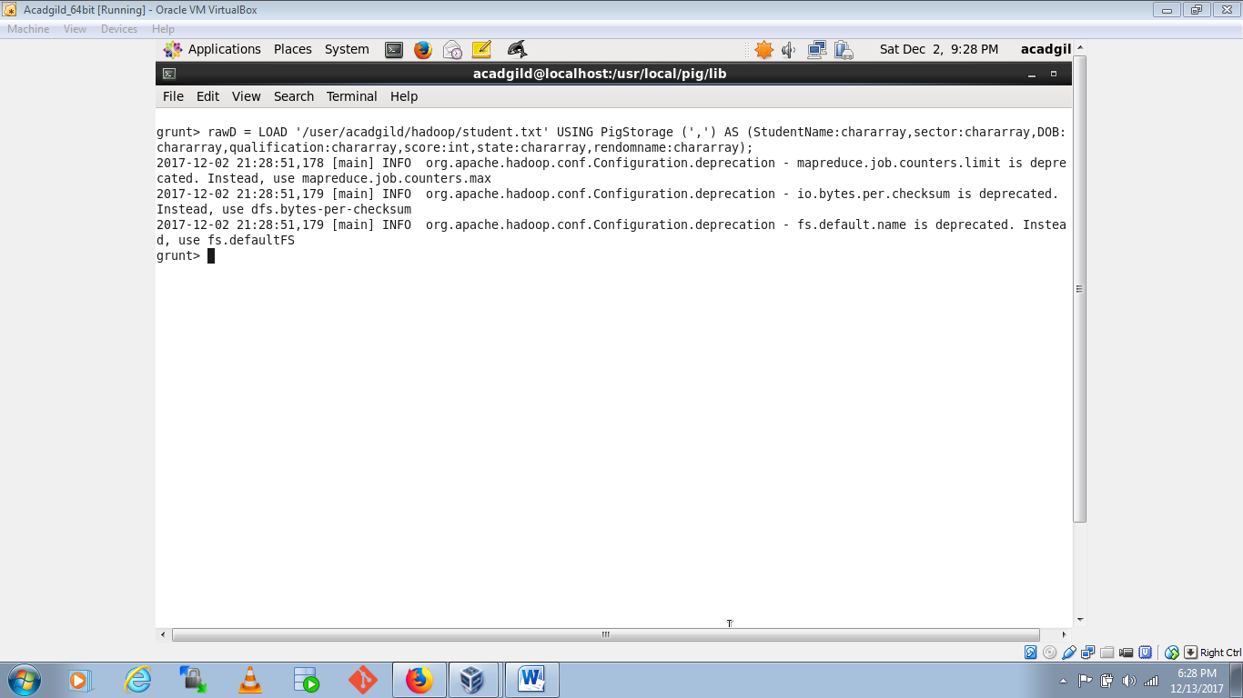

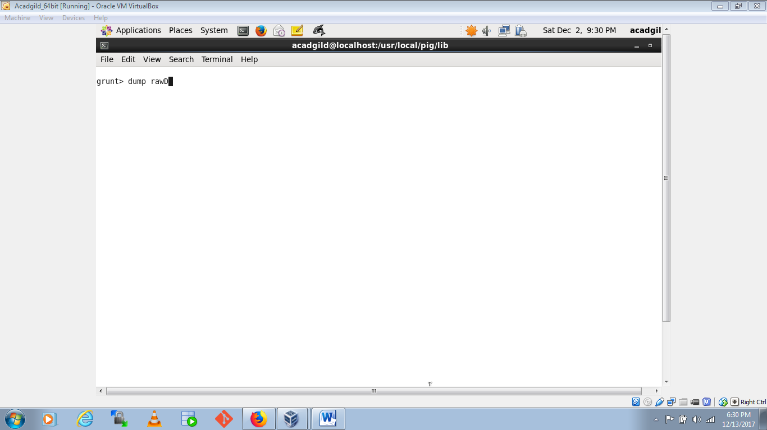

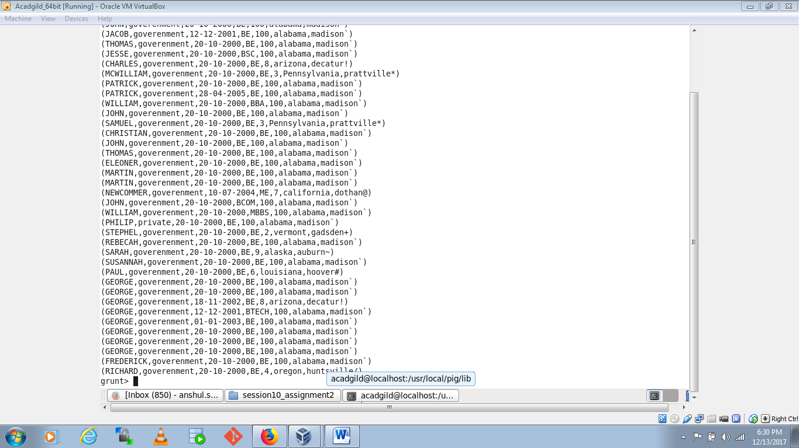

Now we can transfer the data inside HBase by STORE command.

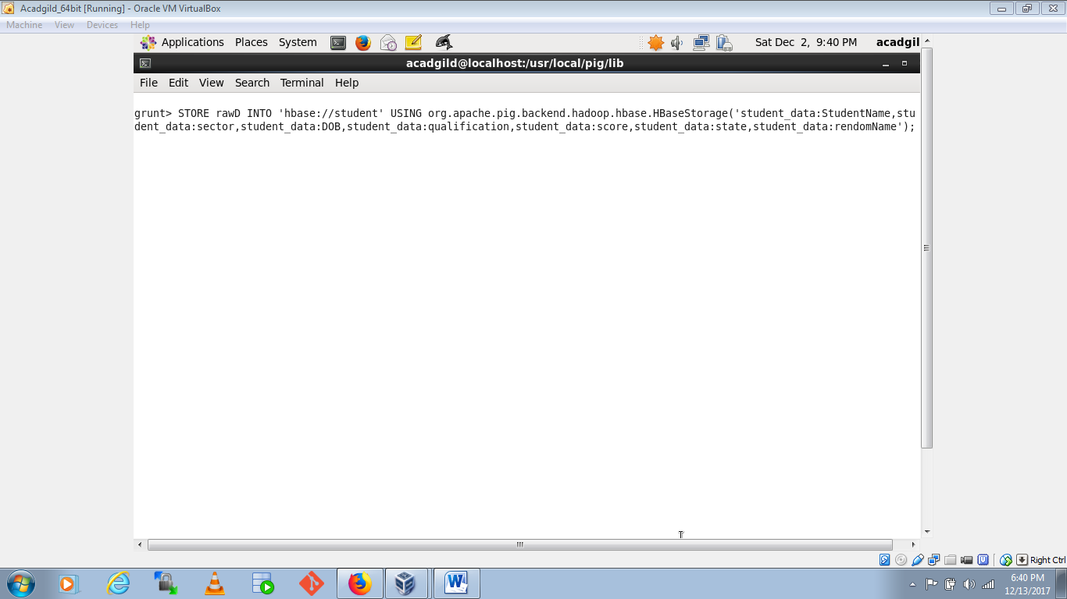

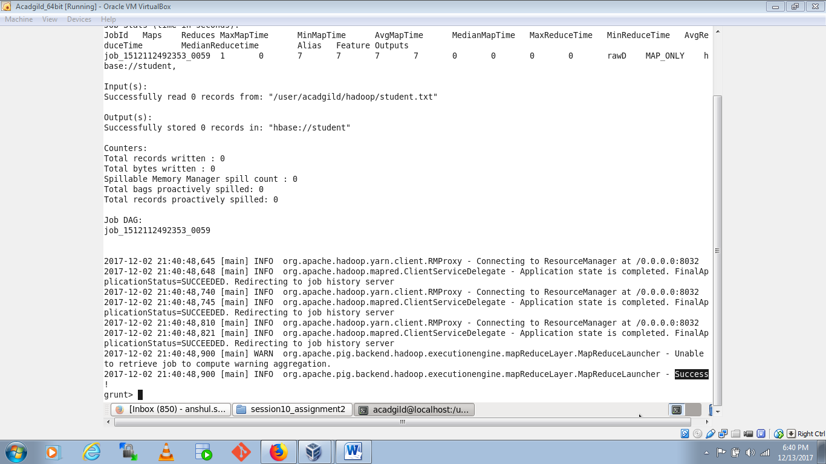

The result can be displayed through scan command followed by table name inside quotes( ‘ ‘ ).

