Given a list of strings - List[String] (“alpha”, “gamma”, “omega”, “zeta”, “beta”)

Creating list in scala:

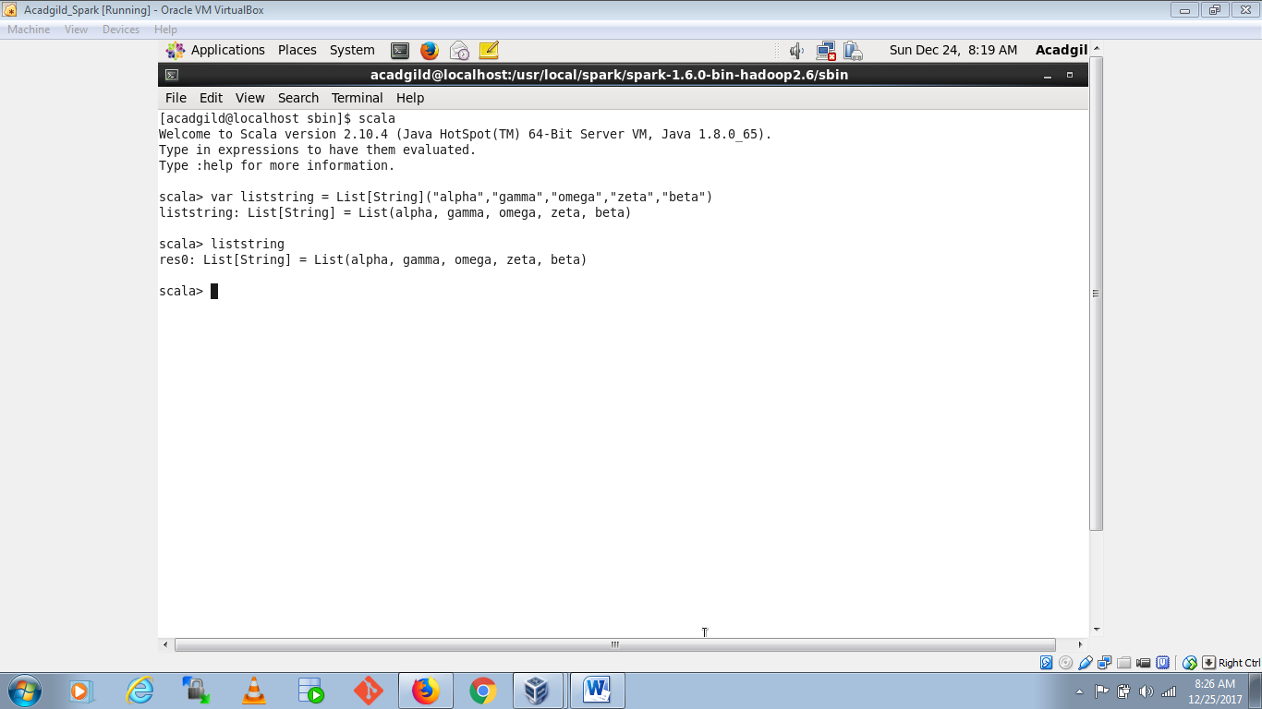

1. find count of all strings with length 4:

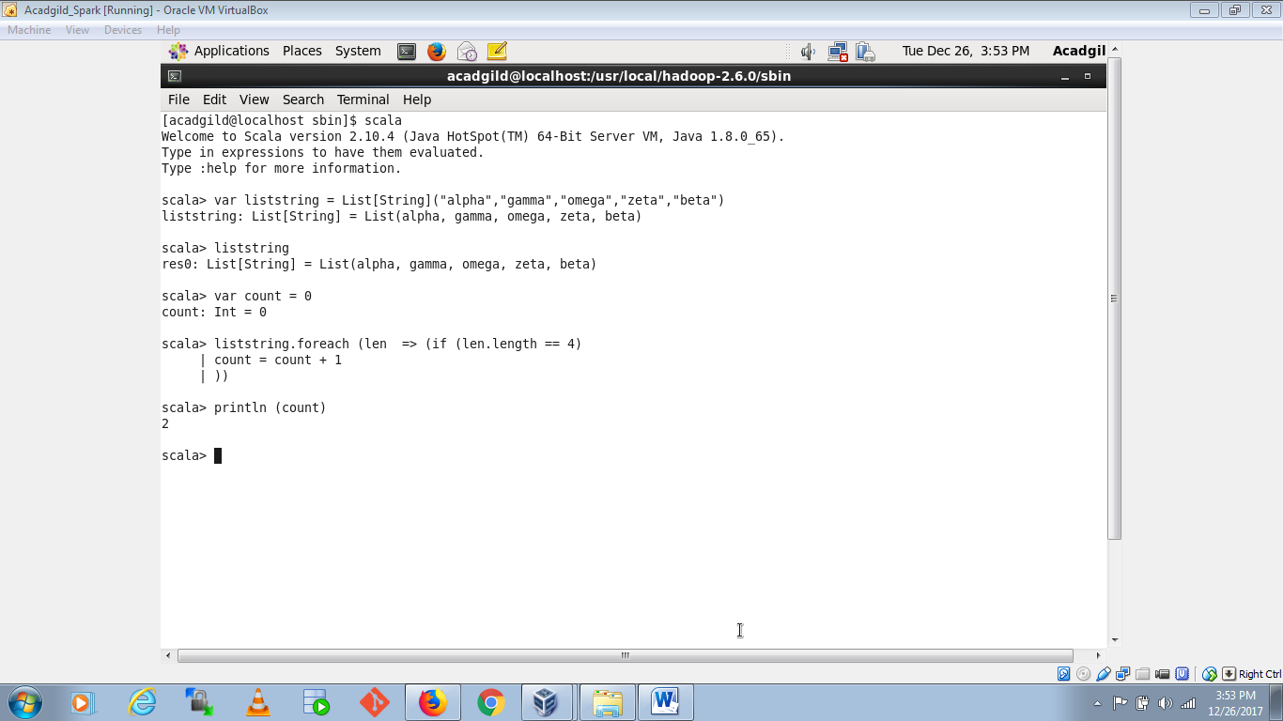

1. convert the list of string to a list of integers, where each string is mapped to its corresponding length

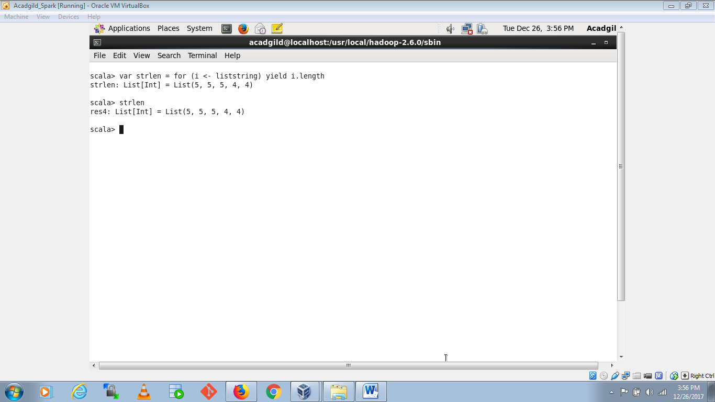

1. find count of all strings which contain alphabet ‘m’

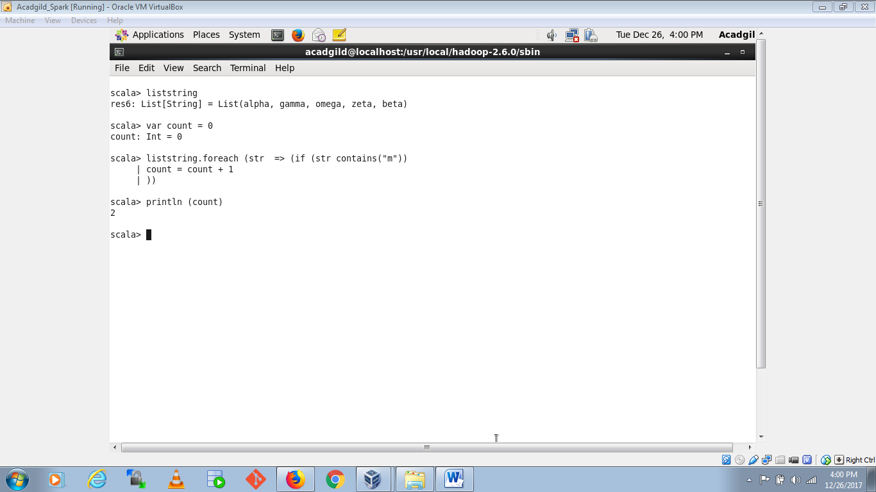

1. find the count of all strings which start with the alphabet ‘a’

