1. Write a simple program to show inheritance in scala.

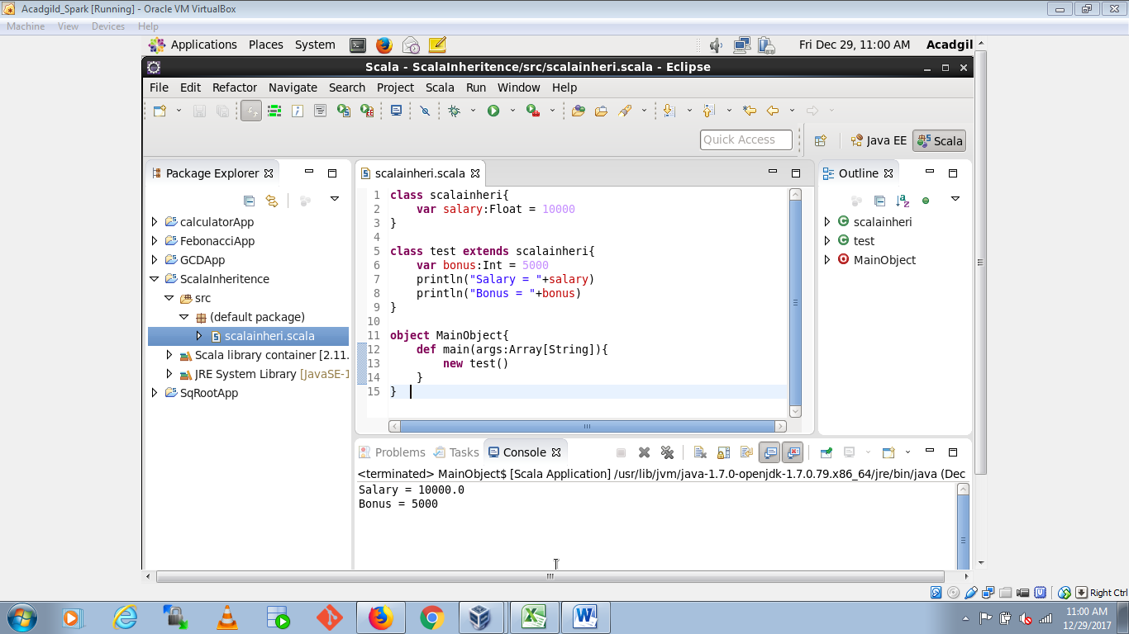

1. Write a simple program to show multiple inheritances in scala.

