Given a list of numbers - List[Int] (1, 2, 3, 4, 5, 6, 7, 8, 9, 10)

1. find the sum of all numbers

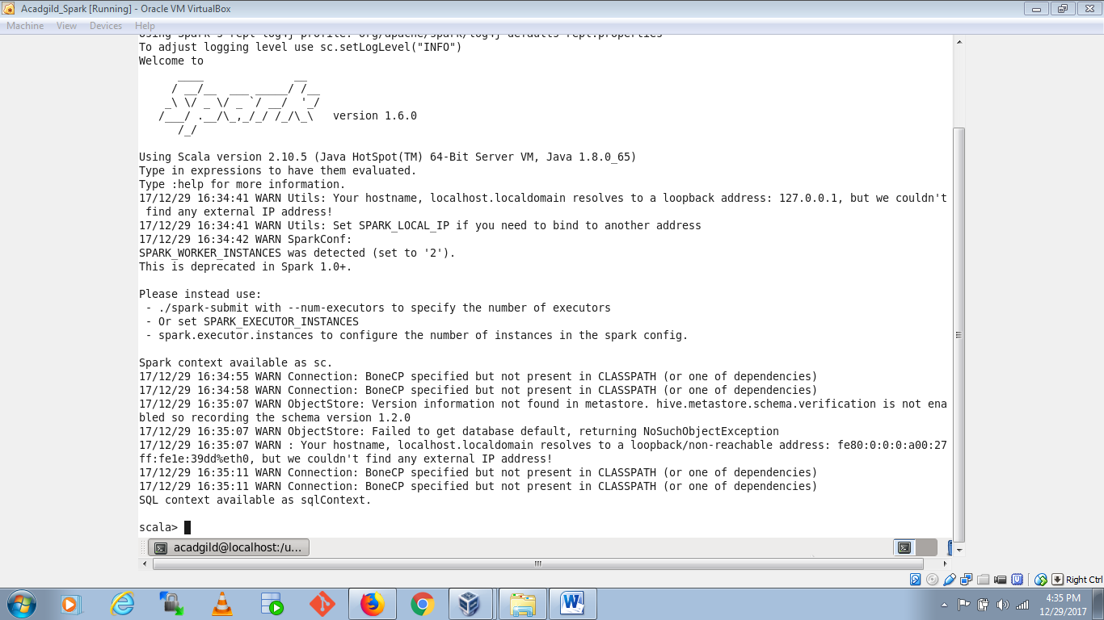

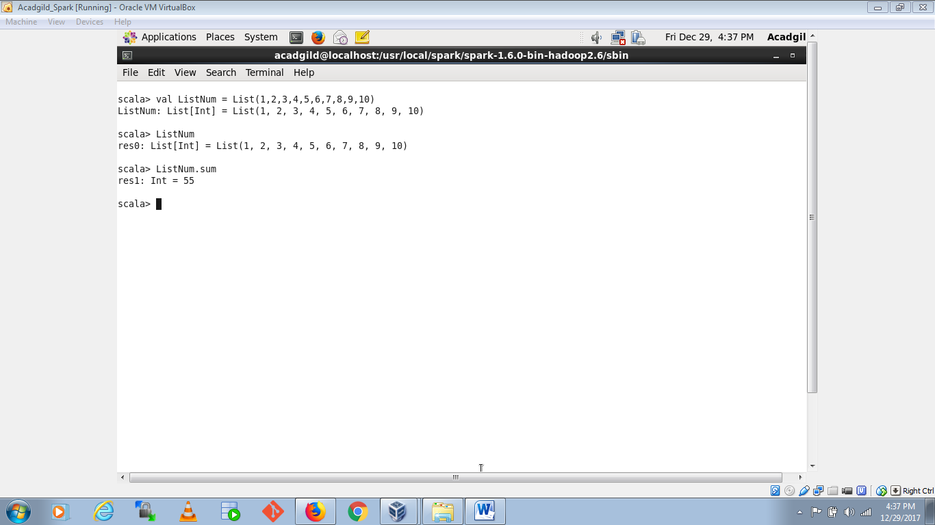

1. find the total elements in the list

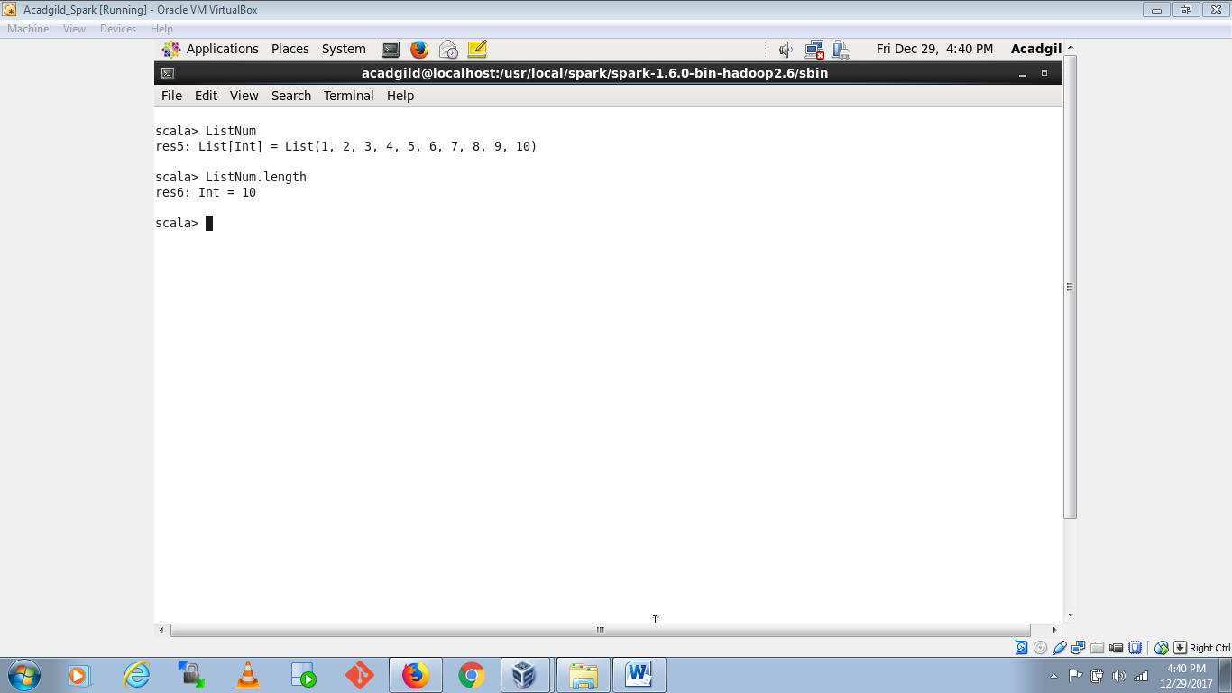

1. calculate the average of the numbers in the list

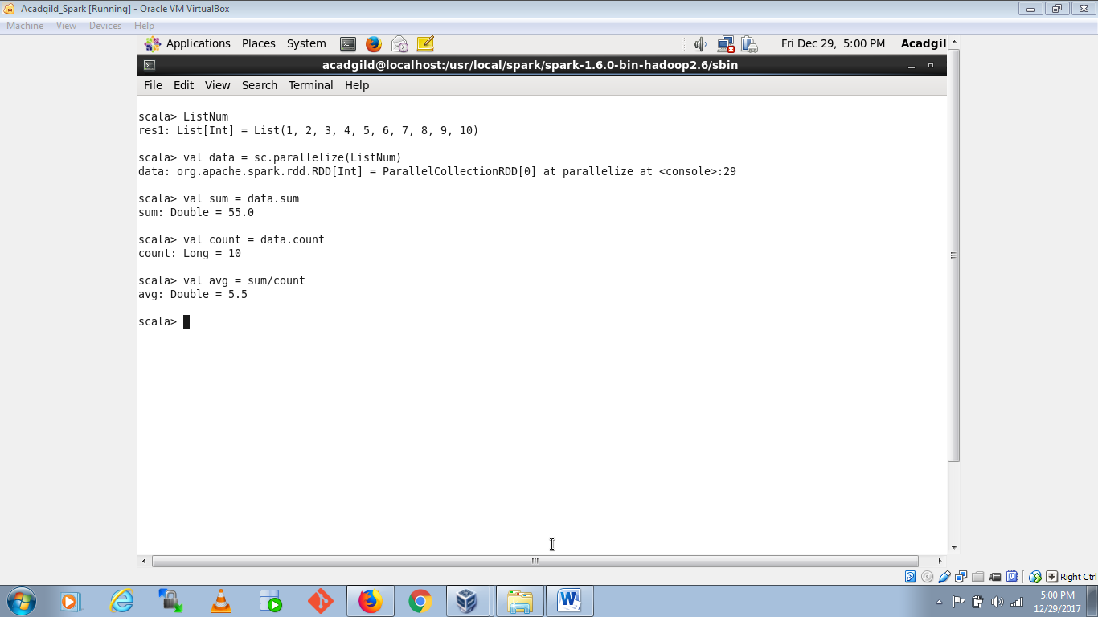

1. find the sum of all the even numbers in the list

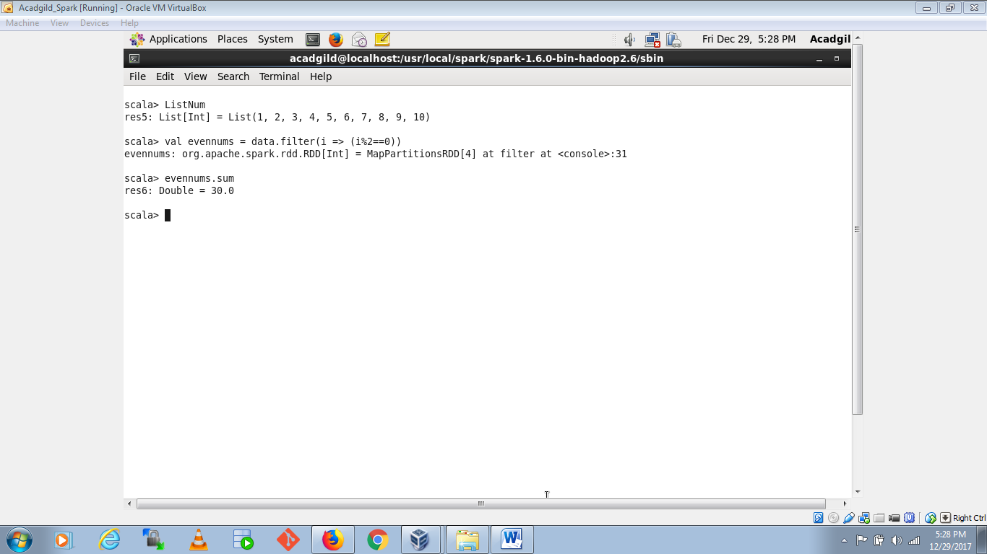

1. find the total number of elements in the list divisible by both 5 and 3

