1. Write a program to read a text file and print the number of rows of data in the document.

Created a file on local file system:

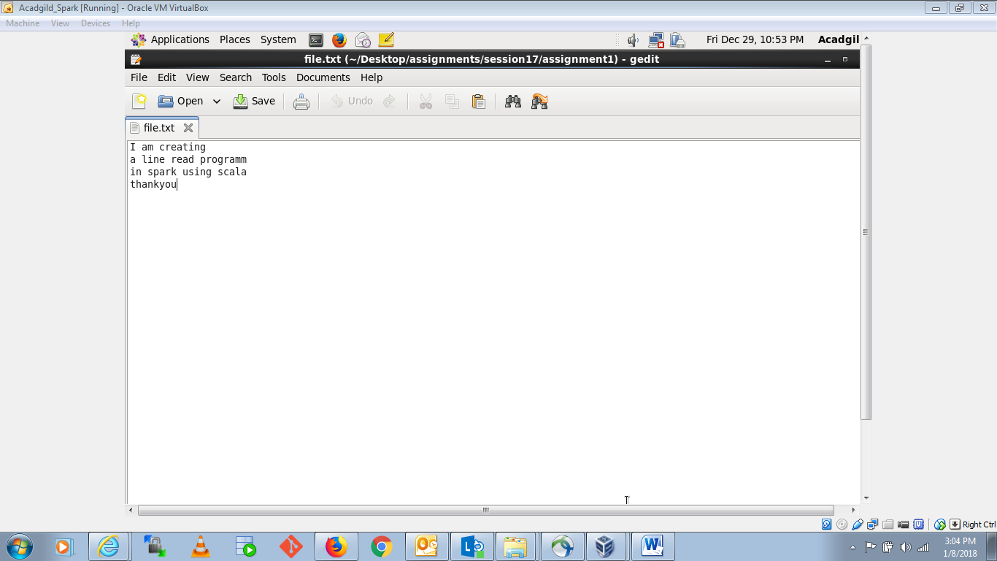

Spark code to print number of rows in file:

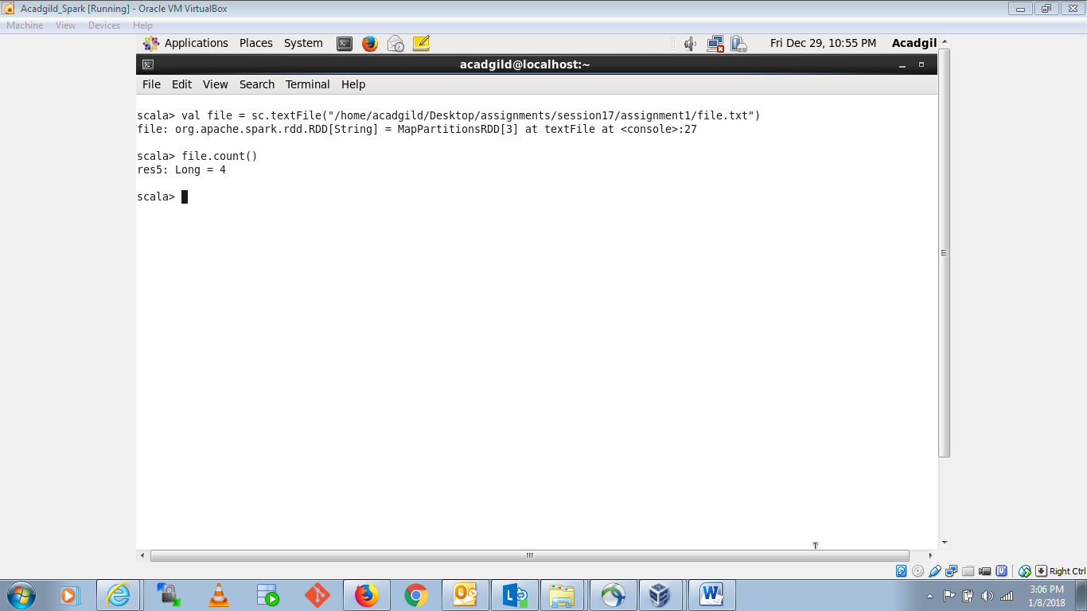

1. Write a program to read a text file and print the number of words in the document.

Created a text file:

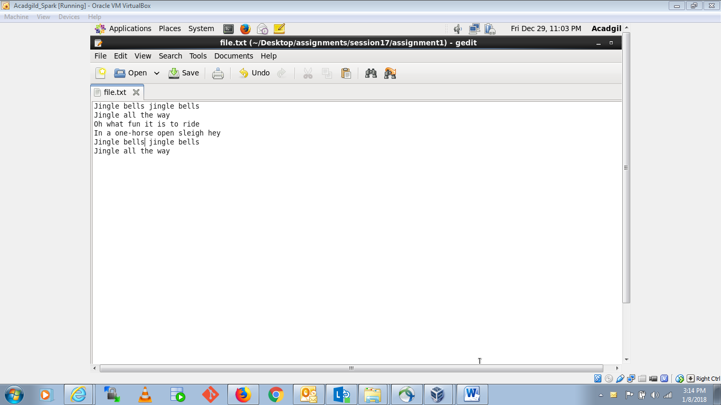

Counting the words occurrence:

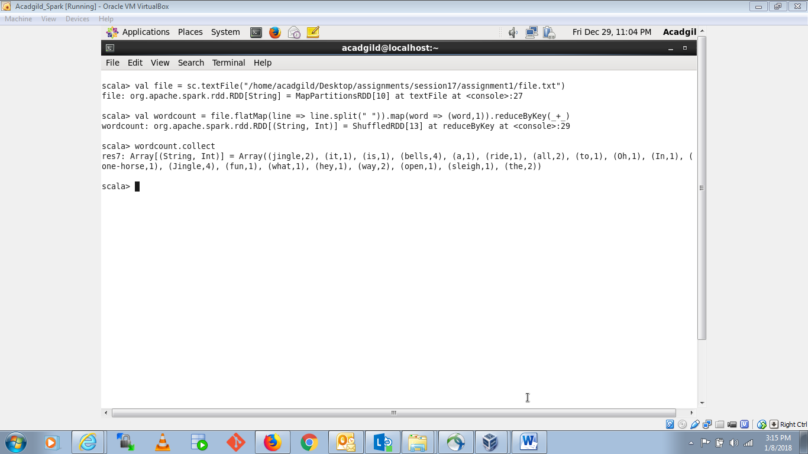

1. We have a document where the word separator is -, instead of space. Write a spark code, to obtain the count of the total number of words present in the document.

Created a text file:

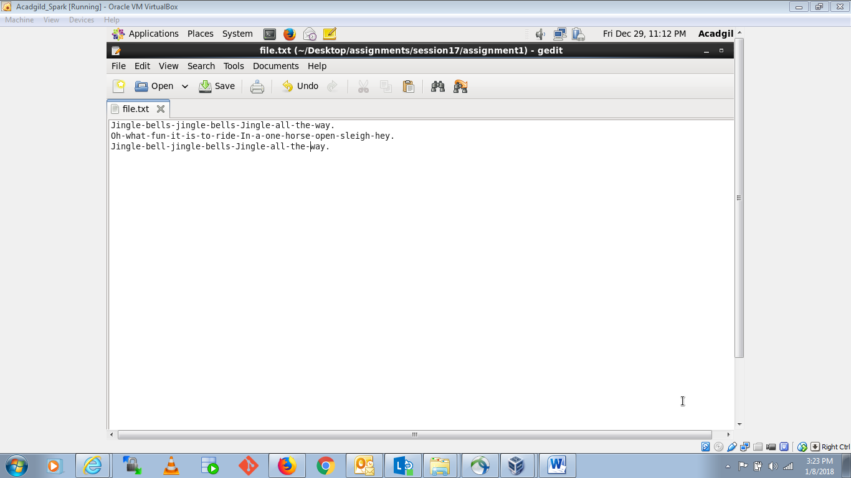

Counting total number of words:

