1. What is the distribution of the total number of air-travelers per year

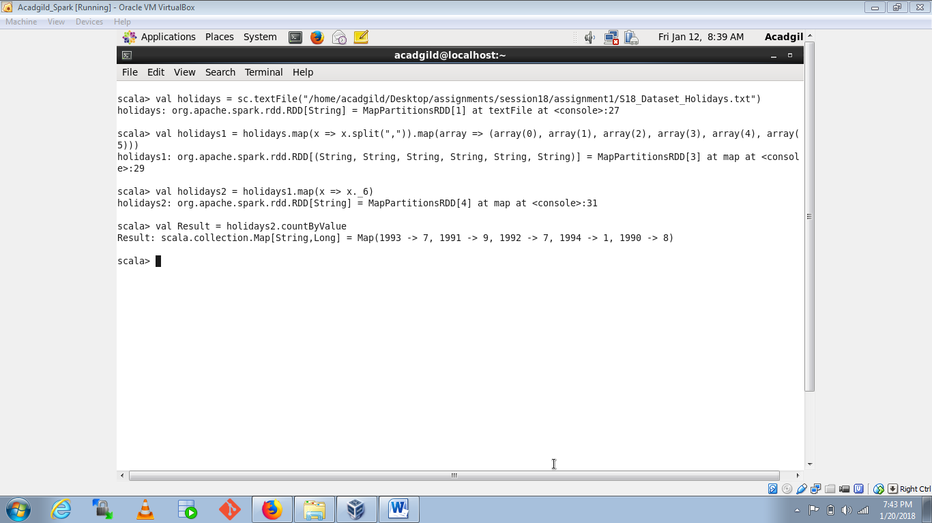

1. What is the total air distance covered by each user per year

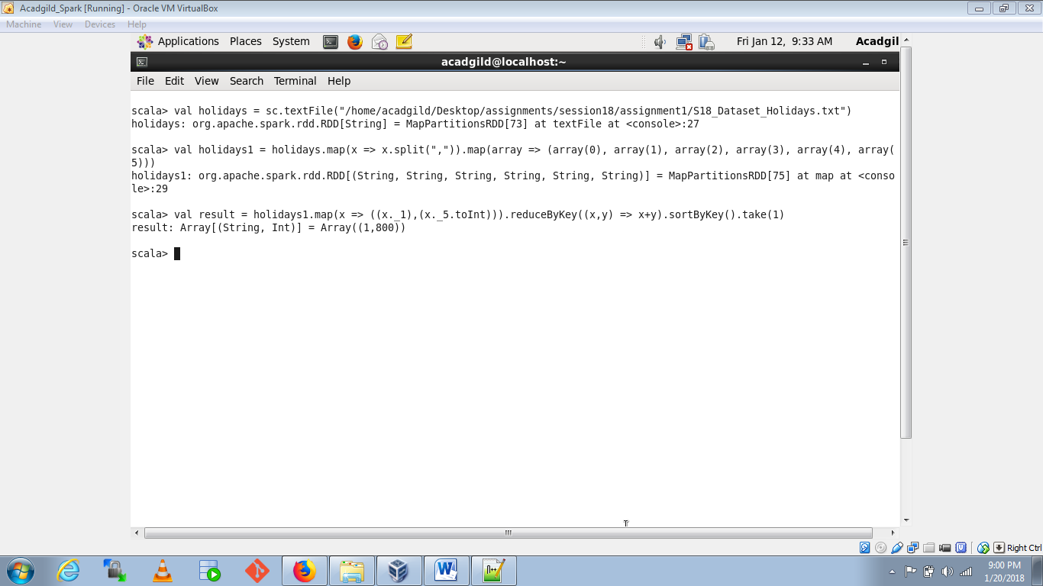

1. What is the most preferred destination for all users.

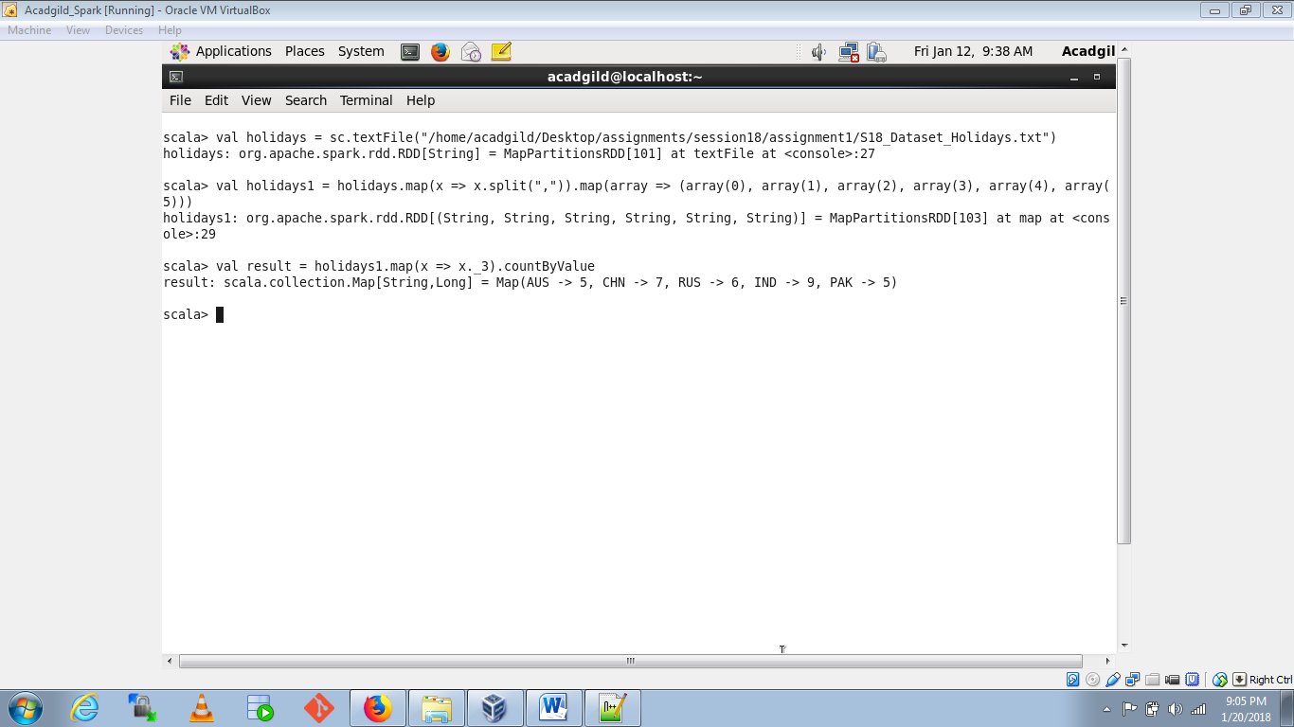

1. What is the total air distance covered per year

