Creating data frames for given txt files:

1. holidays file:

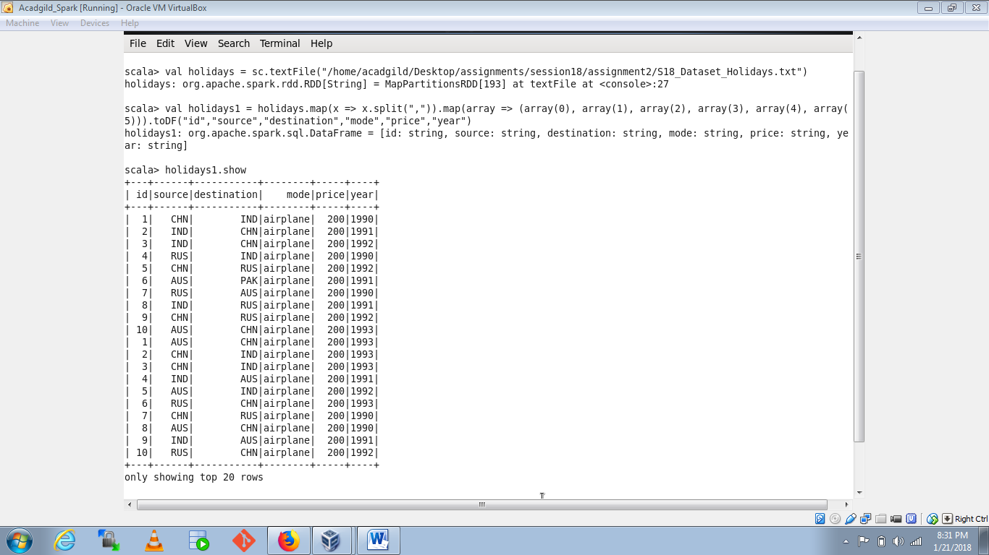

1. transport file:

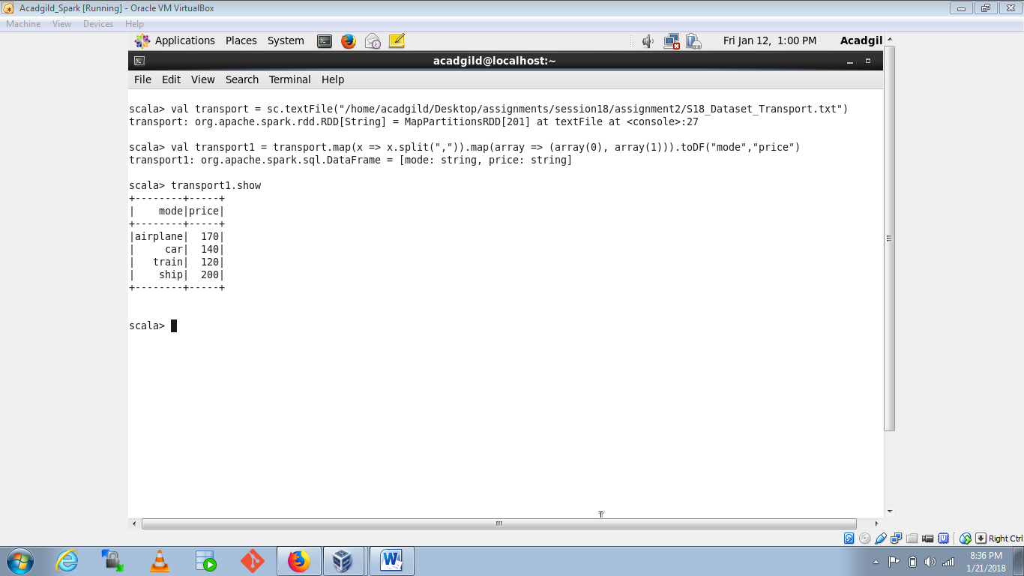

1. User details file:

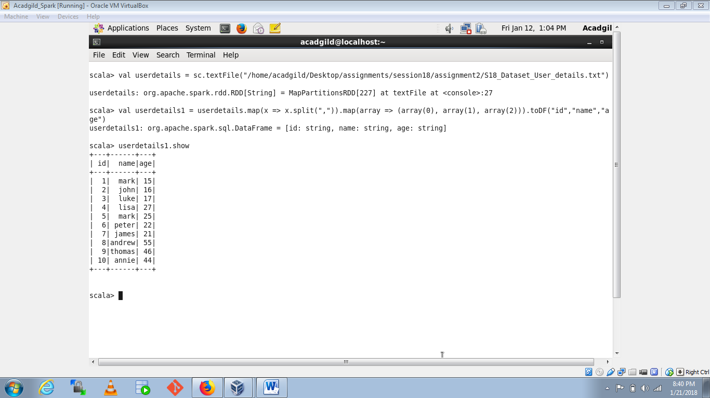

1. Which route is generating the most revenue per year

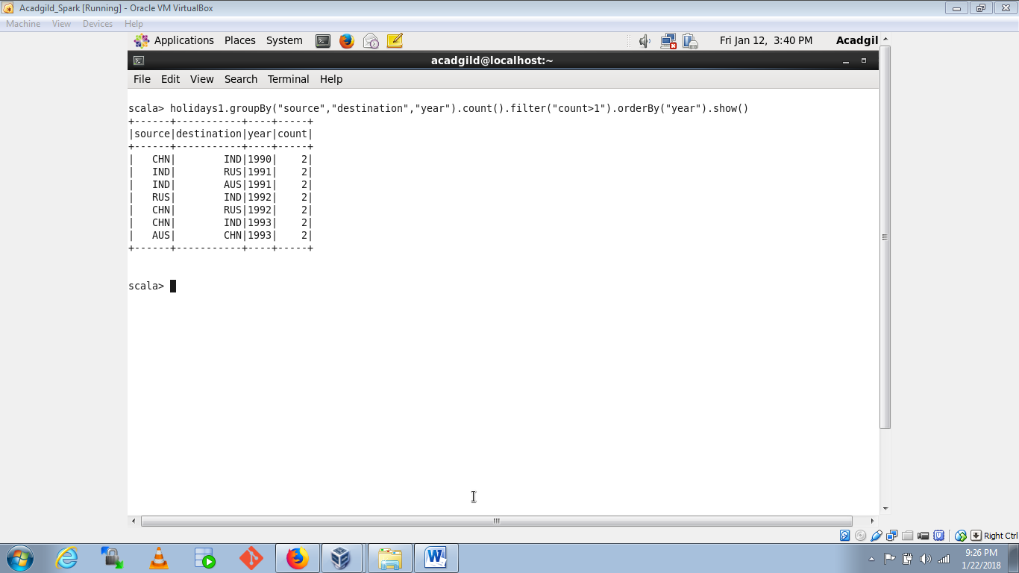

1. What is the total amount spent by every user on air-travel per year

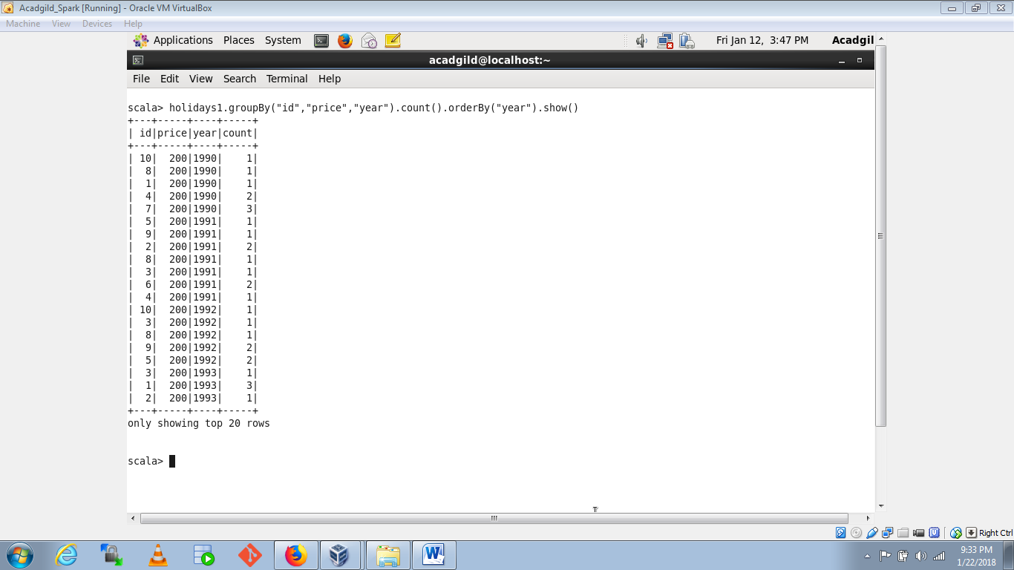

1. Considering age groups of < 20 , 20-35, 35 > ,Which age group is travelling the most every year.

