Creating data frames for given txt files:

1. holidays file:

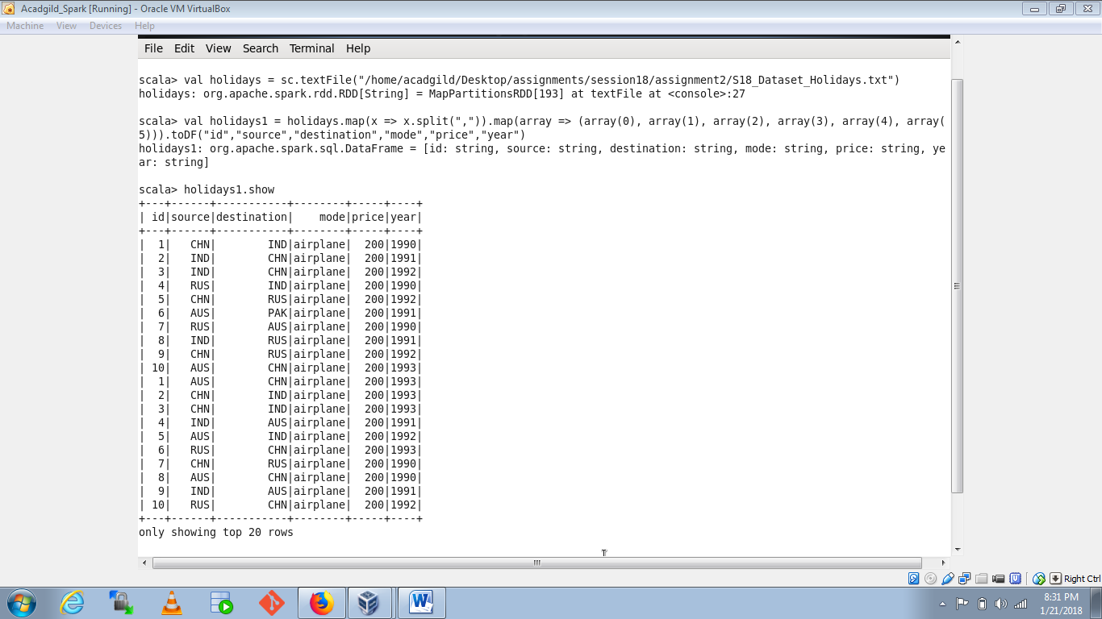

1. transport file:

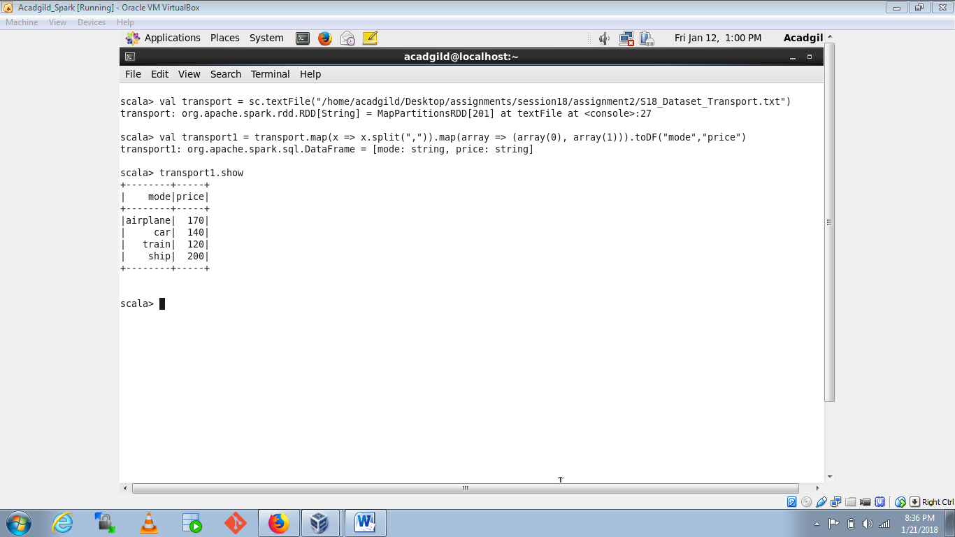

1. User details file:

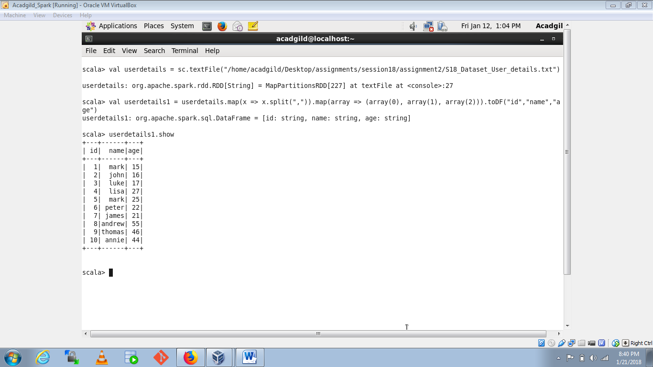

1. Considering age groups of < 20 , 20-35, 35 > ,Which age group spends the most amount of money travelling.

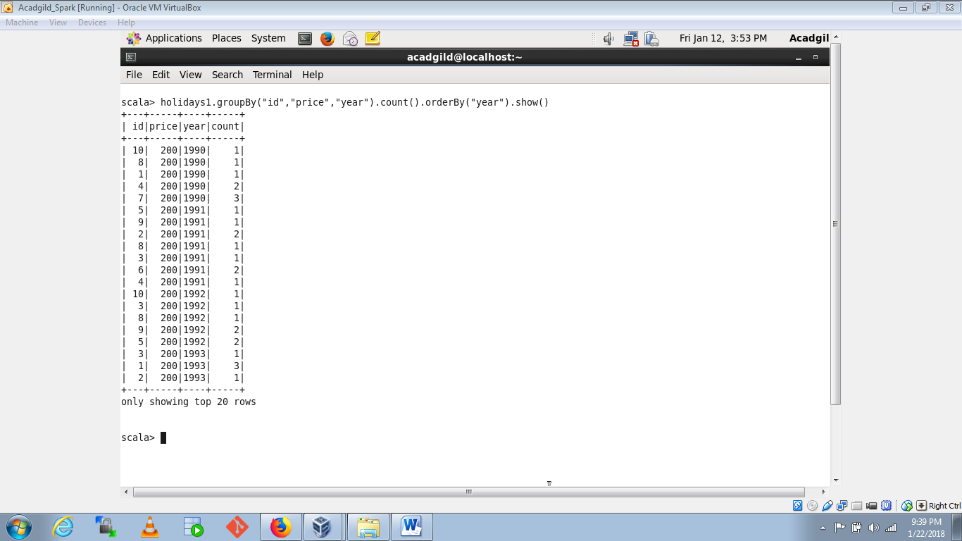

1. What is the amount spent by each age-group, every year in travelling?

