1. pwd

print working directory – pwd command writes the full pathname of the current working directory to the standard output.

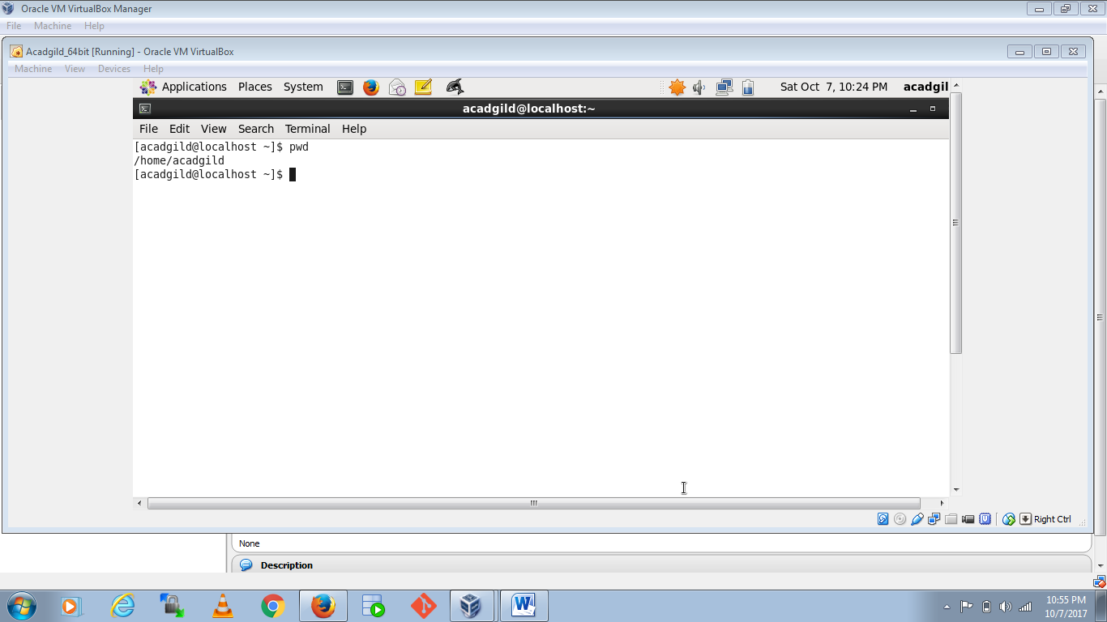

1. vi

vi is a small screen-oriented text editor.

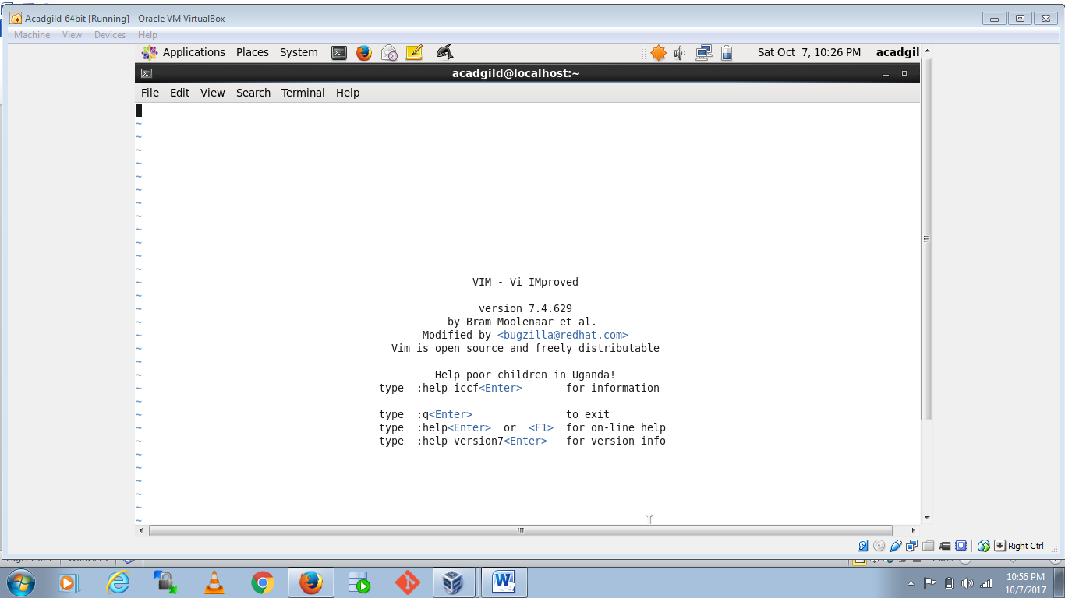

1. touch

The touch command is the easiest way to create new, empty files

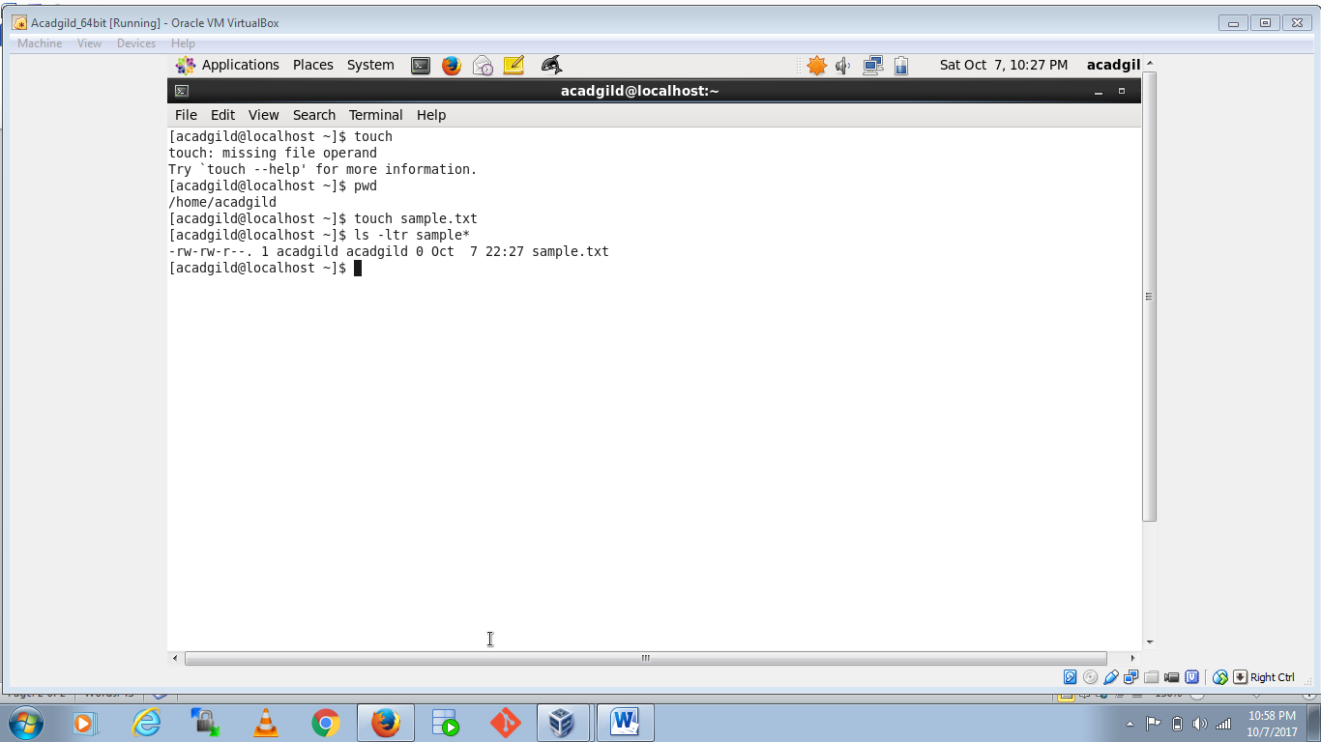

1. mkdir

this command is used to make a new directory

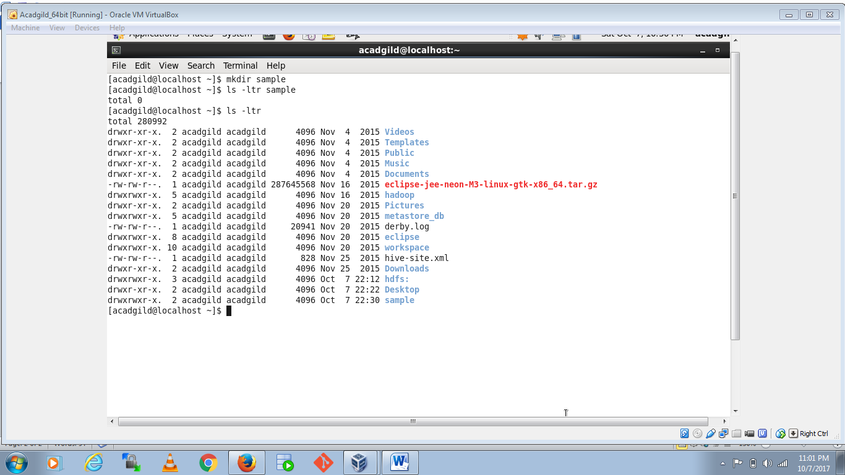

1. rm

rm is a basic UNIX command used to remove objects such as files, directories, device nodes, symbolic links, and so on from the filesystem

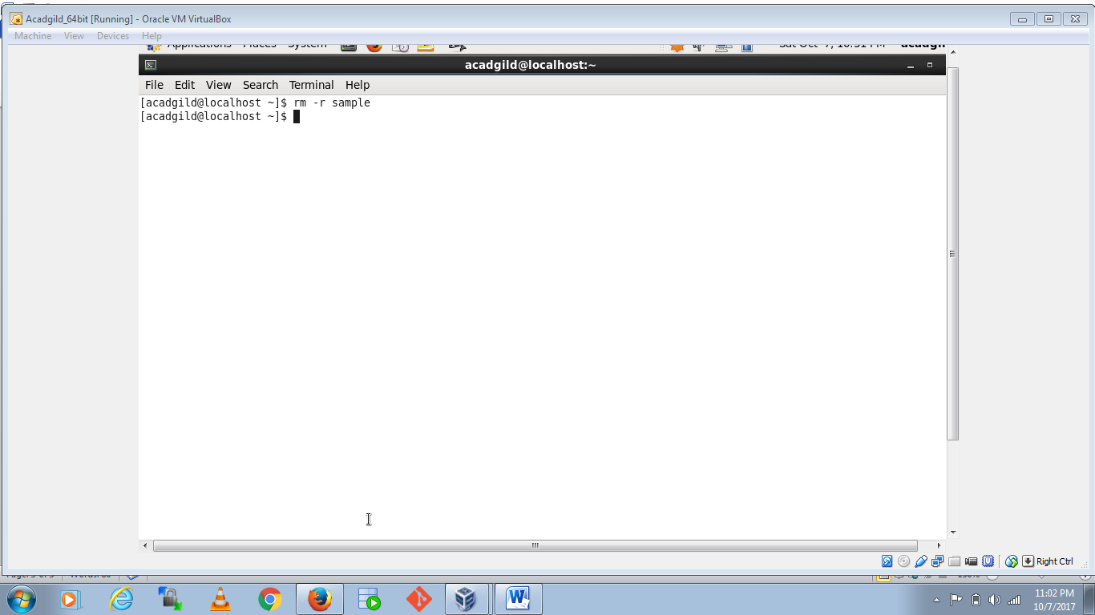

1. ls

ls lists the files in the current working directory

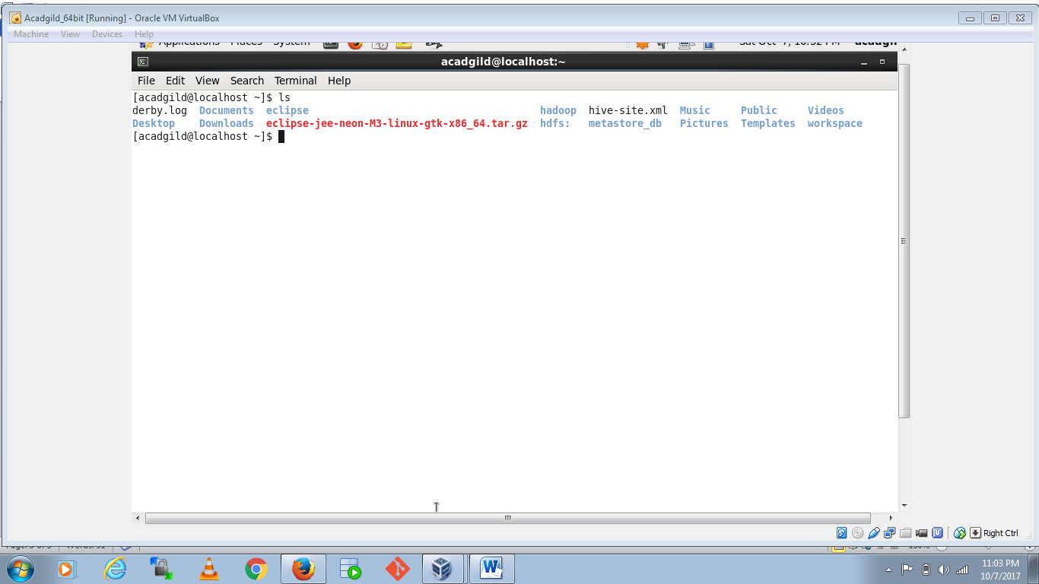

1. echo

outputs the strings it is being passed as arguments

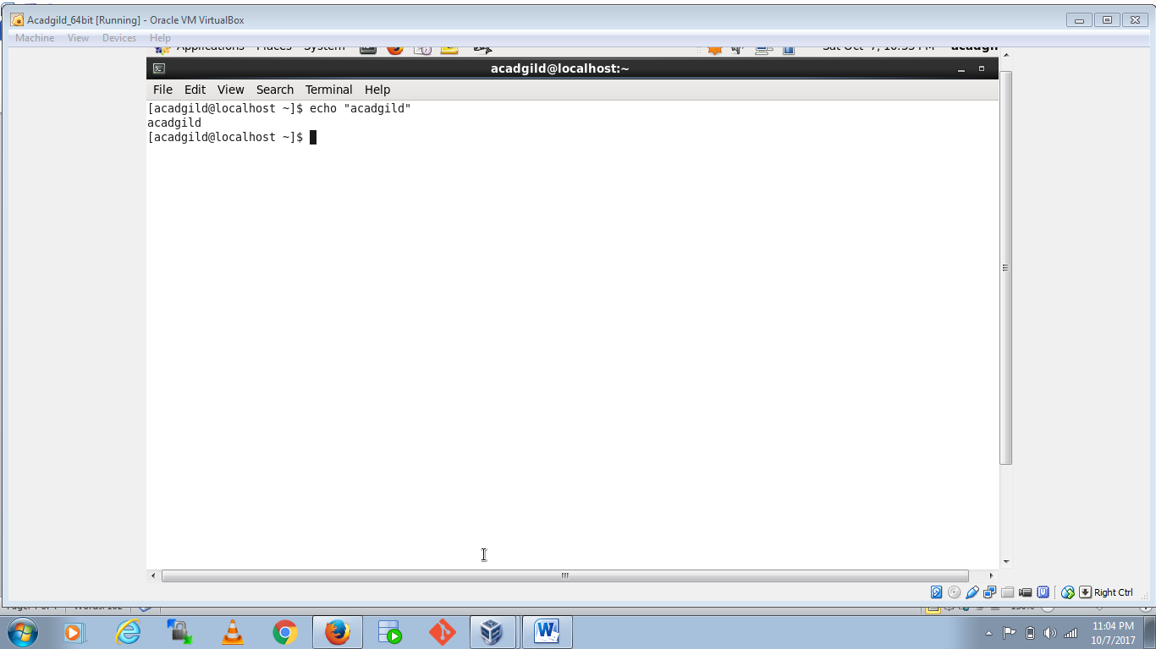

1. cat

cat is a standard Unix utility that reads files sequentially

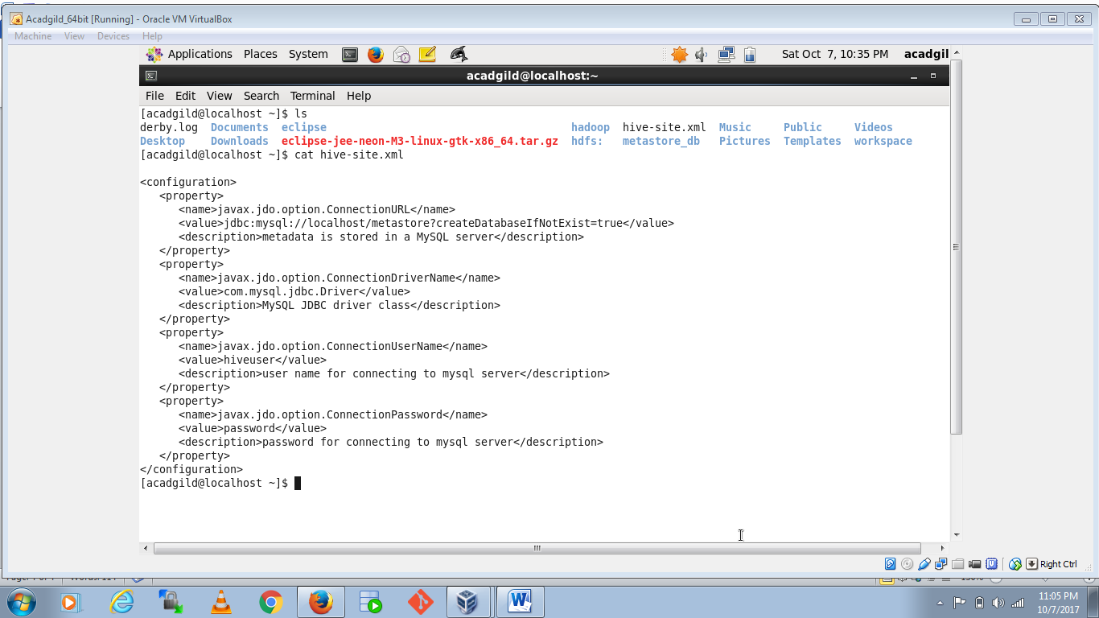

1. who

who displays a list of users who are currently logged into the computer

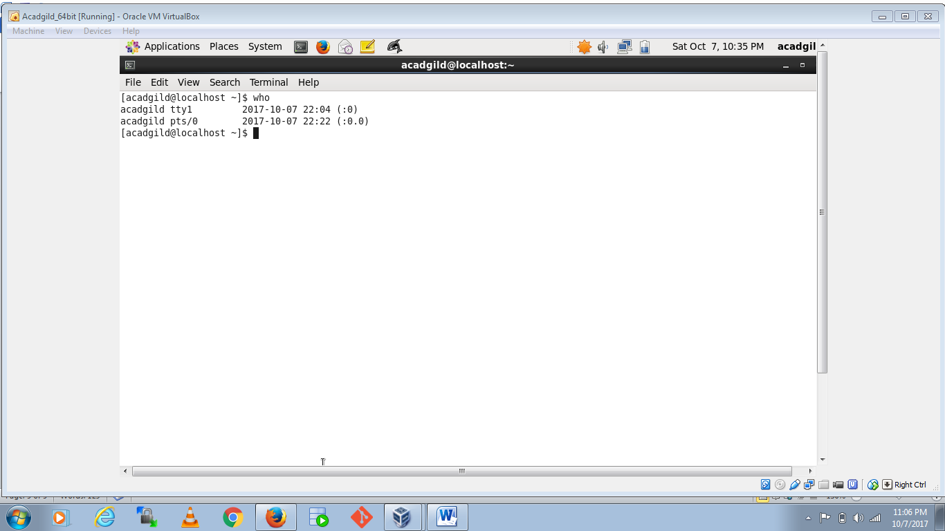

1. cd

cd used to change the current working directory

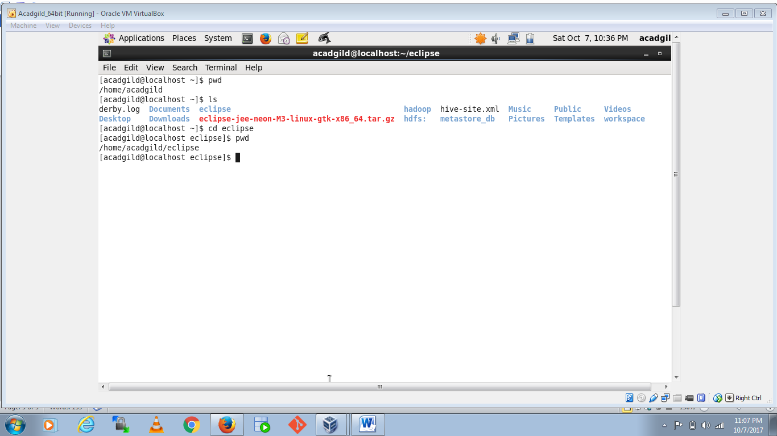

1. date

Display time

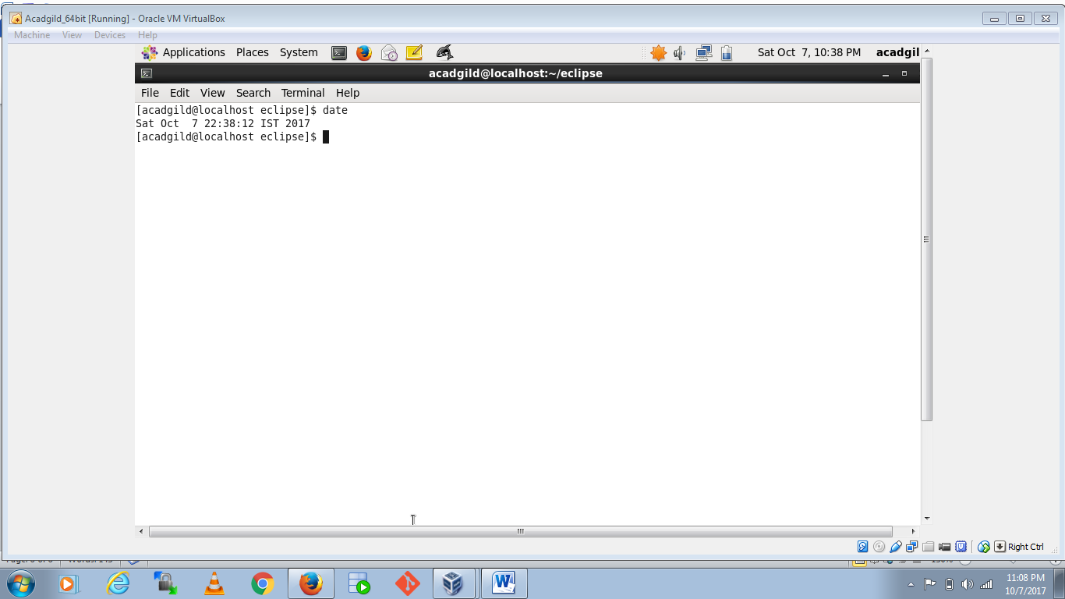

1. cal

cal prints an ASCII calendar of the given month or year

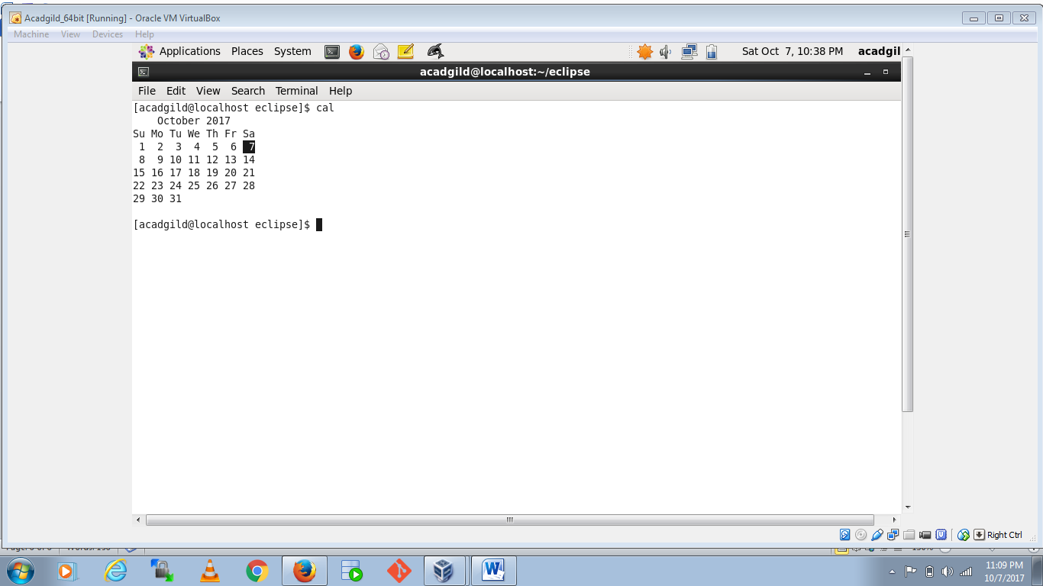

1. mv

mv moves one or more files or directories from one place to another.

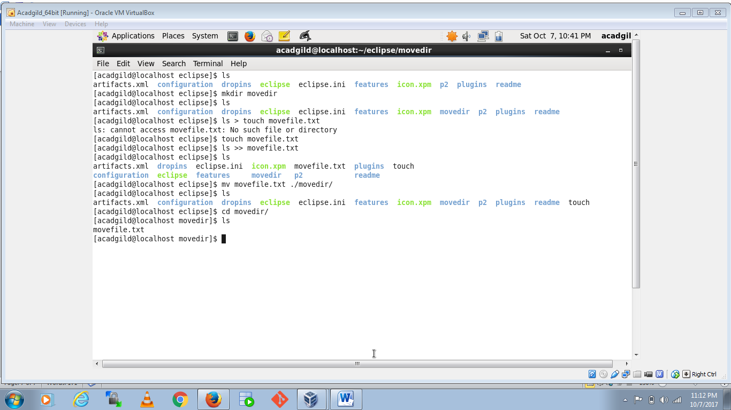

1. cp

used for copying files and directories

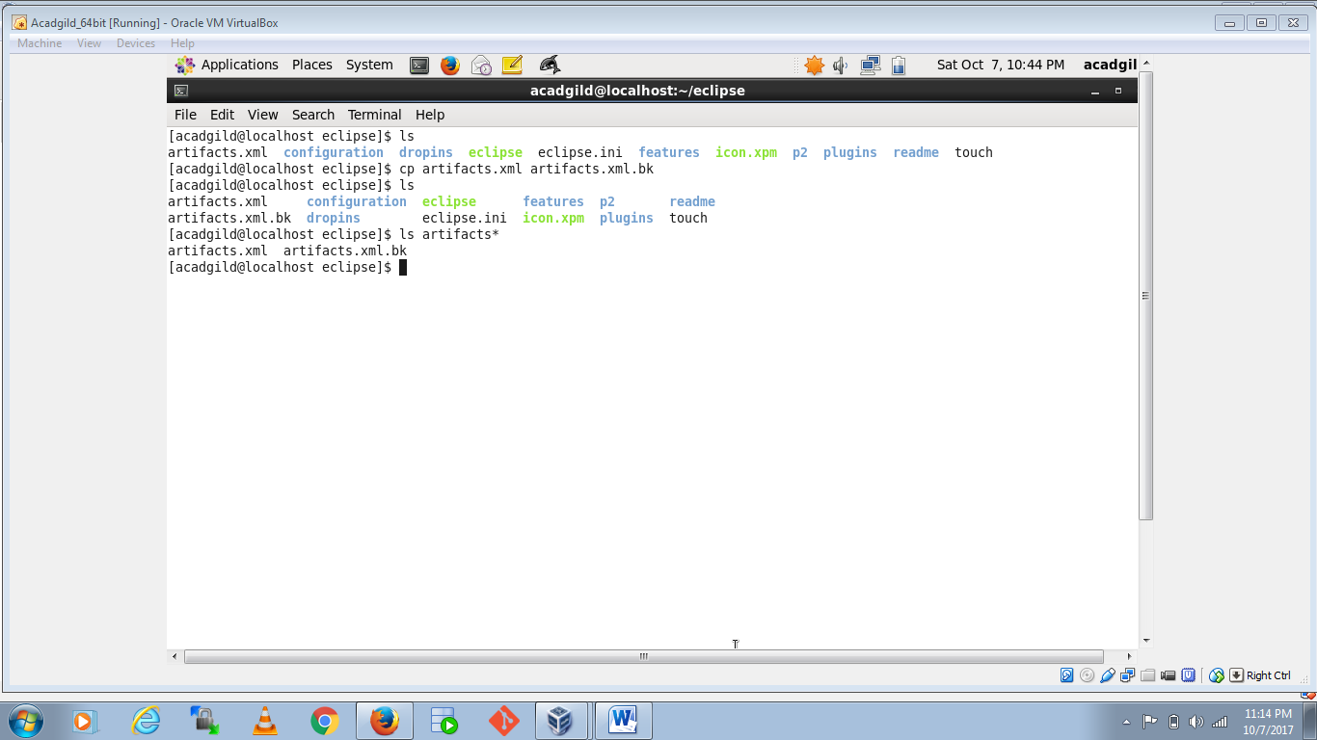

1. which

which is a Unix command used to identify the location of executables

