Problem Statement 1

Find out the top 5 most visited destinations.

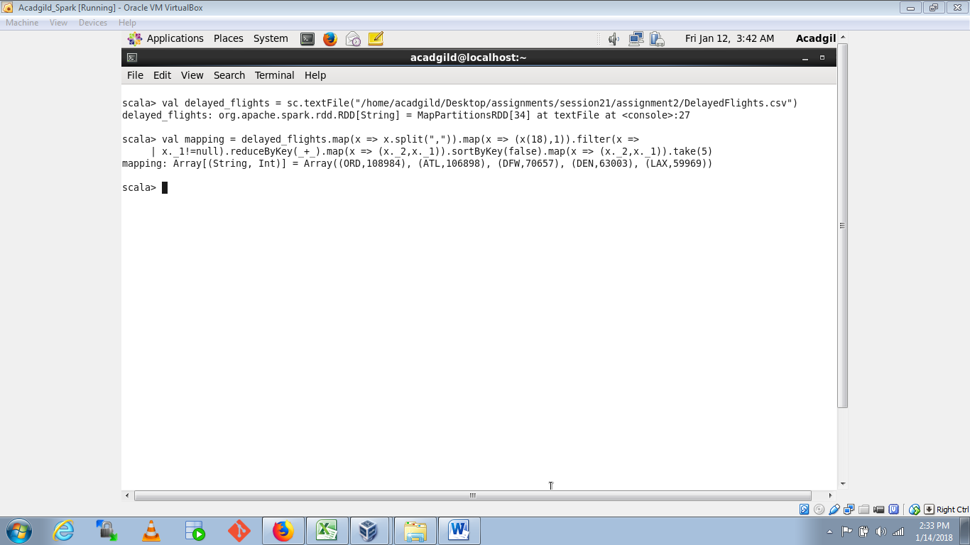

Problem Statement 2

Which month has seen the most number of cancellations due to bad weather?



Problem Statement 3

Top ten origins with the highest AVG departure delay



Problem Statement 4

Which route (origin & destination) has seen the maximum diversion?

