Check whether /user/acadgild directory exists or not in the HDFS.

Yes, it exists.

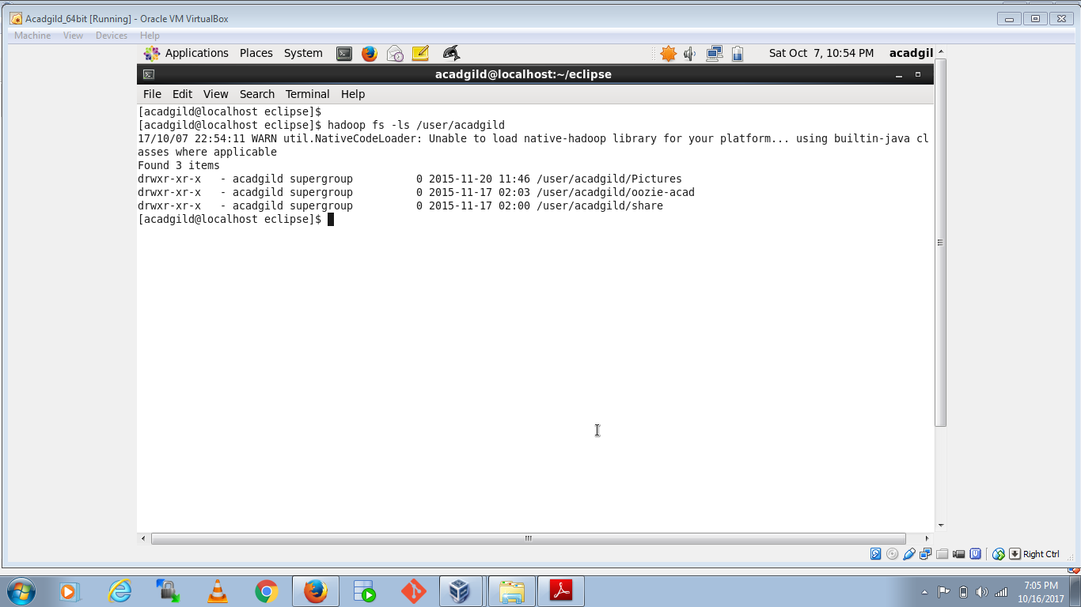

Create a directory /user/acadgild/hadoop.

/user/acadgild/hadoop. Directory created.

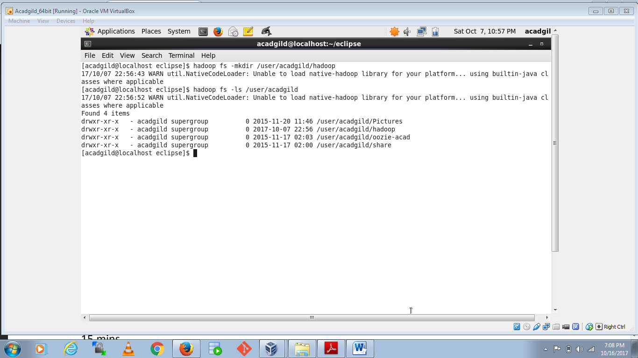

Create a file in HDFS under directory /user/acadgild/hadoop, with name word-count.txt

File created.

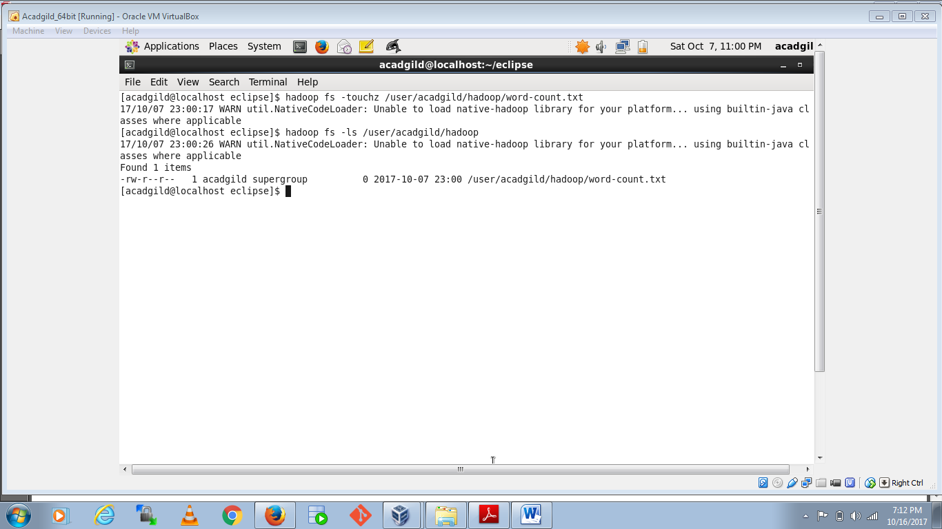

Whatever we type on screen should get appended to the file.

Done

