Create a file max-temp.txt in local FS. Put some 10-15 records of date and temperature example:

Done

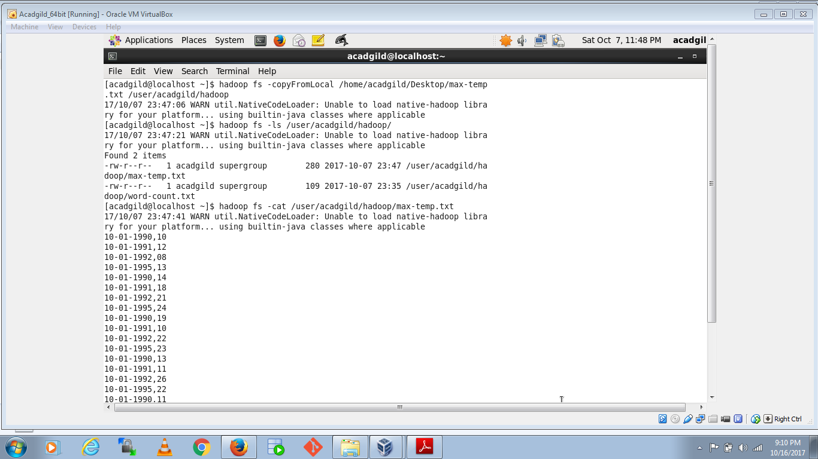

Change the permission of the file /user/acadgild/hadoop/max-temp.txt, such that only the owner and the group members have full control over the file.

Done

