1) Write a java code with the class named ‘acad’ and a method ‘main’. Hard Code the program with two integers and print the sum of those two.

Please see below program run screenshot:

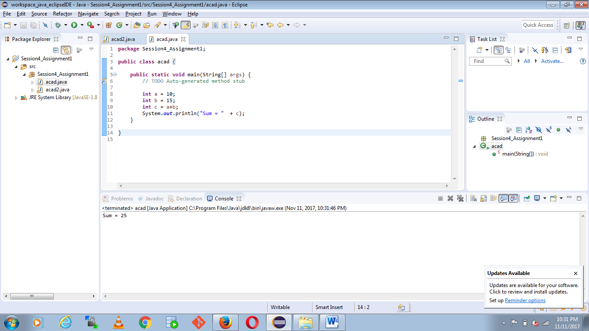

2) Rewrite the above code, where, inputs are provided by the user at runtime and the output is printed.

Please see below program run screenshot:

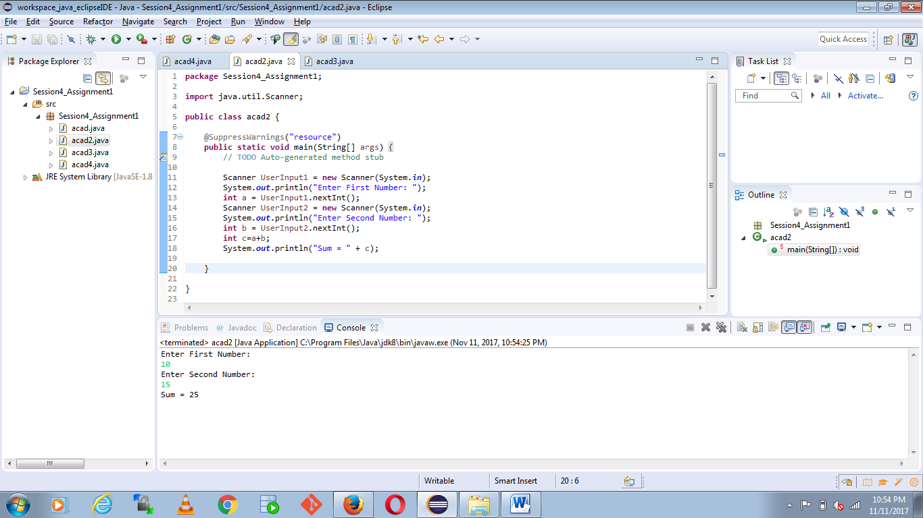

3) Write a program with method name sum() that accepts two parameters from user and print the sum of two numbers. Output format should be as:

Please see below program run screenshot:

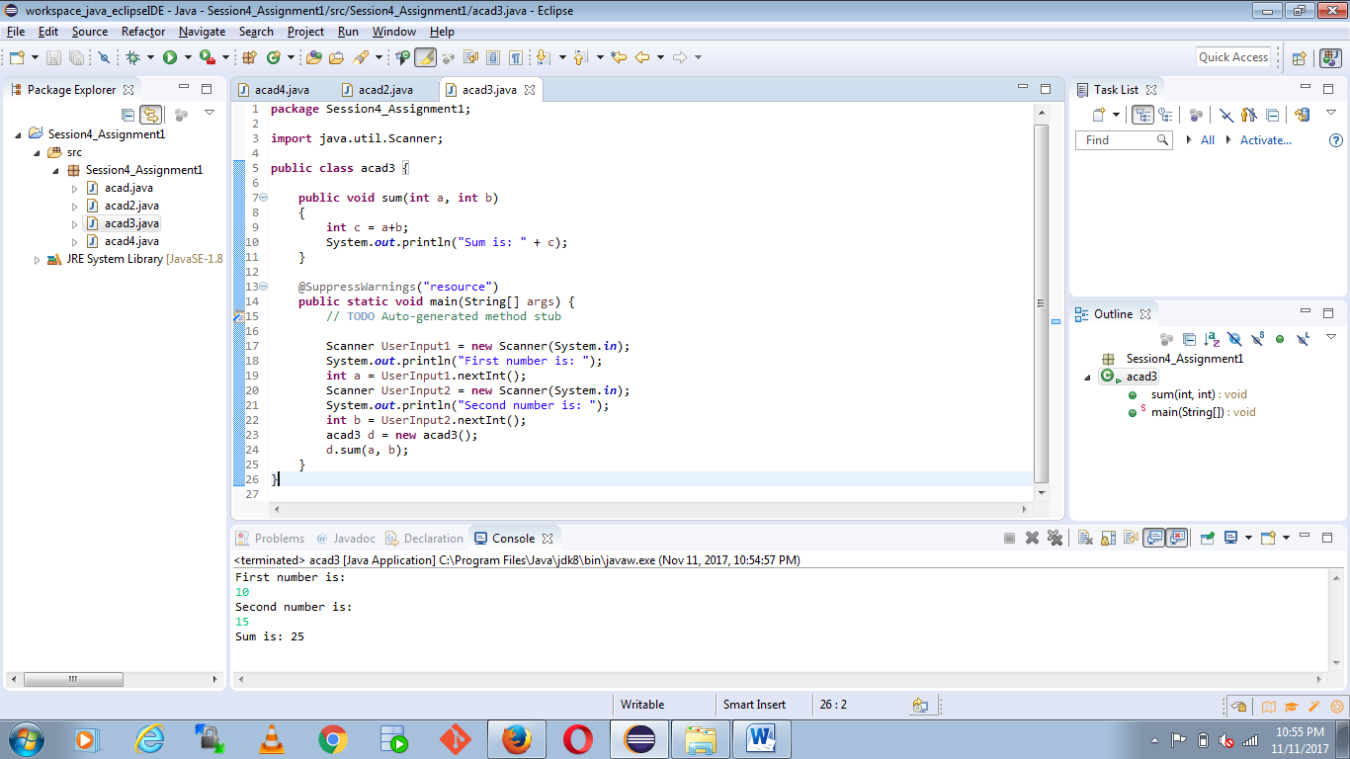

4) Write a program to accepts two numbers from stdin and find all the odd as well as even numbers present in between them.

Please see below program run screenshot:

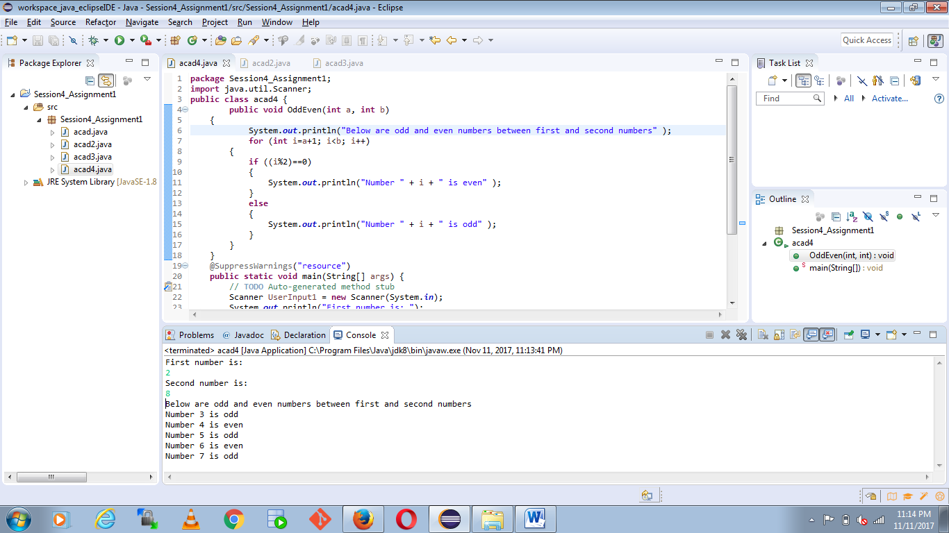

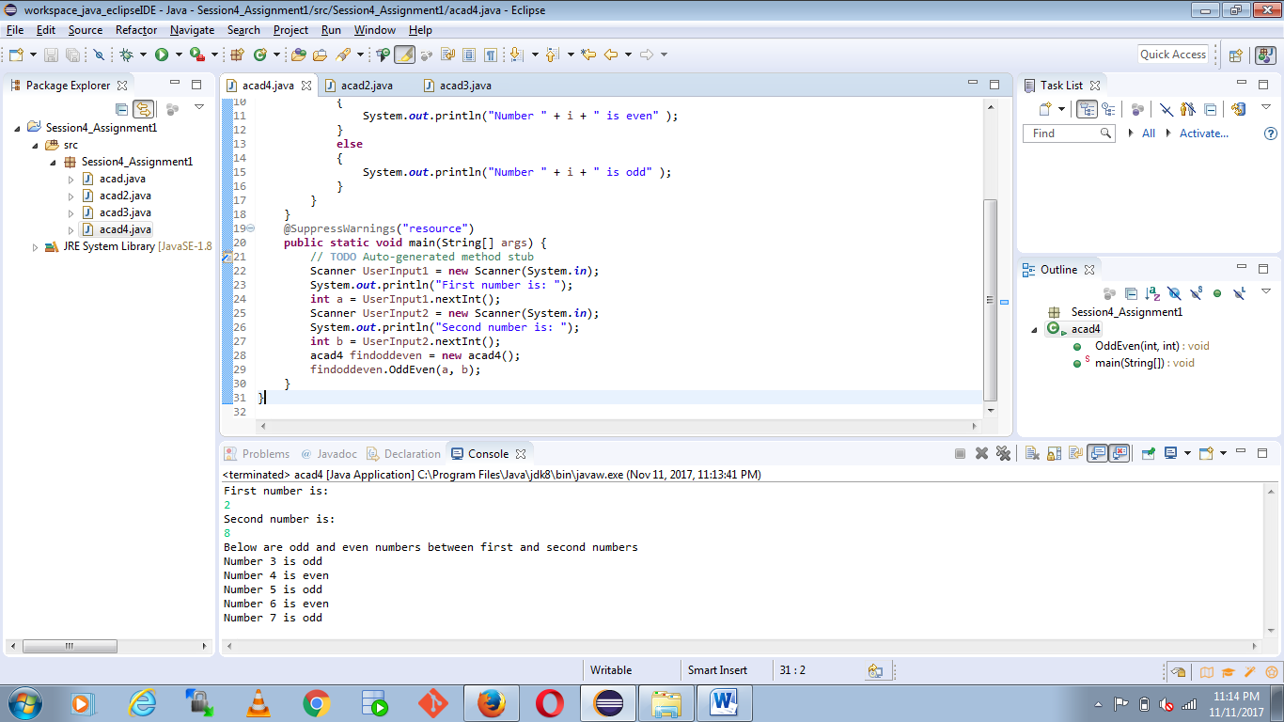

5) Joe is scared to go to school. When her dad asked the reason, joe said she is unable to complete the task given by her teacher. The task was to find the “first 10 multiples” of the number entered from stdin

Please see below program run screenshot:

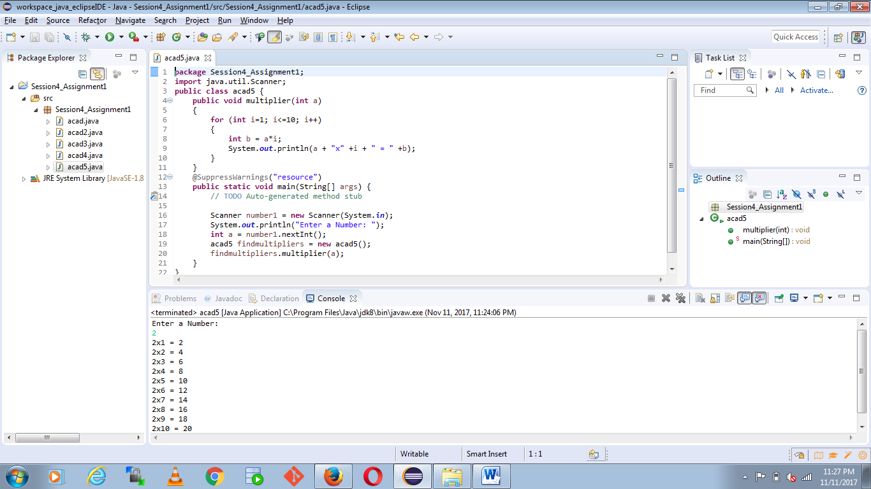

6) Write a program consisting method sum() and demonstrate the concept of method overloading using this method.

Please see below program run screenshot:

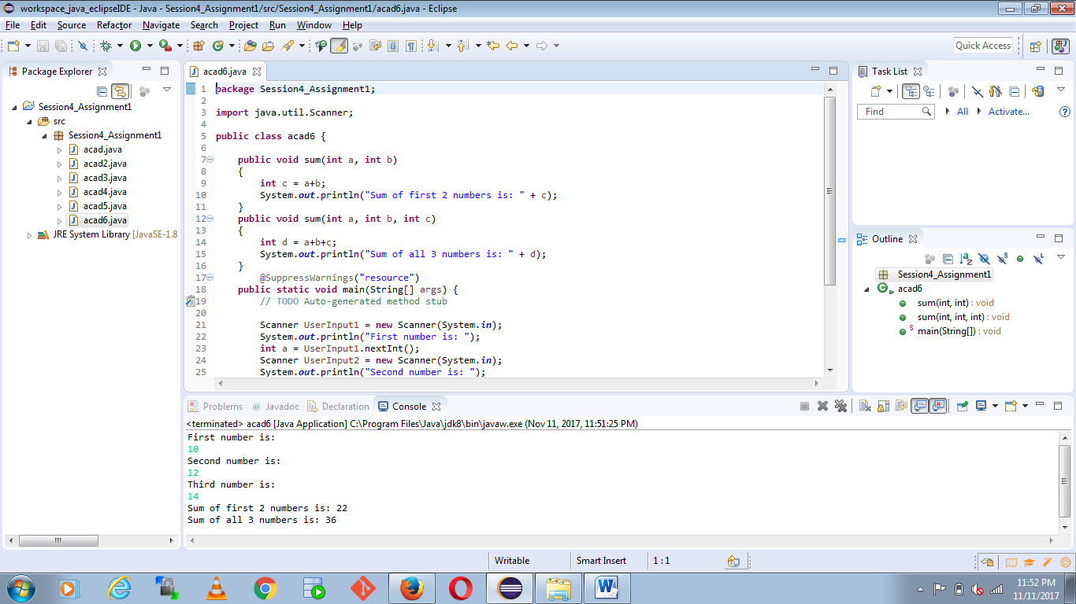

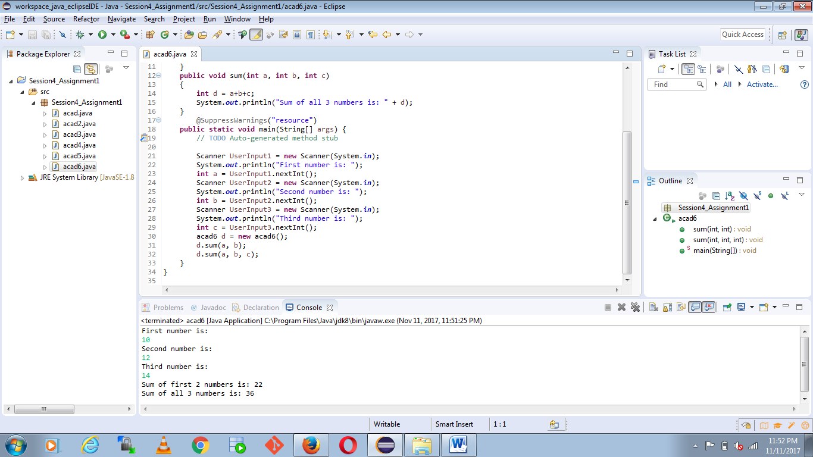

7) Can you overload a method with same return type? Explain your answer with proper logic.

Yes we can. Please see below program run screenshot:

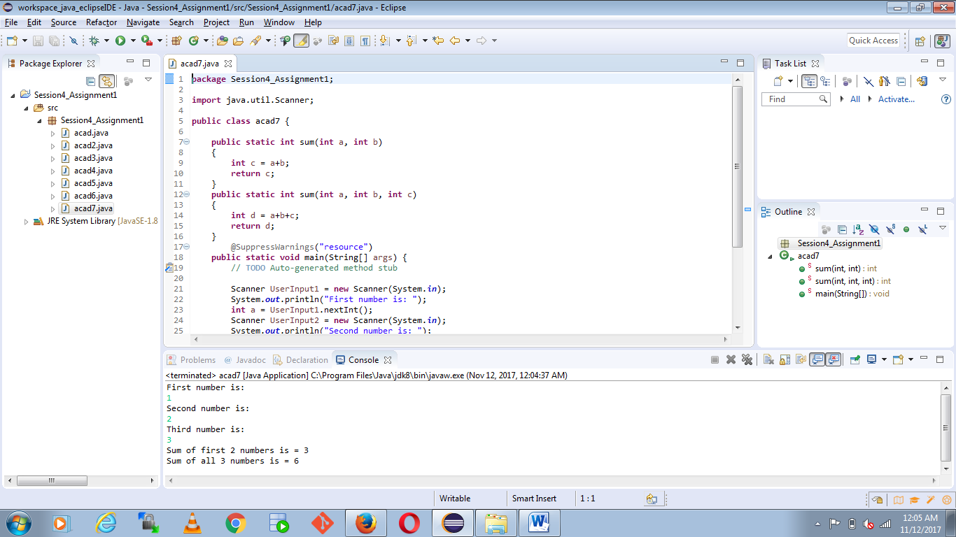

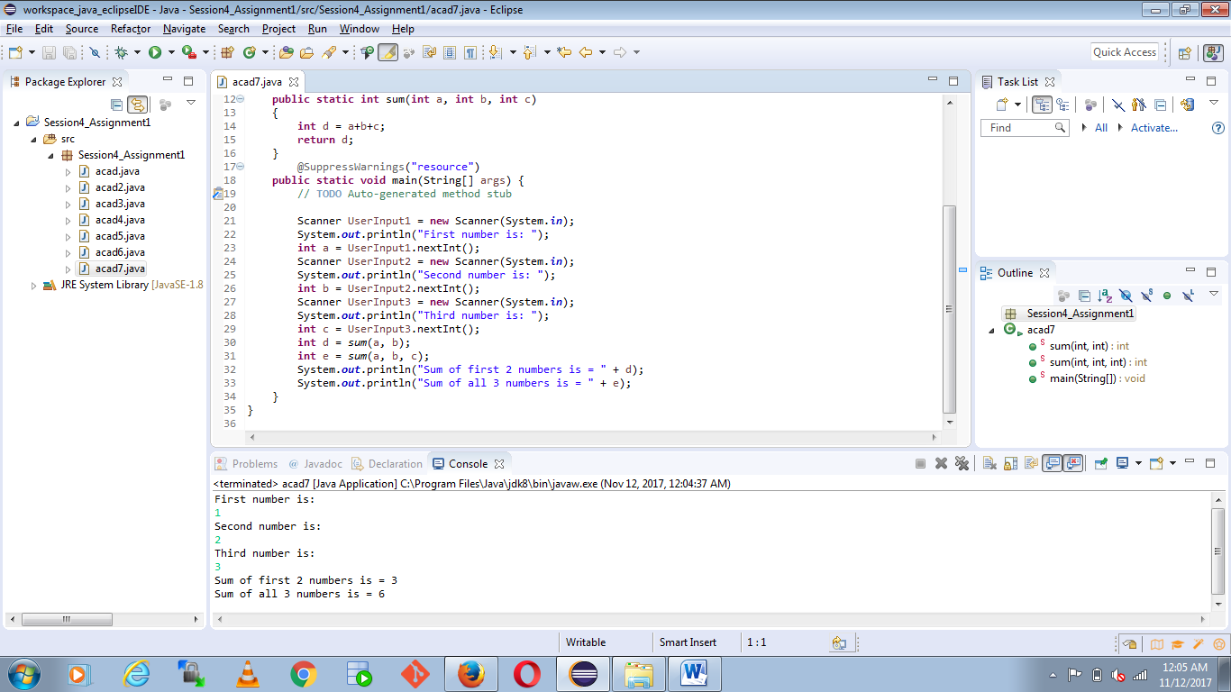

8) Write a program in java using Arrays, that sorts the element in descending order.

Please see below program run screenshot:

