Task: Write a program to implement wordcount using Pig. Share the screenshots of the commands used with its associated output.

Screenshots of command and final output:

1. Input file used for this assignment:

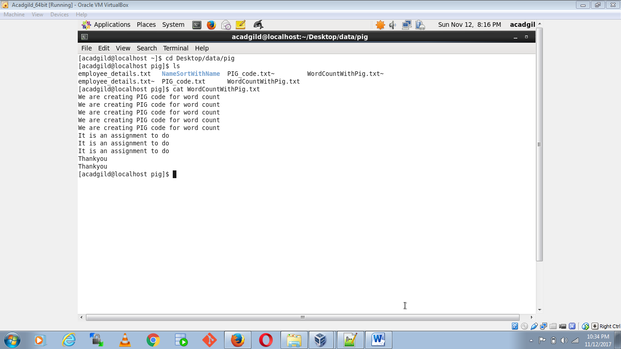

1. PIG commands:

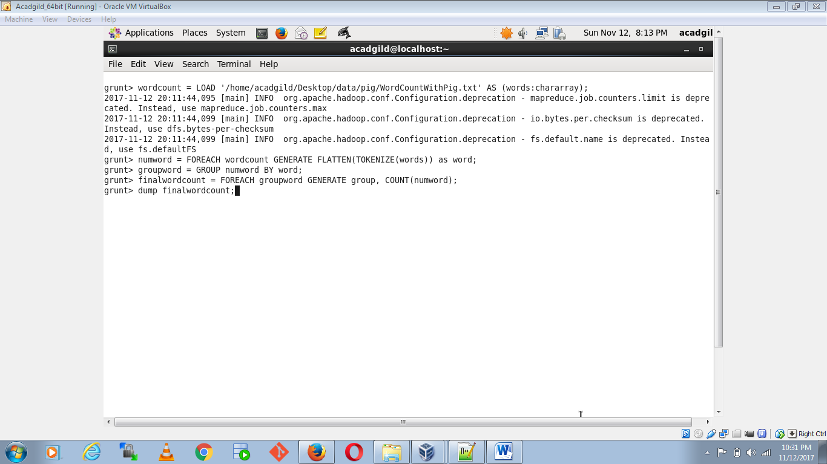

1. Final output:

