Registering piggybank.jar in pig local on VM:

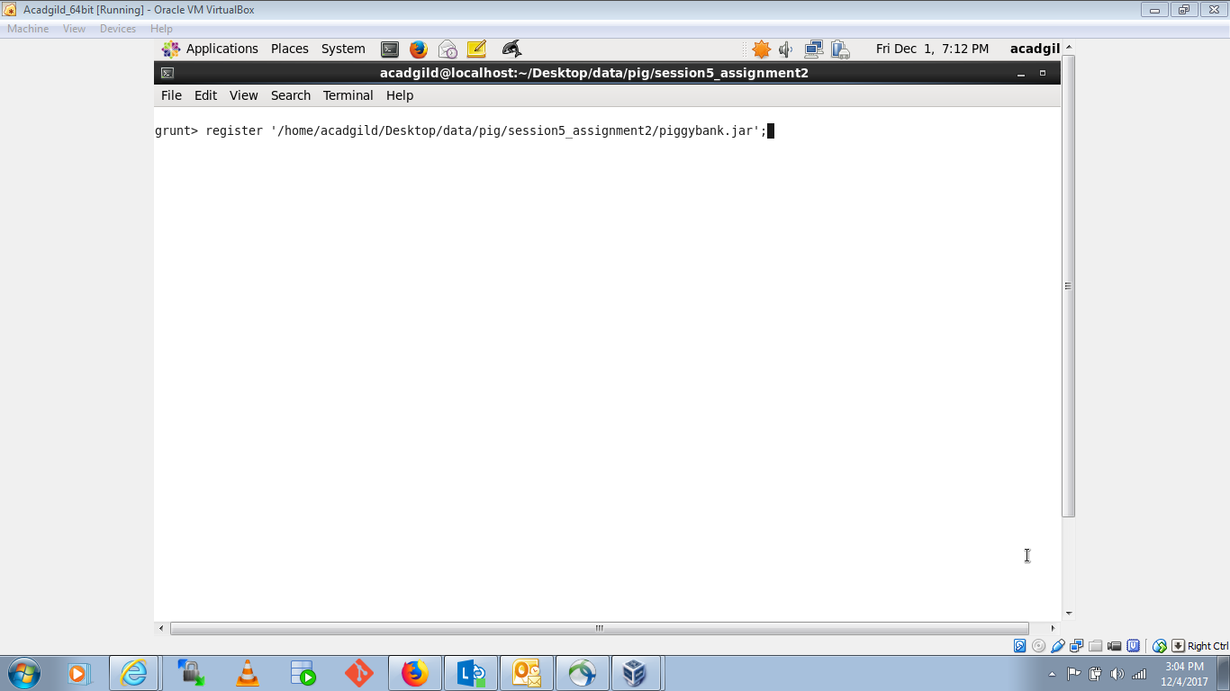

Loading DelayedFlights.csv into grunt shell:

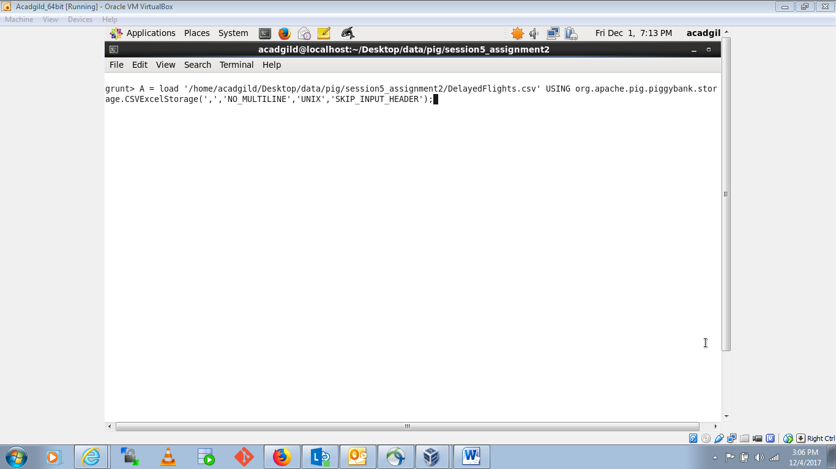

Loading airport.csv into grunt shell:

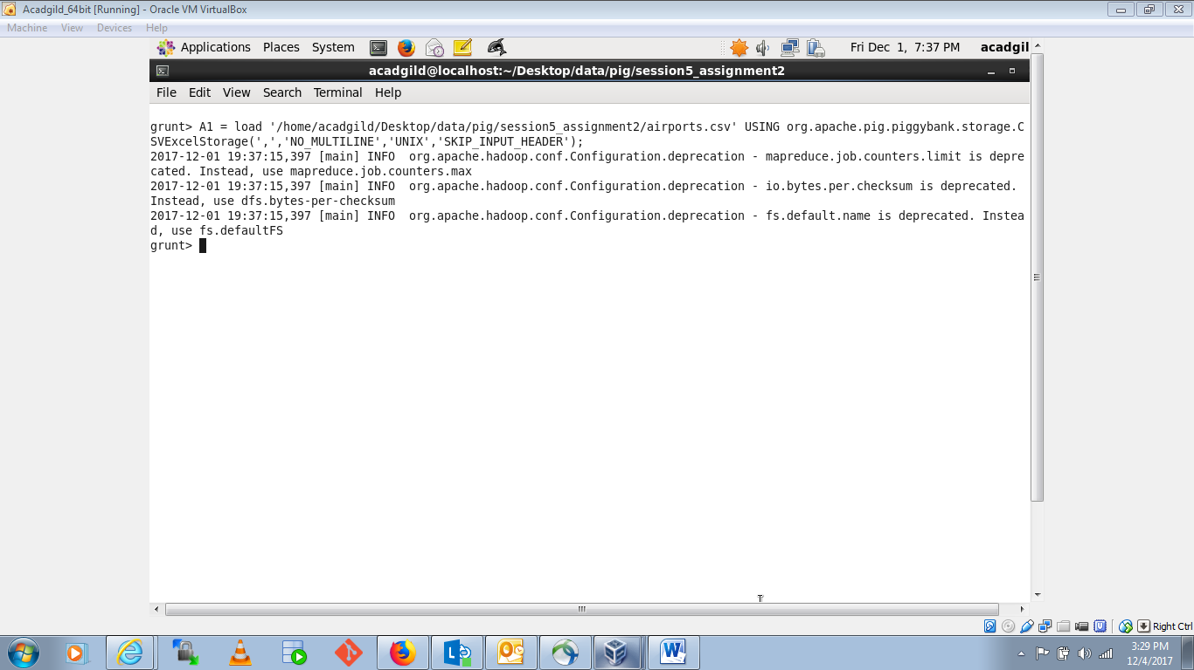

**Problem Statement 1**

Find out the top 5 most visited destinations.

1. Taking out relevant data columns from loaded csv file:

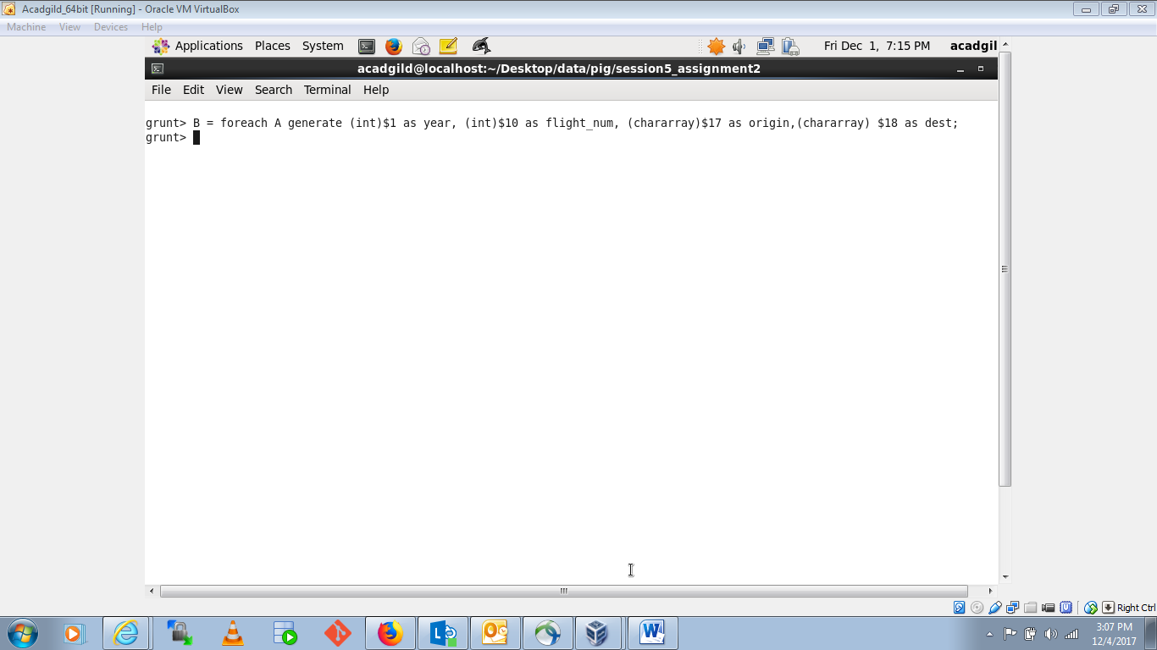

1. Pig commands to find the result:

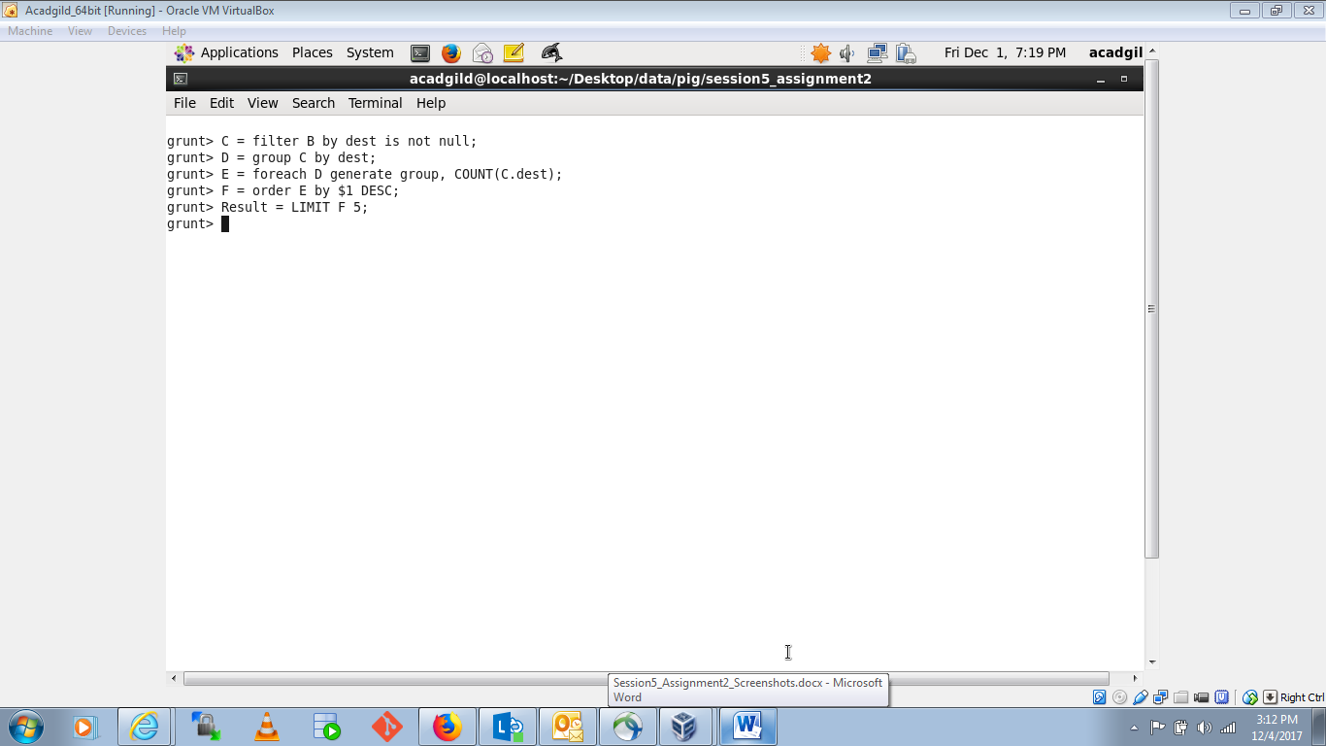

Result: top 5 most visited destinations.

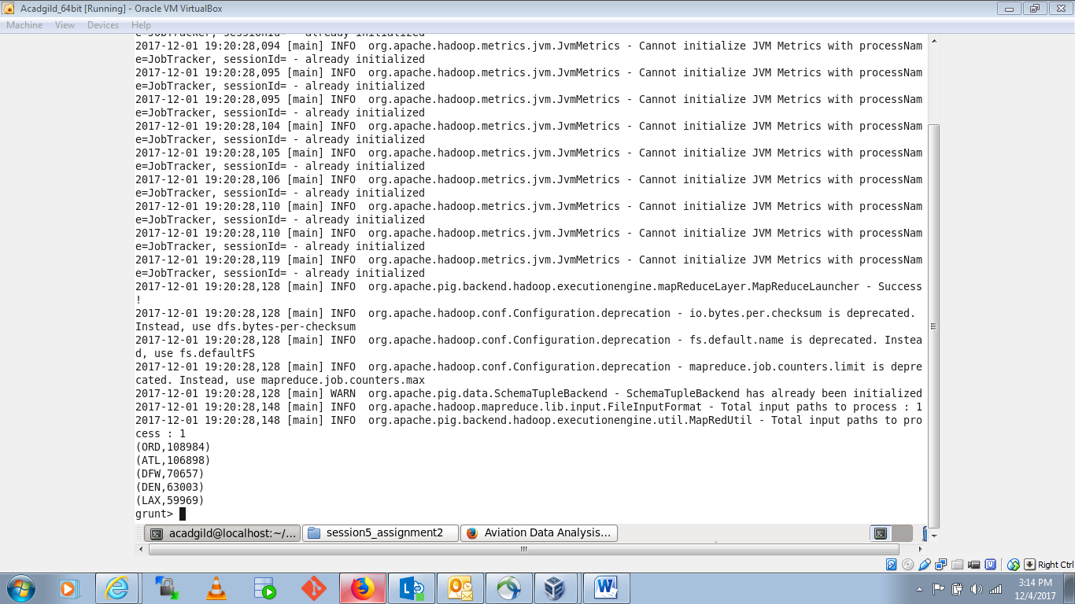

Result: top 5 most visited destinations with city and country name:

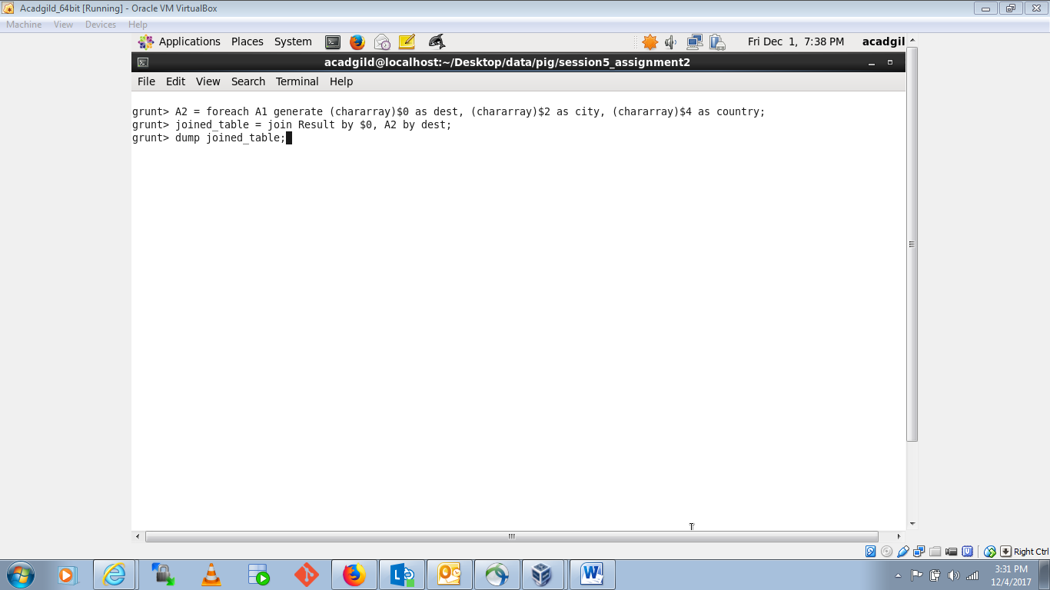

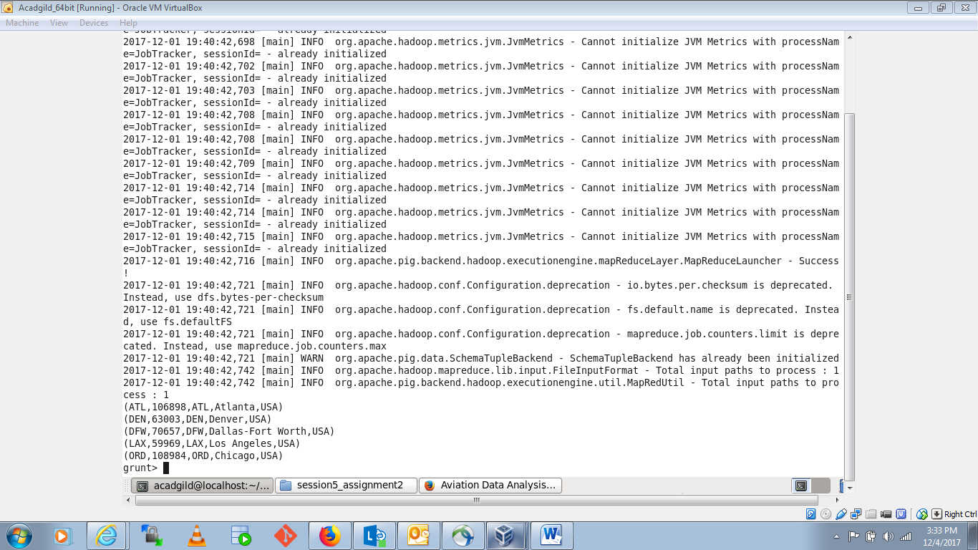

## Problem Statement 2

Which month has seen the most number of cancellations due to bad weather?

Pig commands:

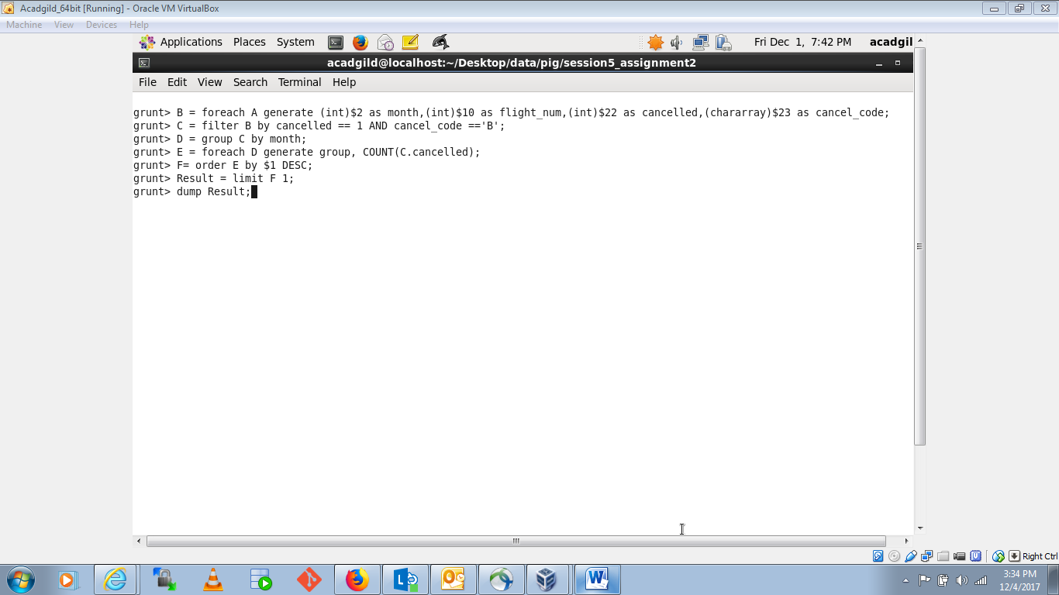

Result: month has seen the most number of cancellations due to bad weather

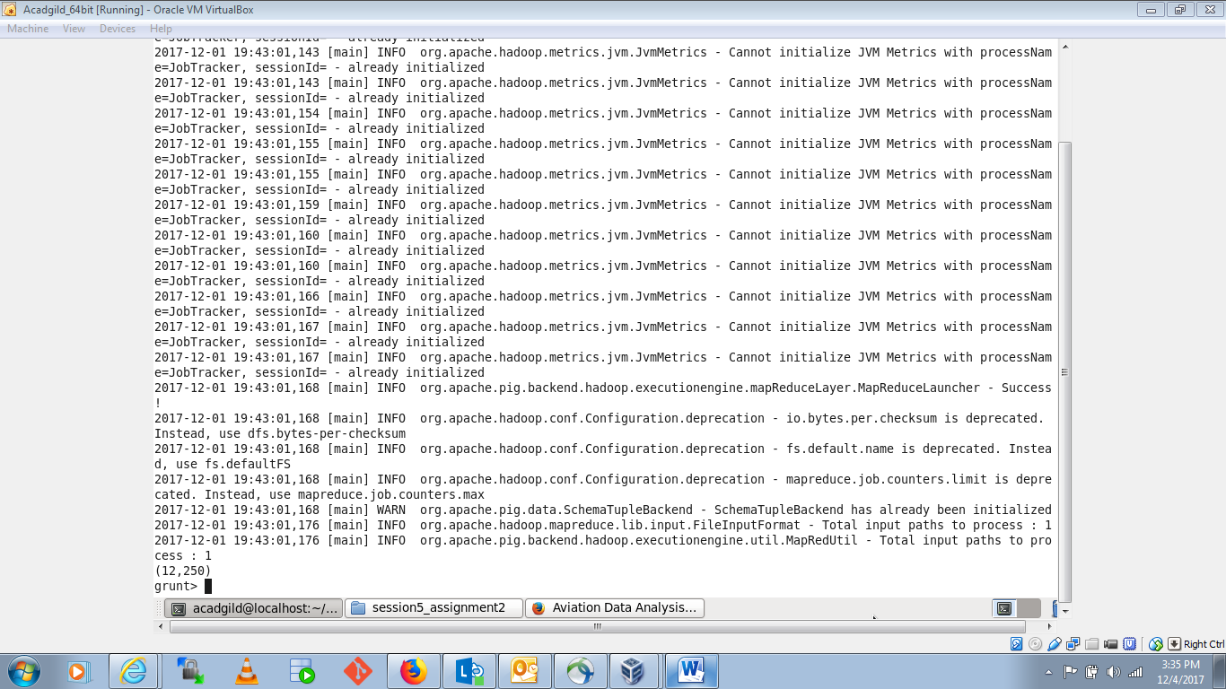

## Problem Statement 3

Top ten origins with the highest AVG departure delay

Pig commands:

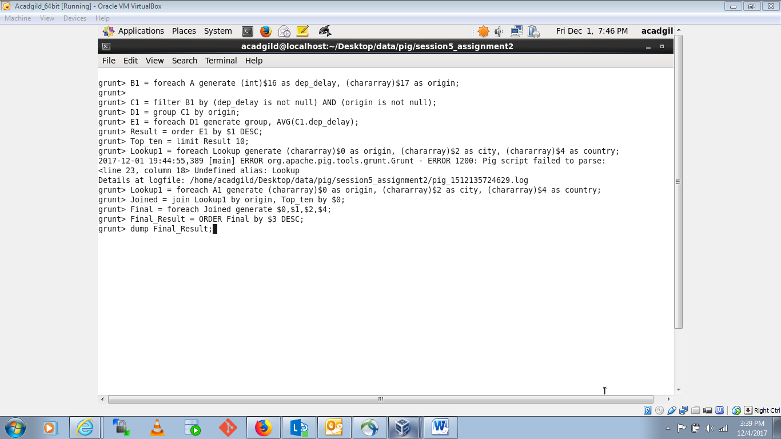

Result: Top ten origins with the highest AVG departure delay

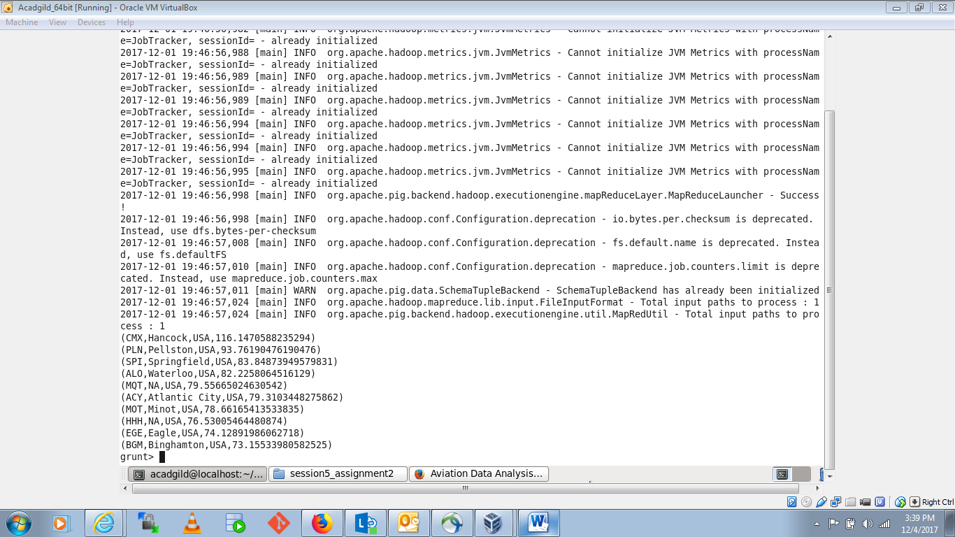

## Problem Statement 4

Which route (origin & destination) has seen the maximum diversion?

Pig commands:

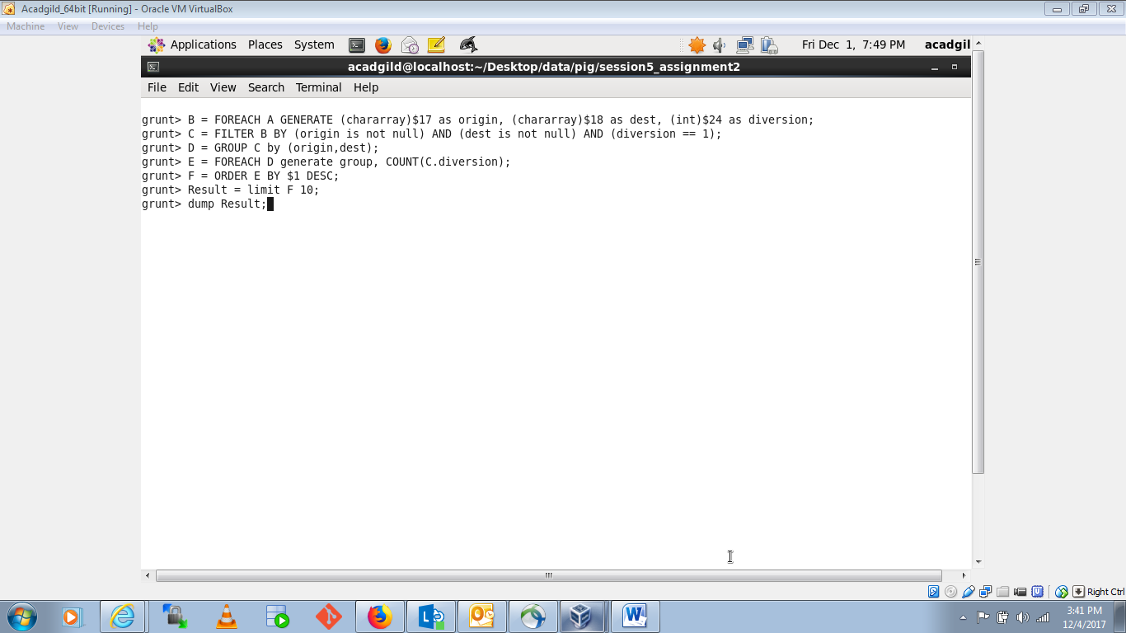

Result: Which route (origin & destination) has seen the maximum diversion?

