WSJF: Weighted Shortest Job First

CoD: Cost of Delay

# Portfolio

## Portfolio Kanban

Is the highest-level backlog.  
Is a pull based holding mechanism for upcoming business and epic enablers to create the holistic portfolio set into the **Canvas**.

* Provides visibility for the overall system
* Brings structure for analysis and making process
* Provides WIP limits
* Prevents unrealistic expectations
* Drives collaborations from stakeholder
* Provides quantitative basis for economic decision-making

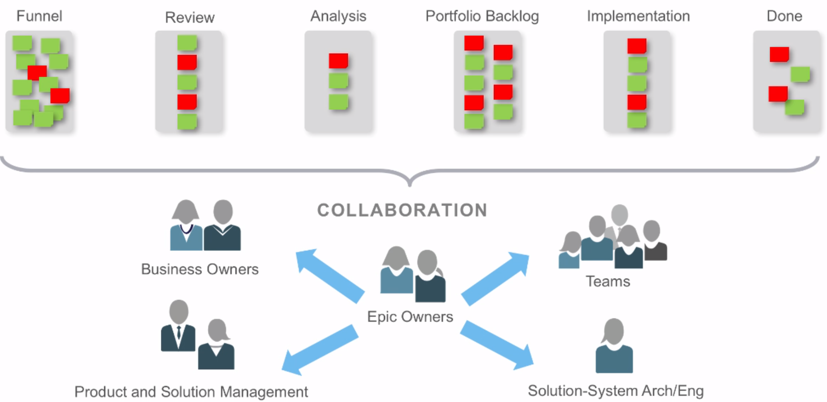

* **Funnel**: where every idea is welcome
* **Review**: where is **WIP limits** are inserted and where the **Epic Value Statement is defined**
* **Analysis**: evaluate the Epic and consider alternative solutions. Use the lightweight Business Case. Its produce TO GO or NOT TO GO
* **Backlog**: Epics approved by the Portfolio Management Team enters here and prioritize
* **Implementation**: Where are assigned to Owner

## Changellenges with Flow

* Too much work in progress
* Lack of visibility
* Lack of collaboration
* Top-down nature
* No decentralization
* Silo’d concerns
* Objective methods for priritization

## The Goal of DevOps

* Increases the frequency and quality of deployments
* Improves innovation and risk-taking by making it safer to experiment Realizes faster time to market
* Improves solution quality and shortens the lead time for fixes
* Reduces the severity and frequency of release failures
* Improves the Mean Time to Recovery (MTTR)

## Responsibilities of Product Management

* Understand customer needs and validate solutions
* Understand and support portfolio work
* Develop and communicate the program vision and roadmap
* Manage and prioritize the flow of work
* Participate in PI planning
* Define releases and program increments
* Work with System Architect/Engineering to understand Enabler work
* Participate in demos and Inspect and Adapt (I&A)
* Build an effective Product Management/Product Owner team

## Lean Budget Guardrails

* Guiding investments by horizon
* Optimizing value and solution integrity with capacity allocation
* Approving significant initiatives
* Continuous Business Owner engagement