**DataStream – Terminal – User Guide**

1. Import the Postman Collection from the git location:

<https://github.com/mail2sonam/datastream-terminal/blob/main/postman/DataStream-Terminal.postman_collection.json>

1. Replace the clientSecret with the secret shared with you.
2. Create an Auth Token using it in postman – Authorization section, and copy it.
3. **Simulate Subscribe Service using Curl [This will be done by the UI].**

Replace <***AuthToken>*** with the actaul auth token obtained and run the following:

curl -i -N -H "Accept: text/event-stream" -H "Authorization: Bearer <***AuthToken>***" http://**104.154.188.48:8081**/stream/accid/topicname/abcd

1. **Simulate the Post Data into Stream [This will be done by Phonebridge when saving CTI info]**

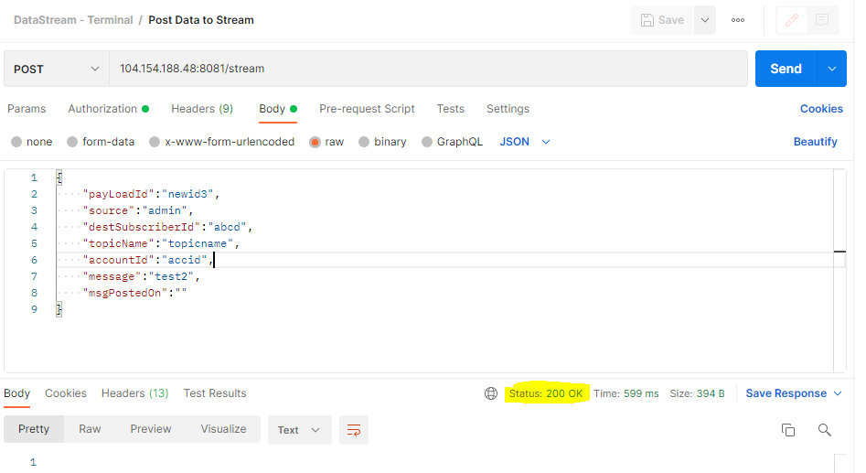

Ensure that you get a 200 response for the same.

1. Once you start posting data into the stream, you will see it getting received by the curl command that we started on step 4.

