Project test-doc-gen
test-swb-1

BLOKSET
Technical offer

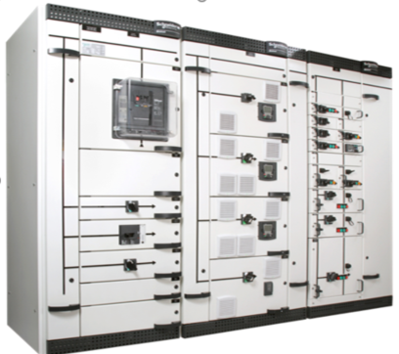

*Picture shown here is an example of Blokset switchboard without any link with the project configuration
Table of content

1 Foreword 3
2 BLOKSET equipment general description 4
3 test-swb-1 switchboard summary 5
4 Applicable standards 7
5 BLOKSET technical description 7
5.1 Frame structure 7
5.2 Bus bar compartment 7
5.3 Cable compartment 7
5.4 Switchgear and switching devices compartment 8
5.5 Withdrawable functional units 8
5.6 Motor applications 8
5.7 Power factor correction 9
6 test-swb-1 switchboard characteristics 10
6.1 General characteristics 10
6.2 Typical diagrams 11
6.2.1 Incomers 11
6.2.2 Bus Ties 12
6.2.3 PCC / ACBs 13
6.2.4 PCC / MCCBs 14
6.2.5 Motor outgoers 15
6.2.6 VSD/SS 16
6.2.7 PFC 17
6.3 Description of functional Units 18
6.3.1 General functional unit description 18
6.3.2 Customized cubicles 18
6.3.3 Customized functional unit 18
6.4 General Arrangement 19
7 Routine factory inspection 20
8 Limit of supply 20
9 Documentation supplied 20
10 Reference documents used 20
11 Comments and deviations on the technical specification 20
12 Afterword 21

Foreword

BLOKSET equipment general description

Blokset is an offer oriented on people and goods safety

Tested according to the latest standards, IEC61439-1&2, because compliance with standards is a guarantee for end users,
Tested under most severe internal arc conditions in order to ensure the protection of people and equipment as described into the technical report IEC61641-V2.
Proposed according to several type of partitioning (Form 2 to 4b) in order to ensure operation and maintenance personnel’s safety.
Proposed with several interlocking systems in order to avoid any false operation
Engineered to meet most difficult and polluted environmental atmospheres constraints (SO2) as well as earthquake constraints.

Blokset offers significant benefits for the most demanding customers:

 | Ecologically designed and manufactured without hazardous materials, Blokset is compliant with RoHS and REACh standards. All efforts are done to reduce carbon footprint and energy consumption.

Blokset is a modular switchboard equipped with the world reference breaking and control devices (Masterpact, Compact NSX, Tesys, Altivar….)
Pre-engineered solutions for every application:
- Pcc: Power Control Centers
- Mcc: Motor Control Center
An answer through a fix or withdrawable solution
An architecture with different compartments enabling to house:
- The main horizontal bus bars installed either in the top or bottom position,
- The vertical distribution bus bars,
- The breaking and switching devices,
- The customer terminals for cable connections
Cable connections in order to ensure onsite customers installation constraints:
- From top or bottom side
- From front or rear side
A variety of front faces in order to answer all needs:
- Full height door
- Individual doors for each function unit types
- Control device through or behind the door with a rotary operating handle or a toggle
Simple and safe operation through the use of a comprehensive range of security functions and interlocks

test-swb-1 switchboard summary
Blokset is a low voltage switchboard dedicated for large sites applications.
Designed for indoor installations, Blokset is an extremely flexible offer, made of several type of panels enabling to full fill the most demanding applications of many projects around the world.

Swbd | Voltage | Intensity | Short circuit | Sections | Cubicles | Functional Units
test-swb-1 | 415 | 1200 A | 25 kA | 1 | 2 | 2

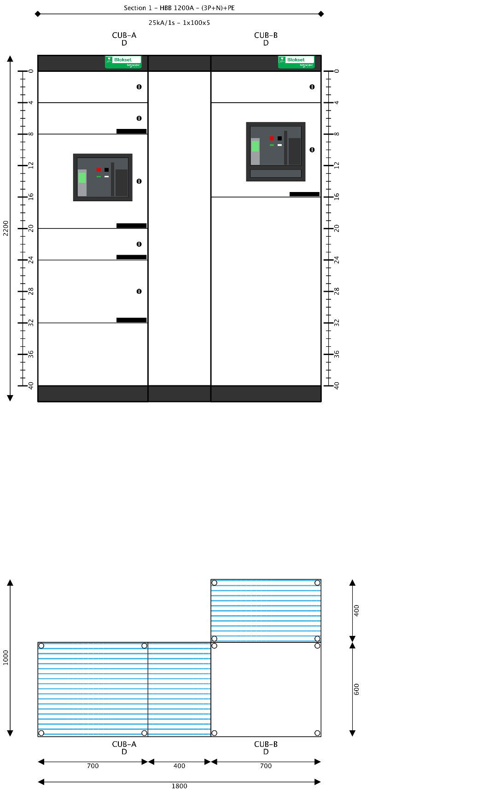

Applicable standards
The equipment proposed in this offer has been designed, manufactured, and tested according to the relevant IEC recommendations.
- IEC 61439-1/2 Low voltage switchgear & controlgear assemblies – Part 2 Power switchgear and controlgear assemblies
- IEC61641-v2 Enclosed low voltage switchgear and controlgear assemblies Guide for testing under conditions of arcing due to internal fault
- IEC60044-1 Current transformers
- IEC60186 Voltage transformers
- IEC60529 Degrees of protection provided by enclosures
- IEC60947-2 Low voltage switchgear & controlgear – part 2 Circuit breakers
- IEC60947-3 Low voltage switchgear & controlgear – Part 3 Switches, disconnectors, switch-disconnectors & fuse combination units
- IEC60068 Environmental testing
- IEC61140 Protection against electric shock – Common aspects for installation and equipment – Basic safety publication
- IEC60 947-4-1 Contactors and motor starters

BLOKSET technical description

Frame structure
The construction of Blokset switchboard will be industrial type, self standing cabinets and factory assembled. Except for some few internal partitions, the panel construction is made of 2mm folded metal sheets thickness.
Panel painting is done with epoxy powder polymerized at high temperature. The finish color of cover parts is defined as follow:
- Front & lateral face : RAL 9003
- Top or bottom cross member : RAL 7016

When Blokset equipment is to be used in seismic area a 2G reinforced solution can be offered in order to answer severe seismic up to marked 9 on Richter scale.

Bus bar compartment
Each section is equipped with electrolytic copper to carry the power throughout the switchboard while ensuring correct thermal and electrical behavior.
- Horizontal bus bar: installed at the top or at the bottom of each section.
(Main) Allows to feed all sections installed in a switchboard.
- Vertical bus bar: installed on the lateral or back part of the section.
(distribution) Allows to feed all functional units installed with each section.

Cable compartment
Depending upon site constraints, Blokset proposes two ways of cable access:
- Front access : Switchboard installed with a 700/1200mm free space at front
2 cable ducts dimensions: width 200 or 400mm
- Rear connection : Switchboard installed with a 700/1200mm rear corridor
2 cables compartments sizes: depth 600mm or 1000m

Switchgear and switching devices compartment
Each section have a defined zone that can be organized in several functional units that can each house circuit breakers, switching devices or all other motor control equipment.
The functional units may be fix or withdrawable and may be dedicated for power control center or motor control center.
Type of devices:
ACB: Masterpact NT 630 to 1600A or NW from 800 to 6300A
MCCB: Compact NSX from 100 to 630A
Compact NS 80, NS 630 to 3200A
Motor application: Tesys range GV2 or GV3 or GV7
Tesys T motor protection relay
Switching: Tesys range contactor & thermal relays
Drives / Soft staters : Altivar / Alti Start

Withdrawable functional units
Withdrawable functional units are proposed with a safe stopper in order to prevent units to fall while being extracted.
Each functional unit is equipped with a position indication:
- In standard feature a mechanical index on drawers’ left side
- In option a mechanical indicator gives drawer position at the front face
3 different positions are proposed : Inserted / Test / extracted. Operation to move drawers is simply made through the action of an indexing push button enabling the position change. While drawer is moving from inserted to test position, all auxiliary information is kept connected.

Motor applications
Several solutions are possible to answer motor applications within Blokset functional units: Considering the basic motor starter structure, each motor feeder is equipped with :
- Disconnecting and breaking function
- Short circuit protection
- Overload protection
- Control

Conventional motor feeders
Equipped with a set of 3 devices: Breaker + Contactor + thermal relay
Magnetic & thermal in separate devices
Coordination type 2
Equipped with a set of 2 devices: Breaker + Contactor
Magnetic & thermal protection imbedded in the breaker
Coordination type 2
Equipped with one device: Breaker (magnetic + thermal) + contactor imbedded in on device.
Total coordination

Coordination type2
Blokset motor feeders offer coordination type 2 in order to increase reliability of operations.
Type 2 coordination requires that in a short circuit condition, the contactor starter must not present any danger to personnel or installation and must subsequently be able to resume operation.

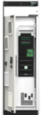
Variable speed drives motor feeders & soft starters
Motor feeder solution designed to optimize low voltage applications with standardized drives and soft starters systems. All solutions are ready to use and based on the latest technology. It brings energy savings through optimized energy efficiency of electric motors as well as maintenance reduction with smooth motor start-up that reduces mechanical stress.

Power factor correction
To boost the electrical installation efficiency, Blokset proposes a dedicated section in order to improve the power factor network and filter the harmonics generated by electronic starters, drives, induction furnace, welders.. Power systems sometimes need help in order to optimize electrical equipment as well as master the operating cost.

Customer benefits:
Reduce CAPEX : reduce installation size
- Installing power factor correction system allows conductor cross section to be reduced since less current is absorbed by compensated installation for the same active power.
Power factor | 0,7 | 0,8 | 0,85 | 0,9 | 0,95 | 1
Cable section factor | 1 | 1,05 | 1,1 | 1,17 | 1,25 | 1,43

Reduce OPEX : bring savings on electricity bill
- Eliminating penalties on reactive energy and decreasing KVA demand.
- Reducing power losses in the transformers & conductors installation, thus reducing CO2 emission

Increase available power
- Allow a better use of electrical equipment. Fitting a power factor correction at the transformer LV side increases the available power.
Power factor | 0,7 | 0,8 | 0,85 | 0,9 | 0,95 | 1
Increased power | 0 | +14% | +21% | +28% | +36% | +43%

Improve power quality
Harmonics are responsible of several nuisances:
- Deterioration of supply voltage quality
- Stress on the electrical network
- Overheating of transformers, motors and cables
- Reduction of equipment life span by elevated operating temperature

test-swb-1 switchboard characteristics

General characteristics
Blokset switchboard test-swb-1 is fully compliant to international standard IEC 61439-1.

Nominal voltage | 415 | V
Short-circuit-withstand | 25 | kA
Neutral system | TN-S
Distributed neutral | Yes
Switched neutral | No
Reduced neutral | No
Protected neutral | No
iPMCC | No
IP code | IP31
Ambient temperature – daily average | 35 | °C
Lower limit of ambient temperature | -5 | °C
Upper limit of ambient temperature | 40 | °C
Relative humidity at 20°C | 50 | %
Ventilation of switchboard | Natural only
Ventilated roof | No
Chemical environment (corrosion) | 3C1 class
Busbar material | Copper
Coating option | No
Epoxy coating | No
Standard compliance | IEC
Form | 3b
Max harmonics ratio | 20%
Pfc cubicle ventilation type | Forced
Internal arc resistance | No
Maximum height | 2200 | mm
Identified wire cabling | Yes
Type of auxiliary voltage #1 | AC
Auxiliary voltage #1 | 220 | V
Type of auxiliary voltage #2 | AC
Auxiliary contact Type #2 | Standard
Auxiliary voltage #2 | 220 | V
Type of auxiliary voltage #3 | AC
Auxiliary voltage #3 (fans) | 115 | V
Network frequency | 50 | Hz
Altitude | Up to 2000m
Plinth | No

Typical diagrams
Functional Units with the same auxiliaries and accessories are grouped into Typical Diagrams, regardless of their ampacity or power..

Incomers
 | INC-A
Electrical function | Circuit breaker (NW)
Withdrawability | FFF
Intelligent protection | Yes
Protection | External relay
Relays and auxiliaries compartment | Medium
Current Transformer (CT) | 2
Number of control wires | 50-79
Auxiliaries, measurement & iPMCC | =S= 54442

Bus Ties
Not in this switchboard

PCC / ACBs
 | ACB-A
Electrical function | Circuit breaker (NW)
Withdrawability | WWW
Intelligent protection | No
Protection | Embedded trip unit
Relays and auxiliaries compartment | None
Current Transformer (CT) | 0
Protection type of embedded protection (Micrologic) | Basic (Micrologic 2.0*)
Measurement type of embedded protection (Micrologic) | Ammeter (Micrologic *.*A)
Number of control wires | 50-79
Auxiliaries, measurement & iPMCC

PCC / MCCBs
Not in this switchboard

Motor outgoers
Not in this switchboard

VSD/SS
Not in this switchboard

PFC
Not in this switchboard

Description of functional Units

General functional unit description

FU Designation | Nb | Type | Typical diagram | Cubicles | Section | Main devices | Ampacity or  Power | FU / Device nb of pole | Size
QA-1 | 1 | PCC/ACB | ACB-A | CUB-B | Section 1 | NW20 | 2000A | 4P / 3P | 600
QA-2 | 1 | Incomer | INC-A | CUB-A | Section 1 | NW32 | 3050A | 4P / 3P | 1000

Customized cubicles

Cubicle Designation | Type | Product Reference | qty

Customized functional unit

FU Designation | Cubicle Designation | Cubicle Type | Product Reference | qty

General Arrangement

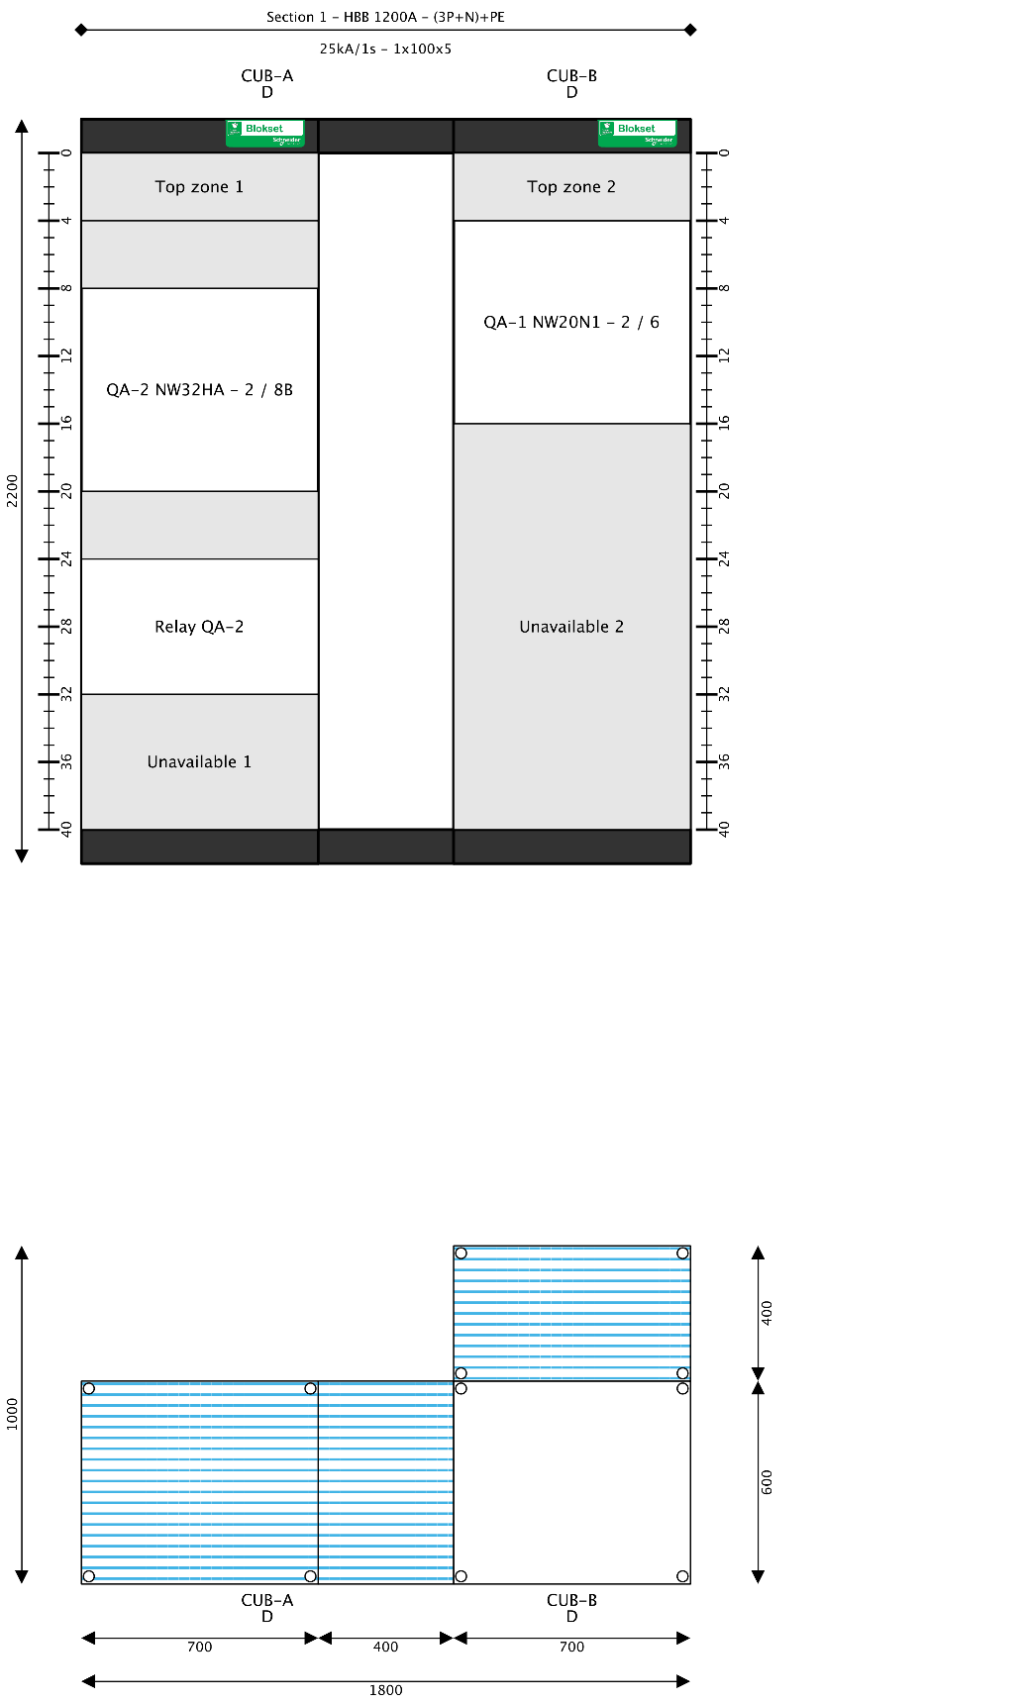

Cubicle Designation | Cubicle  Type | Cubicle  Width  (mm) | Cubicle  Depht  (mm) | Cubicle  Heigt  (mm) | Number  of wires | Rated Short circuit  Icw – 1s | Horizontal  busbar | Vertical  busbar | PE  or PEN
CUB-A | D | 1100 | 600 | 2200 |  | 50 | 1x100x5
CUB-B | D | 700 | 600 | 2200 |  | 50 | 1x100x5

Routine factory inspection
After the equipment will be terminated, we, as assembly manufacturer will proceed with a routine factory inspection on the manufactured panels in accordance with IEC61439-1/2.
Routine inspection performed during the factory inspection will be as follow :
  - Equipment conformity to the customer specifications, drawings and manufacturer technical guides
  - Check of conformity with mechanical assembly, wiring diagrams
  - Mechanical operation tests, and interlocks checking
  - Dielectric test withstand
  - Insulation resistance measurement
  - Earth continuity

Limit of supply
This technical offer is valid for the supply of equipment in strict compliance with the specified quantities and the detailed technical description included in this quotation.
Generally speaking, all equipment or services not explicitly mentioned in our offer are not included, such as :
  - Cables, cable termination,
  - Cable glands, lugs and screws,
  - Site services such as installation and commissioning (quoted as an option)
  - Alternative or direct auxiliary supplies,
  - Floor frames,
  - Special tools

Documentation supplied
Drawings and documents will be prepared after the contract signature in the defined duration for the customer approval. They are to be approved with or without comments, and returned to us according to the deadlines defined in the order.
Documents provided with the panels delivery:
  - Single line diagrams, front view arrangements, civil engineering layout
  - Electrical Schematic diagrams
  - Material list
  - Instruction manual for installation, maintenance
  - Catalogues

Reference documents used
Our tender has been prepared using the following documents available in your request for tender:
-
-
-

Comments and deviations on the technical specification
Based on the documents analyzed, our comments are as follow:
Specification reference | Clause n° | Specification requirement | Offer proposal

Afterword

<<img_sld>>

