**WEBHOOK**

**Step1:** check mark the GitHub hook trigger for GITScm polling in build-triggers section and then click on save

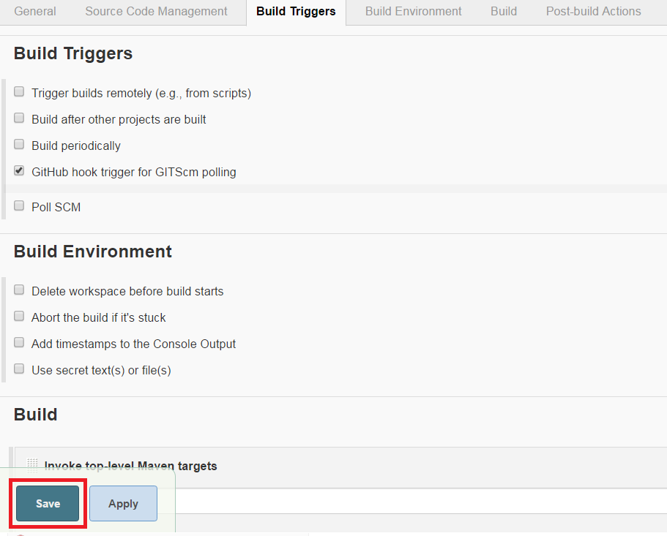

**Step2:** Goto manage Jenkins. 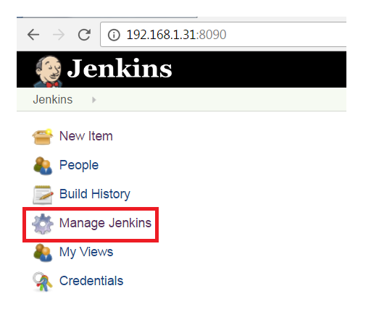

**Step3:** Click on configure system

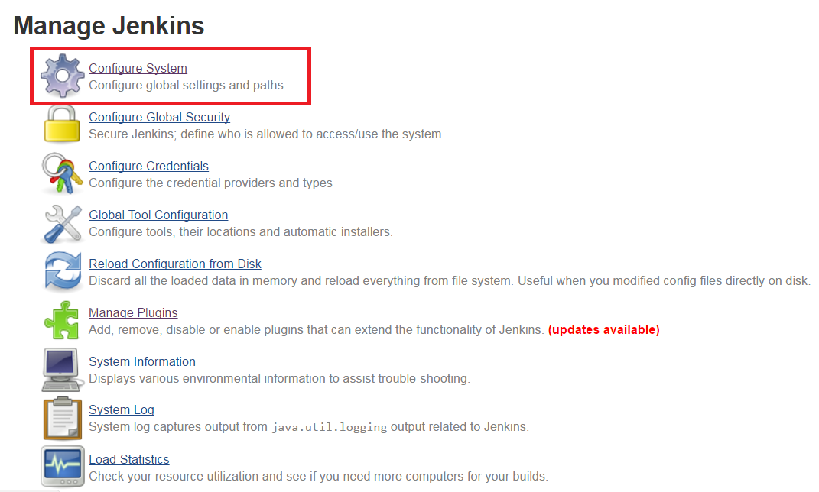

**Step4:** Goto GitHub section and click on Advanced

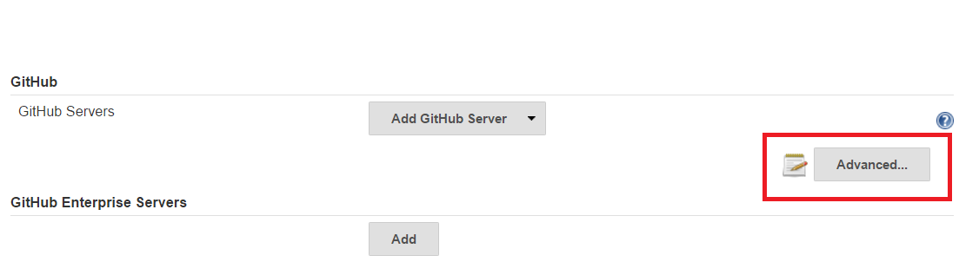

**Step5:** Check mark the Specify another hook url for GitHub configuration and copy that url and again uncheck it.

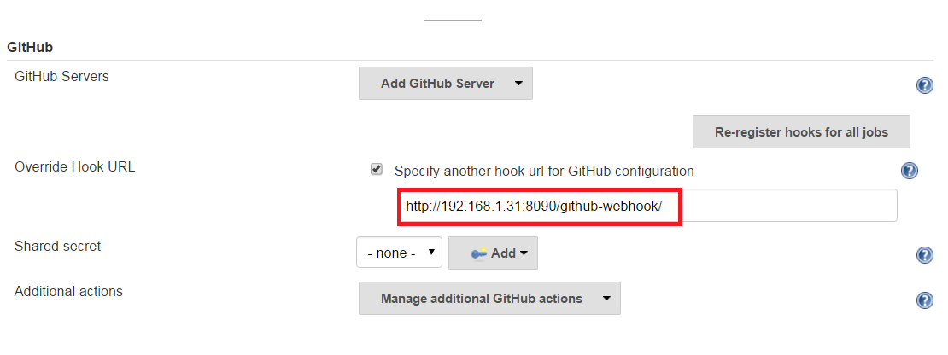

**Step6:** Now goto GitHub repository on which you want to trigger the build

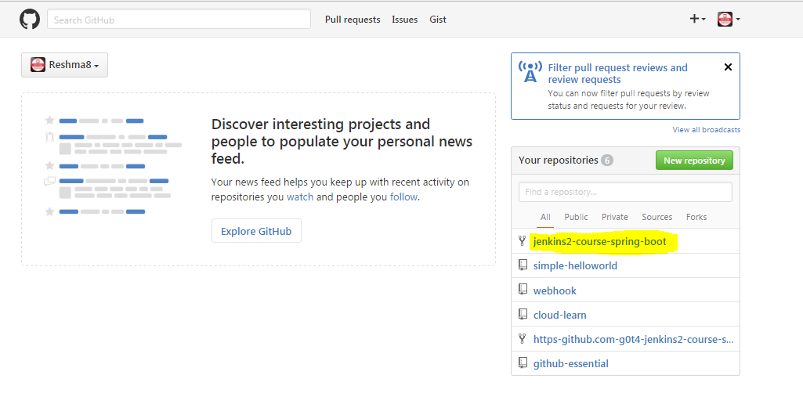

**Step7:** Goto settings and click on webhooks and then click on Add Webhook

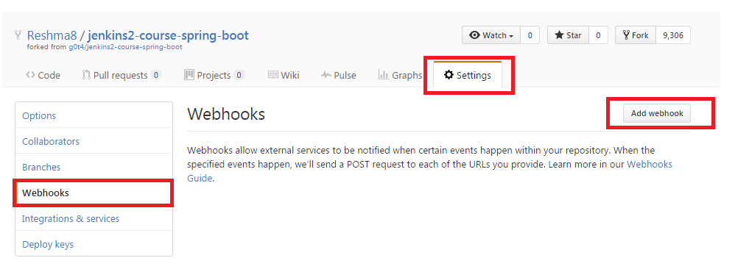

**Step8:** Mention the Payload URL which you have copied from Jenkins and check mark the Just push event and then click on Add Webhook

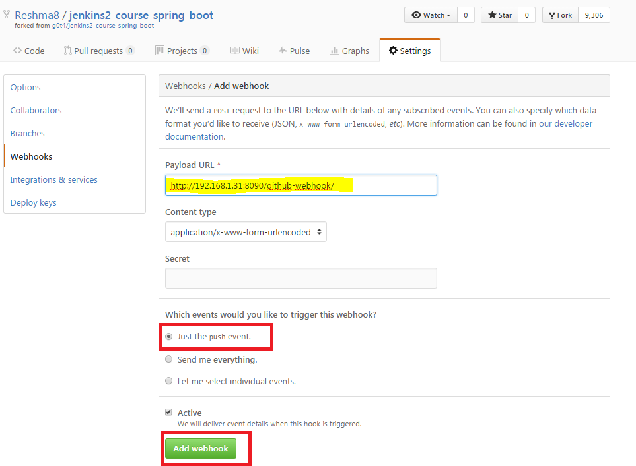

**Step9:** Now goto git and make some changes in the file, add files and commit the changes and push it to the github.

**Or**

Do directly changes in the github and commit changes

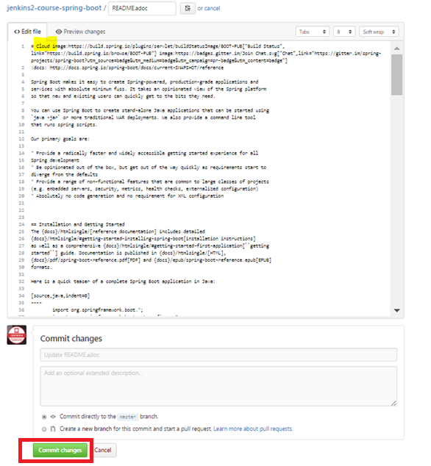

**Step10:** After pushing changes to github the build should trigger automatically. 