**OBJECT ORIENTED SYSTEM ASSESSMENT**

**BY**

**STEPHEN EKEH ST20253971**

**CARDIFF SCHOOL OF TECHNOLOGIES**

**DEPARTMENT OF COMPUTER SCIENCE**

**©2022**

**TABLE OF CONTENT**

1. Design and Implementation Requirements
2. Use Case Diagram
3. UML Diagram
4. Source File
   1. Server side
   2. Client side
5. Documentation
6. References

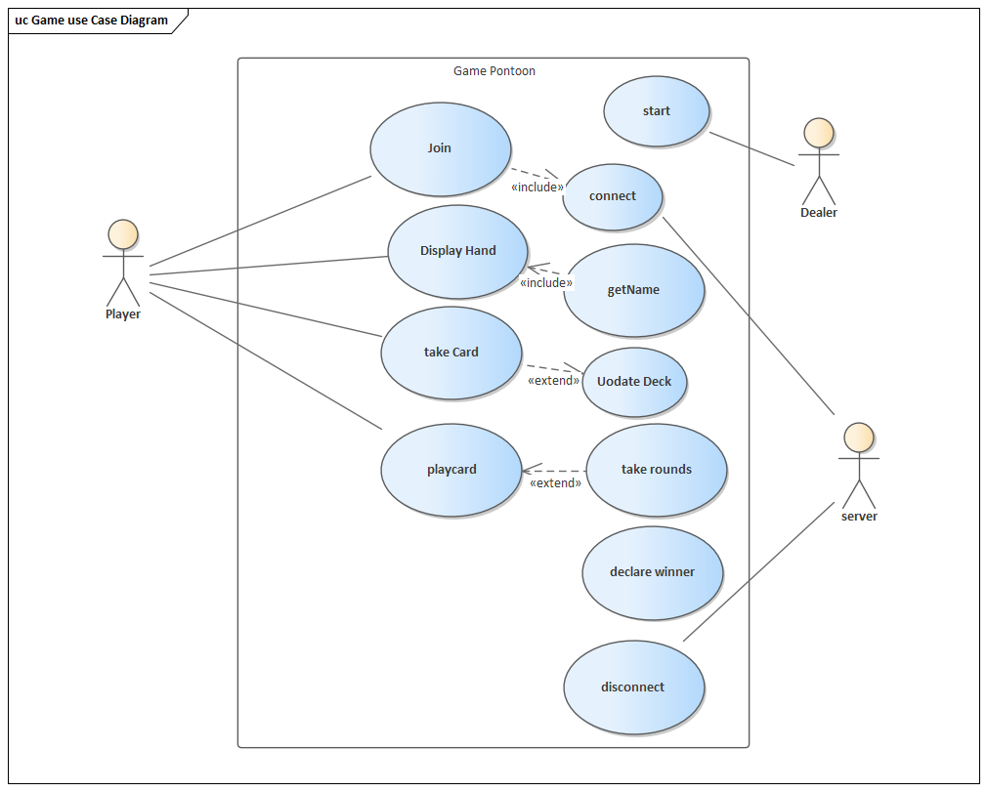 ***Design and Implementation requirements***

* **UML class diagram:**
* 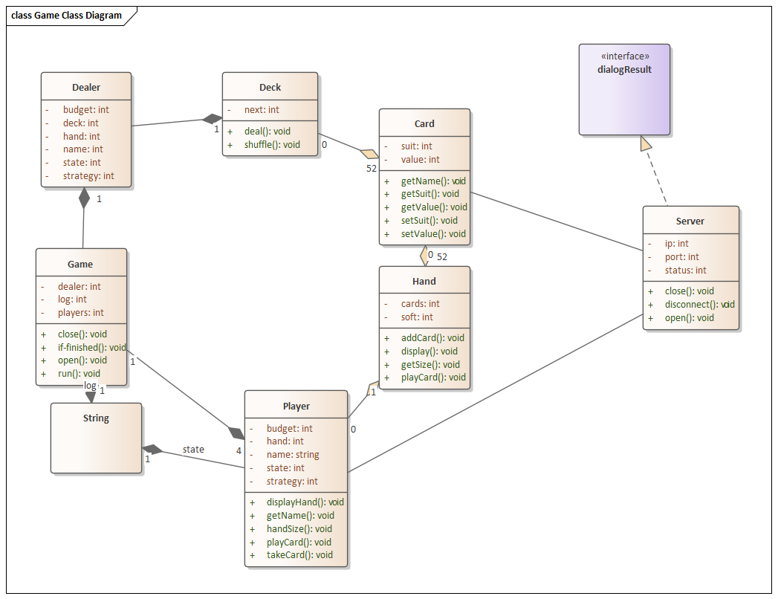
* UML Notes should be used where applicable to explain the design approaches

**Source files** corresponding to the software component simulating the **server-side** implementation that performs the functions identified in Sec. 1.1.

* 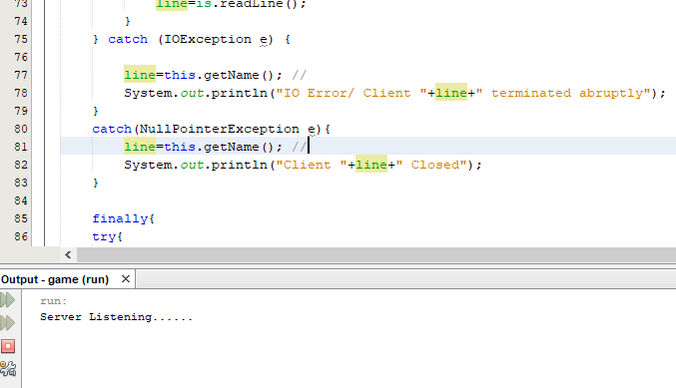
* Server can be initiated from the command line by typing
* Javac server_1

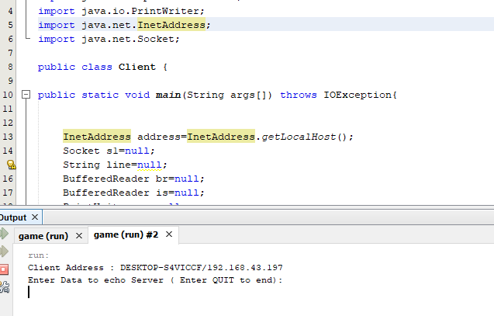

* **Source files** corresponding to the software component simulating the **client-side** implementation that performs the functions identified in Sec. 1.2.

Client side can be initiated by typing

Javac client

* **Documentation**

The server side component is used to store information in linked list, which can be accessed by clicking simulate on java IDE such as netbeans or Eclipse.

Use cases

Use case diagram is a behavioral UML diagram type and frequently used to analyze various systems. They enable you to visualize the different types of roles in a system and how those roles interact with the system.

Use case diagrams consist of 4 objects.

* Actor
* Use case
* System
* Package

Class Diagram

Class diagrams are one of the most useful types of diagrams in UML as they clearly map out the structure of a particular system by modeling its classes, attributes, operations, and relationships between objects.

Benefits

Class diagrams offer a number of benefits for any organization. Use UML class diagrams to:

Illustrate data models for information systems, no matter how simple or complex.

Better understand the general overview of the schematics of an application.

Visually express any specific needs of a system and disseminate that information throughout the business.

Components

The standard class diagram is composed of three sections:

Upper section: Contains the name of the class. This section is always required, whether you are talking about the classifier or an object.

Middle section: Contains the attributes of the class. Use this section to describe the qualities of the class. This is only required when describing a specific instance of a class.

Bottom section: Includes class operations (methods). Displayed in list format, each operation takes up its own line. The operations describe how a class interacts with data.

How to access server and Launch

Cd project directory in command line

type

java server.java

References

Java Programming: From the Ground Up by Bravaco, Simonson

* Page 496