DATE: 7/20/2011 9:30 AM

Everyone,

As I was told, currently the firewall is fully open/unrestricted and the network routing issues are resolved by Mike Gilton. The current network access and aix access is as the following:

NETWORK:

- GOOD: PROD MES to DEV/QA DB2 over the network is good/accessible (MES [10.46.6.23] -------> letmap_d:50001)
- GOOD: PROD MES to PROD DB2 over the network is good/accessible (MES [10.46.6.23] -------> letmap_p:50001)
- GOOD: DEV/QA AIX machine to PROD MES over the network is good/accessible (aixjava1d [207.130.184.206] -------> MES [10.46.6.23:44446] with plans to move to port 44444)
- UNKNOWN: PROD AIX machines to PROD MES over the network is currently not testable since I cannot telnet into the aixjava1p or aixjava2p machines.

See the screenshots for details.

PROD
--------------------------------------------
STEP #1) MES -------> letmap_d:50001
STEP #2) MES -------> letmap_p:50001
STEP #3) MES:44446 <-------- aixjava1p / aixjava2p
STEP #3) MES:44446 <-------- aixjava1p / aixjava2p

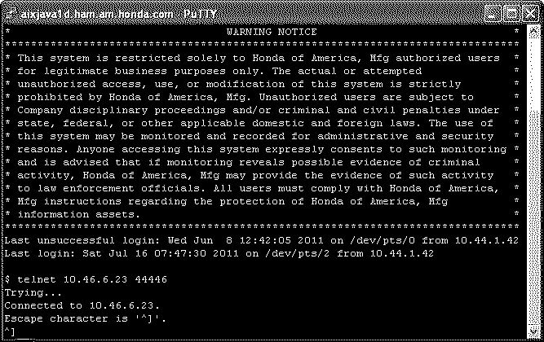

MES workbench screenshot to IP address 207.130.184.199 is the IP address of letmap_p (PROD DB2)
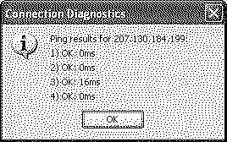


MES workbench screenshot to IP address 207.130.184.216 is the IP address of letmap_d (DEV/QA DB2)
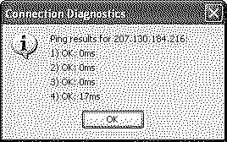


Regards,
Jeff Lutz
-----------------------------------------------
Technical Services
Honda of America Mfg.
937-642-5000 x 66780 office

