Honda Manufacturing of Indiana (HMIN)

Information Services

SQL Migration Test Plan
Version 1.1

Creation Date: 3/21/2012 7:45:00 AM

Last Saved: 5/16/2012 11:49:00 AM

TABLE OF CONTENTS

1. Revision History 2
2. Document Overview 4
2.1. Referenced Documents 4
2.2. Acronym List 4
3. Environment 4
4. Test Execution 5
4.1. Test Case 1 – Normal Flow 5
4.1.1 Pre-Conditions 5
4.1.2 Test Steps 5
4.1.1 Post-Conditions 7
4.2. Test Case 2 – Abnormal Flow 7
4.2.1 Test Steps 7
4.3. Test Case 3 – Abnormal Flow 7
4.3.1 Test Steps 7
4.4. Test Case 4 – Abnormal Flow 8
4.4.1 Test Steps 8

Revision History
Revision | Section | Description | Editor | Date
1.0 | All | Original | Sarada Kesari | 3/21/2011
- Reviewers
Name | Position | Version | Comments
- Approval Signatures
Name | Position | Version | Signature / Date

Document Overview
This document describes the test scenarios for making sure the SQL scripts are in executable format after removing the various comments.

Removing the unnecessary comments in the SQL Scripts before migrating it to the desired environment.
It deletes the following comments.
- Comments in a single line. SQL comments starts with “- -“
Eg: -- delete from galadm.gal246tbx where process_point_id = ‘PP10610’;
- Comments in a single line or speeded to multiple lines. SQL comments starts with “/*” and ends with “*/”
Eg: a) /* delete from galadm.gal246tbx where process_point_id = ‘PP10610’ ;
Insert into galadm.gal143tbx(product_id, product_spec_code) values (‘19VDE3F73DE300002’,
‘LEA29980002’) ; */
b) /** delete from galadm.gal246tbx where process_point_id = ‘PP10610’;
delete from galadm.gal246tbx where process_point_id = ‘PP10610’ ;
Insert into galadm.gal143tbx(product_id, product_spec_code) values (‘19VDE3F73DE300002’,
‘LEA29980002’) ;
*/
3) It also removes “;” if it is the last character in an SQL Statement.

Referenced Documents
- None.

Acronym List
- None.

Environment
This section describes the environment that the test was executed against.

Environment | WAS Version | App Server | DB Server | OPC Server | Device

Test Execution

Test Case 1 – Normal Flow

Pre-Conditions
Each individual SQL query should be in a separate line in a given SQL file (SQL Script).
Make sure that each query SQL syntax is correct and Valid data is used in the queries.

Test Steps

This section describes the steps to be taken in order to execute the test.

Step1: Prepare SQL file.
- Create SQL file with the extension as “.sql”. Eg.. “sample.sql”
- Add SQL queries in created SQL file. Please make sure that each query should be in only one single line.

Step 2: Add the SQL file to nativeSql folder.

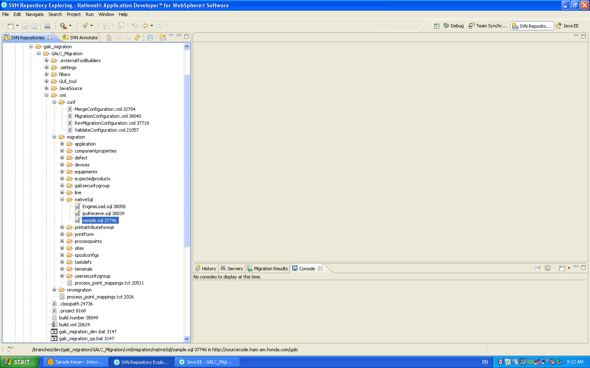

Step3: Modify MigrationConfiguration.xml

Add MigrationTask for nativeSql in MigrationConfiguration.xml.

<MigrationTask>
<TargetType>nativeSql</TargetType>
<Identity> sample </Identity>
</MigrationTask>

Here TargetType is nativeSql and Identity is name of the SQL file.

Step4: Build GALC_MIGRATION in required environment by using Cruise Control url.

Step5: Deploy GALC_MIGRATION in required environment by using Cruise Control url.

Step | Procedure | Expected Results | Actual Results | Pass/Fail
1 | Prepare the SQL Script (Eg sample.sql) with a single line comments (Eg –aaaa bbbb) in it and each SQL query in a separate line. | The single line comments should be removed in the output SQL Script (sample.sql). | Removed the single comments | Pass
2 | Prepare the SQL Script (Eg sample.sql) with multiline line comments (Eg /* aaaa bbbb */) in it and each SQL query should be in a separate line. | The single line comments should be removed in the output SQL Script (sample.sql). | Removed the single comments | Pass
3 | Prepare the SQL Script (Eg sample.sql) with each SQL query should be in a separate line and last character in the line “;”. | The last character “;” should be removed in the output SQL Script (sample.sql). | Removed semicolon(;)  At the end of query | Pass
4 | Prepare the SQL Script(Ex sample.sql) with empty spaces at the end of file. | The empty space at the end of file is removed and execute valid queries only. | Removed empty spaces in the file. | Pass
5 | Prepare the SQL Script (Eg sample.sql) with the combination of single line comments, multiline line comments and SQL query ends with “;” and each SQL query should be in a separate line. | Removed all comments(single, multiline) , semicolon, empty spaces in the file and prepare the list of queries then execute all queries. | Execute all queries in the file. | Pass

Post-Conditions
This section describes the conditions or predicates that must always be true just after the execution of the file.
The SQL Script should not have any comments and “;” at the end of the SQL statements. It should be ready for migration.

Test Case 2 – Abnormal Flow

Test Steps

Step1: Prepare SQL file.
- Create SQL file with the extension as “.sql”. Eg.. “sample.sql”
- Add SQL queries in multiple lines in created SQL file.

Eg: insert into GALADM.GAL208TBX (PART_GROUP_NAME,
PART_GROUP_DESCRIPTION_SHORT,
PART_GROUP_DESCRIPTION_LONG,
MODEL_CODE)
select replace (a.PART_GROUP_NAME, '-TX8', '-TT1') as PART_GROUP_NAME,
a.PART_GROUP_DESCRIPTION_SHORT,
a.PART_GROUP_DESCRIPTION_LONG,
'TT1' as MODEL_CODE
from GALADM.GAL208TBX a
where a.PART_GROUP_NAME like '%-TX8%';

Step | Procedure | Expected Results | Actual Results | Pass/Fail
1 | Prepare the SQL Script (Eg sample.sql) in multiple lines. | It throws “Exception in thread "main" javax.persistence.PersistenceException” exception | Throws Exception due to reading single line as a query. | Pass

Test Case 3 – Abnormal Flow

Test Steps

Step1: Prepare SQL file.
- Create SQL file with the extension as “.sql”. Eg.. “sample.sql”
- Add SQL queries with already existing data in created SQL file.

Eg: insert into GALADM.GAL143TBX (product_id) values (‘19VDE3F73DE300002’);

Step | Procedure | Expected Results | Actual Results | Pass/Fail
1 | Prepare the SQL Script (Eg sample.sql) with invalid data. | It throws “javax.persistence.EntityExistsException: org.hibernate.exception.ConstraintViolationException” exception | Throws Exception  Due to primary key data violation | Pass

Test Case 4 – Abnormal Flow

Test Steps

Step1: Prepare SQL file.
- Create SQL file with the extension as “.sql”. Eg.. “sample.sql”
- Add SQL queries with wrong sql syntax in created SQL file.

Eg: 1. update galadm.gal257tbx where client_id=’IPURECEIVE1’;

Step | Procedure | Expected Results | Actual Results | Pass/Fail
1 | Prepare the SQL Script (Eg sample.sql) with invalid sql syntax or invalid column names. | It throws “Exception in thread "main" javax.persistence.PersistenceException” exception | Throws Exception  Due wrong syntax. | Pass

