**Java, Selenium, Maven and Cucumber Setup steps in Eclipse:**

**Steps to follow:**

* **Java Environment Setup:**
* Install JDK and JRE in system.
* Set new System environment variable as JAVA_HOME = C:\Program Files\Java\jdk1.8.0_172
* Edit Path variable and append: %JAVA_HOME%\bin
* Verify Java path: Open command prompt >> type >> java -version

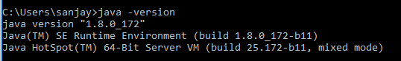

* Download and install eclipse: <https://www.eclipse.org/downloads/>
* **Selenium Setup:**
* Selenium download required, only if the project is a simple java or TestNG Project.
* No need to download selenium standalone jar for Maven Project.
* Download Selenium standalone server jar file: <https://www.seleniumhq.org/download/>
* Download browser (Chrome, FF, IE etc..) drivers from above URL.
* **Maven Setup:**
* Download Maven zip file: <https://maven.apache.org/download.cgi> and unzip it.
* Set new System environment variable as MAVEN_HOME = C:\Apache\maven_3.5.4
* Edit Path variable and append: %MAVEN_HOME%\bin
* Verify Maven path: Open command prompt >> type >> mvn -version

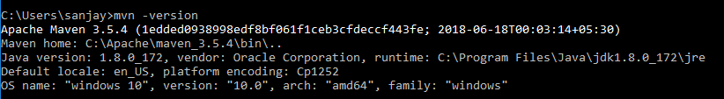

* Install Maven Plugin in Eclipse: Open Eclipse
* Go to >> Help >> Install New Software
* In Work with box enter: <http://download.eclipse.org/technology/m2e/releases>
* Select respective maven plugins and install
* Restart eclipse
* Now update settings.xml file and m2 repository path in:
* If required change proxy settings path in settings.xml file.
* By default, it will be in: C:\Apache\maven_3.5.4\conf
* Eclipse >> Window >> Preferences >> Maven >> User Settings
* **Cucumber Setup:**
* Install Cucumber Plugin in eclipse
* Follow link: <http://toolsqa.com/cucumber/install-cucumber-eclipse-plugin/>