There 4 things you have notice as I mention below

1. Install testiNG to eclipse

Check this link for how to install TestNG

<http://toolsqa.com/selenium-webdriver/install-testng/>

1. firefox verion

please download firefox verion 47.0.1 due to the newest of Selenium works only with 47.0.1 or older.

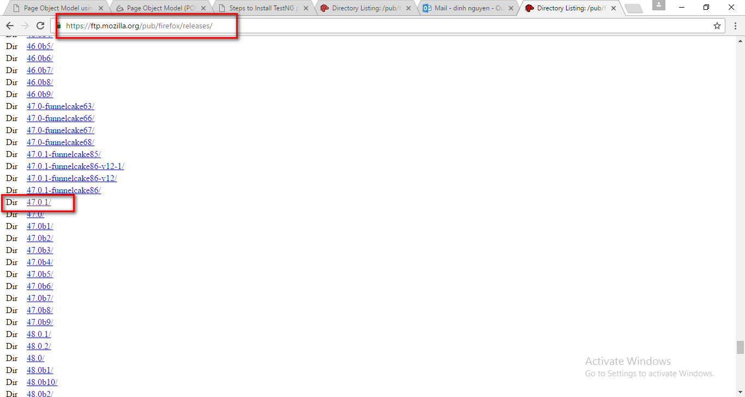

Download the source.

You have to turn of internet while install firefox.

After install fire fox,you have to turn of auto update of firefox, don’t let firefox auto update

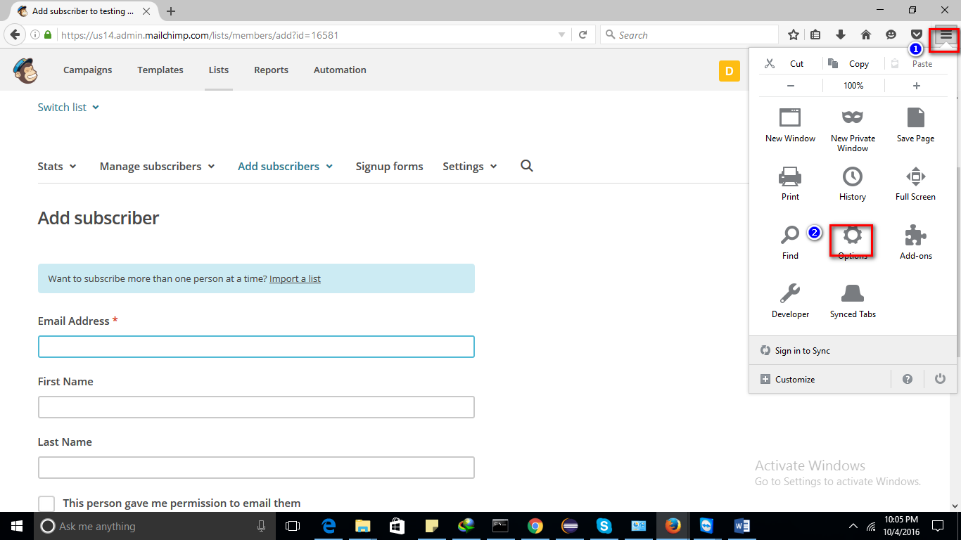

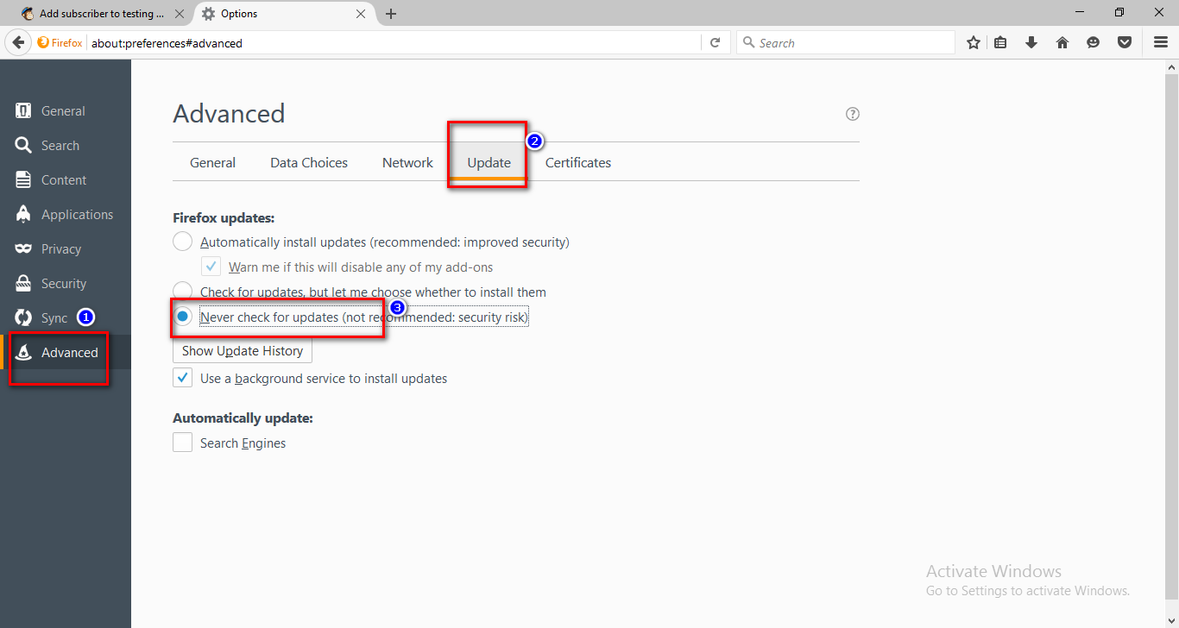

Then you can turn on internet .

1. Get the source code

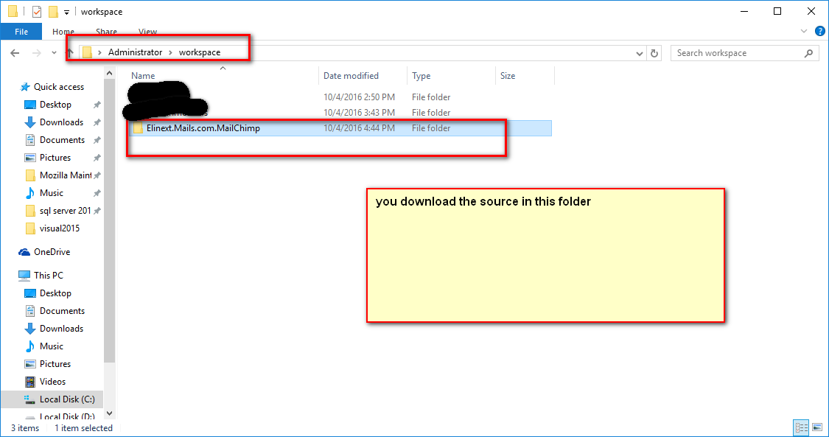

Then open eclipse

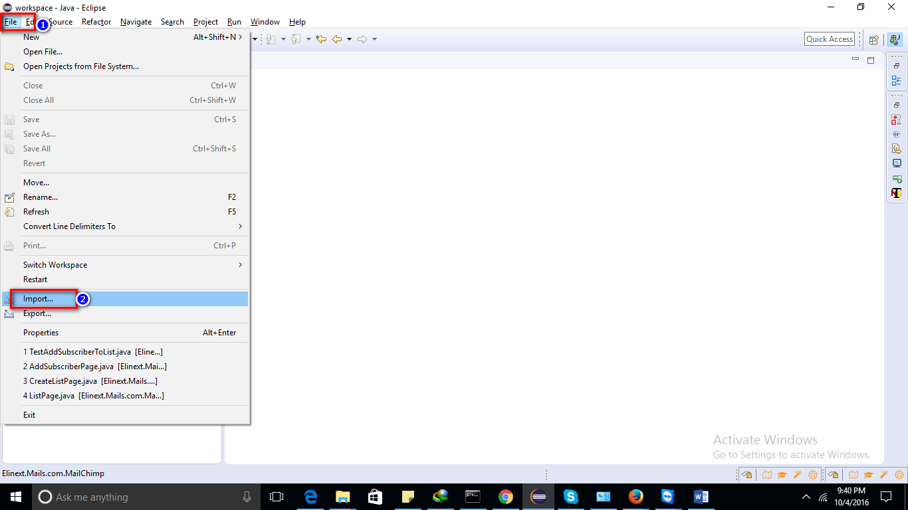

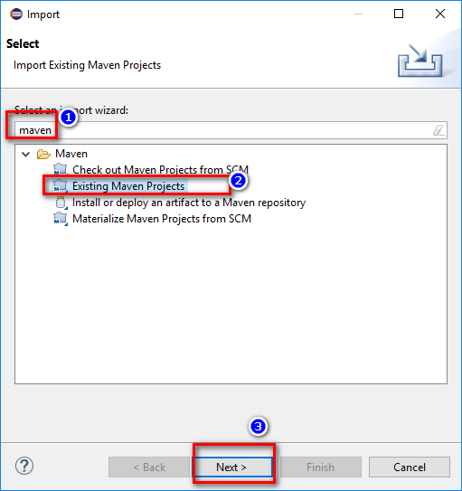

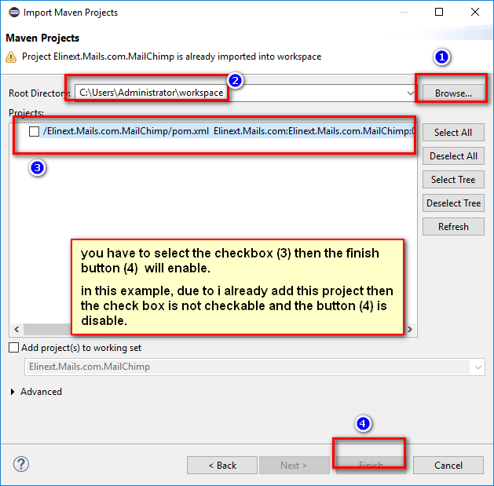

Then you will see the project like that

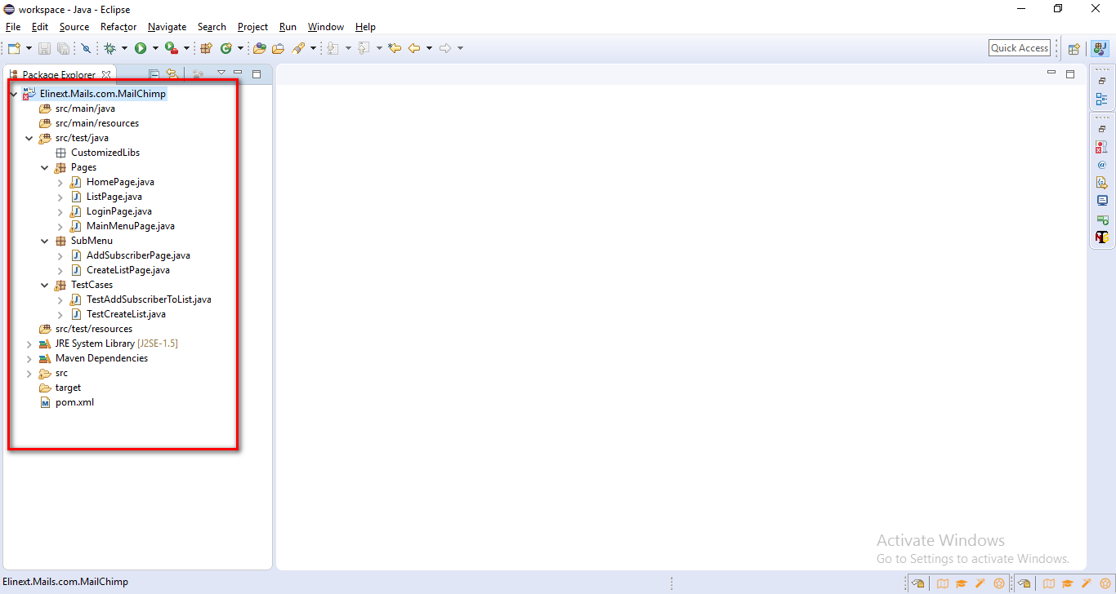

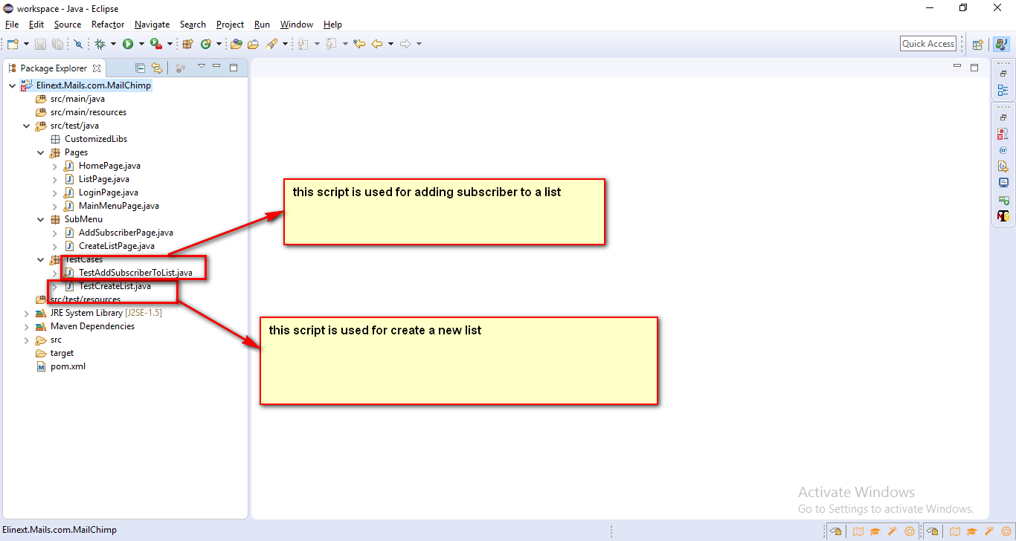

1. Edit the script

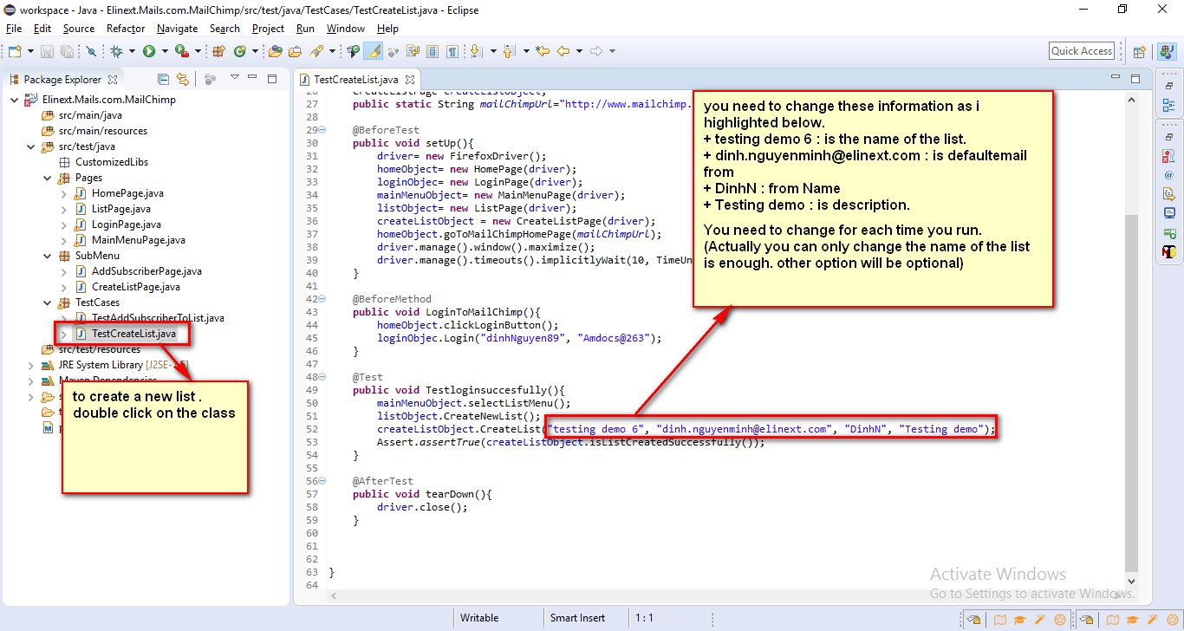

How to run

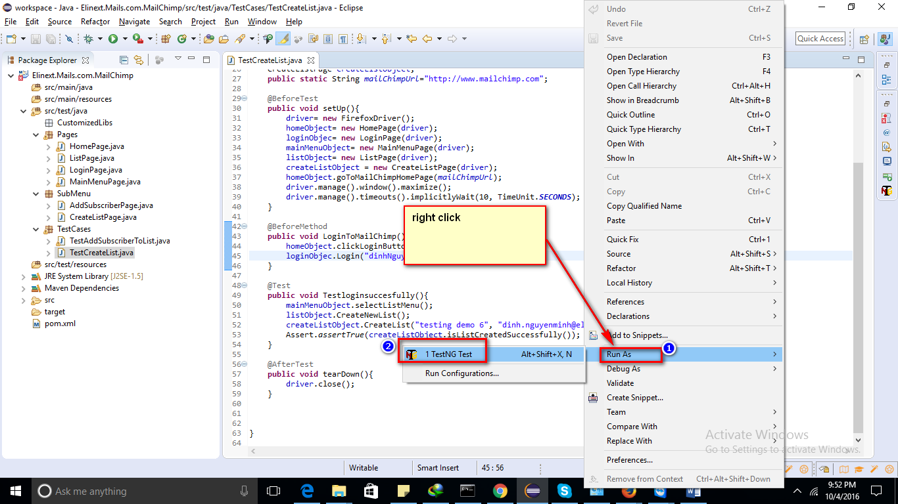

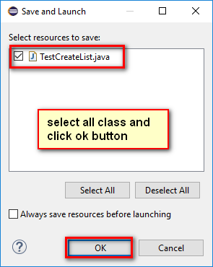

After it run

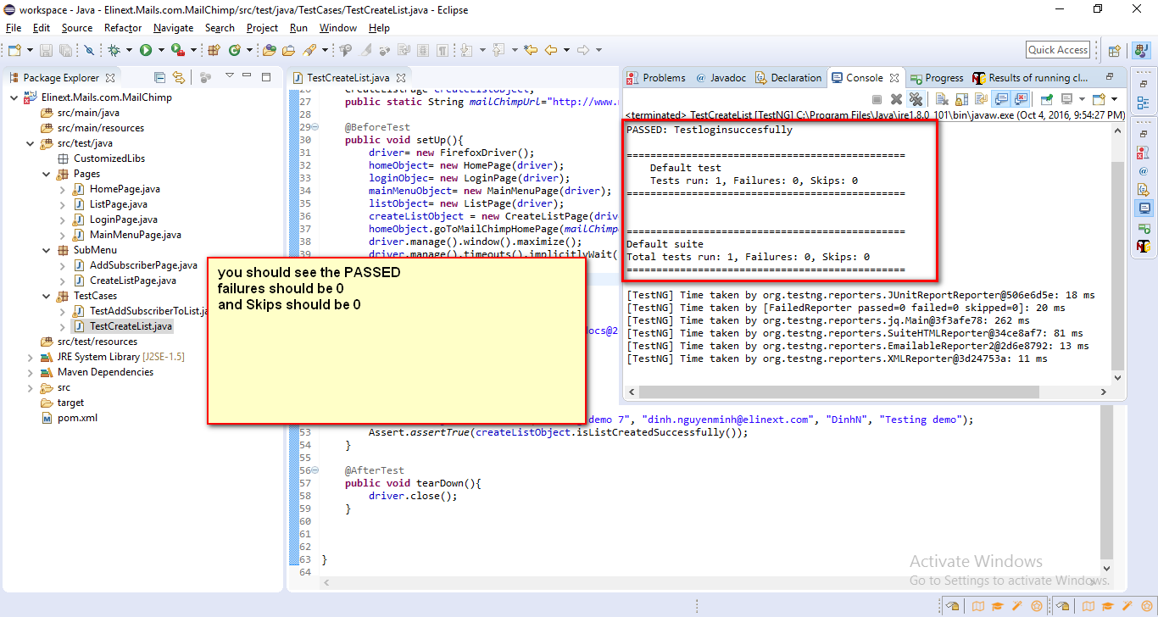

And go to web and check if the list is there.

For adding subscriber to a list

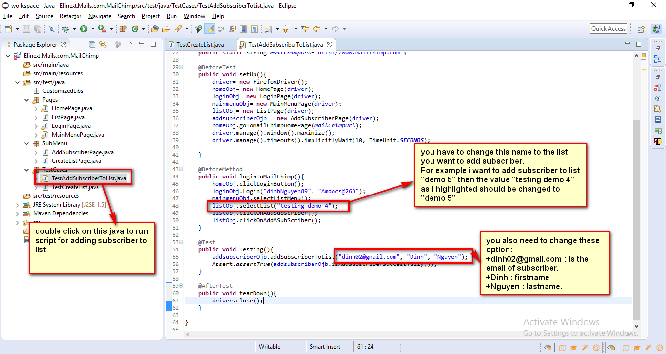

After update , then right click and run as testing option like the “create list” .

Have fun.