Ask every client, every time: “Were you born in the United States?”

RIAC should receive a referral whenever a client's intake sheet lists them as having been born outside the United States. Clients thus fall into one of three categories:

            - They are currently a non-citizen;
            - They were born outside the United States, but are now a citizen, or
            - They were actually born inside the United States (and thus have always been a U.S. citizen) but the wrong box was checked on the form.

For most clients, establishing immigration status or U.S. citizenship is easy: the attorney asks where they were born and the client either (1) convincingly confirms a specific location in the U.S. (in which case please simply let the RIAC know and we can close our file), (2) they state an overseas location, or (3) there is some ambiguity/doubt (in which case, you should seek the documents and information on the following page).

Getting It Right Is Critical
The proper categorization of clients is imperative, because the consequences of wrongly assuming a client is a U.S. citizen can be profound such as:

- The ineffective assistance of counsel (if counsel fails to make adequate inquiries regarding citizenship status);
- Federal criminal liability on your client’s part (a false claim to U.S. citizenship is a crime); and
- Dire immigration consequences for your client (getting convicted of a deportable offense because the criminal case will proceed without immigration advice; ineligibility for a green card or citizenship; and a false claim to U.S. citizenship has unwaivable immigration consequences)

No RIAC Advisal Is Needed If You See One Of These Documents:
If your client is able to produce any of the following documents, you do not need an immigration advisal from RIAC (because your client has always been a citizen and that can never be taken away):

- A U.S. birth certificate from any of the U.S. states or territories (e.g. including Puerto Rico etc.);
- A U.S. passport which lists the place of birth as being inside the U.S. or territories;
- A Consular Report of Birth Abroad; or
- A Certificate of Citizenship

Please do not hesitate to contact us for help verifying any documents you receive.

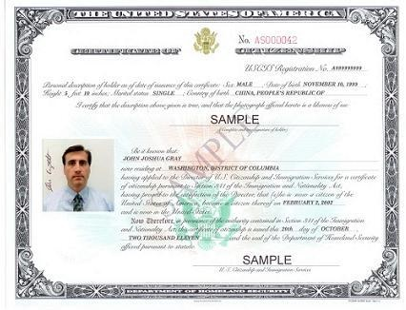
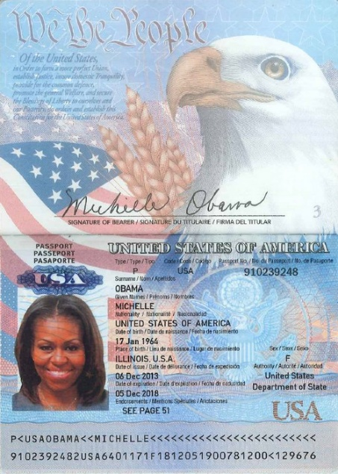
Passport must list birth location within the U.S.

NOTE: Certificate of CITIZENSHIP, (not Certificate of Naturalization)

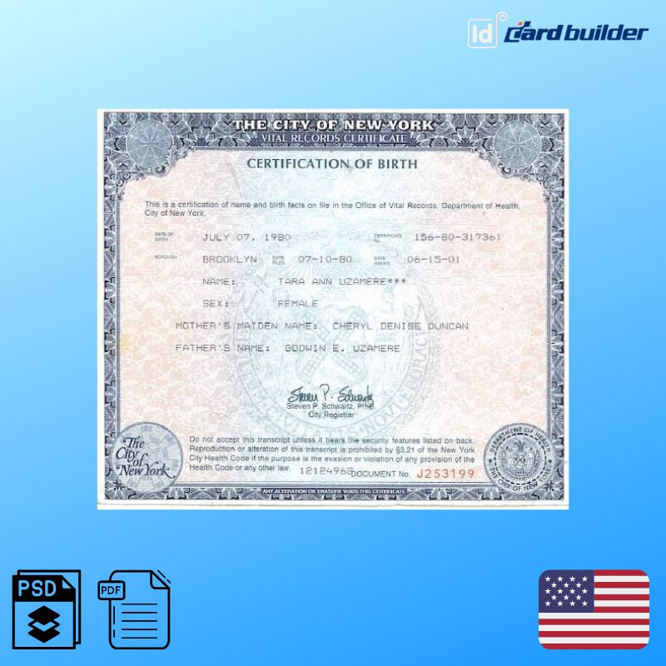

If You See One Of These Documents, Your Client Is A Citizen, But You Still Need A RIAC Advisal
If your client produces either (1) a U.S. passport that lists their place of birth as outside the U.S. or (2) a Certificate of Naturalization, you must still contact the RIAC for immigration support.

In this situation, we will generally need confirmation of two things:

            - The date that your client naturalized to become a U.S. citizen; and
            - Whether any misconduct (including uncharged misconduct like drug use/abuse or historical misconduct) is alleged to have occurred prior to that date.
With this information, we will be able to advise whether your client has any risk of being placed into denaturalization proceedings (in which case, we would undertake the full advisal process) or not (in which case, we will advise you can proceed in your representation as normal).

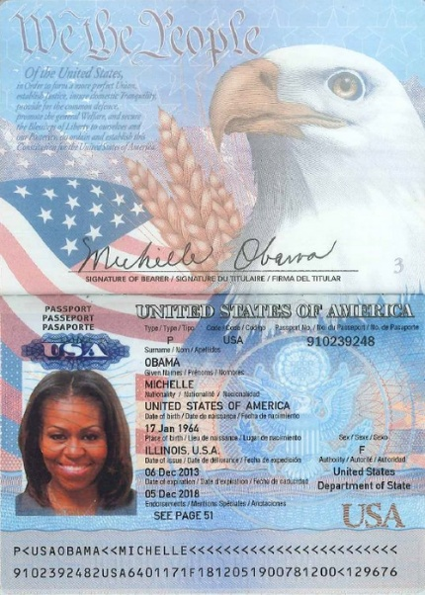
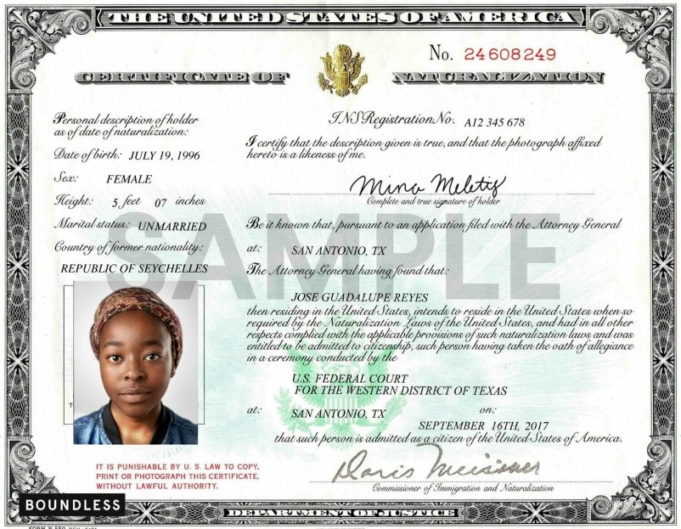
Only if passport lists overseas place of birth

Questions to Ask Before Your RIAC Consult If Your Client’s Citizenship Status Is Ambiguous
If there is any ambiguity as to whether your client was born in the United States and documents are not available, please gather as much of the following information as you can from your client. We can then advise you whether you can proceed as normal, or if the full RIAC advisal process is needed:

- Ask for specifics of where your client was born;

- Ask for details about how they came to the United States, such as when it was, who they came with, how they entered the U.S. and where (plane, car, by foot unlawfully) and if they remember why or whether they were entitled to some kind of status in the U.S.;

- Ask if they remember details about a green card, such as where and when they were interviewed by USCIS, did they have a lawyer with them, when did they get the actual card;

- Ask details about their parents, such as if they were U.S. citizens (whether by birth or naturalization);

- Double check the RAP sheet - especially the interstate addendum (if you have it). While often inaccurate as to citizenship, this sometimes has annotations which confirm an immigration status.

- Even if your client says the documents are unavailable, you should use every opportunity to get copies of documents from your client. RIAC has had great success supporting investigators in obtaining documents the client was not previously aware or / thought were lost.

Some non-citizens may either be confused, or attempt to avoid admitting their status. For example, some may believe they would not be entitled to representation unless they are a citizen. Others may be mistaken because they have been told by family that they were born in the U.S. and assumed it was true. If in doubt, call RIAC!

