ICE “WARRANTS” ARE NOT WARRANTS;
ICE DETAINERS ARE LEGALLY MEANINGLESS: ARRESTING OR PROLONGING DETENTION BASED ON EITHER = UNLAWFUL IMPRISONMENT

Arresting or detaining someone based on an ICE warrant or detainer (as opposed to a signed judicial warrant) constitutes unlawful imprisonment. People ex rel. Wells v. DeMarco, 88 N.Y.S.3d 518, 168 A.D.3d 31, 2018 N.Y. Slip Op. 7740 (N.Y. App. Div. 2018).

Courts should be careful to differentiate between an administrative “warrant” and an actual warrant, signed by an Article III Judge:

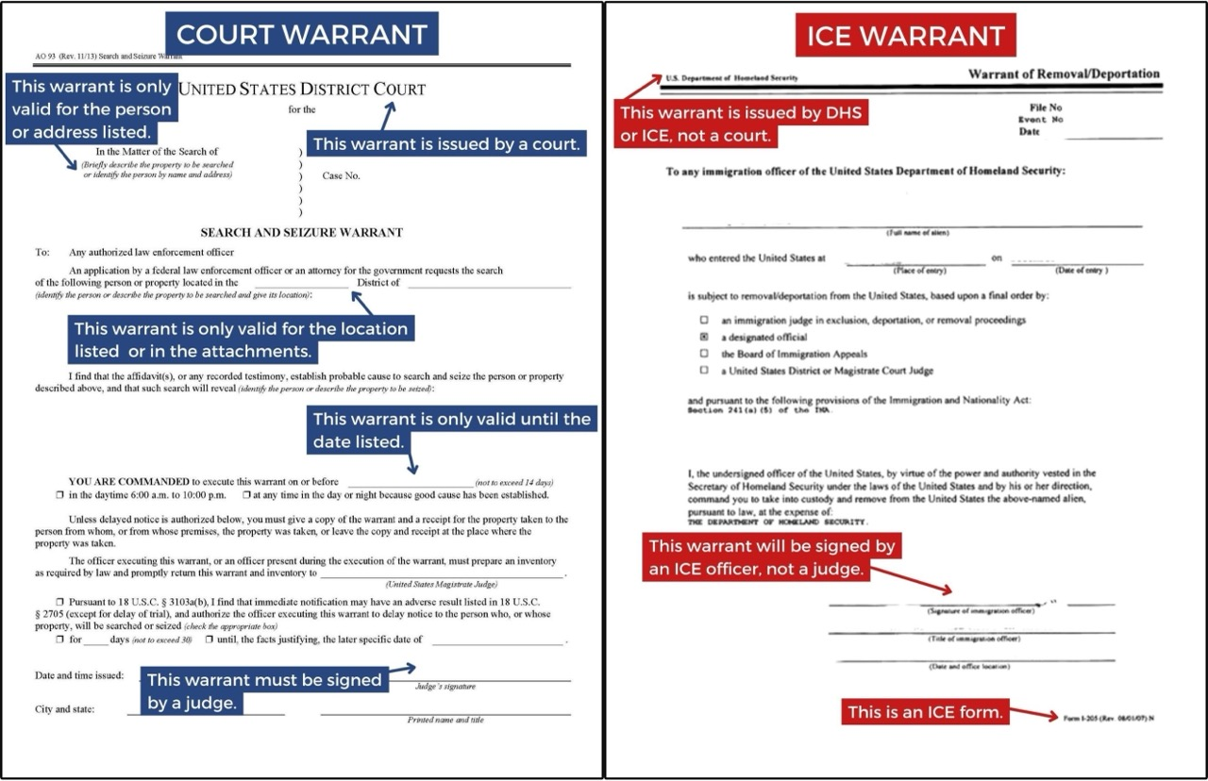

NEW YORK COURTS AND THEIR STAFF ARE REQUIRED TO COMPLY WITH SPECIFIC PROTOCOLS REGARDING ICE ENFORCEMENT ACTIONS IN OR NEAR COURTS
Judges, court staff and uniformed UCS personnel are required to follow various mandatory procedures regarding law enforcement actions in and around NY courthouses.

These procedures are based on the requirements of the Protect our Court Act (Chapter 322 of the Laws of 2020), as (1) specified in the Administrative Order of the Chief Administrative Judge of the Courts, dated January 29, 2021 and (2) further explained in the February 6, 2025 Memorandum of Chief Administrative Judge Zayas (Click here for the current protocol). The latter provides the following specific guidance:

- Except under extraordinary circumstances, absent leave of the Court, no arrest of an individual may take place within a courtroom.
- No civil arrests may be executed inside a New York State courthouse or court facility except pursuant to a judicial warrant or judicial order.
- Every courthouse and court facility will have a judge designated to review any paperwork to determine if it constitutes a valid judicial warrant or judicial order, as well as at least one other judge who will conduct such review if the designated judge is not available.
- Upon outside law enforcement officials presenting themselves to UCS uniformed personnel, the UCS uniformed personnel shall ascertain the nature of the visit, including any proposed enforcement action to be taken. In addition, the UCS uniformed personnel shall ask the outside law enforcement officials to provide the warrant, order or other paperwork relating to their visit.
- UCS uniformed personnel shall immediately advise a uniformed supervisor of the presence of the outside law enforcement officials and their intended action, and shall also provide the uniformed supervisor with a copy of any paperwork presented by the outside law enforcement officials.
- The uniformed supervisor shall immediately: (1) notify the Department of Public Safety via email of the circumstances; and (2) advise the designated judge for that courthouse or court facility of the circumstances, and provide the designated judge with a copy of any paperwork provided by the outside law enforcement officials. If the designated judge is not available, the uniformed supervisor shall provide the information and paperwork to the designated alternate judge.
- The designated judge (or designated alternate judge) shall make the determination as to whether the outside law enforcement officials have presented a valid judicial warrant or judicial order justifying law enforcement action within the courthouse or court facility.
- If the law enforcement action relates to a party or witness in a proceeding taking place or scheduled to take place in the courthouse or court facility, the uniformed supervisor shall also:
- inform the judge presiding over the case that an outside law enforcement official covered by this protocol is present in the courthouse or court facility with the intent of taking law enforcement action;
- provide the presiding judge with a copy of the related paperwork; and
- advise the presiding judge of the determination made by the designated judge (or designated alternate judge) as to whether the outside law enforcement official has presented a valid judicial warrant or judicial order justifying law enforcement action.
- The presiding judge shall have complete discretion to decide whether or not to notify the parties in the proceeding of the presence of the outside law enforcement officials and/or their intended actions.
- If the documentation is found not to be a valid judicial warrant or judicial order, UCS uniformed personnel will advise outside law enforcement of such finding and advise outside law enforcement that no law enforcement activity is permitted in the courthouse or court facility. However, if outside law enforcement personnel nonetheless proceed to go forward with their intentions outside the courtroom, UCS uniformed personnel should neither obstruct nor assist in any way. Should outside law enforcement signal an intention to move forward with law enforcement activity outside of a courtroom without a valid judicial warrant or judicial order or any law enforcement activity within a courtroom, immediate notification should be made to the Chief of Department of Public Safety for direction.
- UCS court security personnel shall file an Unusual Occurrence Report (UCS101) for each law enforcement action taken in a New York State courthouse by a law enforcement agency covered by this protocol, and must locally maintain a copy of said judicial warrant, or judicial order, or local arrest warrant or ICARD referenced to the corresponding UOR number.
- UCS court security personnel remain responsible for ensuring public safety and decorum in all courthouses and court facilities at all times. This policy and protocol is subject to modification based on changed circumstances.

ANYONE WHO “WILLFULLY ASSISTS” A WARRANTLESS, CIVIL COURTHOUSE ARREST IS COMMITTING “CONTEMPT OF THE COURT AND FALSE IMPRISONMENT”
Anybody who (1) willfully assists a warrantless civil arrest of (2) a party or witness (3) in court or travelling to or from court, commits unlawful imprisonment and contempt of court.

N.Y. Civ. Rights Law § 28(1) & (2):
1. A person duly and in good faith attending a court proceeding in which such person is a party or potential witness, or a family or household member is a party or potential witness, is privileged from civil arrest while going to, remaining at, and returning from, the place of such court proceeding, unless such civil arrest is supported by a judicial warrant or judicial order authorizing such civil arrest.
2. It is a contempt of the court and false imprisonment for any person to willfully violate subdivision one of this section, or an order of the court issued pursuant to section four-a of the judiciary law, by executing an arrest prohibited by subdivision one of this section or section four-a of the judiciary law, or willfully assisting an arrest prohibited by subdivision one of this section or section four-a of the judiciary law;

COURTS & THEIR STAFF MAY NOT ASSIST WARRANTLESS, CIVIL COURTHOUSE ARRESTS
(BUT THEY ALSO MAY NOT ACTIVELY HELP ANYONE EVADE ARREST)

Judges and court staff are prohibited from assisting any warrantless, civil arrest. But they also may not assist anyone in evading such arrest (whether or not it violates state law).

The case of Milwaukee County, Wisconsin Circuit Court Judge Hannah C. Dugan is instructive. See generally, U.S. v. Dugan, 797 F.Supp.3d 855 (E.D.Wis., 2025). The judge was alleged to have:

- Directed an ICE Task Force to leave the location of a planned arrest (a public hallway outside of the Judge’s courtroom) and go to the Chief Judge's office;
- Gone off the record while ICE Task Force members were in the Chief Judge's office and directed the defendant and his counsel to exit her courtroom through a non-public jury door; and
- Advised that the defendant could appear by “Zoom” for his next court date.
On these facts, she was alleged to have (1) concealed a person so as to prevent their discovery by law enforcement, contrary to 18 U.S.C. § 1071 and (2) corruptly obstructed the administration of law under 18 U.S.C. § 1505. She was ultimately convicted, despite claims of judicial immunity. The Judge’s affirmative steps to prevent the arrest (e.g. directing a defendant leave through a non-public doorway, having instructed ICE personnel to go to a different location) were delineated from standard judicial acts (such as allowing a litigant to appear by zoom upon request or maintaining their own courtroom).

