Q & A, first to start in developing a software

|  |  |  |
| --- | --- | --- |
| **No.** | **Module / Screen** | **Description** |
| 1 | Changing payment method | If the case of customer changing payment method, do it necessary to inform the changes in payment process? |
| 2 | Upload user data | In the situation where user info such as face recognize that have been recorded, do the user be informed about? |
| 3 | Same credit info being use at two different machine at the same time | The user's credit card or digital wallet may have been obtained by unauthorized mean, should the payment be suspended and inform higher clearance personel? |

|  |  |  |
| --- | --- | --- |
| **Create date** | **Answer** | **Answer date** |
| March 20th, 2023 | It's unnessary to inform user for payment process will occur step by step with guides on every steps. | March 25th, 2023 |
| March 20th, 2024 | Yes, the user will be notified whenever they are being recorded or taking photo by the system. | March 25th, 2023 |
| March 20th, 2025 | The safety measures must be initiate in order to prevent damaging intentions. | March 25th, 2023 |
|  |

Functional and Non-functional

|  |  |  |
| --- | --- | --- |
| **Order** | **Functional** | **Non functional** |
| **1** | Set destination | When the passenger presses the start button, a menu display of potential destinations is activated, along with message to user to select a destination. |
| 2 | Chose payment method | The system allow user to select the mode of payment: Credit Card, QR Code payment linked with banking system or digital wallet). |
| **3** | Validation | Once a destination has been selected, user is requested to input their credit card, or scan QR code for digital wallet. When the credit transaction has been validated, the ticket is issued. |

Domain Requirement

|  |  |
| --- | --- |
| **Order** | **Domain Requirement** |
| **1** | In Ticket Vendor Machine system, a credit card cannot be use for payment at the same time at two different machines, however in case such situation happen, a warning message must be display. |
| **2** | User may want cancel the already validated ticket, a compensation should be pay in the percentage of original price depend on the owners of the system. |

User Case Diagram

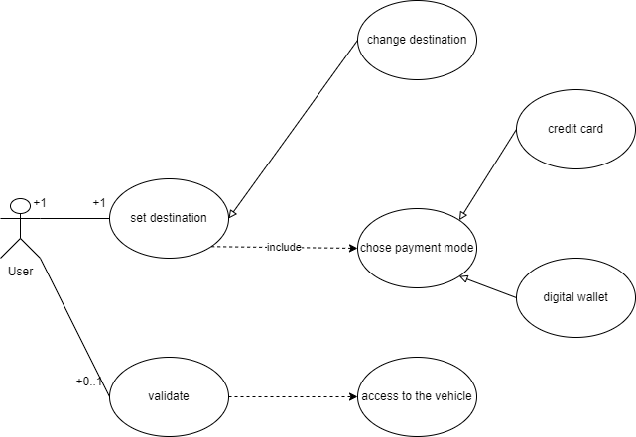

User Case Sescription

|  |  |
| --- | --- |
| Use Case ID: | UC_1 |
| Use Case Name: | Ticketing |
| Created By: | Mai Tyron |
| Date Created: | March 27th, 2023 |
| Description: | This user case allow making the payment for public transportation. The main user role is the user who want to travel by public vehicle. To be granted access, all users set their destination on Ticket Vendor Machine, then choose the method of payment. No credit card or digital wallet able to use at the same time at two different machine, if happen higher ups will be informed and the payment be suspended. |
| Primary Actor: | User |
| Secondary Actors: | None |
| Preconditions: | User have to set a destination |
| Postconditions | The system will issues a paper ticket or show a QR code to making payment. |

Activity Diagram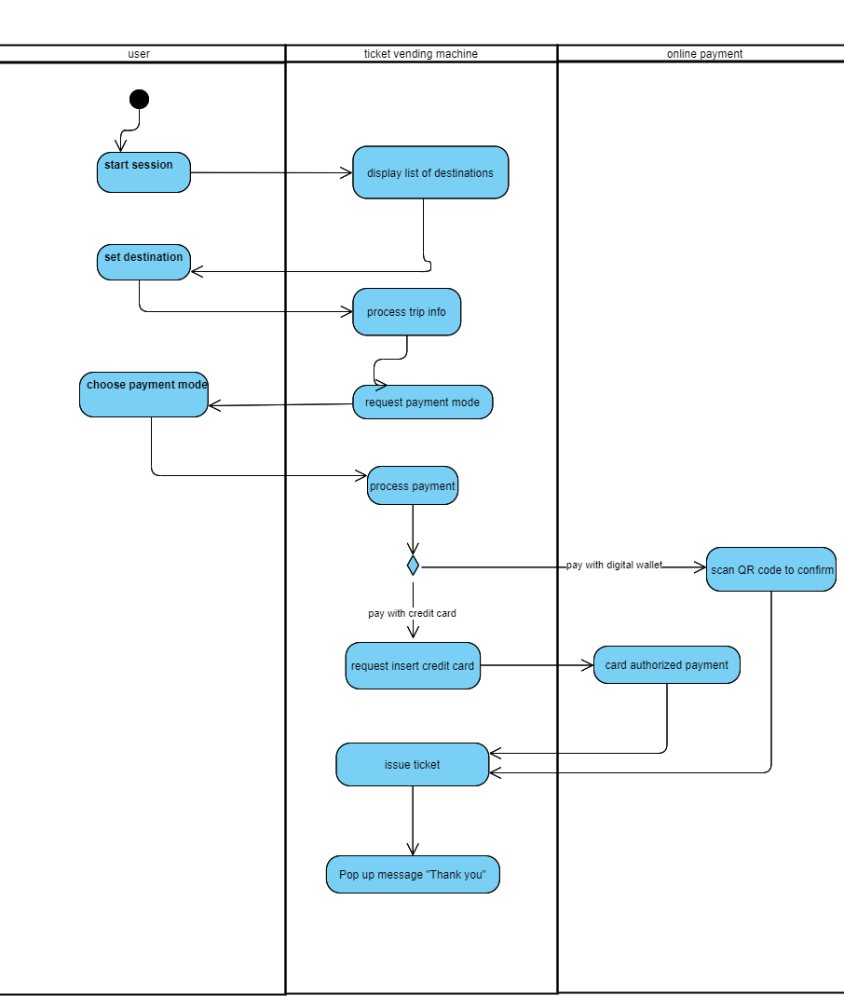

Sequence Diagram

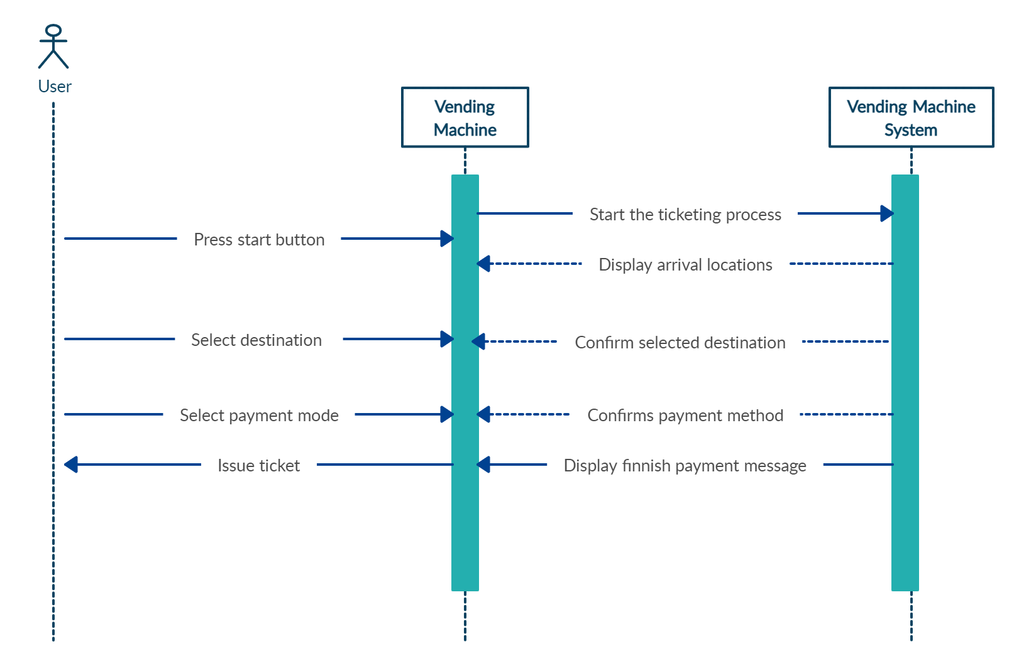

Communication Diagram

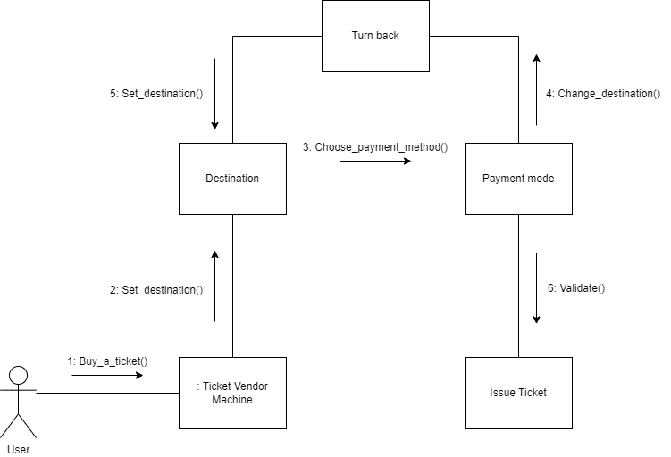

Balsamiq wireframe

Press button to start the ticket acquiring process

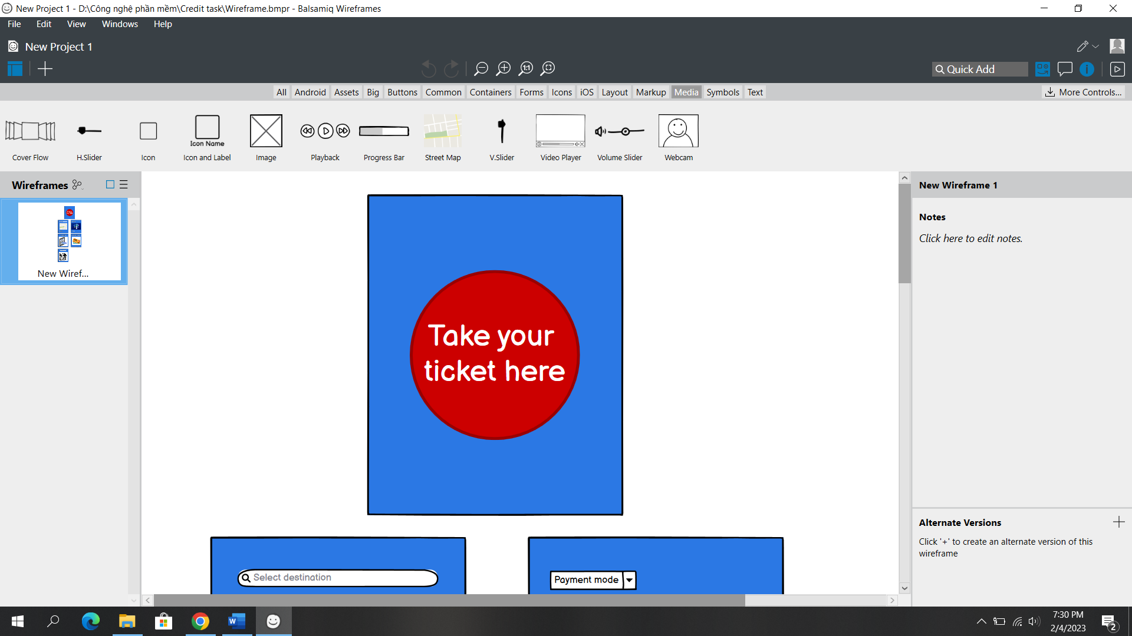

Select arrival destination

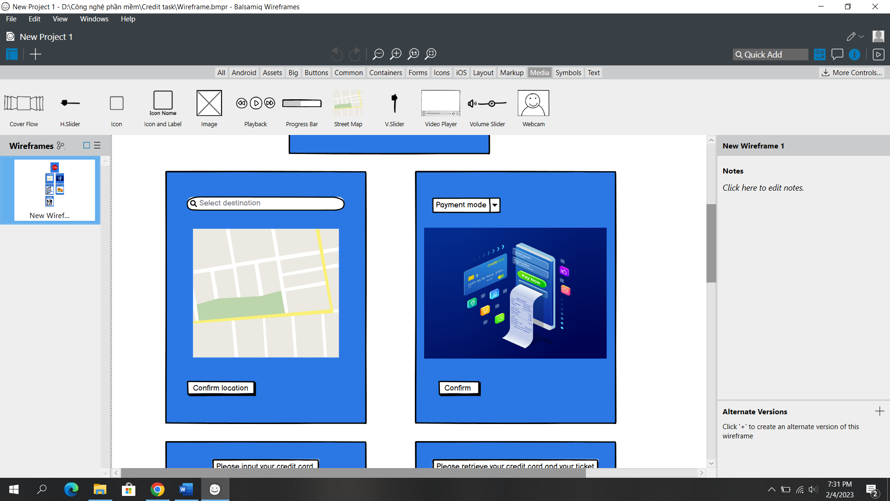

Select payment mode and confirm

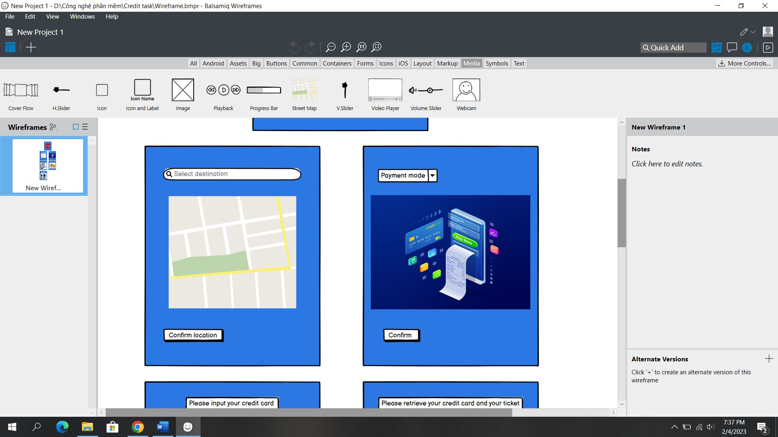

In case of using credit card

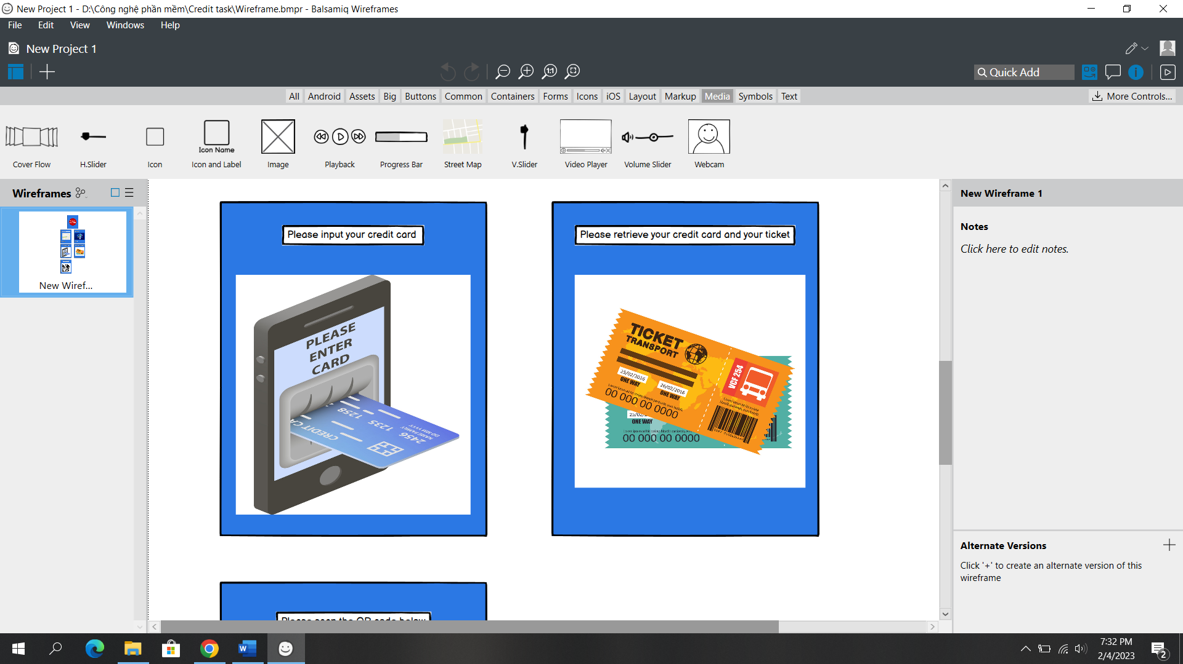

If using digital wallet

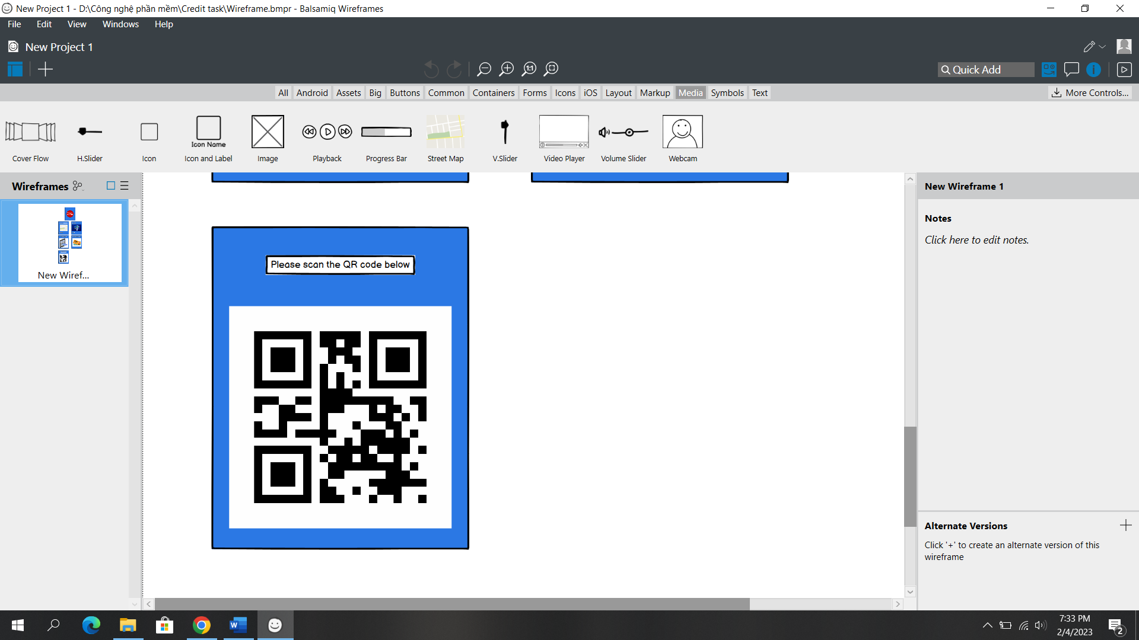

Finnish

