Q) Implement the Iterative Depth First Search algorithm to solve the same problem.

Code:
import time

def dls(edges, start, goal, limit, pass_label=""):
graph = {}
for a, b in edges:
graph.setdefault(a, []).append(b)
graph.setdefault(b, []).append(a)
visited = set()
order = []
stack = [(start, 0)]
cutoff_occurred = False
while stack:
node, depth = stack.pop()
if node in visited:
continue
visited.add(node)
order.append(node)
if node == goal:
return order, True, cutoff_occurred, "REACHABLE"
if depth == limit:
cutoff_occurred = True
continue
for neighbour in reversed(graph.get(node, [])):
if neighbour not in visited:
stack.append((neighbour, depth + 1))
found = goal in visited
if found:
status = "REACHABLE"
elif cutoff_occurred:
status = "LIMIT REACHED"
else:
status = "UNREACHABLE"
return order, found, cutoff_occurred, status

def iddfs(edges, start, goal, max_limit=None):
if max_limit is None:
max_limit = len(edges) + 1
previous_count = -1
for limit in range(max_limit + 1):
order, found, cutoff_occurred, status = dls(edges, start, goal, limit)
count = len(order)
if status == "REACHABLE":
return order, "REACHABLE", count, limit
if count == previous_count:
return order, "UNREACHABLE", count, limit
previous_count = count
return order, "UNREACHABLE", len(order), max_limit

if __name__ == "__main__":
n = int(input("Enter number of edges: "))
edges = []
print("Enter each edge in format: node1 node2")
for i in range(n):
edge = tuple(input(f"Edge {i+1}: ").split())
edges.append(edge)
start, goal = input("Enter start and goal nodes (space separated): ").split()
t0 = time.perf_counter()
order, status, count, depth_found = iddfs(edges, start, goal)
t1 = time.perf_counter()
print("\nTraversal Order:")
print(" ".join(order))
print("Status:")
print(status)
print("Stations Inspected:")
print(count)
if status == "REACHABLE":
print(f"Goal found at depth {depth_found}")
print(f"Time: {(t1 - t0) * 1000:.4f} ms")

Output:
1) Directly reachable
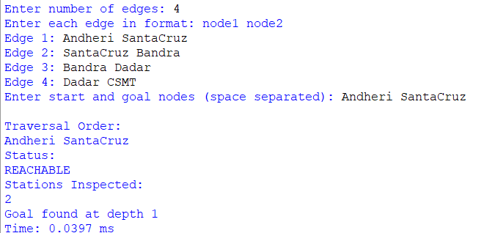
2) Reachable through multiple stations
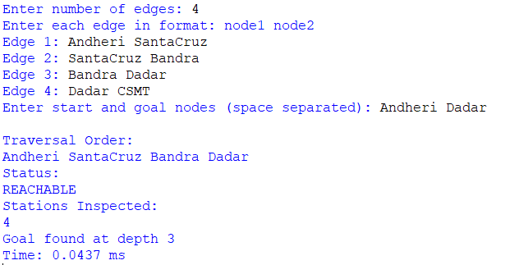

3) Source = Destination
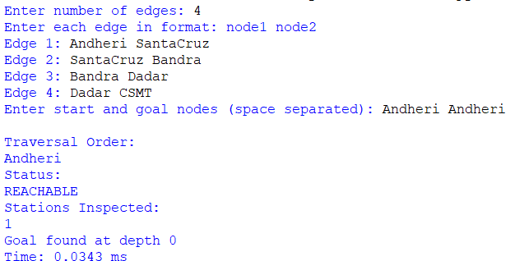

4) Destination Unreachable
