Q) Implement the Decision Tree Learning algorithm to build a decision tree for a given dataset.

Code:
import pandas as pd
import matplotlib.pyplot as plt
from sklearn.datasets import fetch_openml
from sklearn.model_selection import train_test_split
from sklearn.tree import DecisionTreeClassifier, plot_tree
from sklearn.preprocessing import LabelEncoder
from sklearn.metrics import accuracy_score, confusion_matrix, classification_report

titanic = fetch_openml(name="titanic", version=1, as_frame=True)
df = titanic.frame

features = ["pclass", "sex", "age", "sibsp", "parch", "fare", "embarked"]
df = df[features + ["survived"]].copy()

df["survived"] = df["survived"].astype(int)
df["age"] = df["age"].fillna(df["age"].median())
df["fare"] = df["fare"].fillna(df["fare"].median())
df["embarked"] = df["embarked"].fillna(df["embarked"].mode()[0])

df["sex"] = LabelEncoder().fit_transform(df["sex"].astype(str))
df["embarked"] = LabelEncoder().fit_transform(df["embarked"].astype(str))

X = df[features]
y = df["survived"]

X_train, X_test, y_train, y_test = train_test_split(
X, y, test_size=0.2, random_state=42
)

model = DecisionTreeClassifier(
criterion="entropy",
max_depth=4,
random_state=42
)

model.fit(X_train, y_train)

y_pred = model.predict(X_test)

print("Accuracy :", accuracy_score(y_test, y_pred))
print("\nConfusion Matrix:\n", confusion_matrix(y_test, y_pred))
print("\nClassification Report:\n", classification_report(y_test, y_pred))

plt.figure(figsize=(18, 8))
plot_tree(
model,
feature_names=features,
class_names=["Died", "Survived"],
filled=True,
rounded=True,
fontsize=8
)
plt.title("Decision Tree - Titanic Survival")
plt.savefig("titanic_tree.png", dpi=150, bbox_inches="tight")
plt.show()

Output:
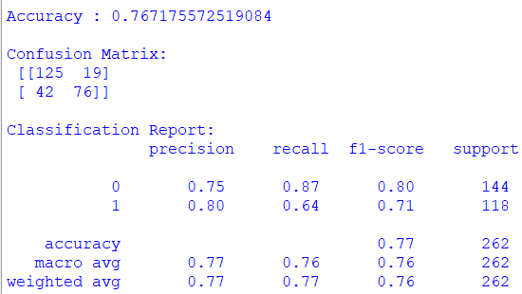
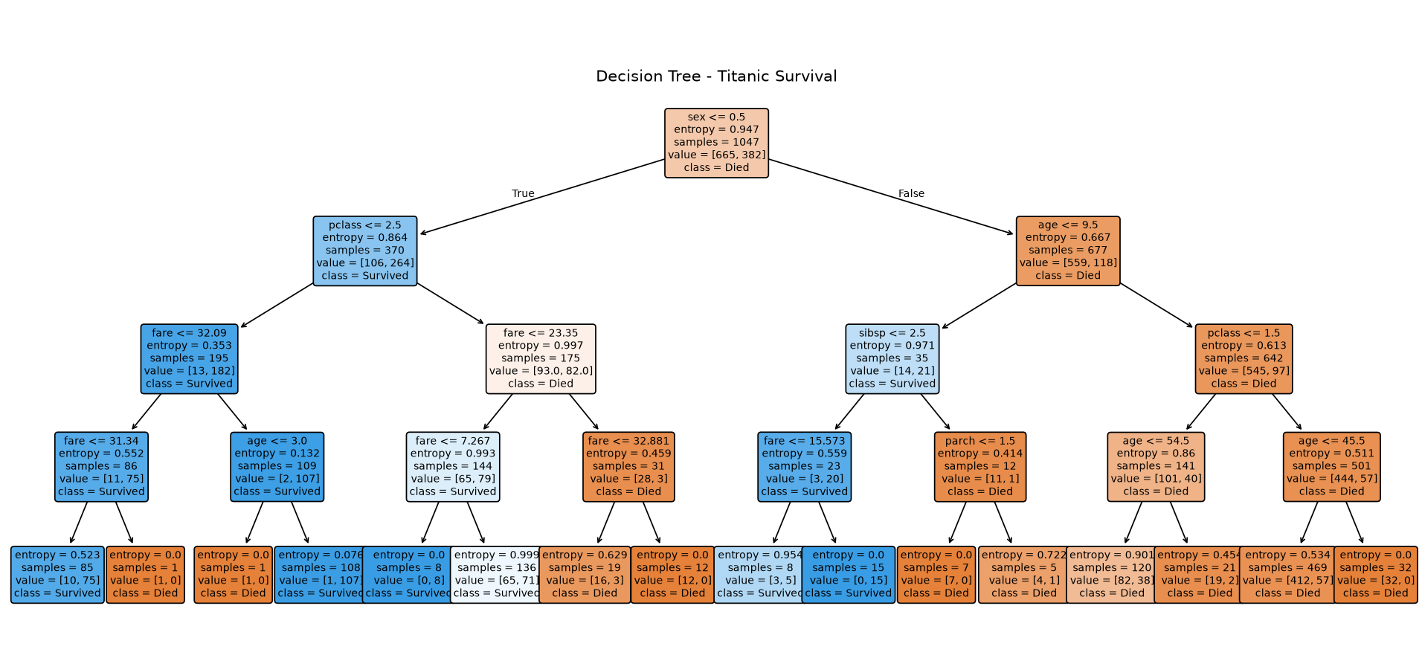
Q) Evaluate the accuracy and effectiveness of the decision tree on test data.

Code 3B:
from sklearn.datasets import load_diabetes
from sklearn.model_selection import train_test_split
from sklearn.tree import DecisionTreeRegressor, plot_tree
from sklearn.metrics import mean_squared_error, r2_score
import matplotlib.pyplot as plt

data = load_diabetes(as_frame=True)
X = data.data
y = data.target
X_train, X_test, y_train, y_test = train_test_split(
X, y, test_size=0.2, random_state=42
)

model = DecisionTreeRegressor(max_depth=4, random_state=42)
model.fit(X_train, y_train)
y_pred = model.predict(X_test)
print("MSE :", mean_squared_error(y_test, y_pred))
print("R2 Score :", r2_score(y_test, y_pred))

plt.figure(figsize=(18, 8))
plot_tree(
model,
feature_names=X.columns,
filled=True,
rounded=True,
fontsize=8
)

plt.title("Decision Tree - Diabetes Progression Regression")
plt.savefig("diabetes_tree.png", dpi=150, bbox_inches="tight")
plt.show()

Output:
