Programs in Nodejs

Q) Print Hello World
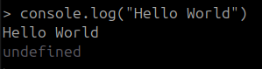

Q) Declare Variables
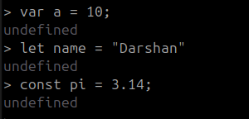

Q) Arithmetic Operations
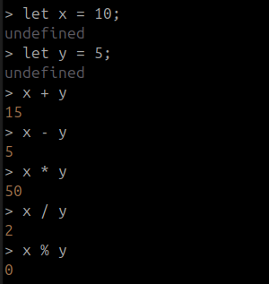

Q) Error Message
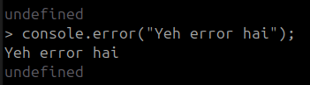

Q) Warn Message
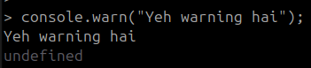

Q) Time Log
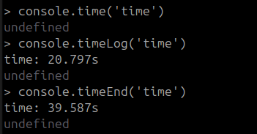

Q) Empty Table
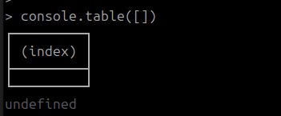

Q) Add values to table
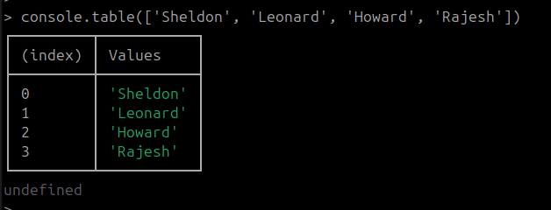

Q) Add values through an object
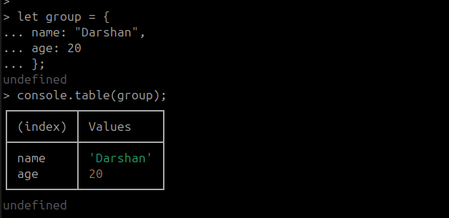

Q) Add multiple values using the same object
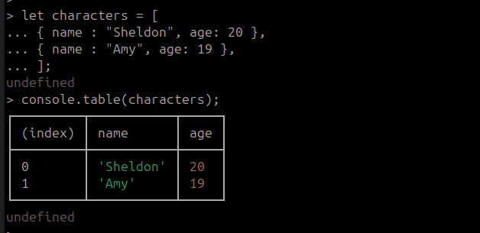
Q) Create a function

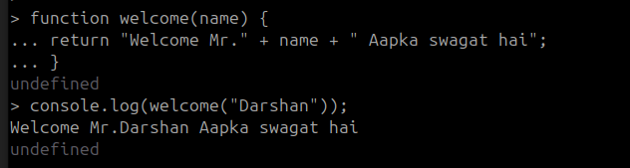

Q) Buffer Allocation and Unsafe
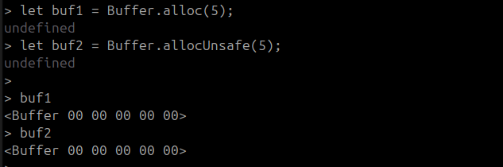
Q) Count Labels
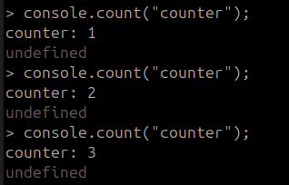

Q) For Loop
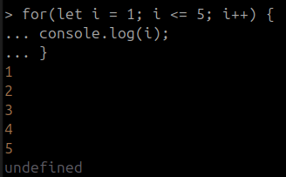

Q) While Loop
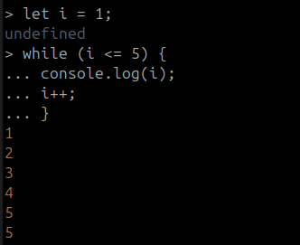

Q) Process funtions
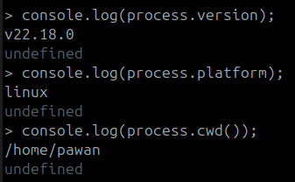

Q) Convert to ASCII Code
