Mining block via Postman.

Program :

import hashlib
import json
from time import time
from flask import Flask, jsonify

class Blockchain:
def __init__(self):
self.chain = []
self.current_transactions = []

self.create_block(proof=100, previous_hash='1')

def create_block(self, proof, previous_hash=None):
block = {
'index': len(self.chain) + 1,
'timestamp': time(),
'transactions': self.current_transactions,
'proof': proof,
'previous_hash': previous_hash or self.hash(self.chain[-1]),
}

self.current_transactions = []
self.chain.append(block)

return block

@property
def last_block(self):
return self.chain[-1]

@staticmethod
def hash(block):
block_string = json.dumps(block, sort_keys=True).encode()
return hashlib.sha256(block_string).hexdigest()

def proof_of_work(self, last_proof):
proof = 0
while self.valid_proof(last_proof, proof) is False:
proof += 1
return proof

@staticmethod
def valid_proof(last_proof, proof):
guess = f'{last_proof}{proof}'.encode()
guess_hash = hashlib.sha256(guess).hexdigest()
return guess_hash[:4] == "0000"

app = Flask(__name__)
blockchain = Blockchain()

@app.route('/mine', methods=['GET'])
def mine():
last_block = blockchain.last_block
last_proof = last_block['proof']
proof = blockchain.proof_of_work(last_proof)

blockchain.current_transactions.append({
'sender': "0",
'recipient': "miner_wallet_address_xyz",
'amount': 1,
})

prev_hash = blockchain.hash(last_block)
block = blockchain.create_block(proof, prev_hash)

response = {
'message': "New Block Mined Successfully",
'index': block['index'],
'transactions': block['transactions'],
'proof': block['proof'],
'previous_hash': block['previous_hash'],
}

return jsonify(response), 200

@app.route('/chain', methods=['GET'])
def full_chain():
response = {
'chain': blockchain.chain,
'length': len(blockchain.chain),
}
return jsonify(response), 200

if __name__ == '__main__':
app.run(host='0.0.0.0', port=5000)

Steps to follow after this :

- Save this file as ‘server.py’
- Open Terminal/Cmd Prompt
- Install Flask – pip install Flask
- Run the Program, here – python server.py

OUTPUT:

Installing Flask :
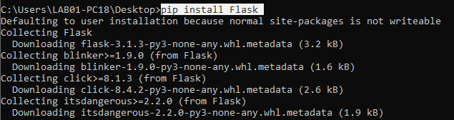

Running the Program:
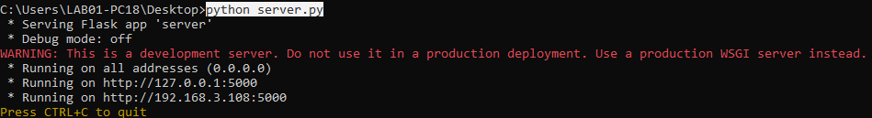

Now after running the program :
Step 1: Open Postman
Step 2: Test the APIs, /mine and /chain

Testing /mine:
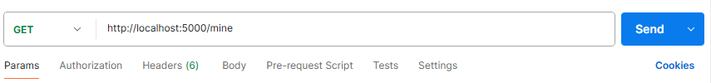

Response:
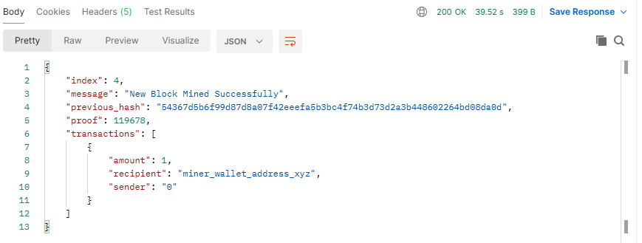

Testing /chain
Response
