Creating a Forensic Image using FTK Imager
Step 1: Installing AccessData FTK Imager
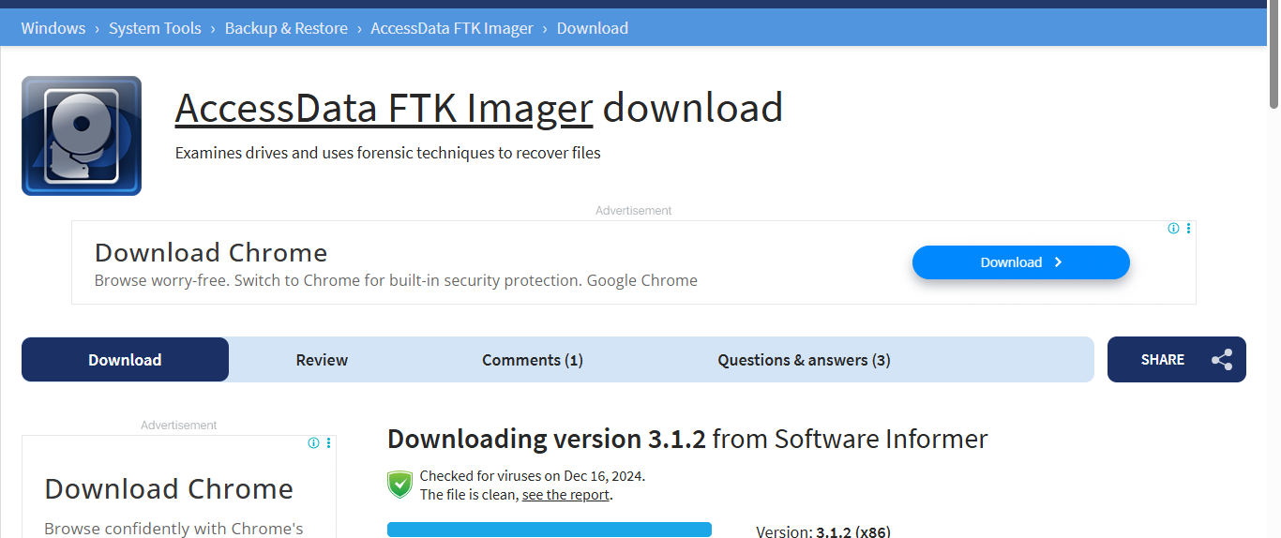

Step 2: Create input & output folder
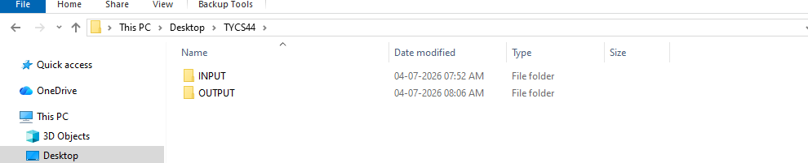

Step 3: Launch FTK imager and select file then create disk image to begin the evidence imaging process
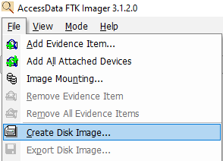

Step 4: Choose content of folder as evidence source type for logical acquisition
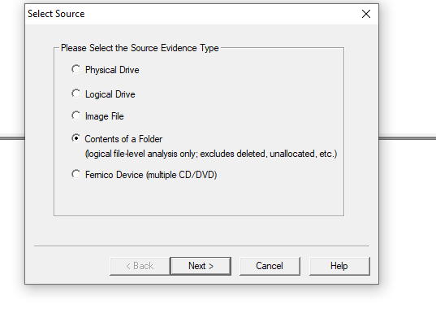

Step 5: Browse and select the input folder containing the file that need to be acquired
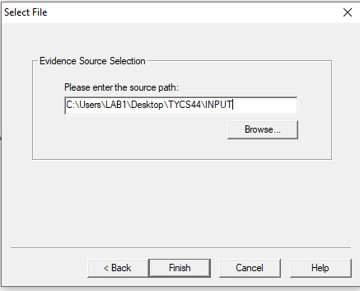

Step 6: Enter the case details

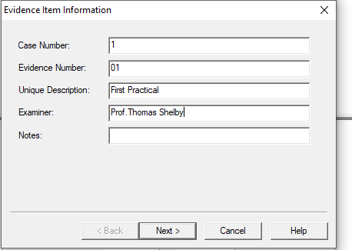

Step 7: Specify the output location, image filename, and acquisition setting before starting the image process
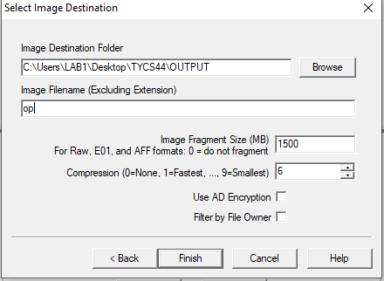

Step 8: FTK image creates forensic image and display acquisition process until completion
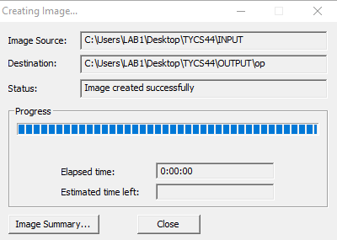

Step 9: Verify the MD5 and SHA! Hash values to ensure forensic image has been created without modification
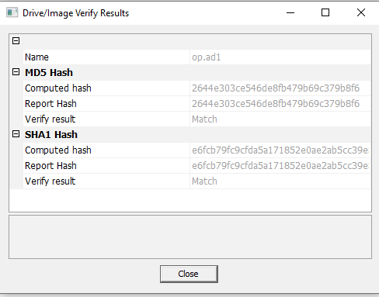

Step 10: Select file then add evidence item load the created forensic image for examination


Step 11: Choose the image file as evidence source to import previously created forensic image
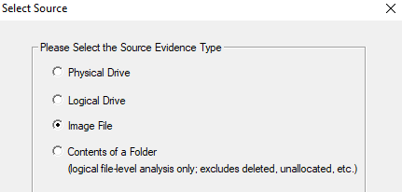

Step 12: Browse and select the generated .ad1 forensic image from output folder
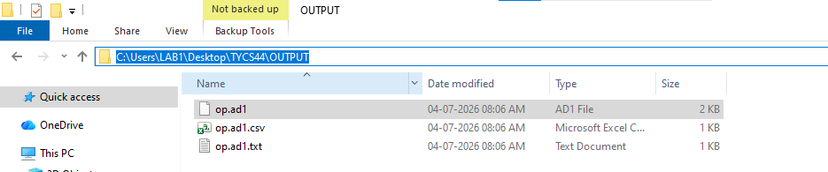

Step 13: Confirm the selected image file path and click finish to load evidence into FTK imager
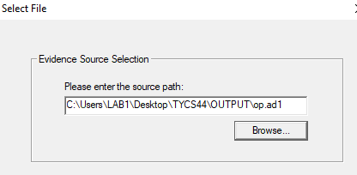

Step 14: Browse the evidence content and examine the recover files stored within forensic image