Aim:- Forensics Case Study: Solve the Case study (image file) provides in lab using Encase Investigator or Autopsy

Things to Note: Make sure you have image created (of Practical 2) from FTK imager before performing this practical

Step 1: Create Input and output Folder


Step 2: Open Autopsy and Create a new case
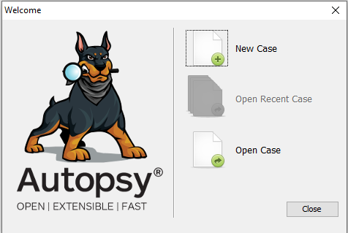

Step 3: Write Case name and select the base directory
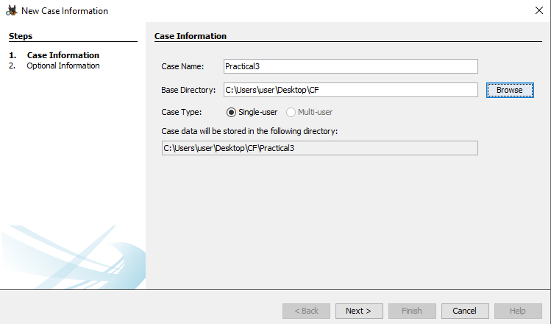

Step 4: Enter Case number and Fill the details
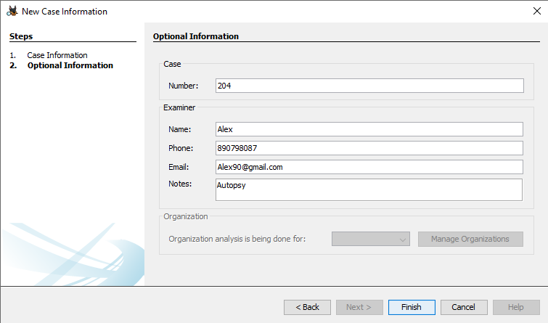

Step 5: Select Disk Image
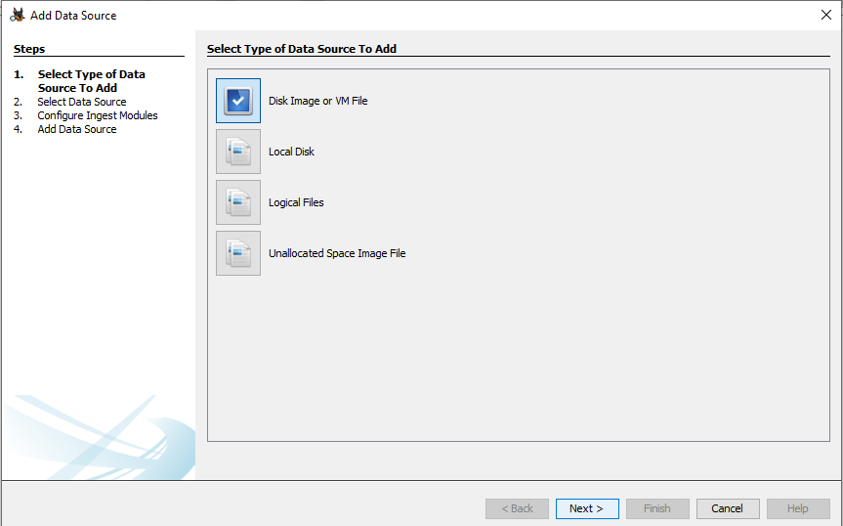

Step 6: Now in Add Data, Browse “Path” and select your Disk Image
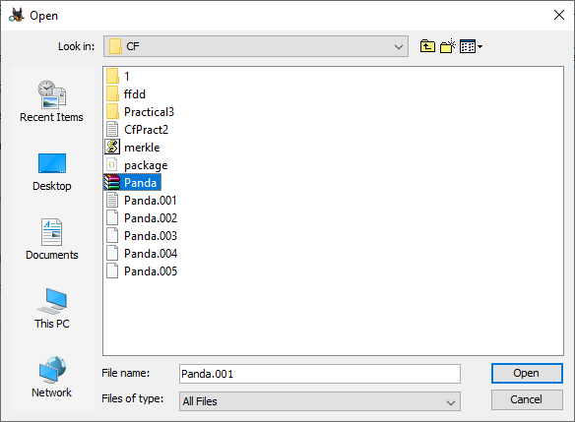

Step 7: After Selecting the path of your disk image, now click next
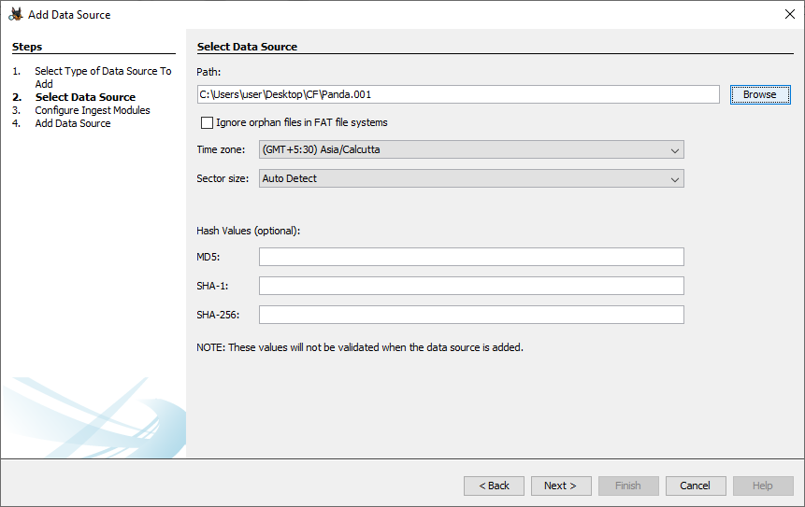

Step 8: In Ingest Modules, make sure all modules are selected, Click Next
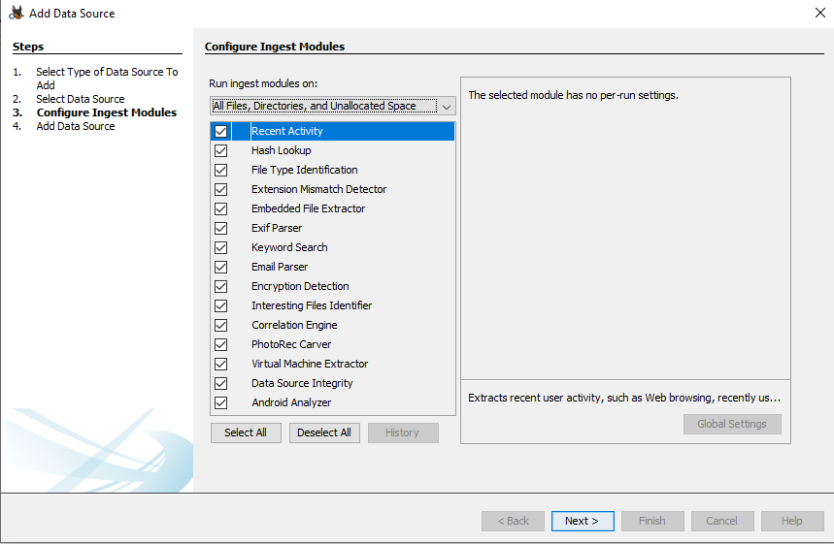

Step 9: This message below shows that your Image data source has been added
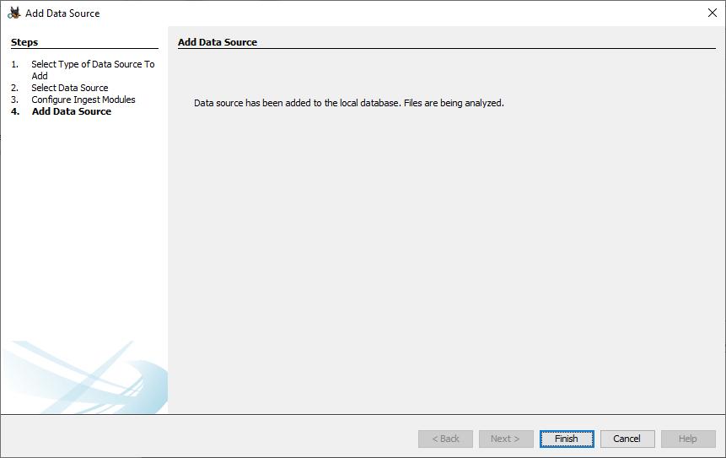

Step 10: Open View Folder and find Deleted files

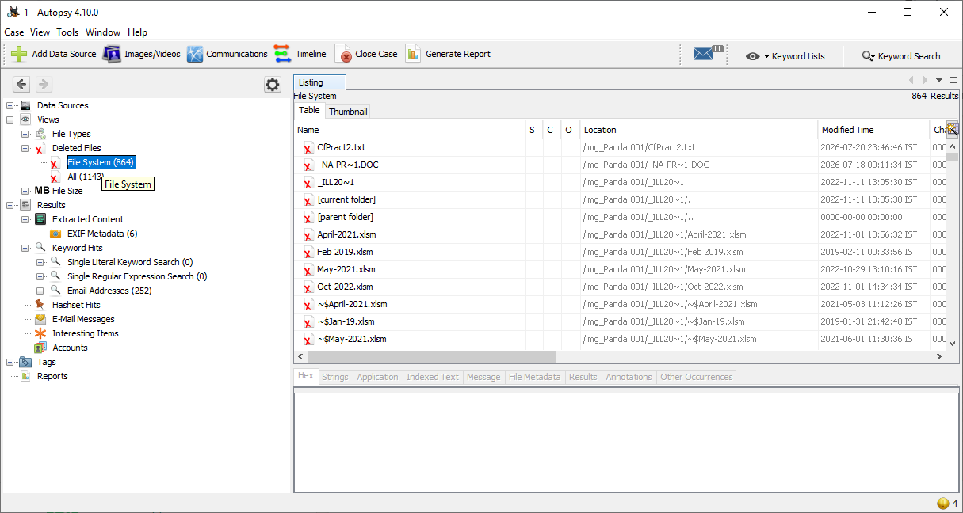

Step 11: Select a File you want to extract and extract it
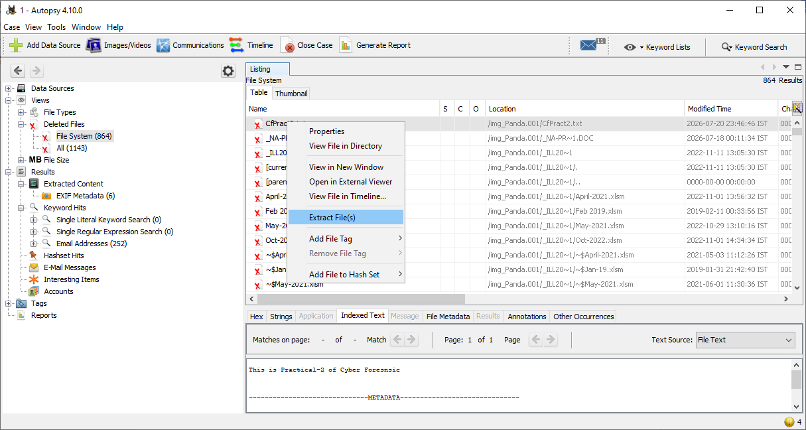

Step 12: Select the folder to save in, The “output” file
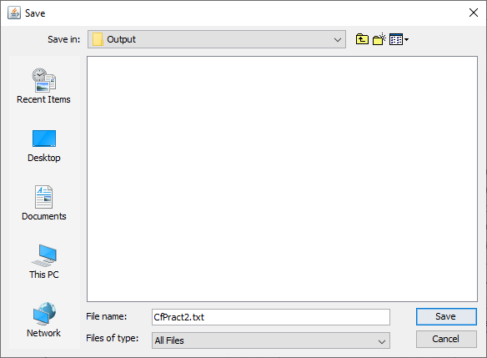

Step 13: After extracting, Check Output folder
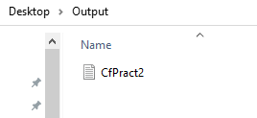

Conclusion:
This practical demonstrated the process of conducting a digital forensic investigation using a disk image created with FTK Imager. After creating a forensic case in Autopsy, the disk image was analyzed, and a deleted file was successfully identified and recovered. The exercise highlighted the importance of forensic imaging, evidence preservation, and file recovery techniques in digital investigations while maintaining the integrity of the original evidence.

