Aim: Capturing and analyzing network packets using Wireshark (Fundamentals):
- Identification the live network
- Capture Packets
- Analyze the captured packets

Step 1: Open Wireshark
Step 2: Click on Ethernet
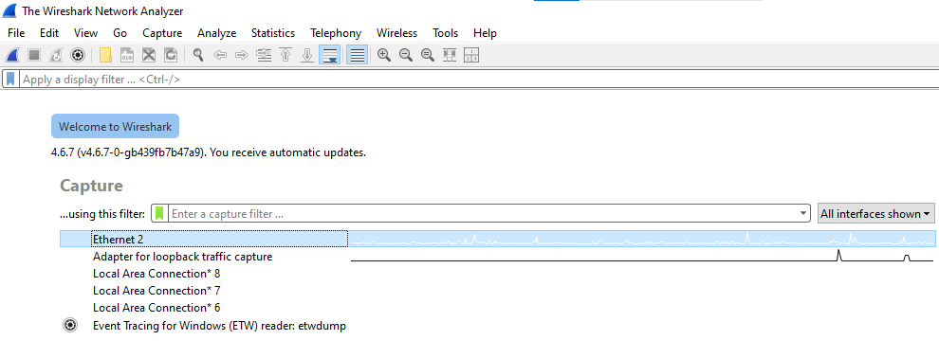

Step 2: This interface will open
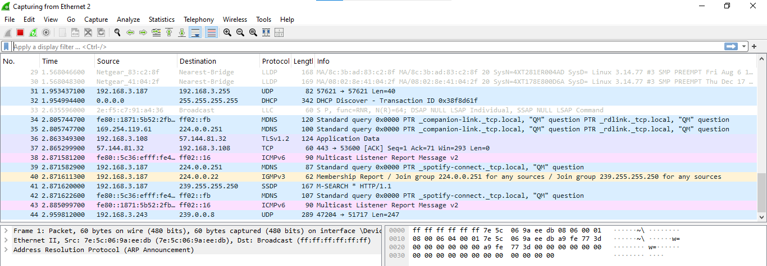

Step 3: Go on Browser, run some Websites on it



Step 4:
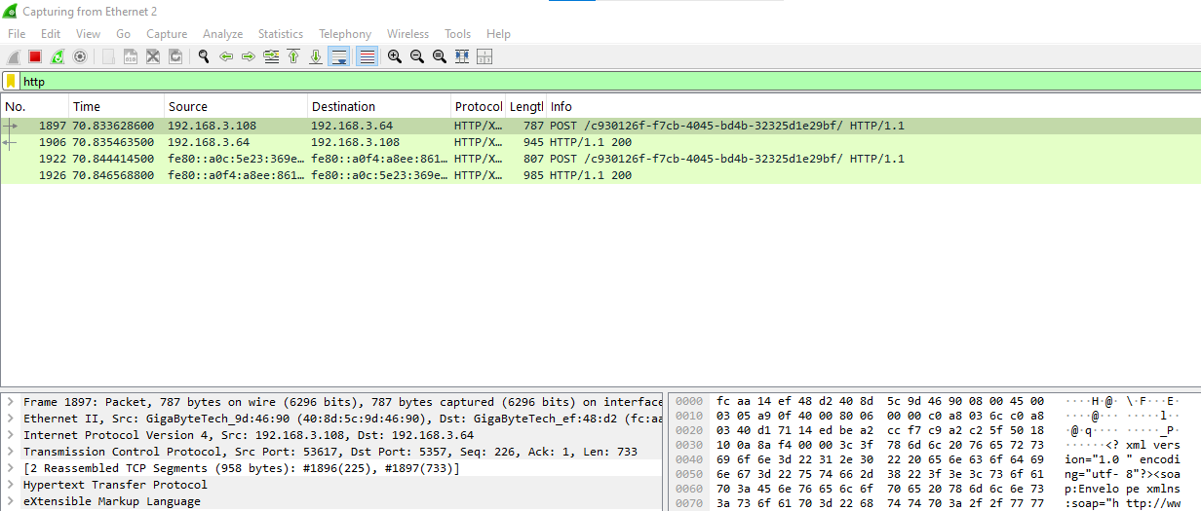

Step 4:Now Stop the Wireshark capture
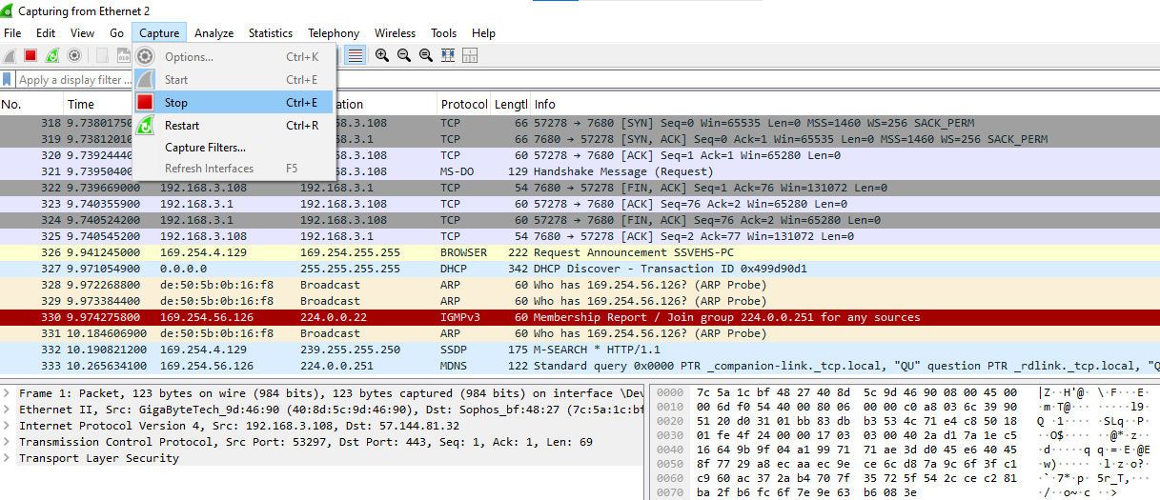

Step 5: Run filter command: udp
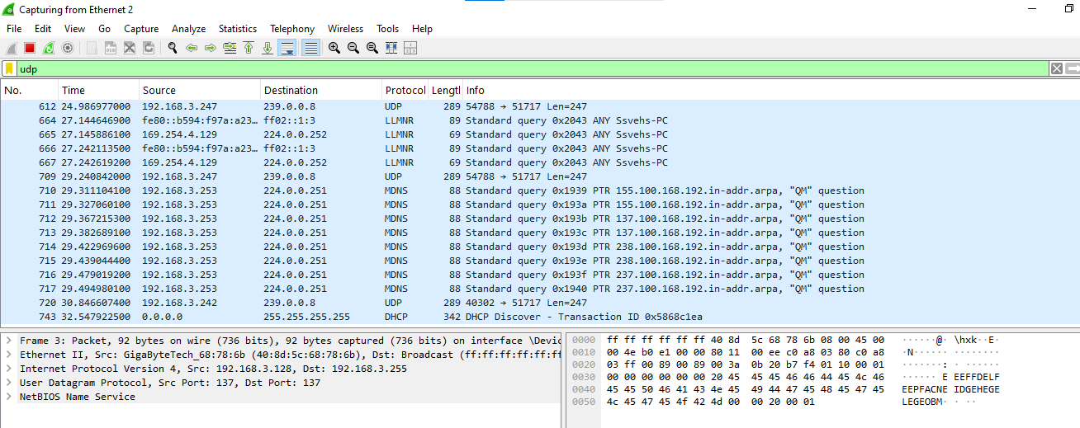

Step 6: Run filter command: tcp
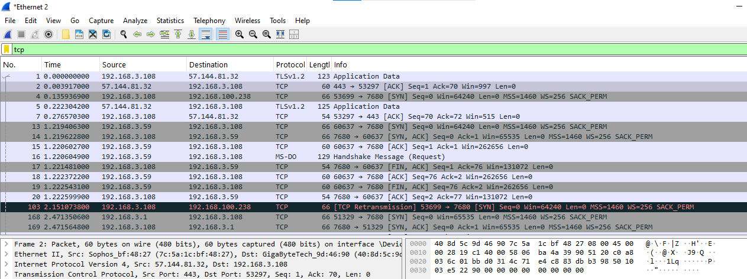

Step 7: Run Filter command: arp
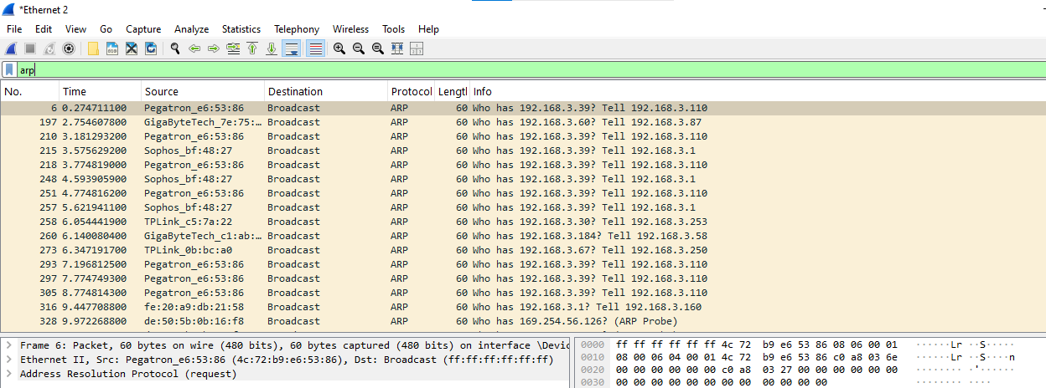

Step 8: Run the following Filter command
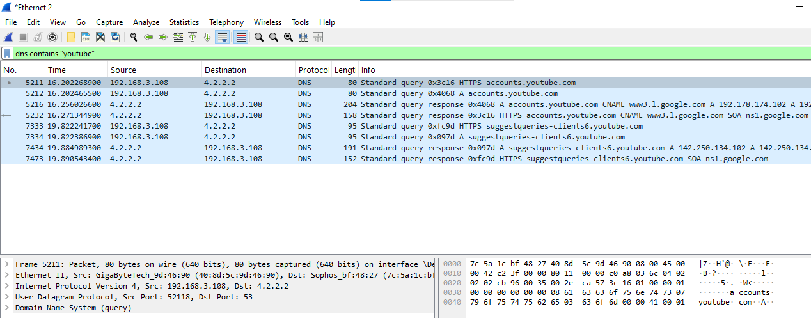

Step 9: Start the capture again and Open an Unsecure Website( for eg: www.zero.webappsecurity.com) and try to login with any random credentials
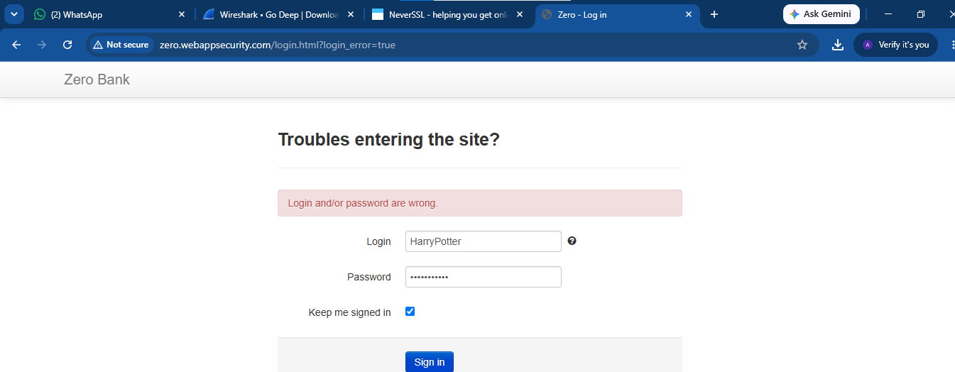
Step 10: Run this filter
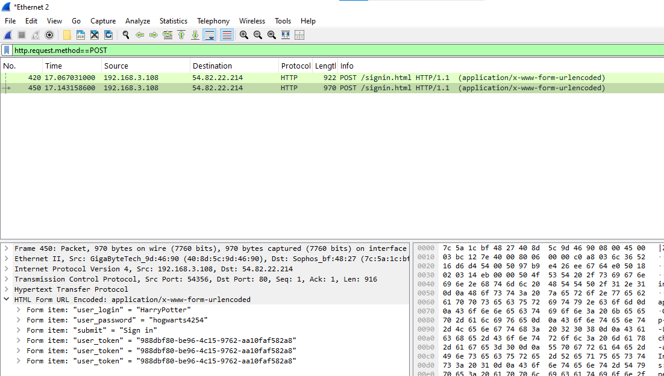

Step 11: Now try with any secure Website
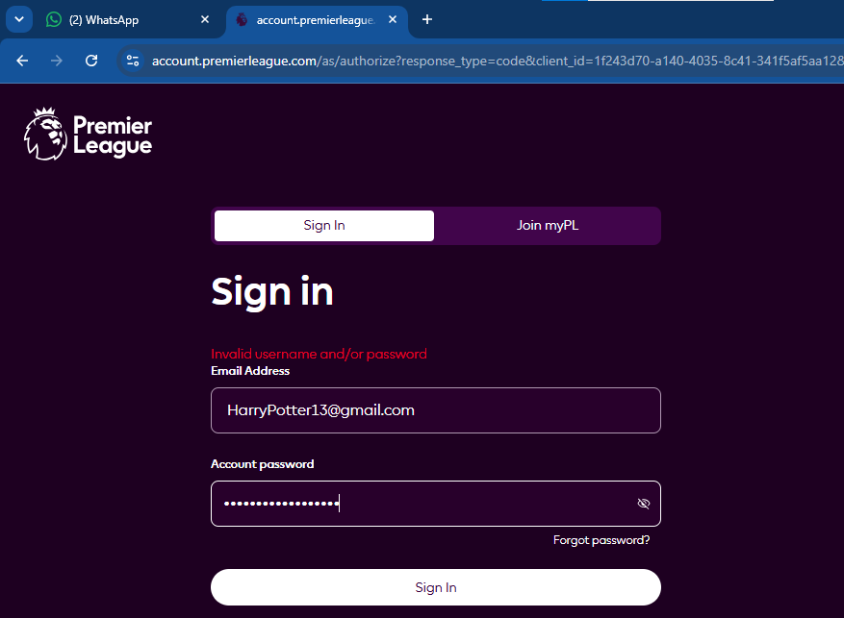

Step 12: Stop the capture again and you can see the credentials are not visible for a secured website
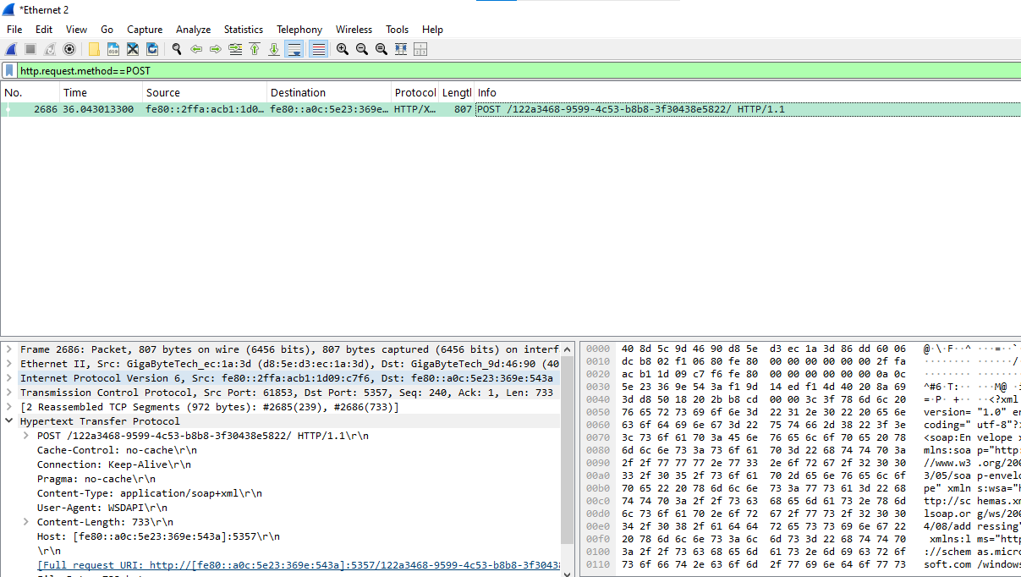

Step 13: Run this Filter command
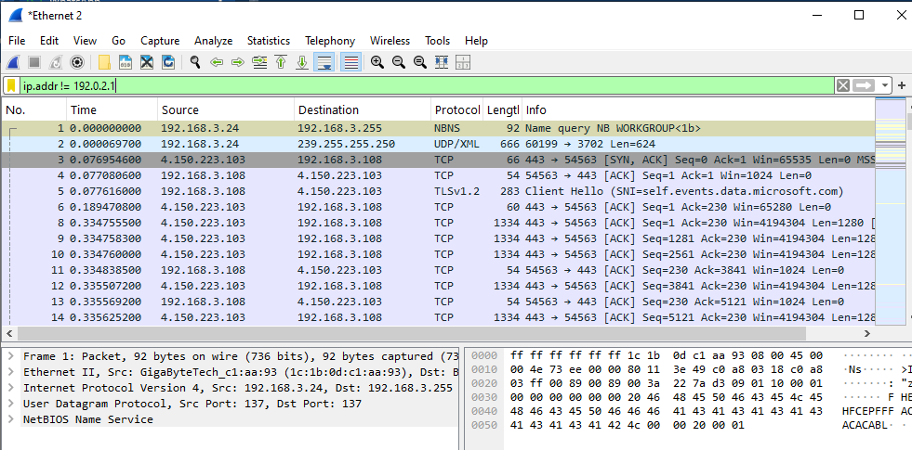

Step 14: Click on Analyze and then Display Filter expressions
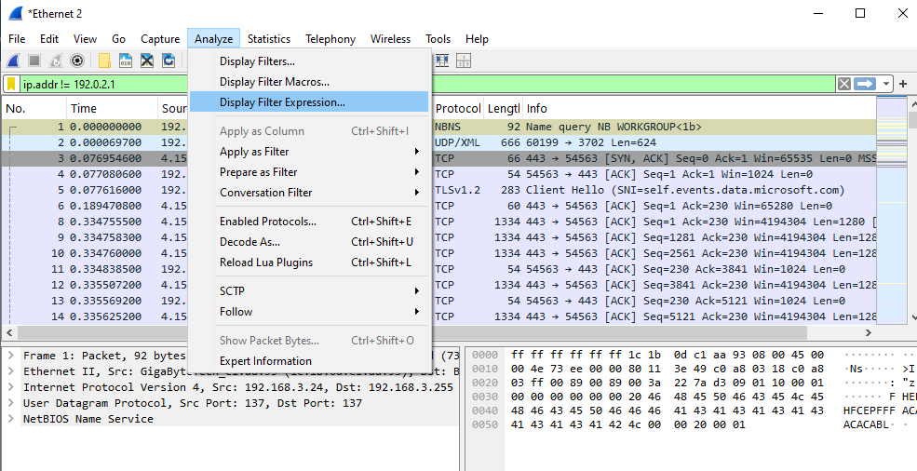

Output:
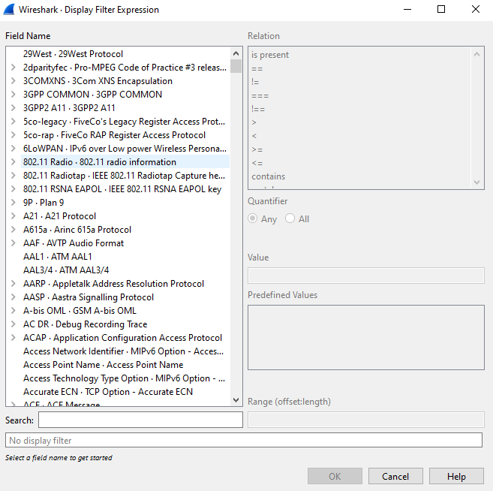

Step 15: Run this filter Command
