Using Sysinternals toolss for Network Tracking and Process Monitoring:
-Check Sysinternals tools
-Monitor Live Processes
-Capture RAM
-Capture TCP/UDP Packets
-Monitor HardDisk
-Monitor Virtual Memory
-Monitor Cache Memory

Solutions:
Step 1. Check for SysInternalsSuite “.zip” file and Extract it

This is the Extracted File:

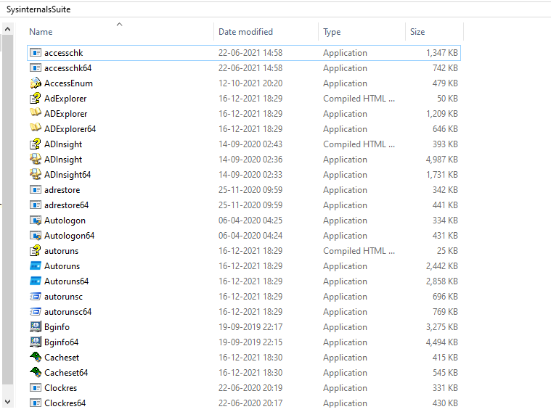

Step 2 : Open Command Prompt and Change directory and run the command – ‘procmon’ to monitor live processes.
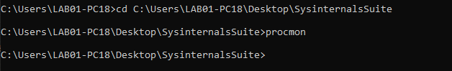

This is the Process Monitor Window
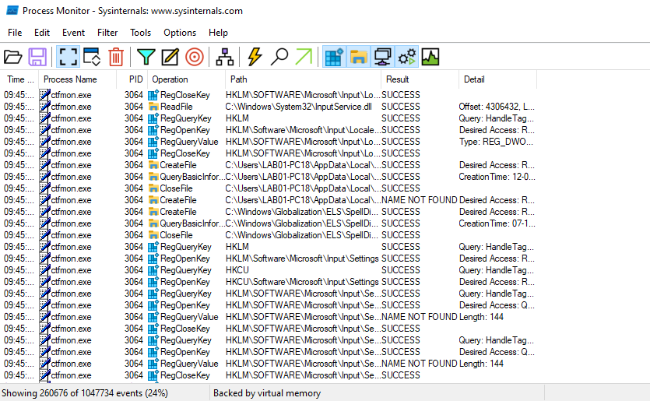

Step 03: Go to the Process Tree
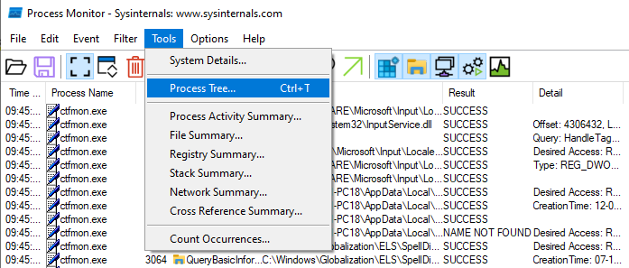

This is the process tree window:
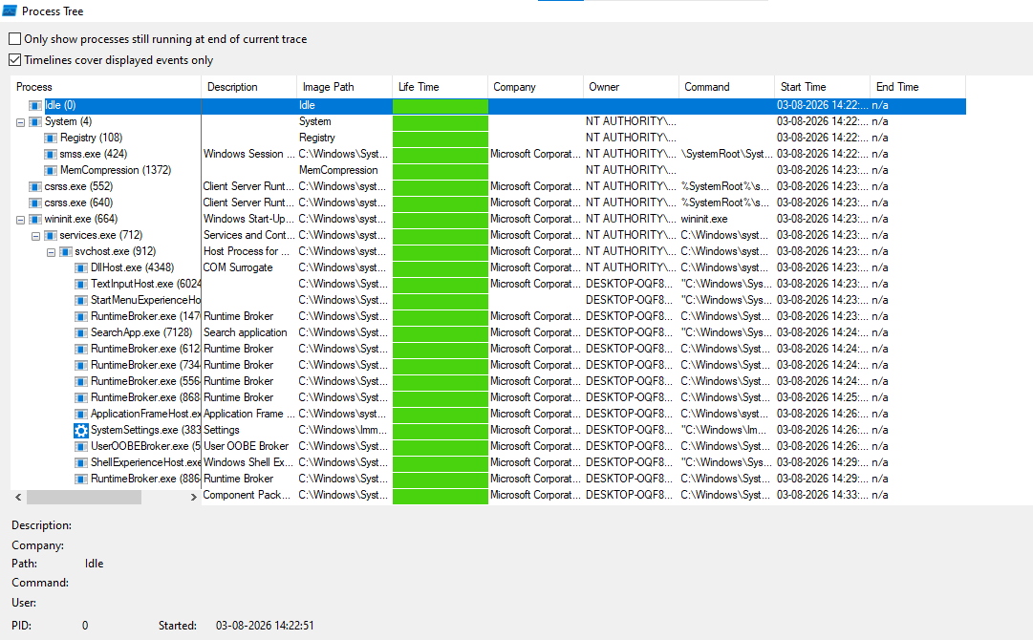

Step 04: Now search for Ram Capturer ‘zip’ file in lab softwares and Go to the RAM Capturer
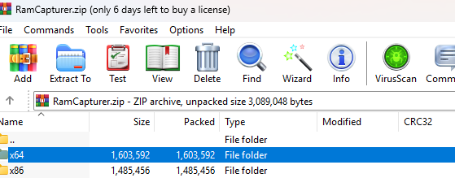

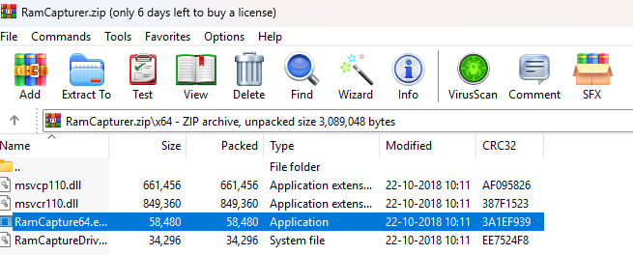

Step 05: Click on Capture to start capturing RAM

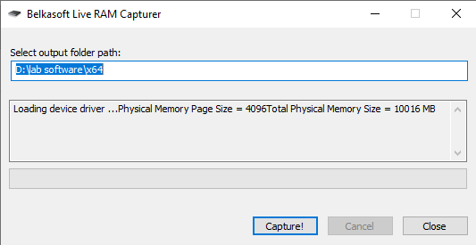

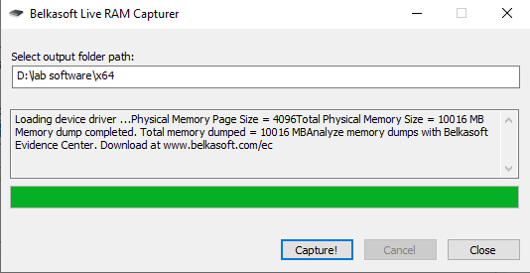

This is the captured file :

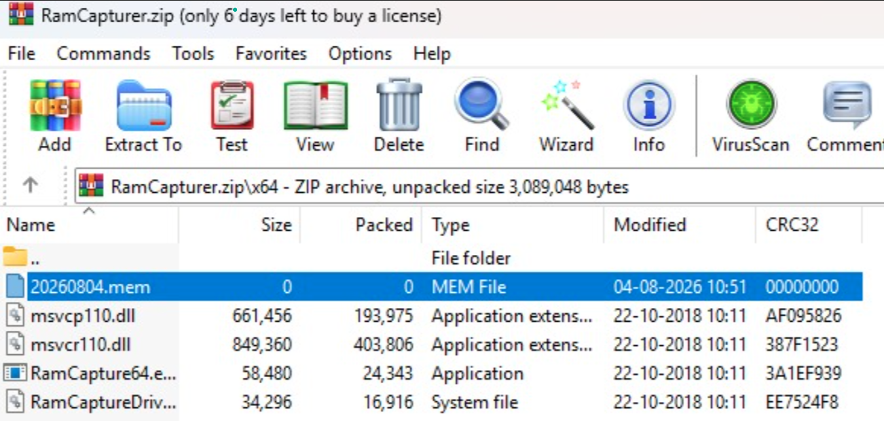

Step: 06 Now go to the Command Prompt and Open it as an Administrator

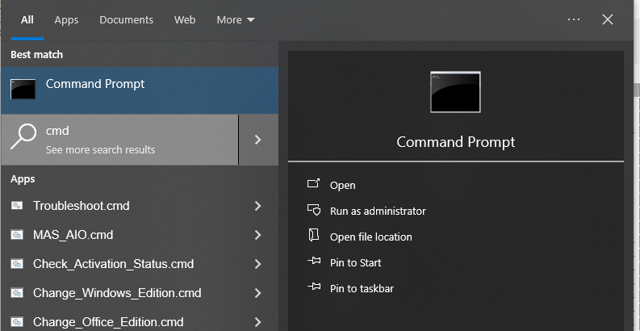

Step 07 : Again change the directory to sysInternalsSuite and run the following command - “tcpview”

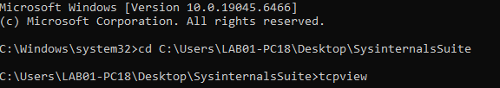

Then it will show all TCP and UDP Processes running live
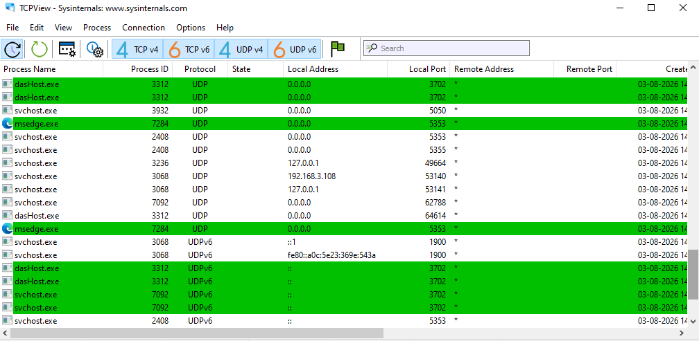

Step 08 : Now run this command – diskmon

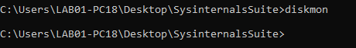

This is DiskMonitor screen:
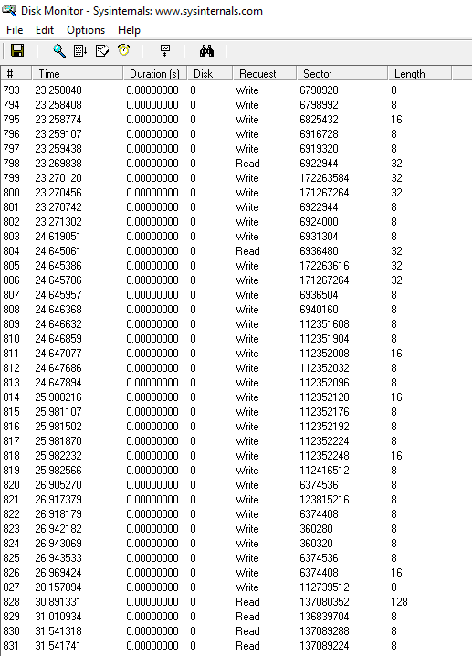

Step 09 : Now coming back and running this command - vmmap

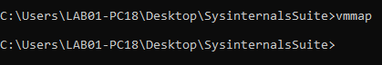

Then it will ask to select or Launch Process – Click OK and continue

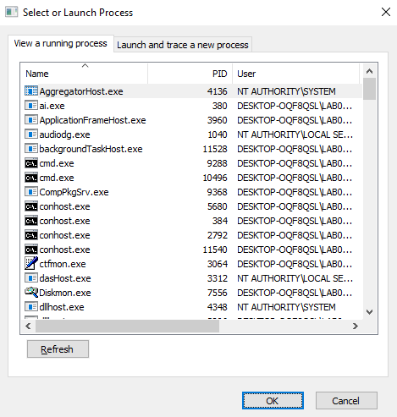

This is the VMMap Screen:

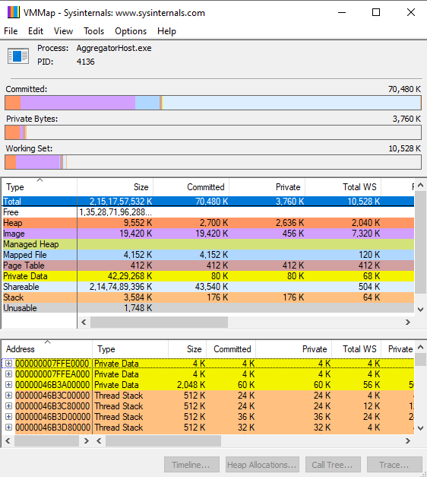

Step 10 : Run this command - ‘rammap’
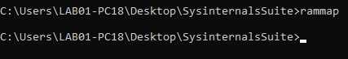

This is the RamMap ‘Use Counts’ Screen:

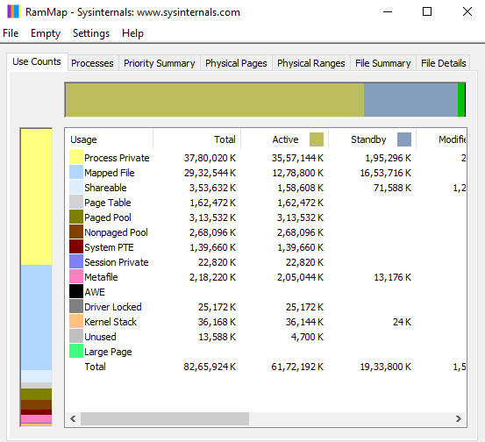

This is RamMap’s Processes Screen:

