Shortest paths, Density and Egocentric networks

Step 1: Import Libraries
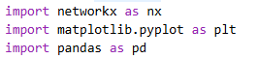

Step 2: Create a Sample network graph and add edges
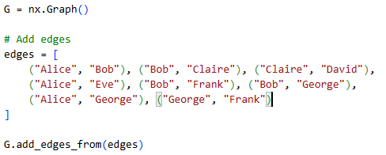

Step 3: Draw the network
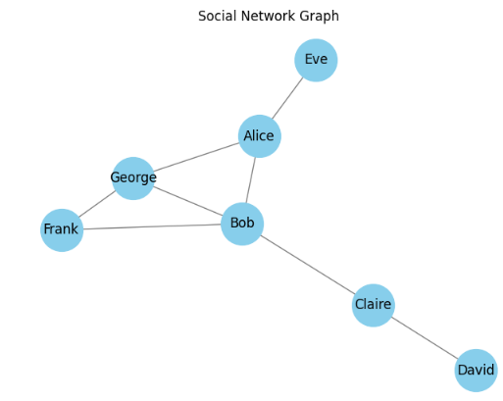
Step 4: Shortest path
Output:
Step 5: Network density
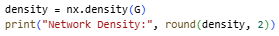
Output:

Step 6: Egocentric Networks
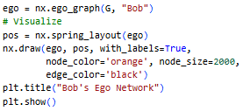
Output:
