Structural equivalence - Automorphic equivalence - Regular equivalence - Brute force and Tabu search
Step 1: Import Libraries
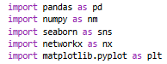

Step 2: Create Edges and Plot the Network Graph
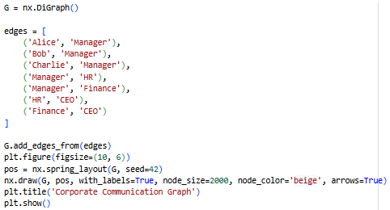
Output:
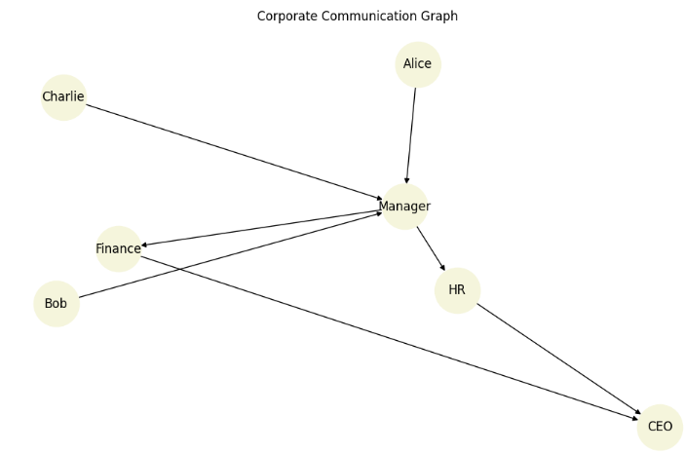
Step 3: Find Structurally equivalent nodes
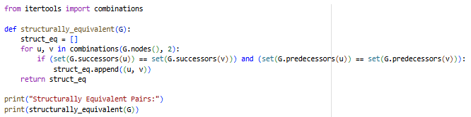
Output:

Step 4: Find Automorphic Equivalent nodes
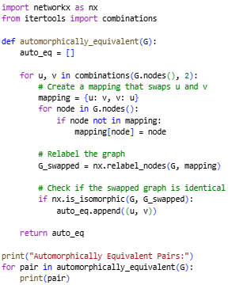
Output:
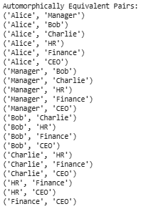
Step 5: Classify a Structural roles of Nodes in a graph
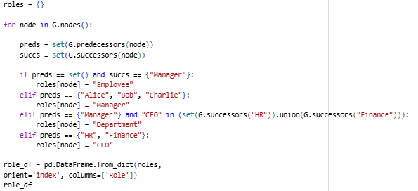
Output:
