Practical-1

Q) Write a Program for tokenization of given input.

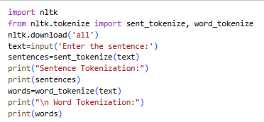
Output:
