Practical-2

Q) Write a Program for generating regular expression for regular grammar.

A) Word Match
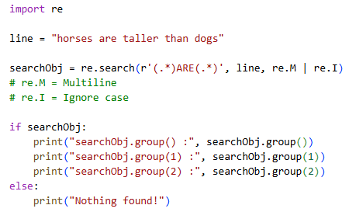
Output:
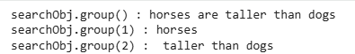

B) [] – Square Brackets
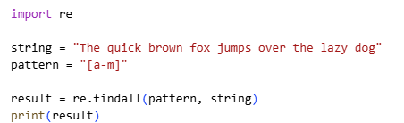
Output:

C) $ - Dollar Sign
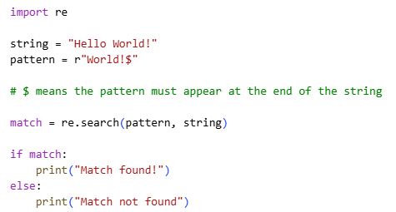
Output:
D) Case-Insensitive
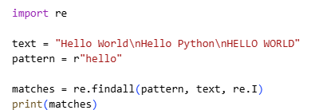
Output:

