Commendatory

# Abstract

This is an application which generates commentary for a football match by randomly selected commentary in a state flow manner. It follows some steps. Each steps will have a number of valid comments with variables in it and is selected any of them randomly from the list when ever that particular step is reached.

# Introduction

This is a java command line application for reproducing football commendatory. The program starts a match between two teams, he we use Real Madrid and FC Barcelona. The flow of execution of the program follows state flow. The state begins with the welcome message. The message is taken from list of messages that is given as an array of strings. There is no limit for the number of messages can be given here. The more messages given, more real it would show. Then the teams are introduced. The introduction comment list is given with variables in it for team and team players. Any of the comments from the list is selected randomly, which makes it unpredictable which comment being taken. Then on next state game begins. After that passing, shooting, throwing ,taking corners and similar states are executed in random with the possible next football action. The time is also delayed with a 100ms to 2000 ms , that is being 2 seconds as maximum comment delay. For convenience we implement game starting only from 7.30 pm to 8.30 pm. The time delay for moving from 7.30 to next time is also updated. The time is incremented by minutes. Goal status is given at the end.

# Background

Other related works similar to this one is chat bots used in several chat applications where the chatting app provides a bot application to act like a person. It keeps list of comments and with the last comment send by user, from the list of suitable comment is selected and send. The football commentator does the same.

# Methodology

The method to implement this kind of application is using state flow or state machine. First, had to design the application as per the requirement. Had to learn football rules and comments that are used frequently. The next action after an action need to be selected from a list of actions. Classes for basic modules are made. Classes for basic structures like Player, Teams etc are created. Each team will have 11 players. CommentGenerator class has all the code to find next comment.

# Result

Programs output works fine as expected. Comments are randomly selected. If more text chats were added to the Comment generator, it would look more live and random. The program runs from 7.30 pm to 8.30 pm. But the time different is faster than normal time.

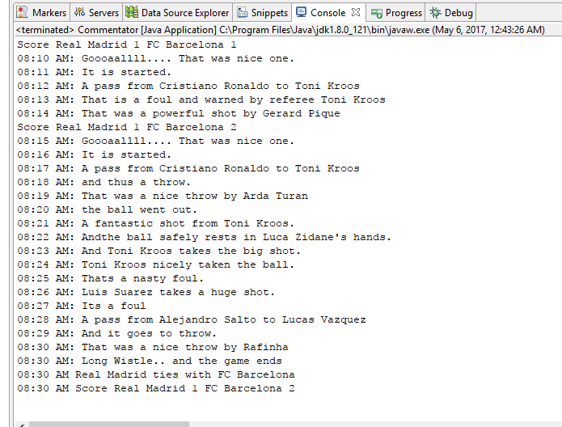

# Evaluation

The program has been tested. Codes are working fine and it generates randomly selected comments. Since the program can be testing just by running, its easy to test.

# Conclusion

The program is just a basic module about auto commentator. The application can be developed further to make it more easy to understand and use. This is almost the same method for developing chat bots. The program can be. This program also deals with time management of football. The programs runs from 7.30 to 8.30/