- INTRODUCTION

OVERVIEW

Reduced Instruction Set Computer (RISC) represents a CPU design strategy emphasizing the insight that simplified instructions that "do less" may still provide for higher performance if this simplicity can be utilized to make instructions execute very quickly. Many proposals for a "precise" definition have been attempted, and the term is being slowly replaced by the more descriptive load-store architecture.

RISC can be described with the philosophy with three basic levels. It has a limited and simple instruction set and all the instructions will be executed in a single machine cycle. Memory will only be accessed by load and store instructions. For the rest of all instructions it does not utilize memory. All execution units will be hardwired with no micro coding. This gives an emphasis on optimizing the instruction pipeline.

- MICROPROCESSOR OVERVIEW

A microprocessor incorporates most or all of the functions of a central processing unit (CPU) on a single integrated circuit (IC). The microprocessor contains all, or most of, the central processing unit (CPU) functions and is the "engine" that goes into motion when you turn your computer on. A microprocessor is designed to perform arithmetic and logic operations that make use of small number-holding areas called registers. Typical microprocessor operations include adding, subtracting, comparing two numbers, and fetching numbers from one area to another. These operations are the result of a set of instructions that are parts of the microprocessor design. For example, when your computer is turned on, the microprocessor gets the first instruction from the basic input/output system (BIOS) that comes with the computer as part of its memory. After that, either the BIOS, or the operating system that BIOS loads into computer memory, or an application program is "driving" the microprocessor, giving it instructions to perform.

Some of the common components of a microprocessor are:
- Control Unit
- I/O Units
- Arithmetic Logic Unit (ALU)
- Registers
- Cache

Brief introduction to these components are given below.

2.1 CONTROL UNIT
The control unit, as described above, reads the instructions, and generates the necessary digital signals to operate the other components. An instruction to add two numbers together would cause the Control Unit to activate the addition module, for instance.

2.2 I/O UNITS
A processor needs to be able to communicate with the rest of the computer system. This communication occurs through the I/O ports. The I/O ports will interface with the system memory (RAM), and also the other peripherals of a computer.

2.3 ARITHMETIC LOGIC UNIT
The Arithmetic Logic Unit or ALU is the part of the microprocessor that performs arithmetic operations. ALUs can typically add, subtract, divide, multiply, and perform logical operations of two numbers (and, or, nor, not, etc).

2.4 REGISTERS
Register is anything that can be used to store bits of information, in a way that all the bits of the register can be written to or read out simultaneously. The registers are the fastest accessible memory locations, and because they are so fast, there are typically very few of them. The size of the registers defines the size of the computer. For instance, a "32 bit computer" has registers that are 32 bits long. The length of a register is known as the word length of the computer.

2.5 CACHE
Cache is memory that is located on the chip, but that is not considered registers. The cache is used because reading external memory is very slow (compared to the speed of the processor), and reading a local cache is much faster. In modern processors, the cache can take up as much as 50% or more of the total area of the chip. The following table shows the relationship between different types of memory:
smallest |  | largest
Registers | cache | RAM
fastest |  | slowest
Table 2.1 Comparison B/W memories
Cache typically comes in 2 or 3 "levels", depending on the chip. Level 1 (L1) cache is smaller and faster than Level 2 (L2) cache, which is larger and slower. Some chips have

Level 3 (L3) cache as well, which is larger still than the L2 cache (although L3 cache is still much faster than external RAM).
2.6 INSTRUCTION SET
One of the crucial features of any processor is its instruction set, i.e. the set of machine code instructions that the processor can carry out. Each processor has its own unique instruction set specifically designed to make best use of the capabilities of that processor.
- CLASSIFICATION OF INSTRUCTIONS
The actual instructions provided by any processor can be broadly classified into the following groups:
• Data movement instructions: These allow the processor move data between registers and between memory and registers (e.g. 8086 move, push, pop instructions). A ‘move’ instruction and its variants are among the most frequently used instructions in an instruction set.
• Transfer of control instructions: These are concerned with branching for loops and conditional control structures as well as for handling subprograms (e.g. 8086 je, jg, jmp, call, ret instructions). These are also commonly used instructions.
• Arithmetic/logical instructions: These carry out the usual arithmetic and logical operations (e.g. 8086 cmp, add, sub, inc, and, or, xor instructions). Surprisingly, these are not frequently used instructions, and when used, it is often in conjunction with a conditional jump instruction rather than for general arithmetic purposes. Note that we have included the cmp instruction with the arithmetic/logical instructions because it actually behaves like a sub instruction except it does not modify its destination register.
• Input/output instructions: These are used for carrying out I/O (e.g. 8086 in, out instructions) but a very common form of I/O called memory mapped I/O uses ‘move’ instructions for I/O.

• Miscellaneous instructions: (e.g. 8086 int, sti, cti, hlt, nop) for handling interrupts and such activities. The hlt instruction halts the processor and the nop instruction does nothing at all! These instructions are again not that frequently used relative to data movement and transfer of control instructions. The int instruction could also be classified as a transfer of control instruction and interrupts are described in more detail below.
This is not the only way to classify instructions. For example, the arithmetic/logical instructions mentioned above may be classified as operate instructions. Operate instructions also include instructions that move data between registers and manipulate stacks. Memory-access instructions refer to those that transfer data between registers and memory.
- MICROPROCESSOR CLASSIFICATIONS

4.1 CISC AND RISC CHARACTERISTICS
4.1.1 CISC (COMPLEX INSTRUCTION SET COMPUTER)

CISC (Complex Instruction Set Computer) is the traditional architecture of a computer, in which the CPU uses microcode to execute very comprehensive instruction set. These may be variable in length and use all addressing modes, requiring complex circuitry to decode them. Typically CISC chips have a large amount of different and complex instructions. The philosophy behind it is that hardware is always faster than software; therefore one should make a powerful instruction set, which provides programmers with assembly instructions to do a lot with short programs. In common CISC chips are relatively slow (compared to RISC chips) per instruction, but use little (less than RISC) instructions. Each instruction executes multiple low level operations e.g. a single instruction can load from memory, perform an arithmetic operation, and store the result in memory. It utilizes smaller program size and uses less memory calls.
In the early days of the computer industry, programming was done in assembly language or machine code, which encouraged powerful and easy to use instructions. CPU designers therefore tried to make instructions that would do as much work as possible. With the advent of higher level languages, computer architects also started to create dedicated instructions to directly implement certain central mechanisms of such languages. Another

general goal was to provide every possible addressing mode for every instruction, known as orthogonality, to ease compiler implementation. Arithmetic operations could therefore often have results as well as operands directly in memory (in addition to register or immediate).
The attitude at the time was that hardware design was more mature than compiler design so this was in itself also a reason to implement parts of the functionality in hardware and/or microcode rather than in a memory constrained compiler (or its generated code) alone. This design philosophy became retroactively termed Complex Instruction Set Computer (CISC).
CPUs also had relatively few registers, for several reasons:
- More registers also implies more time-consuming saving and restoring of register contents on the machine stack.
- A large number of registers requires a large number of instruction bits as register specifiers, meaning less dense code.
- CPU registers are more expensive than external memory locations; large register sets were cumbersome with limited circuit boards or chip integration.
An important force encouraging complexity was very limited main memories (on the order of kilobytes). It was therefore advantageous for the density of information held in computer programs to be high, leading to features such as highly encoded, variable length instructions, doing data loading as well as calculation (as mentioned above). These issues were of higher priority than the ease of decoding such instructions.
An equally important reason was that main memories were quite slow (a common type was ferrite core memory); by using dense information packing, one could reduce the frequency with which the CPU had to access this slow resource. Modern computers face similar limiting factors: main memories are slow compared to the CPU and the fast cache memories employed to overcome this are instead limited in size.
4.1.2 CISC PROBLEMS

Performance tuning unsuccessful

- Rarely used high-level instructions
- Sometimes slower than equivalent sequence
High complexity
- Pipelining bottlenecks → lower clock rates
- Interrupt handling can complicate even more
Marketing
- Prolonged design time and frequent microcode errors hurt competitiveness

In the case of CISC compilers became more prevalent. The majority of CISC instructions were rarely used. Some complex instructions were slower than a group of simple instructions performing an equivalent task. Smaller instructions allowed for constants to be stored in the unused bits of the instruction. This would mean less memory calls to registers or memory.

4.2 RISC (REDUCED INSTRUCTION SET COMPUTER)

The acronym RISC (pronounced as risk), for reduced instruction set computer, represents a CPU design strategy emphasizing the insight that simplified instructions that "do less" may still provide for higher performance if this simplicity can be utilized to make instructions execute very quickly. Many proposals for a "precise" definition have been attempted, and the term is being slowly replaced by the more descriptive load-store architecture.

RISC CPUs keep instruction size constant, ban the indirect addressing mode and retain only those instructions that can be overlapped and made to execute in one machine cycle or less. One advantage of RISC CPUs is that they can execute their instructions very fast because the instructions are so simple. Another, perhaps more important advantage, is that RISC chips require fewer transistors, which makes them cheaper to design and produce.
A common misunderstanding of the phrase "reduced instruction set computer" is the mistaken idea that instructions are simply eliminated, resulting in a smaller set of instructions. In fact, over the years, RISC instruction sets have grown in size, and today many of them have a larger set of instructions than many CISC CPUs. The term "reduced" in

that phrase was intended to describe the fact that the amount of work any single instruction accomplishes is reduced – at most a single data memory cycle – compared to the "complex instructions" of CISC CPUs, that may require dozens of data memory cycles in order to execute a single instruction. In particular, RISC processors typically have separate instructions for I/O and data processing; as a consequence, industry observers have started using the terms "register-register" or "load-store" to describe RISC processors.
Some CPUs have been specifically designed to have a very small set of instructions – but these designs are very different from classic RISC designs, so they have been given other names such as minimal instruction set computer (MISC), Zero Instruction Set Computer (ZISC), one instruction set computer (OISC), transport triggered architecture (TTA), etc. RISC designs are also more likely to feature a Harvard memory model, where the instruction stream and the data stream are conceptually separated; this means that modifying the memory where code is held might not have any effect on the instructions executed by the processor (because the CPU has a separate instruction and data cache), at least until a special synchronization instruction is issued. On the upside, this allows both caches to be accessed simultaneously, which can often improve performance.
Many early RISC designs also shared the characteristic of having a branch delay slot. A branch delay slot is an instruction space immediately following a jump or branch. The instruction in this space is executed; whether or not the branch is taken (in other words the effect of the branch is delayed). This instruction keeps the ALU of the CPU busy for the extra time normally needed to perform a branch. Nowadays the branch delay slot is considered an unfortunate side effect of a particular strategy for implementing some RISC designs, and modern RISC designs generally do away with it.

4.3 COMPARISON OF CISC AND RISC

CISC | RISC
- Complexity found in  hardware  - Memory-to-memory : load  and store functionality found  in a single instruction.  - Less lines of code needed to  provide same functionality  - Instructions not always the  same size.  - Instructions are difficult to  decode because instructions  are not uniform. To make use of pipelining, instructions need to be broken down to smaller components at processor level. | - Complexity on software side  Register-to-Register: Load  and Store are separate  instructions.  - More instructions necessary  to provide same functionality.  - All instructions of a uniform  size.  - Instructions are easier to  decode because of how they  are set up-ex: opcode will  always be in the same place.  - Capable of using pipelining  by design.

Table 2.2 CISC and RISC Comparison

- PROPOSED MODEL
5.1 RISC PROCESSOR:
Considering microprocessor architectures, the RISC processors have a definite set of instruction format. As per our earlier discussions, “Reduced Instruction Set Computer" doesn’t mean that the instruction sets are simply reduced. Instead it utilizes smaller set of instructions. In fact, over the years, RISC instruction sets have grown in size, and today many of them have a larger set of instructions than many CISC CPUs. For any given level of general performance, a RISC chip will typically have far fewer transistors dedicated to the core logic which originally allowed designers to increase the size of the register set and increase internal parallelism.
Normally the RISC architecture comprising of the following things
- Uniform instruction format, using a single word with the opcode in the same bit positions in every instruction, demanding less decoding.
- Identical general purpose registers, allowing any register to be used in any context, simplifying compiler design (although normally there are separate floating point registers).
- Simple addressing modes. Complex addressing performed via sequences of arithmetic and/or load-store operations.
- Few data types in hardware, some CISCs have byte string instructions, or support complex numbers, this is so far unlikely to be found on a RISC.
Exceptions abound, of course, within both CISC and RISC.
RISC designs are also more likely to feature a Harvard memory model, where the instruction stream and the data stream are conceptually separated; this means that modifying the memory where code is held might not have any effect on the instructions executed by the processor (because the CPU has a separate instruction and data cache), at least until a special synchronization instruction is issued. On the upside, this allows both caches to be accessed simultaneously, which can often improve performance.
Many early RISC designs also shared the characteristic of having a branch delay slot. A branch delay slot is an instruction space immediately following a jump or branch. The

instruction in this space is executed; whether or not the branch is taken (in other words the effect of the branch is delayed). This instruction keeps the ALU of the CPU busy for the extra time normally needed to perform a branch. Nowadays the branch delay slot is considered an unfortunate side effect of a particular strategy for implementing some RISC designs, and modern RISC designs generally do away with it.
The features that make the RISC processors unique from the others are given as follows
1) Pipelining
2) Fixed length instructions
3) Load-Store architecture

5.2 RISC PIPELINING
Pipelining is a technique used in advanced microprocessors where the microprocessor begins executing a second instruction before the first has been completed. That is, several instructions are in the pipeline simultaneously, each at a different processing stage.
The pipeline is divided into segments and each segment can execute its operation concurrently with the other segments. When a segment completes an operation, it passes the result to the next segment in the pipeline and fetches the next operation from the preceding segment. The final results of each instruction emerge at the end of the pipeline in rapid succession. Although formerly a feature only of high-performance and RISC -based microprocessors, pipelining is now common in microprocessors used in personal computers. Intel's Pentium chip, for example, uses pipelining to execute as many as six instructions simultaneously. For this design we have implemented the pipeline length of three instructions namely Fetch state, Decode stage and the final Execute state. Pipelining is also called pipeline processing.
An instruction pipeline is a technique used in the design of computers and other digital electronic devices to increase their instruction throughput (the number of instructions that can be executed in a unit of time). The fundamental idea is to split the processing of a computer instruction into a series of independent steps, with storage at the end of each step. This allows the computer's control circuitry to issue instructions at the processing rate of the slowest step, which is much faster than the time needed to perform all steps at once. The term

pipeline refers to the fact that each step is carrying data at once (like water), and each step is connected to the next (like the links of a pipe.)
Most modern CPUs are driven by a clock. The CPU consists internally of logic and memory (flip flops). When the clock signal arrives, the flip flops take their new value and the logic then requires a period of time to decode the new values. Then the next clock pulse arrives and the flip flops again take their new values, and so on. By breaking the logic into smaller pieces and inserting flip flops between the pieces of logic, the delay before the logic gives valid outputs is reduced. In this way the clock period can be reduced. Non-pipeline architecture is inefficient because some CPU components (modules) are idle while another module is active during the instruction cycle. Pipelining does not completely cancel out idle time in a CPU but making those modules work in parallel improves program execution significantly.
Processors with pipelining are organized inside into stages which can semi-independently work on separate jobs. Each stage is organized and linked into a 'chain' so each stage's output is fed to another stage until the job is done. This organization of the processor allows overall processing time to be significantly reduced. A deeper pipeline means that there are more stages in the pipeline, and therefore, fewer logic gates in each pipeline. This generally means that the processor's frequency can be increased as the cycle time is lowered. This happens because there are fewer components in each stage of the pipeline, so the propagation delay is decreased for the overall stage.
Unfortunately, not all instructions are independent. For example, in a simple pipeline, completing an instruction may require 5 stages. To operate at full performance, this pipeline will need to run 4 subsequent independent instructions while the first is completing. If 4 instructions that do not depend on the output of the first instruction are not available, the pipeline control logic must insert a stall or wasted clock cycle into the pipeline until the dependency is resolved. Fortunately, techniques such as forwarding can significantly reduce the cases where stalling is required. While pipelining can in theory increase performance over an unpipelined core by a factor of the number of stages (assuming the clock frequency also scales with the number of stages), in reality, most code does not allow for ideal execution.

The pipelining strategy in our design can be explained as below
The pipeline includes three states like Fetch, Decode and Execute. Each of the instructions is followed by the preceding step of the instruction pipeline.

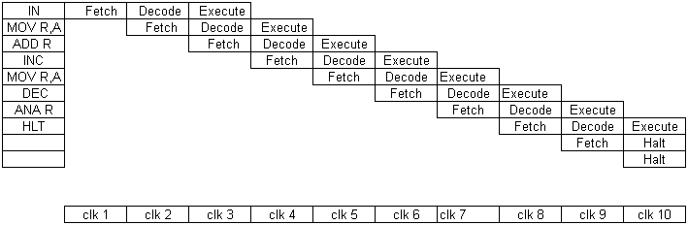
Pipelining
Fig 5.1 Pipelining
Initially the fetch operation is taking place in the instruction pipeline. After the execution of each Fetch stage, there is a Decoding stage followed by an Execution stage. After the Fetching of first instruction on the first clock cycle, the Decoding state of the instruction takes place on the next clock pulse. During this process fetching of the second instruction takes place. In the above given diagram, pipelining operation is explained with a simple program. On the first clock pulse arrival, the fetching operation of the instruction ‘IN’ take place. On the second clock cycle Decode state of the instruction ‘IN’ take place. In the mean time the second instruction ‘MOV R, A’ is Fetched from the memory. The Execution of the first instruction takes place only on the third clock pulse and the Decoding of the instruction ‘MOV R, A’ also happens. So the entire instructions are carried out as the flow of water through the pipe, and each stage is connected to the next.
Pipelining does not help in all cases. There are several possible disadvantages. An instruction pipeline is said to be fully pipelined if it can accept a new instruction every clock cycle. A pipeline that is not fully pipelined has wait cycles that delay the progress of the pipeline.

Hazards: When a programmer (or compiler) writes assembly code, they make the assumption that each instruction is executed before execution of the subsequent instruction is begun. This assumption is invalidated by pipelining. When this causes a program to behave incorrectly, the situation is known as a hazard. Various techniques for resolving hazards such as forwarding and stalling exist.
5.3 Advantages of Pipelining:
- The cycle time of the processor is reduced, thus increasing instruction issue-rate in most cases.
- Some combinational circuits such as adders or multipliers can be made faster by adding more circuitry. If pipelining is used instead, it can save circuitry vs. a more complex combinational circuit.
5.4 Disadvantages of Pipelining:
- A non-pipelined processor executes only a single instruction at a time. This prevents branch delays (in effect, every branch is delayed) and problems with serial instructions being executed concurrently. Consequently the design is simpler and cheaper to manufacture.
- The instruction latency in a non-pipelined processor is slightly lower than in a pipelined equivalent. This is due to the fact that extra flip flops must be added to the data path of a pipelined processor.
- A non-pipelined processor will have a stable instruction bandwidth. The performance of a pipelined processor is much harder to predict and may vary more widely between different programs.
5.5 LOAD STORE ARCHITECTURE
Load Store architecture is used to reduce the memory access instructions .Only Load and Store instructions uses the memory which uses more cycles to complete the instruction.
The simple illustration of the load store architecture operation can be explained as follows.
The operation is the simple addition, say C =A + B. The steps involved in this process are given by the set of instructions as below.

Load R2, A
Load R2, B
Add R3, R1, R2
Store R3, C

The process will start by loading the value of location A to Reg R1.The flow of operation can be diagrammatically represented as below. The content at the memory location A is transferred to the location R1.

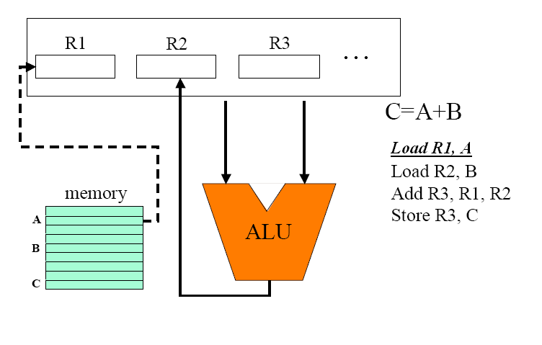
Fig 5.2 Loading R1
As per the next instruction given in the instruction set, the content of the memory location B is loaded to the register R2. This can be viewed as the below diagram.

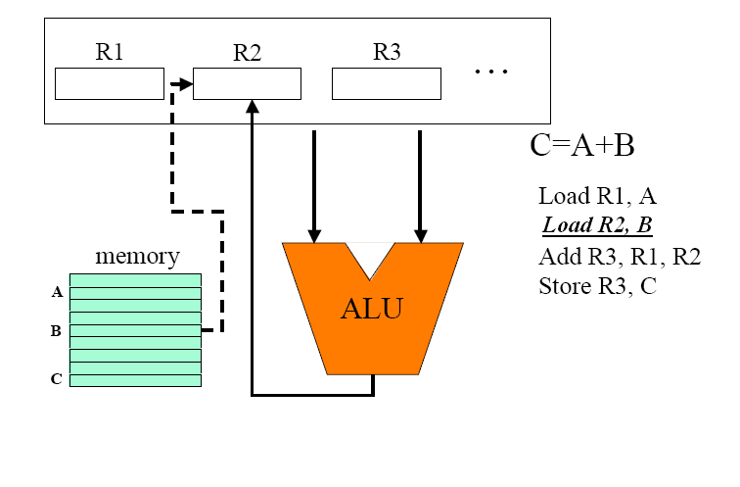
Fig 5.3 Loading R2
The next instruction in the program list is to add the contents of the register R1, R2 and store the contents in the location R3. The operation is carried out at the ALU section of the processor.

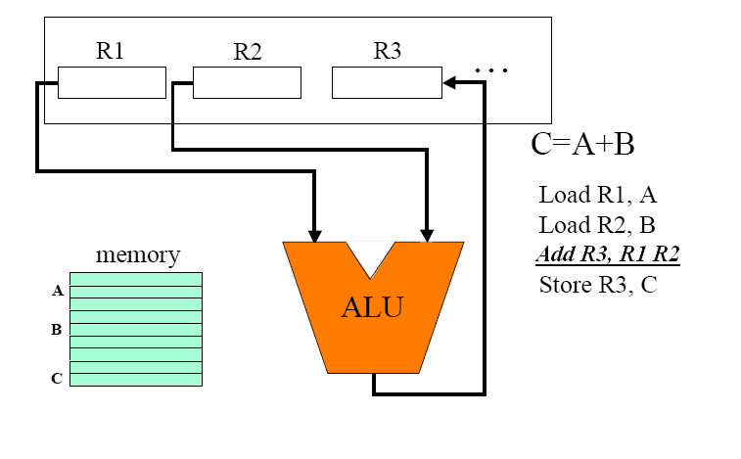
Fig 5.4 Addition Operation
The final step is to store back the contents at the Register R3 to the memory location of C.

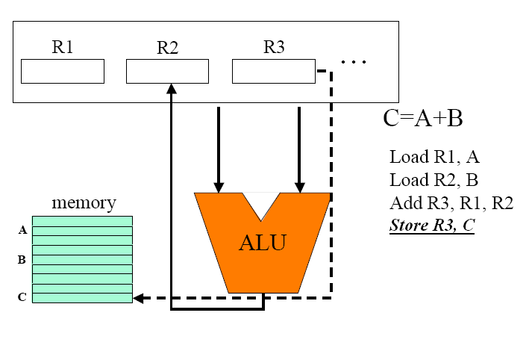
Fig 5.5 Store R3
Hence whenever the load store architecture is considered, the process is carried out by loading the content from the memory to the Register locations and later when the operation is done it writes back the contents to the memory locations.

Most of all the current computers use Load-Store architecture
The reason behind this are,
- Register access is faster.
- Registers can be named with fewer bits
than memory.
- Registers allow for compiler optimizations
(out of order execution).
- Registers can be used to hold all the variables
relevant for a specific code segment – all operations are faster.

5.6 FIXED LENGTH INSTRUCTIONS
The instruction set used in the RISC processors should be in fixed length so that it can be used to implement the pipelining. Every instruction should take only fixed cycles to complete one machine cycle of each instruction. So machines cycles of every instruction will take the same clock cycles to complete.

- HDL IMPLEMENTATION

The implementation of 16 bit RISC processor is done in Verilog HDL. The design is done by building basic components like muxes, registers, memory, gates etc. the basic components are decided according to the instructions implemented. For example for MOV A, R we use two registers named accumulator (A) and register R and uses their enable signals as needed. The enable signals are so designed to be controlled by Control Unit.

6.1 VERILOG HDL
The need for a standard language to describe digital circuits lead in to the evolution of Hardware Description Languages. HDLs allowed the designers to model the concurrency of model found in hardware elements.
Verilog is a Hardware Description Language; a textual format for describing electronic circuits and systems. Verilog HDL allows designers to design at various levels of abstraction. It is the most widely used HDL with a user community of more than 50,000 active designers. Applied to electronic design, Verilog is intended to be used for verification through simulation, for timing analysis, for test analysis (testability analysis and fault grading) and for logic synthesis.
Verilog HDL originated at Automated Integrated Design Systems (later renamed as Gateway Design Automation) in 1985. The company was privately held at that time by Dr. Prabhu Goel, the inventor of the PODEM test generation algorithm.Verilog HDL was designed by Phil Moorby, who was later to become the Chief Designer for Verilog-XL and the first Corporate Fellow at Cadence Design Systems.Gateway Design Automation grew rapidly with the success of Verilog-XL and was finally acquired by Cadence Design Systems, San Jose, CA in 1989.
Verilog was invented as simulation language. Use of Verilog for synthesis was a complete afterthought. Rumours abound that there were merger discussions between Gateway and Synopsys in the early days, where neither gave the other much chance of success.
In the late 1980's it seemed evident that designers were going to be moving away from proprietary languages like n dot, HiLo and Verilog towards the US Department of Defence standard H.D.L., known as the VHSIC Hardware Description Language (VHDL).

6.2 Levels of Abstraction
Verilog descriptions can span multiple levels of abstraction (levels of detail),and can be used for different purposes at various stages in the design process. Figure summarises a series of abstraction levels.
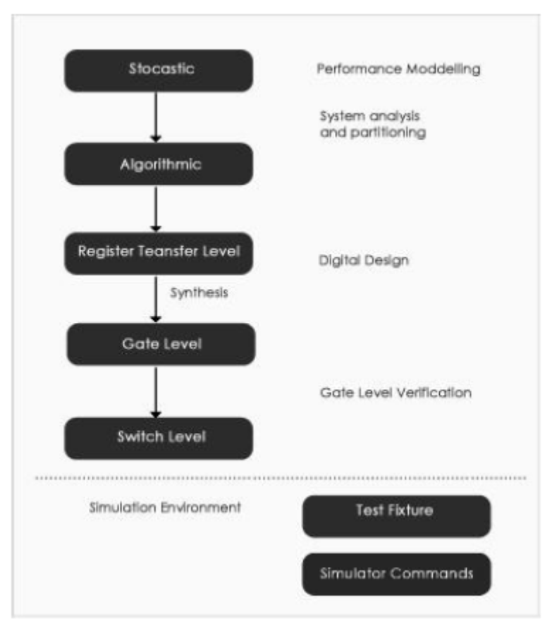
Fig 6.1 Levels Of Abstraction

At the highest level, Verilog contains stochastical functions (queues and random probability distributions) to support performance modeling. Verilog supports abstract behavioral modeling, so can be used to model the functionality of a system at a high level of abstraction. This is useful at the system analysis and partitioning stage.
Verilog supports Register Transfer Level descriptions, which are used for the detailed design of digital circuits. Synthesis tools transform RTL descriptions to gate level. Verilog supports gate and switch level descriptions, used for the verification of digital designs, including gate and switch level logic simulation, static and dynamic timing analysis, testability analysis and fault grading.

Verilog can also be used to describe simulation environments; test vectors, expected results, results comparison and analysis. With appropriate tools, Verilog can be used to control simulations (e.g. setting breakpoints, taking checkpoints, restarting from time 0, and tracing waveforms).However, most of these functions are not included in the 1364 standard, but are proprietary to particular simulators. Most simulators have their own command languages.

6.3 BASICS IN VERILOG HDL

Modules
A module is the basic building block in Verilog. A module can be an element or a collection of lower-level design blocks. A module provides the necessary functionality to the higher-level block through its port interface, but hides the internal implementation. This allows the designer to modify module internals without affecting the rest of the design.
Instances
A module provides a template from which you can create actual objects.
When a module is invoked, Verilog creates a unique object from the template. Each object has its own name, variables, parameters and I/O interface. The process of creating objects from a moduletemplate is called Instantiation, and the objects are called instances. Each instances must be given a unique name.
Components of Simulation
Once a design block is completed, it must be tested.The functionality of the design block can be tested by applying stimulus abd checking results. Such a block is called the Stimulus block. The stimulus block can be written in Verilog. A stimulus block is also commonly called a test bench.

6.4 RISC IMPLEMENTATION IN VERILOG

The 16 bit RISC processor is implemented with certain specifications. The processor design is completed by implementation of these specifications. They are including
- 16 bit data
- 8 bit address
- 19 instructions

The data comprises of 16 bit. The address is specified by the use of 8 bit address. The total number of instructions we implemented is 19. These instructions are executed in the pipeline hierarchy. The total set of instructions we implemented is tabulated below.

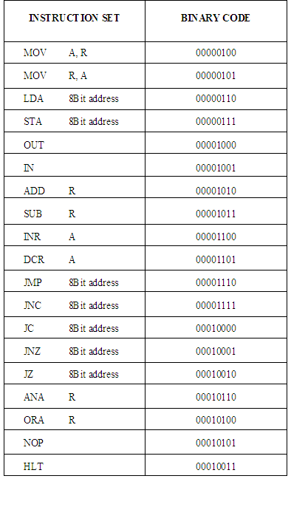
Table 6.1 Instruction Set

The processor design is done in two sections. The data path section and the control unit section. For the design of these respective sections we have adopted the systematic way of approach. The design issues for the entire development process are described in the following sessions.
6.5 DATAPATH DESIGN
The data path section of the processor is constructed by the systematic analysis of the entire instructions that we have to implement. The Data Path consists of subunits that are necessary for performing all of arithmetic and logic operations. The flows of instructions are initially analysed. As per the RISC characteristics, the processor does not

use any memory except for load (LDA) and store (STA) operations. The processor has been designed for two registers, namely the Accumulator and the R register. Contents towards the accumulator register are controlled by the Multiplexer provided with multiplexer select input Amux. As per the three bit input of the multiplexer select from the control unit, the required one is admitted towards the accumulator. The selection of the required one is given by the following table.

Amux input | Input Data Select
000  001  010  011  100  101  110  111 | IN  Register R  Memory  AddSub  OrAnd  Nil  Nil  Nil

Table 6.2 Mux Select
For example, when the Amux becomes 011 the AddSub input is selected to the accumulator. The accumulator is also engaged by the enabling signal named Aload. Similarly the register R also possesses the enabling signal named Rload. Both of these signals are coming from the control unit circuitry. The blocks such as the AddSub and ORAND are enabled and selected by the OrAndSel and AddSubSel respectively. The inputs fed to the AddSub block is fixed by the mux, with the selection signal named AddSubMux. The contents from the accumulator is passed to the Nor gate in order to check whether the accumulator is zero and thus the Zeroflag is set. And as per the Borrow/Carry out from the AddSub block is used for setting the Carryflag. These all constitutes the ALU portion of the microprocessor.
IRload and PCload enable IR (Instruction Register) and PC (Program Counter) respectively. PCMux lets the mux select its inputs, if the PCMux is ‘0’ then input from INC (Increment of Program Counter) is selected otherwise LSB (8 bits) of IR is selected. MemMux signal is used to select the input for the Memory mux. When it is ‘0’ then input from Program Counter is selected and when it is ‘1’ then input from Address which is

coming from Control Unit is selected. Memory input is selected from Memory Mux; it is taken as the address for the Memory. Reading from the Memory and writing to the Memory is decided by the R/W signal. When R/W signal is low (‘0’) then writing to memory mode is selected and when it is high (‘1’) reading from memory mode is selected. The output of Memory can be collected from MemOut.

6.6 DATA PATH FOR RISC PROCESSOR

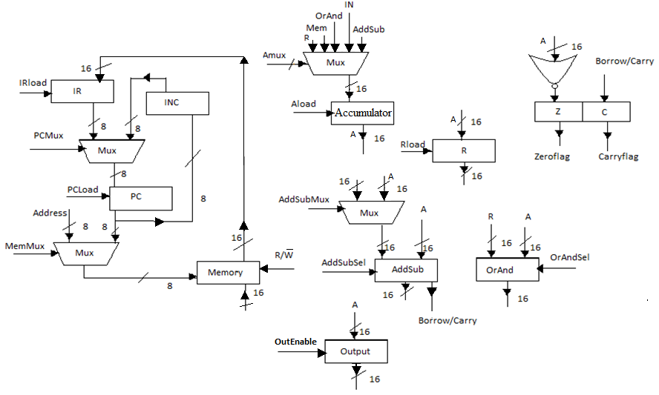
Fig 6.2 Datapath

6.7 CONTROL UNIT DESIGN
The Control Unit section is nothing but the processing area where the control signals are produced. These control signals are responsible for the proper working of Data Path. The control unit decides how the data path should function. Control Unit takes instructions from Memory and produces the desired signals which control the Data Path for the execution of instructions.

6.8 CONTROL UNIT OF RISC PROCESSOR

6.8.1STATE DIAGRAM

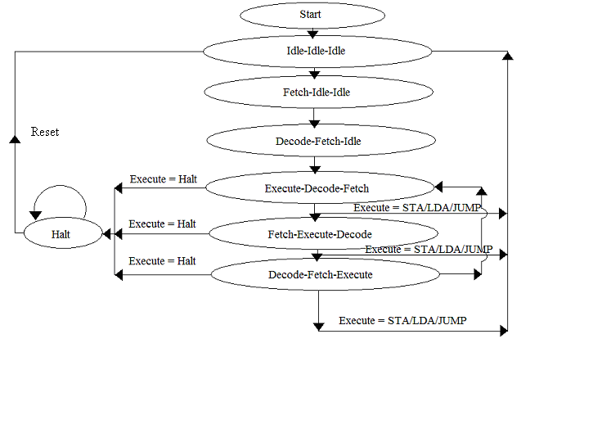

Fig 6.3 Control Unit

6.9 HOW STATE WORKS??
The state diagram of Control Unit shows the states of control unit. From initial state, state is set to ‘Idle-Idle-Idle’. The three Idle states specify the three states of the three depth pipeline. Each state represents one instruction from memory in sequence. From the three Idle state one of the states is set to Fetch state in the next Clock cycle. Then it is unconditionally send to Decode and one of the Idle state to Fetch state in the next Clock cycle. The Decode state is then again set to Execute state, Fetch state is set to Decode state and Idle state to Fetch.
The instruction in the Execute state is checked for STA/LDA or Jump. If the response is negative then the Execute state is changed to Fetch state. And the change of states continues like Fetch-Decode-Execute-Fetch-Decode…until it founds positive for STA/LDA or Jump for any of the Execute states. If the instruction in the Execute state finds STA/LDA or Jump instruction then all the states are set to initial states. Thus the flow of states continues. The entire description for this is given in the figure shown above.

6.10 BLOCK DIAGRAM: 16 BIT MICROPROCESSOR

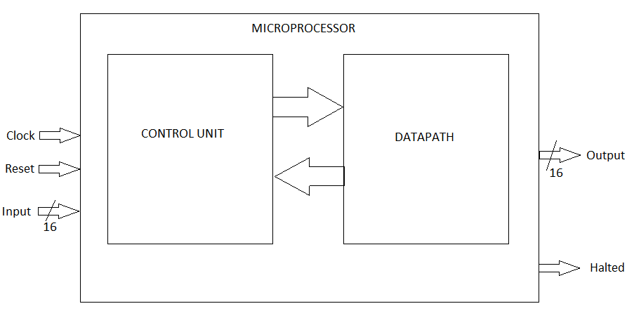
Fig 6.4 Block Diagram Of Microprocessor

6.11 PIPELINE HAZARDS
Pipeline can be implemented easily with fixed clock cycled instructions. But for LDA and STA and for Jump instructions, it will take more clock cycles to complete one instruction. For Jump instructions they are unpredictable.
For LDA/STA instructions it takes more states. For example when LDA instruction is executing it needs to load the accumulator with the memory content of the address provided by the instruction. It takes two clock cycles to complete the instruction. In the first clock cycle, the address is sent to Memory and the R/W signal is set to ‘1’.Thust the output of the memory contains the content of the address provided. In the next cycle the Accumulator is loaded with the content. Accumulator waits one Clock cycle for the data be available at the output of Memory.
Moreover in the first Clock cycle the Execution part is done at the Memory, the same Memory where the Fetch operation is taking place. So the Conflict takes places.For Jump instructions the address of the next instruction to be fetched is taken from the opcode of the Jump instruction. So the already fetched instruction needs to be reset. Otherwise the instruction following the Jump instruction will also be executed.
    - DATAPATH WHILE EXECUTING LDA/STA
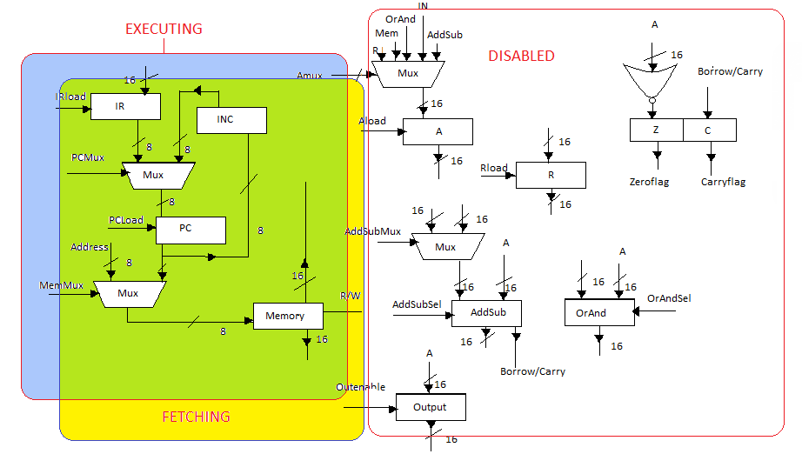
Fig 6.5 Datapath while executing LDA/STA

6.12 SOLVING PIPELINE HAZARDS

1) Jump Instructions: -

For simple Jump instruction, the Program counter is updated by the address provided in the instruction. So the instructions fetched and decoded should be reset to idle or initial state and start fetching from the address provided to the Program counter by the jump instruction.

For conditional Jump instruction it is again different. They should be handled in a different way. The Program counter is updated only if the condition given in the instruction is true. Otherwise it should work normal. Again for checking a condition corresponding signals

should be available on time. For example JNC instruction sets the Program counter with the address specified by the operand only if the Carry flag is set. Since the last instruction executed would be an arithmetic instruction, the Carry flag set may not be available in the checking part (JNC). So to solve the problem one clock cycle delay is provided before executing the conditional Jump.

2) Load - Store instructions: -
Load - Store instructions use memory for execution. So the Fetch state cannot be implemented while executing Load - Store instruction, because both states use the memory at the same time.
For solving the problem Fetch and Decode state is postponed to the next cycle. And Execute state should be suspended in the next cycle.

- CONCLUSION AND FUTURE SCOPE

16 Bit RISC processor has been designed and simulated. The design has been modeled using Verilog HDL and simulated with Mentor Graphics ModelSim 6.5c. The RISC processor is designed concentrating on RISC properties like Pipelining, Fixed length insttruction and Load-Store Architecture. It has only 19 instructions.
In future this can be updated by including more number of instructions and can be added more states like ‘ReadBackMemory’ and ‘WriteToMemory’ for the smooth functioning of Control Unit. It can be further modified to implement interrupts, floating point adder etc. The ROM memory can be changed to RAM and can be modified to let the user program be loaded to Memory. Instead of internal memory which is kept in Data Path, external memory can be used.

