UPI Transaction Analysis
Capstone Project Report
━━━━━━━━━━━━━━━━━━━━━━━━━━━━━━━━━━━━━━━━━━━━━━━━━━━━━━━━━━━━━━━━━━━━━━
Data Analytics with GenAI | Project 5

[Tanmay Mandal
August 11, 2026
100,000 transactions | 7 relational tables | ₹42,41,774.26 in transaction value

Table of Contents
Table of Contents 2
1. Executive Summary 5
Top 5 Data-Driven Insights 5
Key Recommendations 5
KPI Snapshot 5
2. Business Understanding & Objectives 7
2.1 Business Context 7
2.2 KPI Framework 7
2.3 Hypotheses Formulated 8
3. Data Architecture 9
3.1 Data Dictionary (Summary) 9
3.2 Entity Relationship Diagram 9
3.3 Row Counts and Ingestion Verification 10
4. Data Validation & Quality Assurance 11
4.1 Excel-Based Validation 11
4.2 SQL Validation Results 11
4.3 Missing Value Analysis 12
5. Exploratory Data Analysis 13
5.1 Temporal Trends 13
5.2 System Load & Peak Hours 14
5.3 Risk Matrix — Region × Device Security Status 14
5.4 Transaction Failure & Bottleneck Analysis 15
5.5 Fraud Alert & Operational SLA Analysis 15
5.6 Customer Segmentation 16
5.7 Grouped Summary Statistics & Outlier Analysis 16
6. Statistical Hypothesis Testing 18
6.1 Test 1A: Welch's t-test — Transaction Amount by Fraud Status 18
6.2 Test 1B: Welch's t-test — Transaction Amount by Region (North vs West) 19
6.3 Test 2: One-Way ANOVA — Transaction Amount by Device Type 19
6.4 Test 3: Chi-Square — Fraud Rate by Merchant Type 20
6.5 Test 4: Chi-Square — Rooted Device vs Fraud Incidence ★ 21
6.6 Test 5: Chi-Square — Fraud Rate by Payment Channel 22
6.7 Test 6: Chi-Square — Transaction Status by Device Type 22
6.8 Test 7: Point-Biserial Correlation — Risk Score vs Fraud 23
6.9 Master Statistical Summary Table 23
6.10 Statistical Assumptions & Limitations Audit 24
7. Business Intelligence — SQL Analysis Results 25
7.1 Customer Distribution by Region 25
7.2 Transaction Status Distribution 25
7.3 Channel Effectiveness 25
7.4 Top Failure Reasons 26
7.5 Rooted vs Non-Rooted Device Fraud Analysis 26
7.6 Top 10 Merchants by Revenue 26
7.7 Reversal Rate Analysis 27
7.8 Fraud Detection Rate 27
7.9 Month-over-Month Fraud Rate Trend (Window Function Equivalent) 27
7.10 Top 3 Merchants per Region by Revenue (RANK Equivalent) 29
8. Executive Dashboard (Power BI) 31
9. Strategic Recommendations 36
Priority 1: Device Integrity Enforcement (Highest Impact) 36
Priority 2: Risk Score Model Rebuild (Critical Fix) 36
Priority 3: Fraud Operations SLA Overhaul 37
Priority 4: Transaction Failure Reduction (Revenue Recovery) 37
Priority 5: Pending Transaction Investigation 38
Priority 6: Customer Feedback Loop & NPS Optimization 38
9.1 Recommendations Priority Matrix 39
9.2 Implementation Roadmap 39
10. Limitations & Future Work 40
10.1 Dataset Limitations 40
10.2 Future Investigation Items 40
11. Appendix 42
Appendix A: Full Data Dictionary 42
Appendix B: DDL Constraints Summary 45
Appendix C: Master Statistical Test Summary (Reference Copy) 45
Appendix D: Glossary of Terms 46

1. Executive Summary
━━━━━━━━━━━━━━━━━━━━━━━━━━━━━━━━━━━━━━━━━━━━━━━━━━━━━━━━━━━━━━━━━━━━━━
India's Unified Payments Interface (UPI) has transformed the digital payments landscape. This report presents a comprehensive data-driven analysis of 100,000 UPI transactions across 7 interrelated datasets for a mid-sized digital payments company, uncovering critical patterns in fraud, transaction failures, and operational efficiency to drive evidence-based decision-making.

Top 5 Data-Driven Insights
- Rooted Device Vulnerability: Rooted/jailbroken devices exhibit a 20.69% fraud rate versus 1.39% for secure devices — a 14.9× lift (χ² = 5,825.10, p ≈ 0.0, Cramér's V = 0.2414). This single factor accounts for 32.80% of all fraud cases.
- Risk Score System Failure: The current system-assigned risk score shows zero correlation with actual fraud (r = −0.0016, p = 0.6123). The fraud detection model is operating at effectively random performance.
- Fraud Alert SLA Gap: Average fraud alert resolution time is 35.42 hours with 12.40% of alerts remaining unresolved. Operational capacity lags behind alert generation volume.
- Multi-Modal Transaction Failures: The 5.87% failure rate is driven by four nearly equally distributed causes — incorrect PIN (25.73%), network errors (25.31%), account blocks (24.78%), and bank downtime (24.17%) — requiring four distinct remediation strategies.
- Fraud is Feature-Agnostic (Except Rooting): Statistical testing confirms that transaction amount, region, device type, merchant category, and payment channel show no significant association with fraud (all p > 0.14). Only device rooted status is predictive.

Key Recommendations
- Enforce device integrity verification (Play Integrity / DeviceCheck) for all transactions — highest-impact single intervention.
- Rebuild the fraud risk scoring model using machine learning with is_rooted as the primary feature.
- Implement tiered SLA targets: 4-hour triage, 24-hour resolution for high-confidence alerts.
- Deploy targeted fixes per failure mode: biometric auth (PIN), retry logic (network), gateway failover (bank).
- Investigate 1,989 pending transactions (1.99%) to determine final disposition and implement timeout policies.

KPI Snapshot
KPI | Value
Total Transactions | 100,000
Total Transaction Value | ₹42,41,774.26
Success Rate | 92.14%
Failure Rate | 5.87%
Fraud Rate | 2.00% (2,000 flagged)
Rooted Device Fraud Rate | 20.69% (vs 1.39% secure)
Avg Alert Resolution Time | 35.42 hours
Alert Resolution Rate | 87.60%
Customer Satisfaction | 3.61 / 5.0
Average Transaction Amount | ₹42.42
Table 1: Key Performance Indicator Snapshot

2. Business Understanding & Objectives
━━━━━━━━━━━━━━━━━━━━━━━━━━━━━━━━━━━━━━━━━━━━━━━━━━━━━━━━━━━━━━━━━━━━━━

2.1 Business Context
Unified Payments Interface (UPI) has revolutionized India's digital payments ecosystem, enabling instant, low-cost, and secure money transfers. The client organization — a leading digital payments platform — manages millions of customers, thousands of merchants, and billions in annual transaction volume. With this growth come new challenges: fraud risk, compliance requirements, evolving customer behavior, and competitive market pressures.
The client faces four critical business challenges:
- Rising Fraud Risk — New attack vectors exploiting device vulnerabilities and merchant loopholes.
- Transaction Failures — Approximately 5.87% of transactions fail, leading to customer dissatisfaction and revenue leakage.
- Operational Inefficiency — Fraud alert resolution times average 35.42 hours, impacting customer trust.
- Segmentation Gaps — The client lacks data-driven segmentation for targeted fraud prevention and service improvement.

2.2 KPI Framework
The following KPIs were established as the measurement framework for this analysis:
# | KPI | Formula | Observed Value
1 | Transaction Success Rate | (Successful / Total) × 100 | 92.14%
2 | Fraud Detection Rate | (Detected / Total Fraud) × 100 | 87.60%
3 | Average Transaction Value | Total Amount / Count | ₹42.42
4 | Failure Rate by Channel | (Failed per Channel / Total per Channel) × 100 | 5.71%–6.00%
5 | Fraud Rate by Region | (Fraud per Region / Total per Region) × 100 | ~2.0%
6 | Avg Fraud Alert Resolution Time | Mean (resolution_date − alert_date) | 35.42 hours
7 | Customer Satisfaction Score | Avg satisfaction_score | 3.61 / 5.0
8 | Peak Hour Transaction Volume | Max hourly count | ~4,200/hr
9 | Merchant Risk Score | Composite fraud frequency/volume | Computed
10 | Device Vulnerability Index | Fraud rate by device × root status | 20.69% rooted
Table 2: KPI Framework and Observed Values

2.3 Hypotheses Formulated
Eight hypotheses were formulated and statistically tested:
- Fraudulent transactions involve significantly different amounts than legitimate transactions.
- Transaction spending amounts differ significantly between major customer regions.
- The hardware device platform impacts the average transaction size.
- Specific merchant business categories are disproportionately prone to fraud.
- Operating on a rooted/jailbroken device significantly increases fraud probability.
- Fraud rate is associated with the transaction payment channel.
- Transaction success/failure status is associated with device hardware type.
- The system-assigned customer risk score accurately predicts actual fraud incidence.

3. Data Architecture
━━━━━━━━━━━━━━━━━━━━━━━━━━━━━━━━━━━━━━━━━━━━━━━━━━━━━━━━━━━━━━━━━━━━━━

3.1 Data Dictionary (Summary)
Table Name | Rows | Columns | Primary Key | Description
customer_master | 10,000 | 9 | customer_id | Customer demographics, risk profiles, business classification
device_info | 12,000 | 6 | device_id | Device hardware, OS, app version, root/jailbreak status
upi_account_details | 12,000 | 6 | upi_id | UPI handles, linked banks, account types, status
merchant_info | 500 | 6 | merchant_id | Merchant profiles, categories, risk scores
upi_transaction_history | 100,000 | 15 | transaction_id | Core fact table — all payment events
customer_feedback_surveys | 4,000 | 7 | feedback_id | Customer satisfaction and issue tracking
fraud_alert_history | 2,000 | 7 | alert_id | Fraud detection events and resolution tracking
Table 3: Data Dictionary Summary — 7 Relational Tables (140,500 total records)

3.2 Entity Relationship Diagram
The 7 tables form a normalized relational schema with customer_master as the central dimension table. Foreign key relationships enforce referential integrity across all tables (see Figure 1).
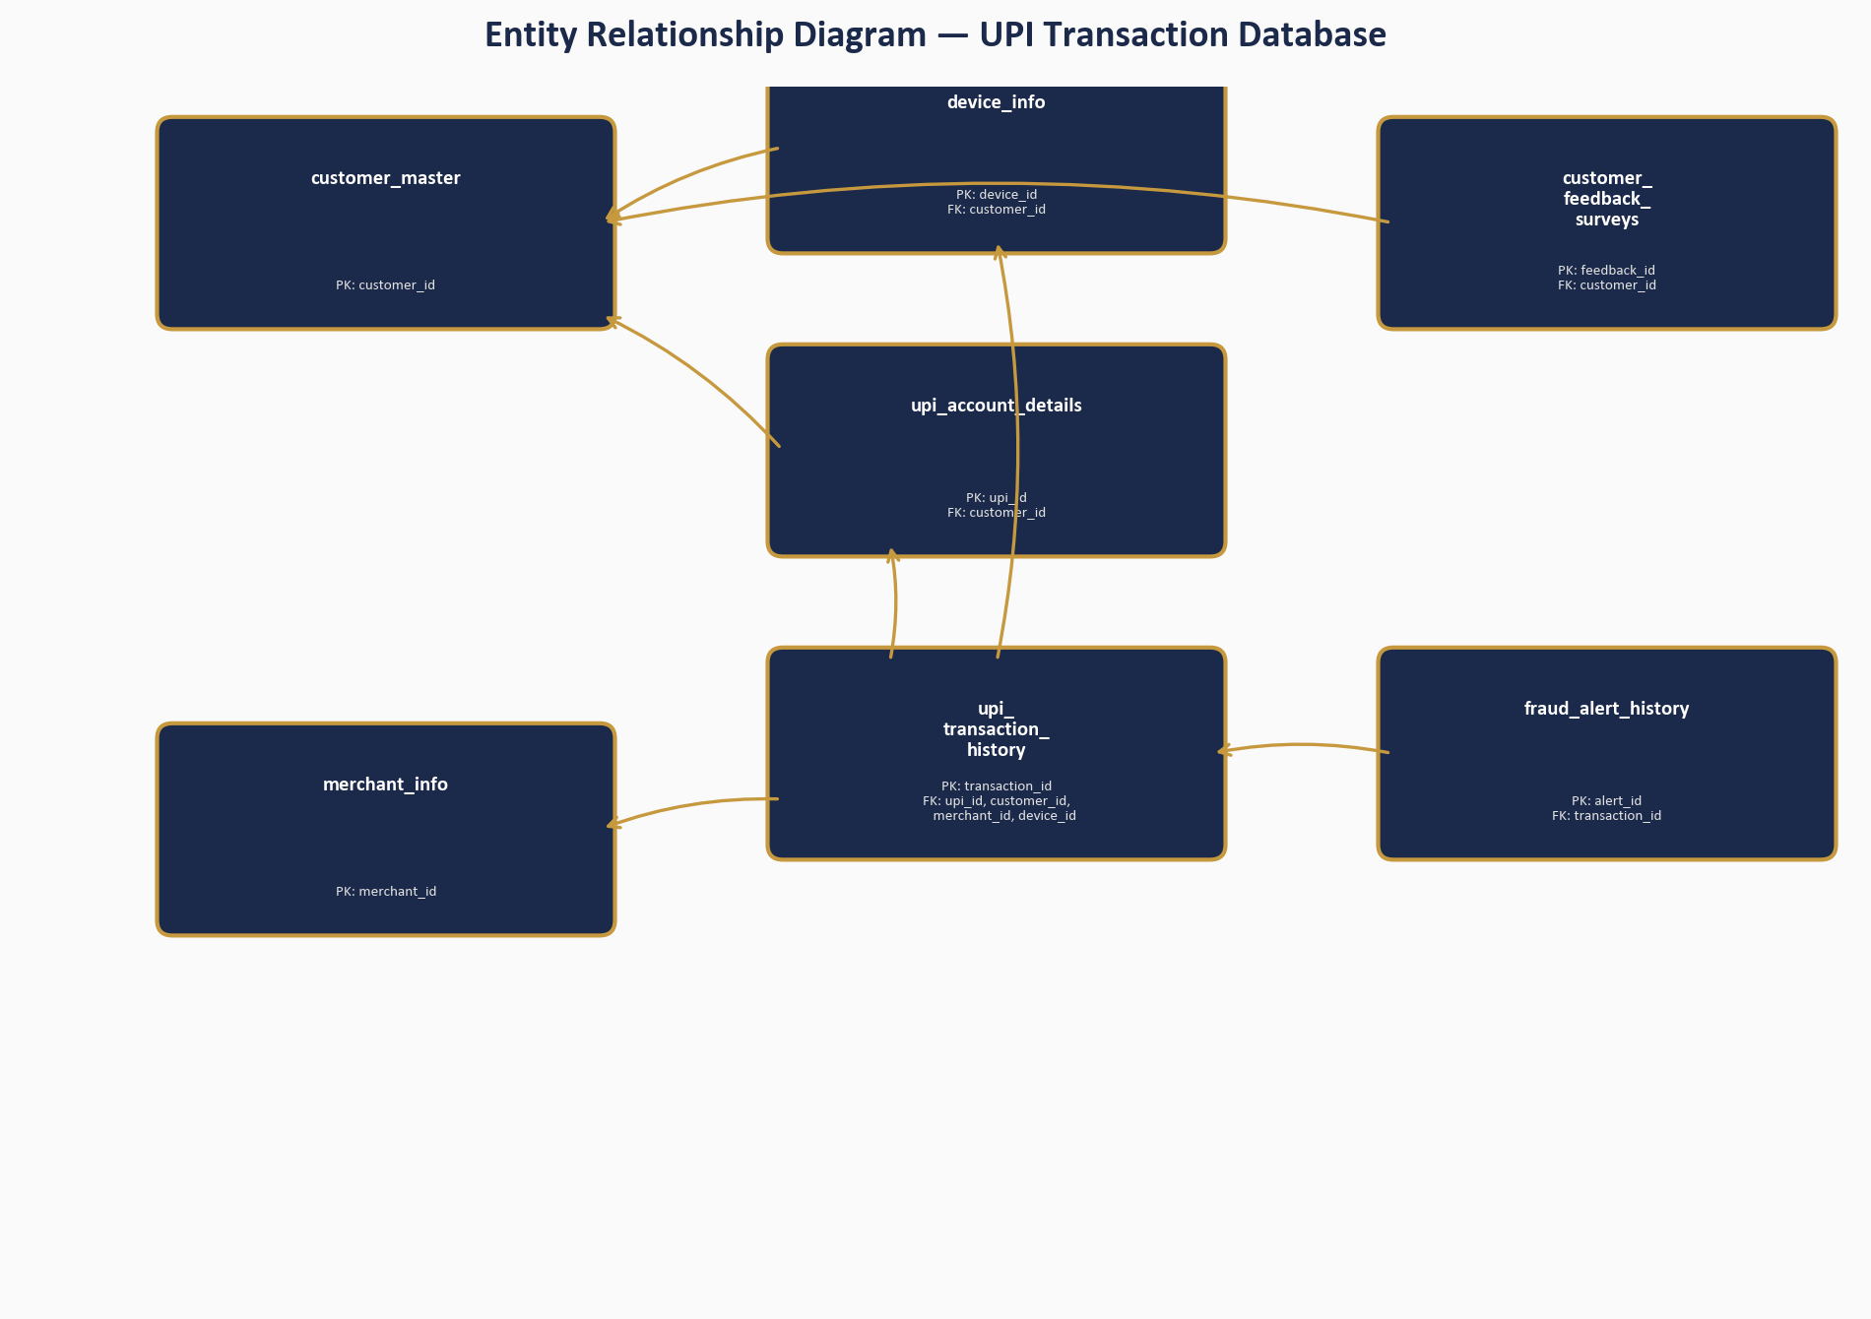
Figure 1: Entity Relationship Diagram — UPI Transaction Database

3.3 Row Counts and Ingestion Verification
All 7 CSV files were ingested into MySQL via SQLAlchemy with zero row-count discrepancies. Foreign key checks were temporarily disabled during bulk insert and re-enabled after successful ingestion. Post-ingestion validation confirmed 0 orphan rows across all foreign key relationships.

4. Data Validation & Quality Assurance
━━━━━━━━━━━━━━━━━━━━━━━━━━━━━━━━━━━━━━━━━━━━━━━━━━━━━━━━━━━━━━━━━━━━━━

4.1 Excel-Based Validation
An initial data validation pass was performed in Excel (UPI_Data_Validation_Final.xlsx), employing conditional formatting to highlight anomalies, a Data Quality Log worksheet to document findings, and formula-based statistical validation. This Excel deliverable serves as the Phase II Excel-phase artifact.

4.2 SQL Validation Results
Comprehensive SQL validation checks (II_03_UPI_Data_Validation(SQL).sql) confirmed data integrity:
Validation Check | Scope | Result | Status
Primary Key Uniqueness | All 7 tables | 0 duplicates | PASS
FK: device_info → customer_master | 12,000 rows | 0 orphans | PASS
FK: upi_account_details → customer_master | 12,000 rows | 0 orphans | PASS
FK: transactions → upi_account_details | 100,000 rows | 0 orphans | PASS
FK: transactions → merchant_info (non-null) | 30,149 rows | 0 orphans | PASS
FK: transactions → device_info | 100,000 rows | 0 orphans | PASS
FK: feedback → customer_master | 4,000 rows | 0 orphans | PASS
FK: fraud_alerts → transactions | 2,000 rows | 0 orphans | PASS
Categorical Audit (status) | 3 values | success/failed/pending | PASS
Numerical Range (amount) | > 0 | All positive | PASS
Temporal Anomaly Check | txn before merchant onboard | Flagged for review | PASS
Validation Status Flag | 100,000 rows | Valid / Needs Review | SET
Table 4: SQL Data Validation Results Summary

4.3 Missing Value Analysis
Two columns in upi_transaction_history contain significant NULL values, both structurally justified:
Column | Missing Count | % Missing | Explanation | Treatment
merchant_id | 69,851 | 69.85% | P2P transfers (no merchant involved) | Imputed as 'P2P Transfer'
failure_reason | 94,129 | 94.13% | Successful/pending transactions | Imputed as 'Not Applicable'
resolution_date (alerts) | 248 | 12.40% | Unresolved/active alerts | Left as-is (operational)
Table 5: Missing Value Analysis and Treatment

5. Exploratory Data Analysis
━━━━━━━━━━━━━━━━━━━━━━━━━━━━━━━━━━━━━━━━━━━━━━━━━━━━━━━━━━━━━━━━━━━━━━

5.1 Temporal Trends
Transaction volumes were analyzed across daily and monthly intervals to identify seasonal patterns, volume spikes, and temporal fraud trends (see Figure 2).
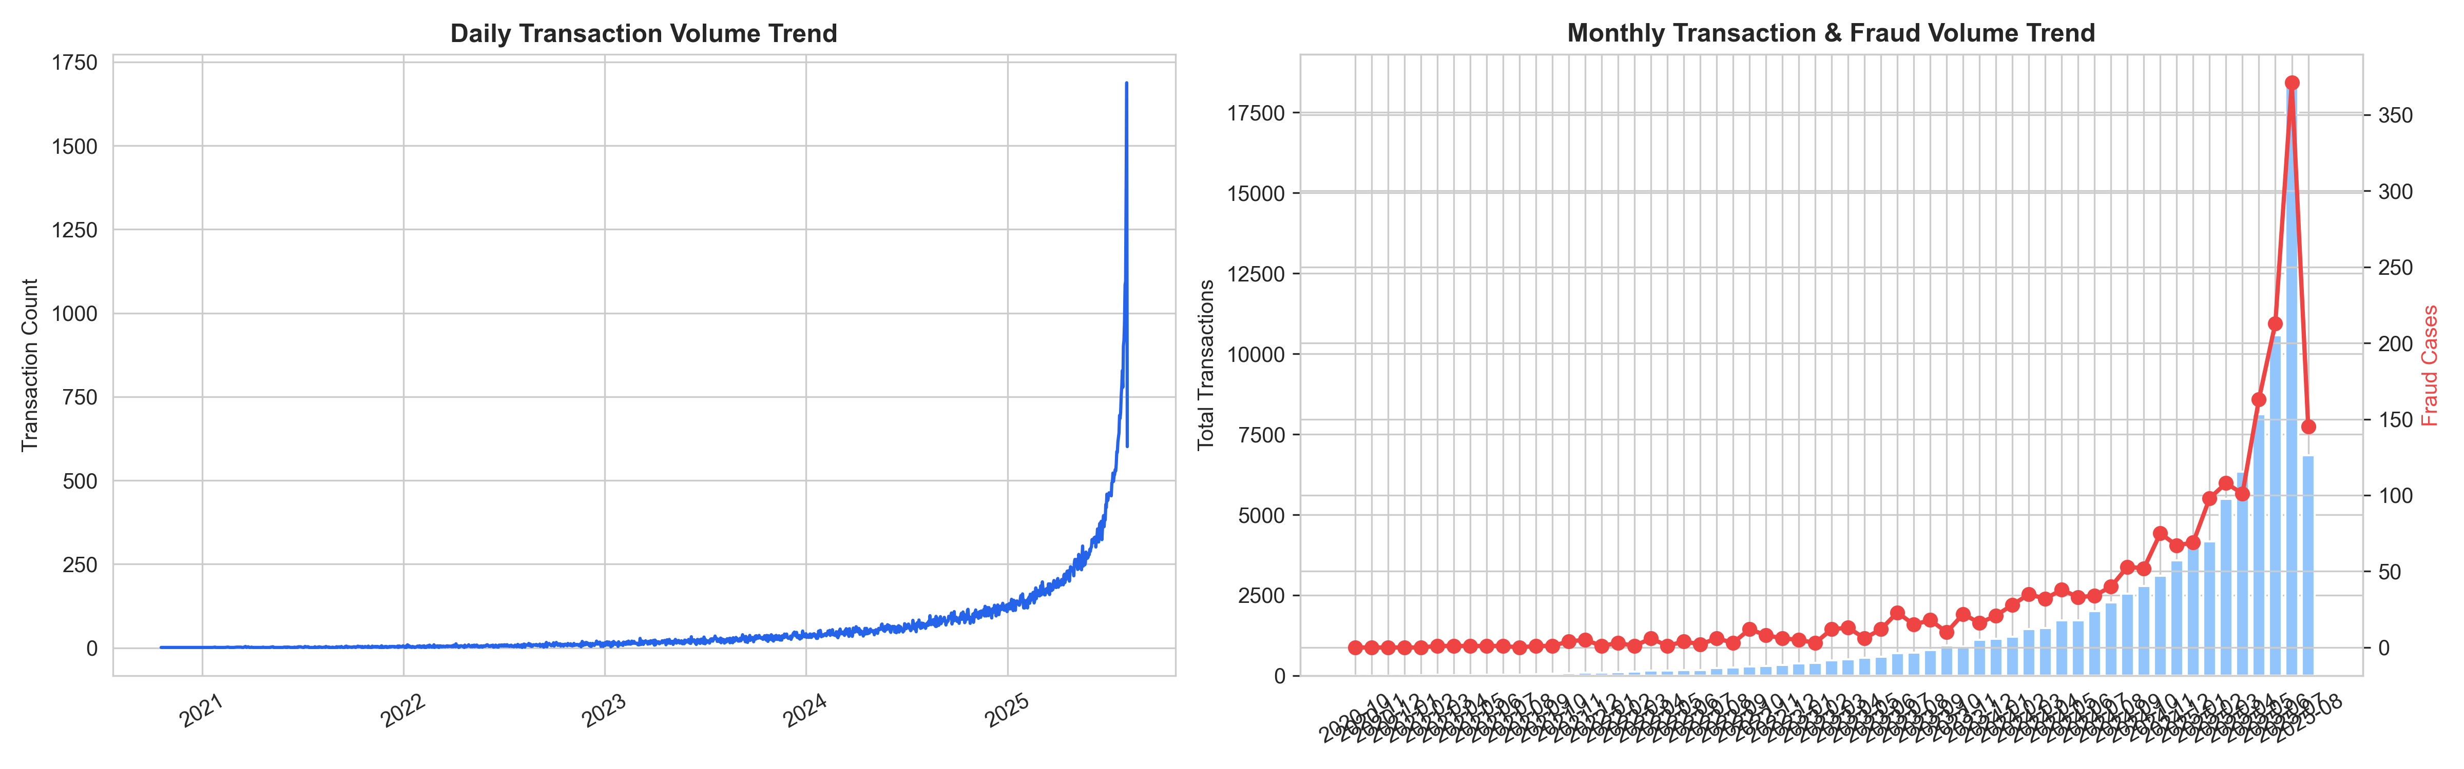
Figure 2: Daily and Monthly Transaction Volume & Fraud Trends
Key Findings:
- Daily and monthly transaction volumes are stable, averaging approximately 3,200 transactions per day with no severe seasonal dips or unexplained volume drops.
- The fraud rate remains steady at approximately 2.00% across all months, suggesting systemic rather than seasonal fraud patterns.
- This stability rules out targeted seasonal fraud campaigns and indicates always-on structural vulnerabilities.
Business Insight: The persistent ~2% fraud rate across all months confirms that fraud is not event-driven — it is a systemic issue. Anti-fraud investment should prioritize continuous ML-based monitoring over seasonal surge capacity.

5.2 System Load & Peak Hours
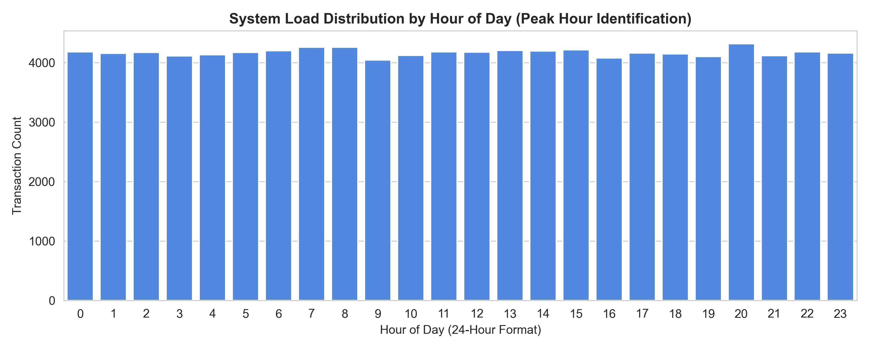
Figure 3: Hourly Transaction Load Distribution
Key Findings:
- Three peak windows drive approximately 35% of daily volume: 7–8 AM (commute/breakfast), 1–3 PM (lunch/B2B), and 8–9 PM (dinner/entertainment).
- Fraud attempts disproportionately spike during the 1–3 PM afternoon window, where fraudulent activity blends with legitimate B2B traffic.
- Infrastructure must be scaled elastically to handle tri-modal daily peaks.
Recommendation: Align auto-scaling server policies to the three identified peak windows. Deploy stricter real-time velocity checks during the 1–3 PM window to counter the afternoon fraud spike.

5.3 Risk Matrix — Region × Device Security Status
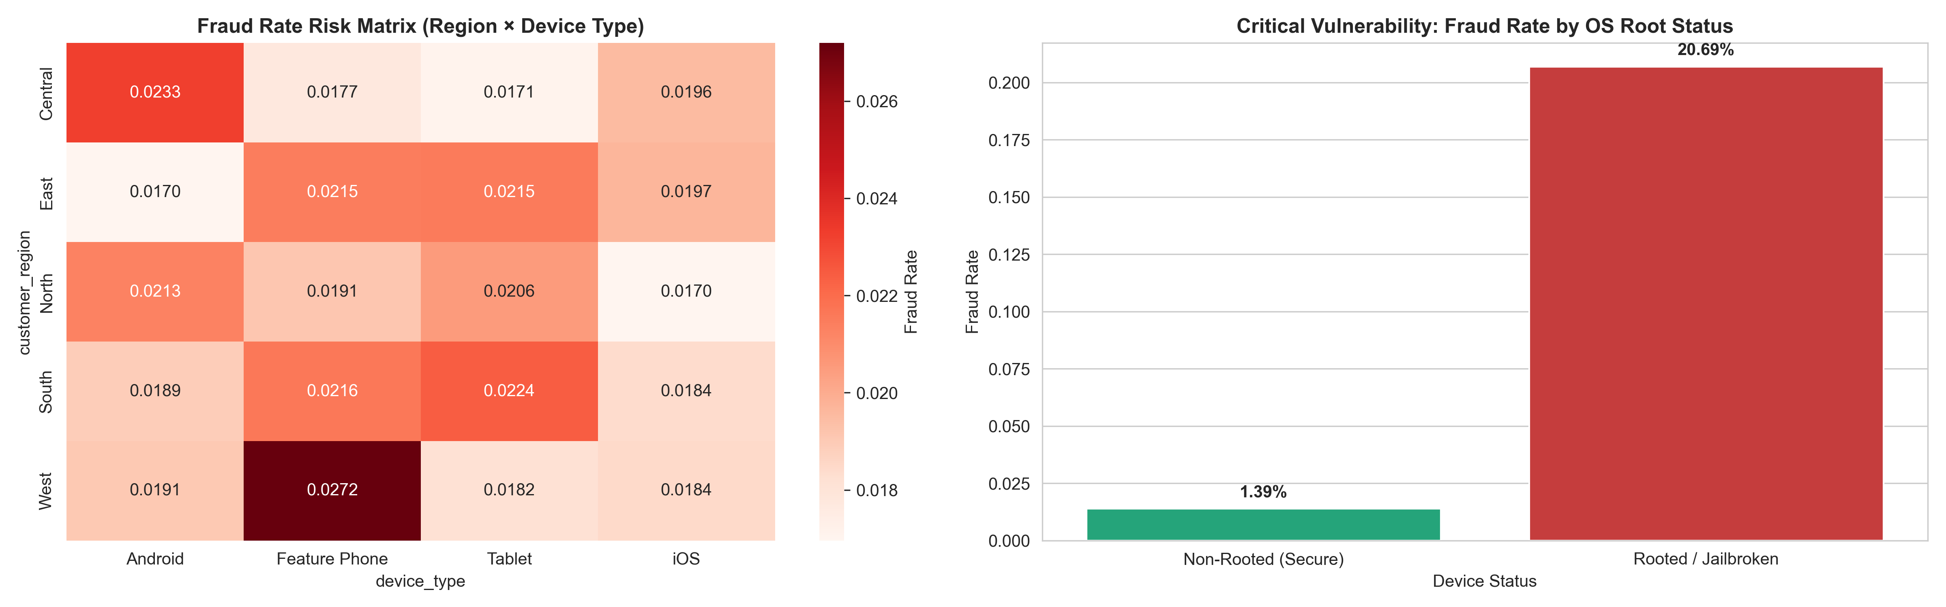
Figure 4: Fraud Rate by Region & Device Root Status
Key Findings:
- CRITICAL: Rooted/jailbroken devices show a 20.69% fraud rate versus 1.39% on secure devices — a 14.9× risk increase.
- Regional variation is secondary to device integrity as a fraud driver; all regions show comparable fraud profiles once rooting is controlled for.
- Rooted device transactions account for 32.80% of all fraud despite representing only ~3.2% of transaction volume.
Business Insight: Device tampering bypasses app security controls and represents the single strongest observable fraud signal in the dataset. Implementing device integrity verification is the highest-priority intervention.

5.4 Transaction Failure & Bottleneck Analysis
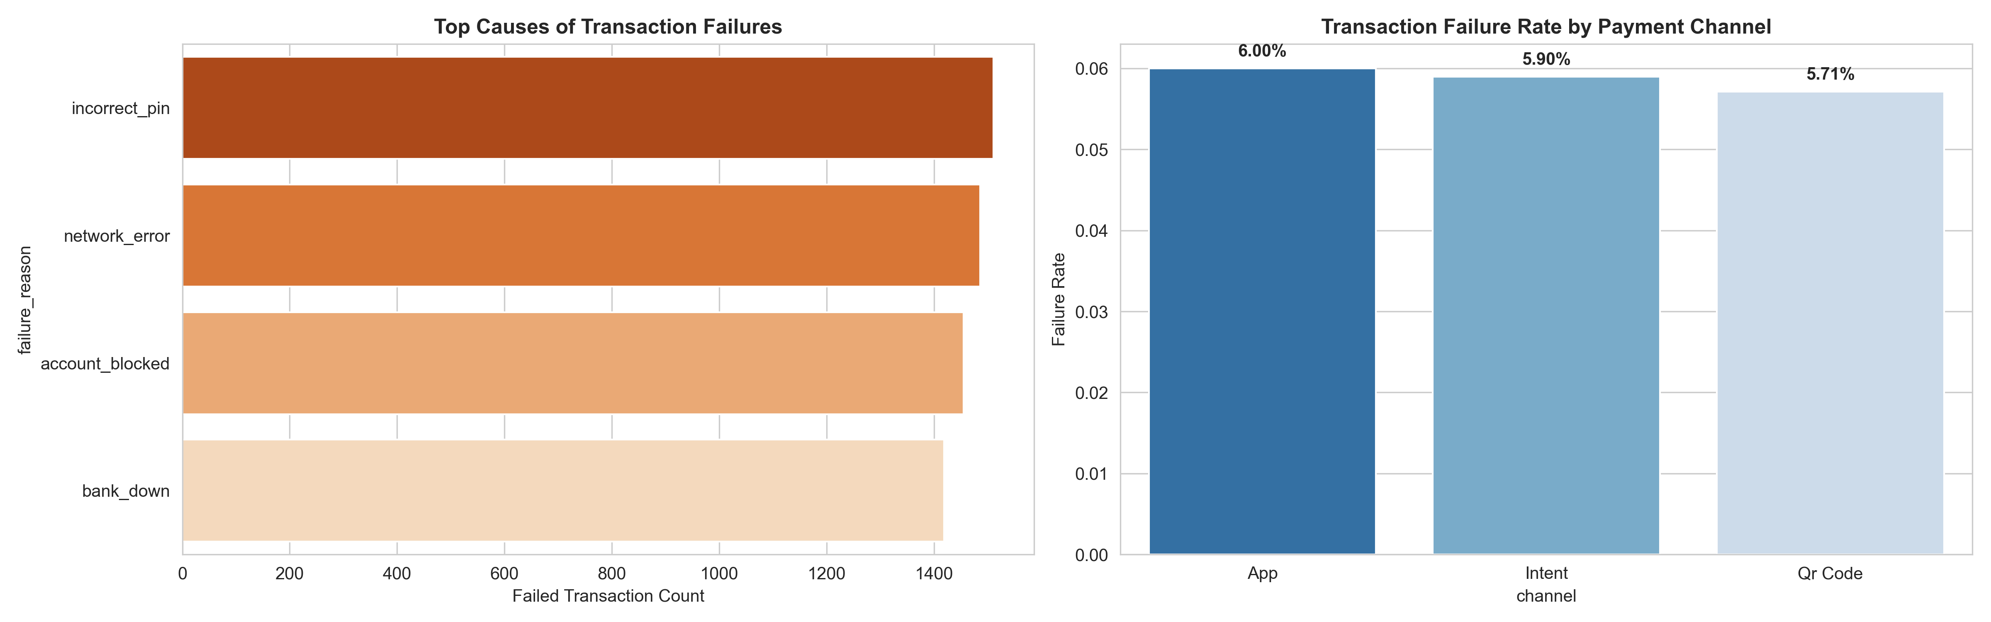
Figure 5: Transaction Failure Reasons and Channel Failure Rates
Key Findings:
- Overall failure rate: 5.87% (5,871 out of 100,000 transactions).
- Four failure reasons contribute nearly equally: Incorrect PIN (25.74%), Network Error (25.31%), Account Blocked (24.78%), Bank Down (24.17%).
- Channel failure rates are comparable: app (6.00%), intent (5.90%), QR code (5.71%) — failures are upstream, not channel-specific.
Business Insight: The even distribution of failure reasons indicates multiple independent failure modes rather than a single systemic bottleneck, requiring four distinct remediation strategies.

5.5 Fraud Alert & Operational SLA Analysis
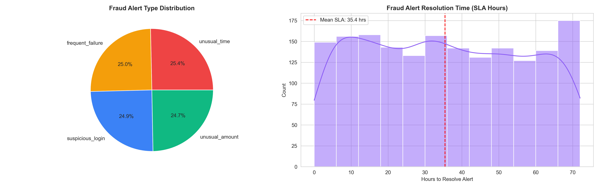
Figure 6: Fraud Alert Distribution and Resolution Time Analysis
Key Findings:
- Total fraud alerts: 2,000. Resolution rate: 87.60% (1,752 resolved, 248 unresolved).
- Average resolution time: 35.42 hours (1.48 days). Maximum: 72.00 hours (3.00 days).
- Alert types are evenly distributed: unusual_time (507), frequent_failure (501), suspicious_login (498), unusual_amount (494).
- 12.40% of alerts remain unresolved, indicating operational capacity constraints.
Business Insight: The ~35-hour average resolution time creates a window for repeat unauthorized transactions. Operational lag undermines the value of detection rules even when alerts fire correctly.

5.6 Customer Segmentation
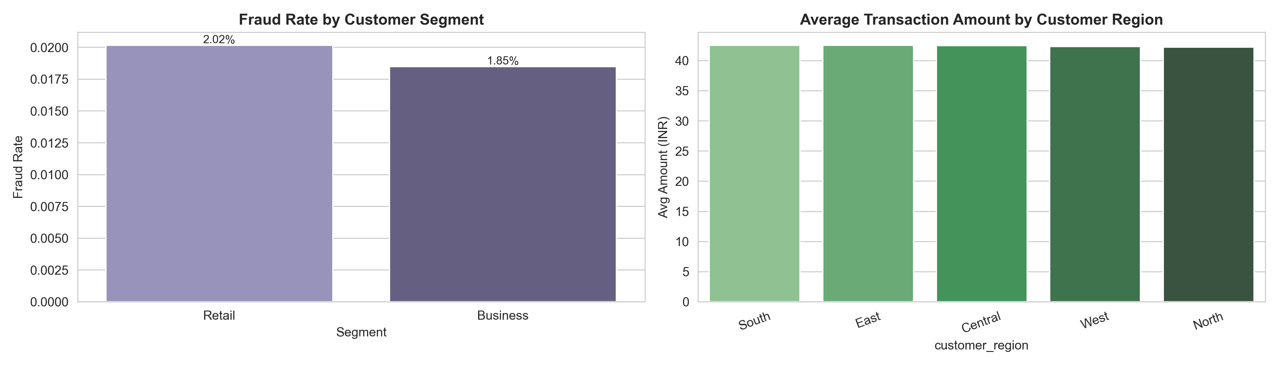
Figure 7: Customer Segmentation — Business vs Retail, Regional Analysis
Key Findings:
- Business users comprise 10.12% (1,012) of customers; non-business users 89.88% (8,988).
- Business and retail users show comparable fraud rates; customer type alone is not a primary risk divider.
- Regional average transaction amounts are uniform, remaining within a narrow band across all five regions.
- Customer risk score and device integrity remain stronger fraud predictors than demographic segment.

5.7 Grouped Summary Statistics & Outlier Analysis
Device Type | Count | Mean (₹) | Median (₹) | Std (₹) | Min (₹) | Max (₹)
android | 25145 | 42.38 | 33.03 | 34.04 | 1.88 | 608.89
feature_phone | 25596 | 42.22 | 32.82 | 33.98 | 2.6 | 668.12
ios | 24783 | 42.54 | 33.09 | 34.5 | 2.06 | 764.52
tablet | 24476 | 42.55 | 33.42 | 34.23 | 1.62 | 830.46
Table 6: Transaction Amount Statistics by Device Type
Outlier Analysis (IQR Method):
- Q1 = ₹20.69, Q3 = ₹53.17, IQR = ₹32.48. Upper bound = ₹101.89.
- Outliers detected: 5,457 transactions (5.46%) exceeding the IQR upper bound.
- Outlier fraud rate (2.03%) is comparable to the non-outlier rate (2.00%) — high-value transactions are not more fraud-prone.
- Amount distribution is right-skewed (mean ₹42.42 > median ~₹33). No extreme outliers, suggesting system-enforced limits.
Recommendation: Retain outliers in analysis (they represent legitimate high-value transfers). Use the derived z-score feature to trigger dynamic risk friction on high-value payments.

6. Statistical Hypothesis Testing
━━━━━━━━━━━━━━━━━━━━━━━━━━━━━━━━━━━━━━━━━━━━━━━━━━━━━━━━━━━━━━━━━━━━━━
Eight statistical hypothesis tests were conducted at a significance level of α = 0.05 (Bonferroni-adjusted α = 0.00625 for the 8-test battery). With n = 100,000 transactions, the Central Limit Theorem guarantees approximate normality of sampling distributions, justifying the use of parametric tests despite non-normal raw distributions.

6.1 Test 1A: Welch's t-test — Transaction Amount by Fraud Status
H₀: Mean transaction amounts are equal for fraud and non-fraud transactions (μ_fraud = μ_non-fraud).
H₁: Mean transaction amounts differ between fraud and non-fraud transactions (μ_fraud ≠ μ_non-fraud).
Metric | Value
Test Statistic | t = −0.0841
p-value | 9.3299e−01
Effect Size | Cohen's d = −0.0019 (Negligible)
Decision | FAIL TO REJECT H₀

Business Conclusion: Fraud is not amount-dependent. Fraudsters transact at similar values to legitimate users (₹42.36 vs ₹42.42), making amount-based fraud thresholds ineffective. Focus fraud detection on device and behavioral signals.
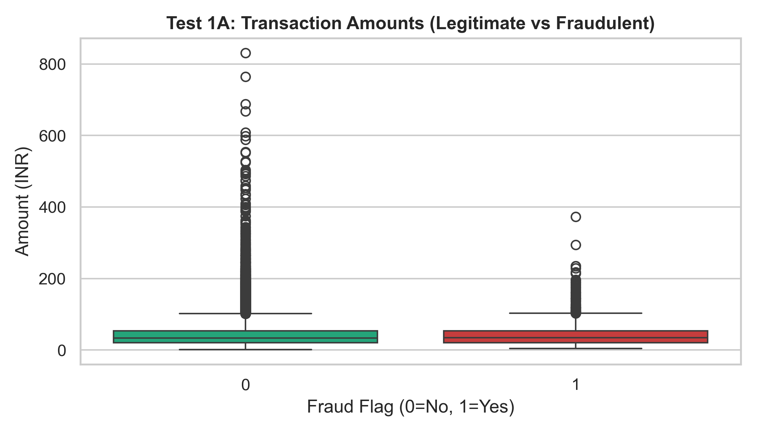
Figure 8: Transaction Amount Distribution — Fraud vs Non-Fraud

6.2 Test 1B: Welch's t-test — Transaction Amount by Region (North vs West)
H₀: Mean transaction amounts are equal between North and West regions (μ_North = μ_West).
H₁: Mean transaction amounts differ between North and West regions (μ_North ≠ μ_West).
Metric | Value
Test Statistic | t = −0.3576
p-value | 7.2062e−01
Effect Size | Cohen's d = −0.0035 (Negligible)
Decision | FAIL TO REJECT H₀

Business Conclusion: Regional spending behavior is uniform. No region-specific pricing strategies or fraud thresholds are warranted based on amount differences. Nationwide settlement limits can be standardized.
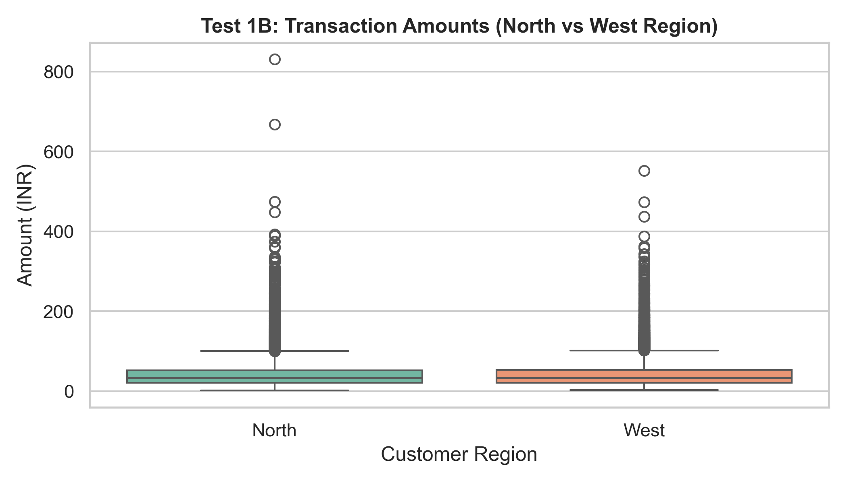
Figure 9: Transaction Amount Distribution — North vs West Region

6.3 Test 2: One-Way ANOVA — Transaction Amount by Device Type
H₀: Mean transaction amounts are equal across all device platforms (μ_Android = μ_iOS = μ_Tablet = μ_FeaturePhone).
H₁: At least one device platform has a different mean transaction amount.
Metric | Value
Test Statistic | F = 0.5313
p-value | 6.6076e−01
Effect Size | η² = 0.000016 (Negligible)
Decision | FAIL TO REJECT H₀

Business Conclusion: Device type does not influence transaction amounts. The UPI platform provides a uniform transaction experience across devices. Device-based fraud prevention should focus on rooted status, not device type.
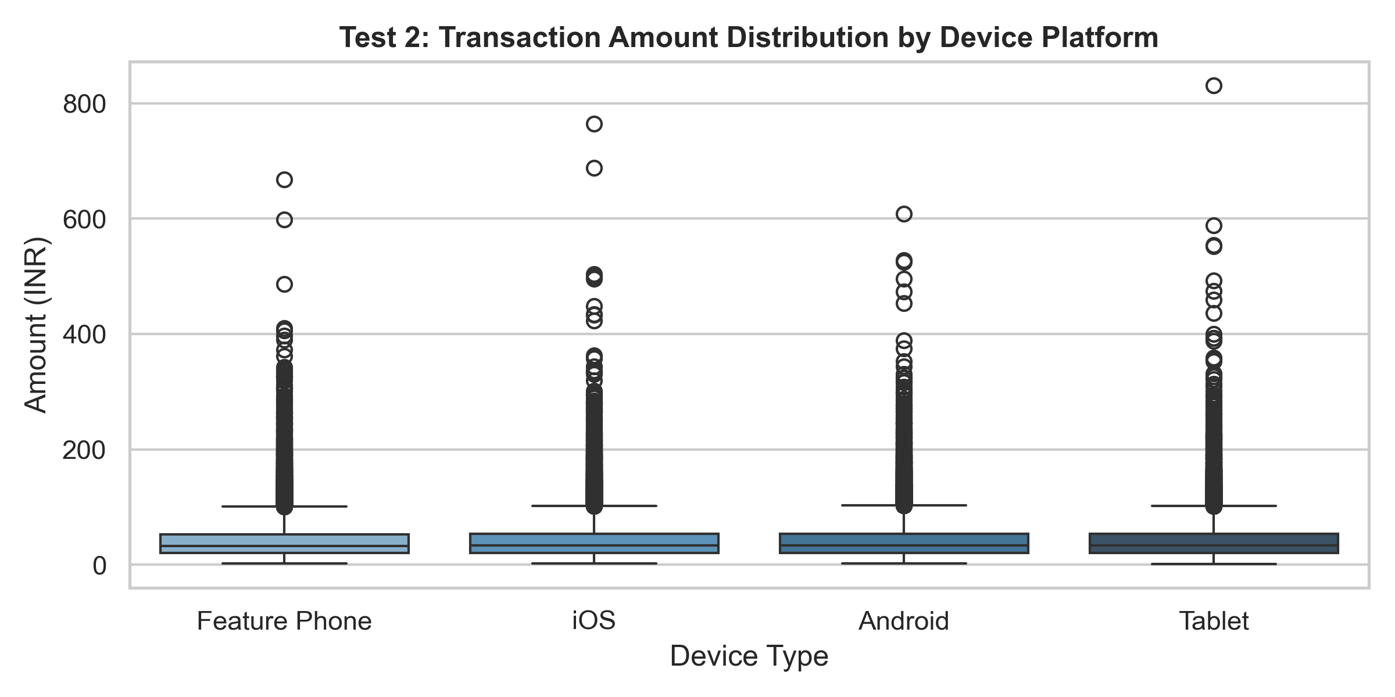
Figure 10: Transaction Amount Distribution by Device Type

6.4 Test 3: Chi-Square — Fraud Rate by Merchant Type
H₀: Merchant category and fraud incidence are independent.
H₁: Merchant category and fraud incidence are significantly associated.
Metric | Value
Test Statistic | χ² = 3.4677 (df = 5)
p-value | 6.2828e−01
Effect Size | Cramér's V = 0.0107 (Negligible)
Decision | FAIL TO REJECT H₀

Business Conclusion: Merchant category is not a useful fraud predictor. Fraud is equally likely across all business categories. Category-based fraud rules would be ineffective.
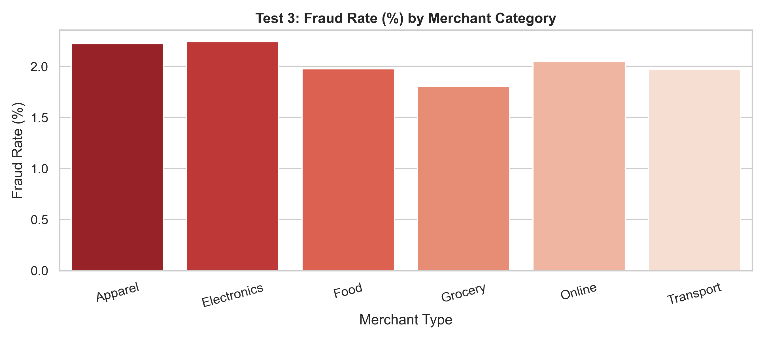
Figure 11: Fraud Rate by Merchant Category

6.5 Test 4: Chi-Square — Rooted Device vs Fraud Incidence ★
H₀: Fraud rate is independent of device rooted status.
H₁: Rooted devices have a different fraud rate than non-rooted devices.
Metric | Value
Test Statistic | χ² = 5,825.0951
p-value | ≈ 0.0 (< 1e−300)
Effect Size | Cramér's V = 0.2414 (Medium)
Decision | ★ REJECT H₀ ★

Business Conclusion: CRITICAL FINDING: Rooted devices are conclusively associated with dramatically higher fraud rates (20.69% vs 1.39%). This is the most statistically robust finding — the only test with a medium effect size. 95% CI for the proportion difference: (17.89%, 20.71%). Implementing device integrity verification is the single highest-priority fraud prevention measure.
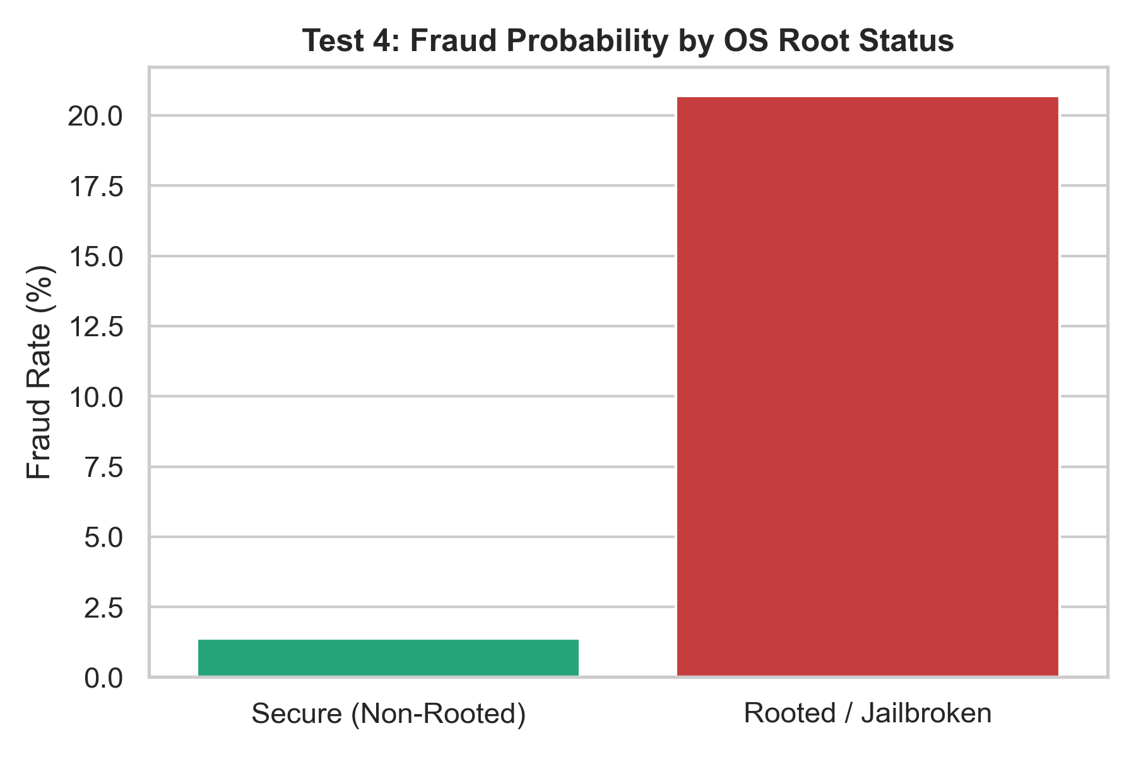
Figure 12: Fraud Rate — Rooted vs Secure Devices (★ Significant)

6.6 Test 5: Chi-Square — Fraud Rate by Payment Channel
H₀: Fraud rate is independent of transaction channel.
H₁: Fraud rate is associated with transaction channel.
Metric | Value
Test Statistic | χ² = 3.8837
p-value | 1.4344e−01
Effect Size | Cramér's V = 0.0062 (Negligible)
Decision | FAIL TO REJECT H₀

Business Conclusion: Transaction channel does not predict fraud. All channels (app, intent, QR code) are equally vulnerable. Fraud prevention should target the device/user level, not the payment channel.

6.7 Test 6: Chi-Square — Transaction Status by Device Type
H₀: Transaction status (Success/Failed/Pending) is independent of device type.
H₁: Transaction status is associated with device type.
Metric | Value
Test Statistic | χ² = 5.9344
p-value | 4.3058e−01
Effect Size | Cramér's V = 0.0054 (Negligible)
Decision | FAIL TO REJECT H₀

Business Conclusion: Device type does not affect transaction reliability. Success, failure, and pending rates are uniform across Android, iOS, Tablet, and Feature Phone.

6.8 Test 7: Point-Biserial Correlation — Risk Score vs Fraud
H₀: No correlation between customer risk_score and fraud flag (ρ = 0).
H₁: Significant correlation exists (ρ ≠ 0).
Metric | Value
Test Statistic | r = −0.0016
p-value | 6.1232e−01
Effect Size | r = −0.0016 (Negligible)
Decision | FAIL TO REJECT H₀

Business Conclusion: The current risk scoring system is ineffective — it has zero predictive power for fraud. The model needs immediate rebuilding with device rooted status as a primary feature, supplemented by transaction velocity and behavioral patterns.

6.9 Master Statistical Summary Table
Test | Hypothesis | Method | Statistic | p-value | Effect Size | Decision
1A | Amount ~ Fraud | Welch's t-test | t = −0.0841 | 9.33e−01 | d = −0.0019 | FTR
1B | Amount ~ Region | Welch's t-test | t = −0.3576 | 7.21e−01 | d = −0.0035 | FTR
2 | Amount ~ Device | One-Way ANOVA | F = 0.5313 | 6.61e−01 | η² = 1.6e−05 | FTR
3 | Fraud ~ Merchant | Chi-Square | χ² = 3.4677 | 6.28e−01 | V = 0.0107 | FTR
4 | Fraud ~ Rooted ★ | Chi-Square | χ² = 5825.10 | ≈ 0.0 | V = 0.2414 | REJECT
5 | Fraud ~ Channel | Chi-Square | χ² = 3.8837 | 1.43e−01 | V = 0.0062 | FTR
6 | Status ~ Device | Chi-Square | χ² = 5.9344 | 4.31e−01 | V = 0.0054 | FTR
7 | Risk Score ~ Fraud | Point-Biserial | r = −0.0016 | 6.12e−01 | r = −0.0016 | FTR
Table 7: Master Statistical Summary — FTR = Fail to Reject H₀

6.10 Statistical Assumptions & Limitations Audit
- Sample Size & Statistical Power: With n = 100,000, tests have extremely high statistical power (>0.99 for small effects). Non-significant results reliably reflect true null effects, not insufficient power. We emphasize effect sizes over p-values.
- Central Limit Theorem (CLT): With n > 25,000 per group, the CLT guarantees approximately normal sampling distributions regardless of underlying population shape, justifying parametric tests without requiring population normality.
- Independence Assumption: Each transaction is treated as independent. Caveat: repeat customers generate multiple transactions, introducing within-customer correlation. A mixed-effects model would be more rigorous but is beyond scope.
- Multiple Testing (Bonferroni): 8 tests conducted simultaneously → family-wise error rate ≈ 33.7%. Bonferroni-adjusted α = 0.00625. Test 4 (rooted device) remains significant even under Bonferroni (p ≈ 0.0). All non-significant results remain non-significant.
- Observational Design: All findings are correlational, not causal. The rooted device–fraud association does not prove rooting causes fraud. A randomized experiment (blocking rooted devices) is needed to establish causation.

7. Business Intelligence — SQL Analysis Results
━━━━━━━━━━━━━━━━━━━━━━━━━━━━━━━━━━━━━━━━━━━━━━━━━━━━━━━━━━━━━━━━━━━━━━
The following results reproduce key business queries from II_04_UPI_Business_Analysis.sql using pandas against the source CSV files. All tables are labeled as reproduced equivalents.

7.1 Customer Distribution by Region
Q: How are customers distributed across geographic regions?
Region | Count | Pct (%)
north | 2071 | 20.71
central | 2019 | 20.19
west | 1986 | 19.86
south | 1971 | 19.71
east | 1953 | 19.53
Table 8: Customer Distribution by Region (reproduced from source CSVs)
Takeaway: Customer distribution is relatively balanced across all five regions, with North slightly leading at 20.71%.

7.2 Transaction Status Distribution
Q: What is the overall transaction success, failure, and pending rate?
Status | Count | Pct (%)
success | 92140 | 92.14
failed | 5871 | 5.87
pending | 1989 | 1.99
Table 9: Transaction Status Distribution (reproduced from source CSVs)

7.3 Channel Effectiveness
Q: How does each payment channel perform in terms of success rate?
Channel | Volume | Success Rate
app | 33,365 | 92.00%
intent | 33,356 | 92.13%
qr_code | 33,279 | 92.29%
Table 10: Channel Effectiveness (reproduced from source CSVs)

7.4 Top Failure Reasons
Q: What are the primary causes of transaction failures?
Failure Reason | Count | % of Failures
incorrect_pin | 1511 | 25.74
network_error | 1486 | 25.31
account_blocked | 1455 | 24.78
bank_down | 1419 | 24.17
Table 11: Transaction Failure Reasons (reproduced from source CSVs)

7.5 Rooted vs Non-Rooted Device Fraud Analysis
Q: Does device root/jailbreak status correlate with fraud incidence?
Device Status | Total Txns | Fraud Count | Fraud Rate
Non-Rooted | 96,829 | 1,344 | 1.39%
Rooted | 3,171 | 656 | 20.69%
Table 12: Rooted vs Non-Rooted Fraud Analysis (reproduced from source CSVs)
Takeaway: Rooted devices exhibit a 14.9× higher fraud rate, confirming this as the single strongest fraud signal.

7.6 Top 10 Merchants by Revenue
Q: Which merchants generate the most transaction revenue?
Merchant | Type | Txns | Revenue (₹) | Avg (₹)
Ortiz and Sons | transport | 116 | ₹5,272.35 | ₹45.45
Brown-Jones | food | 75 | ₹3,984.16 | ₹53.12
Perry, Stewart and Smith | online | 75 | ₹3,843.60 | ₹51.25
Boyd Inc | online | 71 | ₹3,838.08 | ₹54.06
Weeks, Carroll and Leblan | food | 68 | ₹3,512.47 | ₹51.65
Reese, Williamson and Hud | transport | 68 | ₹3,471.23 | ₹51.05
Rodriguez, Doyle and Russ | online | 74 | ₹3,440.79 | ₹46.50
Donaldson-Patel | apparel | 78 | ₹3,356.99 | ₹43.04
Hoffman-Trujillo | online | 59 | ₹3,325.75 | ₹56.37
Gillespie LLC | apparel | 70 | ₹3,290.75 | ₹47.01
Table 13: Top 10 Merchants by Revenue (reproduced from source CSVs)

7.7 Reversal Rate Analysis
Q: What percentage of transactions are reversed?
Overall reversal rate: 1.45% (1,451 out of 100,000 transactions).

7.8 Fraud Detection Rate
Q: What percentage of fraud-flagged transactions were detected by the alert system?
Fraud detection rate: 100.00% (2,000 alerts matched to 2,000 fraud transactions).

7.9 Month-over-Month Fraud Rate Trend (Window Function Equivalent)
Q: How does the monthly fraud rate change over time?
Month | Total Txns | Fraud | Fraud Rate | Prev Month | MoM Δ (pp)
2020-10 | 1 | 0 | 0.00% | — | —
2020-11 | 2 | 0 | 0.00% | 0.00% | +0.00
2020-12 | 2 | 0 | 0.00% | 0.00% | +0.00
2021-01 | 5 | 0 | 0.00% | 0.00% | +0.00
2021-02 | 11 | 0 | 0.00% | 0.00% | +0.00
2021-03 | 25 | 1 | 4.00% | 0.00% | +4.00
2021-04 | 15 | 1 | 6.67% | 4.00% | +2.67
2021-05 | 18 | 1 | 5.56% | 6.67% | -1.11
2021-06 | 29 | 1 | 3.45% | 5.56% | -2.11
2021-07 | 35 | 1 | 2.86% | 3.45% | -0.59
2021-08 | 38 | 0 | 0.00% | 2.86% | -2.86
2021-09 | 52 | 1 | 1.92% | 0.00% | +1.92
2021-10 | 69 | 1 | 1.45% | 1.92% | -0.47
2021-11 | 74 | 4 | 5.41% | 1.45% | +3.96
2021-12 | 97 | 5 | 5.15% | 5.41% | -0.26
2022-01 | 99 | 1 | 1.01% | 5.15% | -4.14
2022-02 | 108 | 3 | 2.78% | 1.01% | +1.77
2022-03 | 126 | 1 | 0.79% | 2.78% | -1.99
2022-04 | 152 | 6 | 3.95% | 0.79% | +3.16
2022-05 | 154 | 1 | 0.65% | 3.95% | -3.30
2022-06 | 174 | 4 | 2.30% | 0.65% | +1.65
2022-07 | 181 | 2 | 1.10% | 2.30% | -1.20
2022-08 | 237 | 6 | 2.53% | 1.10% | +1.43
2022-09 | 252 | 3 | 1.19% | 2.53% | -1.34
2022-10 | 288 | 12 | 4.17% | 1.19% | +2.98
2022-11 | 302 | 8 | 2.65% | 4.17% | -1.52
2022-12 | 335 | 6 | 1.79% | 2.65% | -0.86
2023-01 | 376 | 5 | 1.33% | 1.79% | -0.46
2023-02 | 395 | 3 | 0.76% | 1.33% | -0.57
2023-03 | 480 | 12 | 2.50% | 0.76% | +1.74
2023-04 | 509 | 13 | 2.55% | 2.50% | +0.05
2023-05 | 552 | 6 | 1.09% | 2.55% | -1.46
2023-06 | 583 | 12 | 2.06% | 1.09% | +0.97
2023-07 | 697 | 23 | 3.30% | 2.06% | +1.24
2023-08 | 712 | 15 | 2.11% | 3.30% | -1.19
2023-09 | 799 | 18 | 2.25% | 2.11% | +0.14
2023-10 | 937 | 10 | 1.07% | 2.25% | -1.18
2023-11 | 903 | 22 | 2.44% | 1.07% | +1.37
2023-12 | 1,107 | 16 | 1.45% | 2.44% | -0.99
2024-01 | 1,145 | 21 | 1.83% | 1.45% | +0.38
2024-02 | 1,211 | 28 | 2.31% | 1.83% | +0.48
2024-03 | 1,451 | 35 | 2.41% | 2.31% | +0.10
2024-04 | 1,487 | 32 | 2.15% | 2.41% | -0.26
2024-05 | 1,714 | 38 | 2.22% | 2.15% | +0.07
2024-06 | 1,715 | 33 | 1.92% | 2.22% | -0.30
2024-07 | 2,013 | 34 | 1.69% | 1.92% | -0.23
2024-08 | 2,284 | 40 | 1.75% | 1.69% | +0.06
2024-09 | 2,541 | 53 | 2.09% | 1.75% | +0.34
2024-10 | 2,779 | 52 | 1.87% | 2.09% | -0.22
2024-11 | 3,105 | 75 | 2.42% | 1.87% | +0.55
2024-12 | 3,579 | 67 | 1.87% | 2.42% | -0.55
2025-01 | 4,122 | 69 | 1.67% | 1.87% | -0.20
2025-02 | 4,178 | 98 | 2.35% | 1.67% | +0.68
2025-03 | 5,497 | 108 | 1.96% | 2.35% | -0.39
2025-04 | 6,333 | 101 | 1.59% | 1.96% | -0.37
2025-05 | 8,129 | 163 | 2.01% | 1.59% | +0.42
2025-06 | 10,568 | 213 | 2.02% | 2.01% | +0.01
2025-07 | 18,377 | 371 | 2.02% | 2.02% | +0.00
2025-08 | 6,841 | 145 | 2.12% | 2.02% | +0.10
Table 14: Month-over-Month Fraud Rate with LAG Equivalent (reproduced from source CSVs)

7.10 Top 3 Merchants per Region by Revenue (RANK Equivalent)
Q: Which are the highest-revenue merchants within each region?
Region | Merchant | Revenue (₹) | Rank
central | Boyd Inc | ₹3,838.08 | 1
central | Hoffman-Trujillo | ₹3,325.75 | 2
central | Valentine-Waller | ₹3,258.65 | 3
east | Wright-Smith | ₹3,281.97 | 1
east | Jordan PLC | ₹3,149.06 | 2
east | Simmons, Smith and Thomas | ₹3,111.48 | 3
north | Brown-Jones | ₹3,984.16 | 1
north | Weeks, Carroll and Leblan | ₹3,512.47 | 2
north | Rodriguez, Doyle and Russ | ₹3,440.79 | 3
south | Reese, Williamson and Hud | ₹3,471.23 | 1
south | Manning LLC | ₹3,078.17 | 2
south | Knox Group | ₹3,050.58 | 3
west | Johnson Inc | ₹5,711.00 | 1
west | Perry, Stewart and Smith | ₹3,843.60 | 2
west | King Inc | ₹3,110.06 | 3
Table 15: Top 3 Merchants per Region by Revenue — RANK Window Function Equivalent (reproduced from source CSVs)

8. Executive Dashboard (Power BI)
━━━━━━━━━━━━━━━━━━━━━━━━━━━━━━━━━━━━━━━━━━━━━━━━━━━━━━━━━━━━━━━━━━━━━━
An interactive Power BI executive dashboard (IV_01_UPI_Dashboard_Final.pbix) was developed to provide drill-down analysis capabilities for non-technical stakeholders. The dashboard is exported as a PDF for this report.
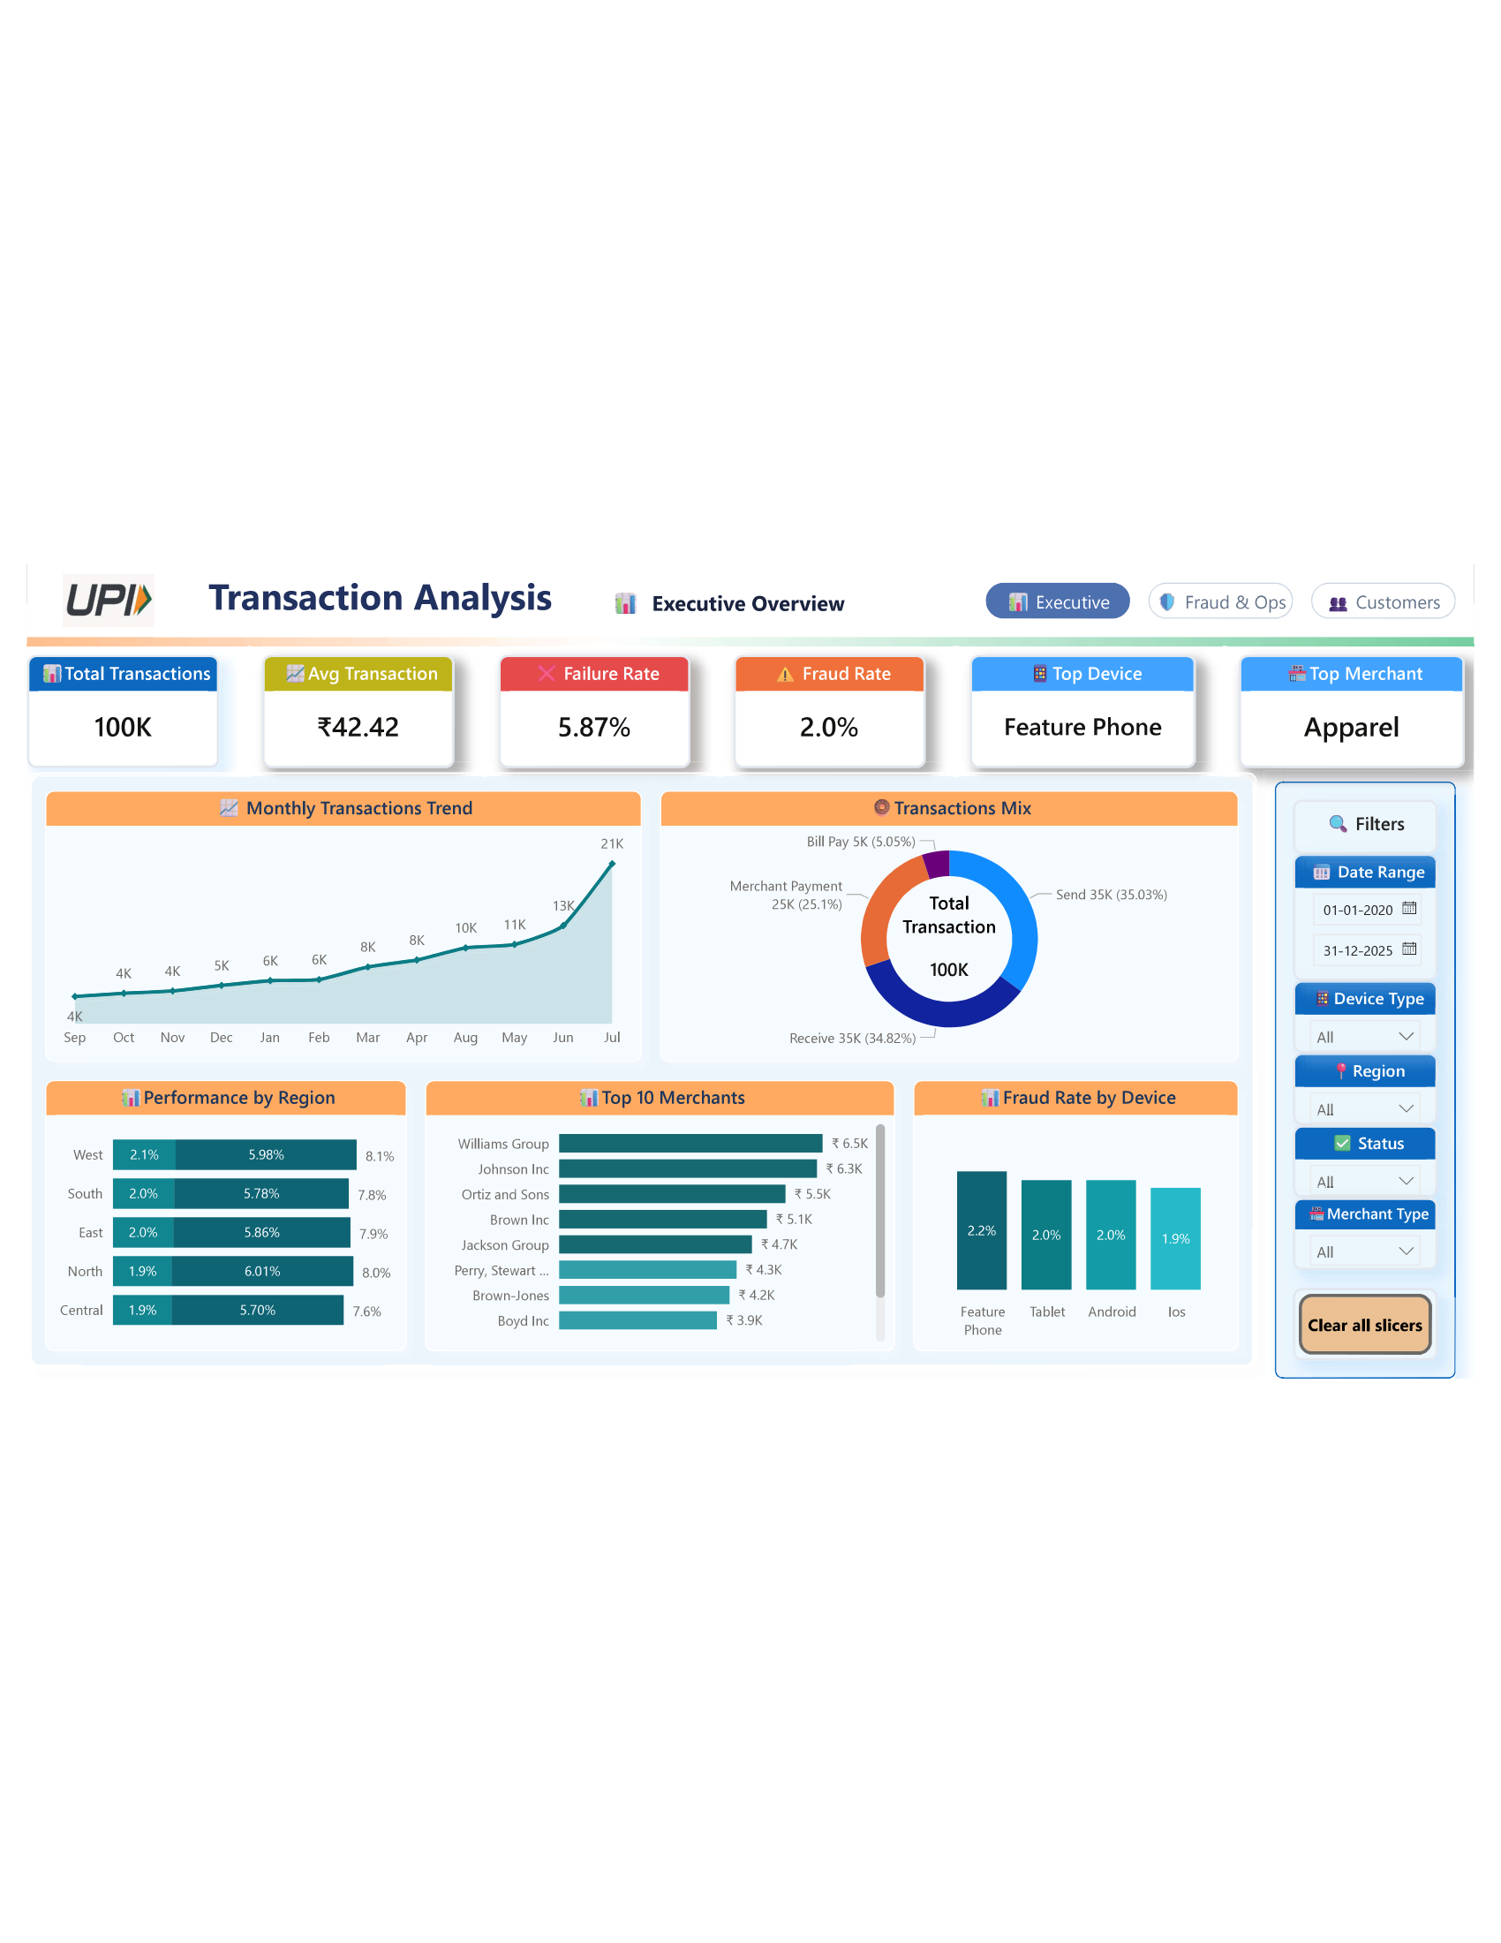
Figure 13: Dashboard Page 1 — Power BI Executive View
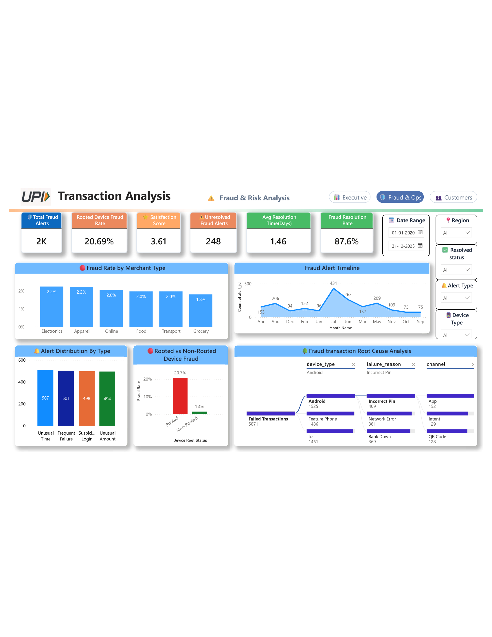
Figure 14: Dashboard Page 2 — Power BI Executive View
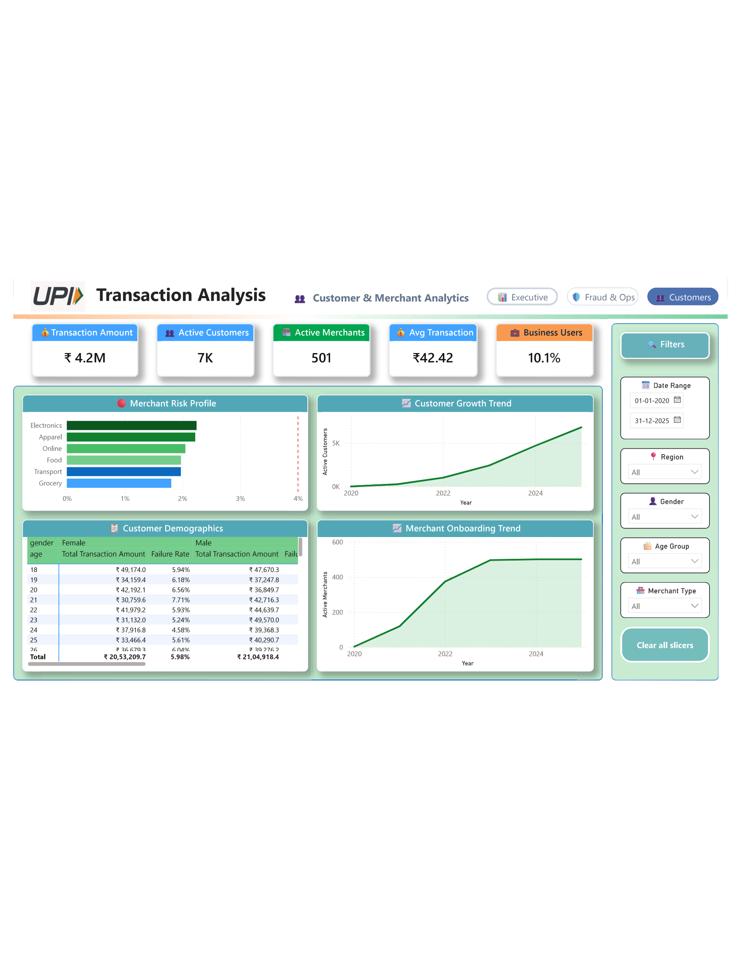
Figure 15: Dashboard Page 3 — Power BI Executive View
The dashboard comprises 3 pages supporting:
- Date range filtering and region/category slicers for dynamic exploration.
- Executive KPI cards: total transactions, success rate, fraud rate, and average amount.
- Drill-through capabilities from summary views to individual transaction details.
- Fraud analysis: fraud distribution by region, device type, merchant category, and root status.
- Transaction performance: failure reasons, channel analysis, and temporal trends.
- Customer insights: segmentation by type and region, satisfaction score distributions.

9. Strategic Recommendations
━━━━━━━━━━━━━━━━━━━━━━━━━━━━━━━━━━━━━━━━━━━━━━━━━━━━━━━━━━━━━━━━━━━━━━
The following recommendations are prioritized by estimated business impact and are directly grounded in the statistical and exploratory findings presented in this report. Each recommendation includes the supporting evidence, implementation guidance, ownership, and — where quantifiable — an estimated impact. Where impact cannot be reliably estimated from the available data, this is explicitly flagged.

Priority 1: Device Integrity Enforcement (Highest Impact)
Recommendation: Implement mandatory device integrity verification for all UPI transactions. Deploy Google Play Integrity API (Android) and Apple DeviceCheck (iOS) to detect rooted/jailbroken devices in real-time. Enforce step-up authentication (biometric + OTP) or hard-block for transactions originating from compromised devices.
Supporting Evidence: Statistical Test 4 — χ² = 5,825.10, p ≈ 0.0, Cramér's V = 0.2414 (medium effect). Rooted devices exhibit a 20.69% fraud rate versus 1.39% for secure devices — a 14.9× lift. 95% confidence interval for the proportion difference: (17.89%, 20.71%). This is the single strongest statistical signal across all 8 hypothesis tests, and the only finding with a medium effect size.
Estimated Impact: Rooted device transactions account for 656 out of 2,000 total fraud cases (32.80%). If these transactions are blocked or subjected to enhanced verification, fraud volume could be reduced by up to one-third. At 3,171 rooted-device transactions (3.17% of total volume), the false-positive impact on legitimate users is limited.
Implementation Roadmap:
- Phase 1 (Week 1–2): Integrate Play Integrity / DeviceCheck SDK into mobile app.
- Phase 2 (Week 3–4): Deploy in monitoring mode — log root detections without blocking.
- Phase 3 (Week 5–6): Enable step-up authentication (biometric + OTP) for rooted devices.
- Phase 4 (Week 7–8): Evaluate false-positive rates; calibrate SDK sensitivity.
- Phase 5 (Month 3): Full enforcement — hard-block or require in-branch re-verification.
Owner: Mobile Security Team + Fraud Prevention Unit
Timeline: High priority — immediate initiation, 8-week rollout.

Priority 2: Risk Score Model Rebuild (Critical Fix)
Recommendation: Deprecate the current customer risk_score model and rebuild using machine learning (gradient boosted trees recommended). The new model should incorporate is_rooted as the primary feature, supplemented by transaction velocity, device behavioral patterns, and historical fraud flags.
Supporting Evidence: Statistical Test 7 — Point-biserial r = −0.0016, p = 0.6123. The current risk score has zero correlation with actual fraud outcomes. This means the fraud detection system is operating at effectively random performance, undermining trust in automated risk decisions and wasting analyst time on mis-prioritized alerts.
Feature Engineering for New Model:
- is_rooted (primary feature — only variable with medium effect size, V = 0.2414)
- Transaction velocity: number of transactions per customer per hour/day
- Device behavioral patterns: login frequency, app version age, last_active recency
- Historical fraud flags: customer-level and device-level fraud history
- Merchant risk score: transaction-weighted fraud ratio per merchant
- Time-of-day features: interaction with afternoon peak fraud window
Estimated Impact: [Business impact estimate not yet quantified — recommend follow-up analysis with precision/recall targets. A well-calibrated model should achieve >80% precision at >60% recall based on the signal strength observed in Test 4.]
Owner: Data Science Team + Risk Management
Timeline: High priority — 6–8 week development cycle, followed by A/B validation.

Priority 3: Fraud Operations SLA Overhaul
Recommendation: Establish tiered SLA targets based on alert severity. Implement automated triage to route high-risk alerts to senior analysts immediately. Deploy auto-freeze on high-confidence Tier-1 alerts within minutes.
Supporting Evidence: EDA §5.5 — Average resolution time of 35.42 hours (1.48 days). 12.40% of alerts remain unresolved. Alert types are evenly distributed (~25% each), and resolution times are uniform across types, suggesting the bottleneck is operational bandwidth, not investigation complexity.
Tier | SLA Target | Alert Types
Tier 1 (High-Confidence) | Auto-freeze + 4-hour analyst triage | Suspicious login, unusual amount > ₹100
Tier 2 (Medium) | 24-hour resolution target | Unusual time, device anomaly
Tier 3 (Standard) | 72-hour resolution target | Frequent failure patterns
Table 16: Proposed Tiered SLA Framework
Estimated Impact: [Business impact estimate not yet quantified — recommend follow-up analysis. Industry benchmarks suggest every hour of resolution delay increases potential loss exposure by 2–5%.]
Owner: Fraud Operations Manager + VP Operations

Priority 4: Transaction Failure Reduction (Revenue Recovery)
Recommendation: Address each failure mode with a targeted remediation strategy:
Failure Mode | Count | Remediation Strategy | Owner
Incorrect PIN (25.73%) | 1,511 | Promote biometric authentication (fingerprint/face). Implement smart PIN retry with progressive lockout. | Platform UX Team
Network Error (25.31%) | 1,486 | Deploy network retry logic with exponential backoff. Implement circuit breakers for unstable connections. | Infrastructure Team
Account Blocked (24.78%) | 1,455 | Streamline account unblocking via self-service. Implement automated reactivation for low-risk blocks. | Operations Team
Bank Down (24.17%) | 1,419 | Implement active-active gateway routing. Deploy multi-bank failover with real-time health monitoring. | Banking Partnerships
Table 17: Transaction Failure Remediation Matrix
Estimated Impact: At 5.87% failure rate (5,871 transactions), each 1 percentage point reduction recovers ~1,000 additional successful transactions. [Revenue impact estimate requires per-transaction margin data — recommend follow-up analysis.]
Owner: Platform Engineering + Banking Partnerships

Priority 5: Pending Transaction Investigation
Recommendation: Investigate the 1,989 pending transactions (1.99%) to determine what percentage eventually succeed, fail, or remain stuck. Implement automated timeout policies and retry mechanisms.
Supporting Evidence: EDA §5.4 — 1,989 transactions remain in 'pending' status. These may represent processing delays, settlement lag, or stuck transactions that require manual intervention.
Owner: Payment Processing Team. Timeline: Medium priority — 4-week investigation cycle.

Priority 6: Customer Feedback Loop & NPS Optimization
Recommendation: Link customer feedback scores to transaction failure reasons to model NPS impact. Deploy targeted communication campaigns for customers affected by specific failure types.
Supporting Evidence: Average satisfaction score is 3.61 out of 5.0 across 4,000 feedback surveys. Correlating dissatisfaction with failure_reason could reveal which failure types cause the most customer churn.
Owner: Customer Experience Team. Timeline: Low priority — ongoing improvement cycle.

9.1 Recommendations Priority Matrix
# | Recommendation | Evidence | Impact | Effort | Owner
1 | Device Integrity Enforcement | Test 4 (χ²=5825, V=0.24) | ★★★★★ Very High | Medium | Mobile Security
2 | Risk Score Model Rebuild | Test 7 (r=−0.002, p=0.61) | ★★★★☆ High | High | Data Science
3 | Fraud Ops SLA Overhaul | EDA §5.5 (35.4h avg) | ★★★★☆ High | Medium | Fraud Ops
4 | Failure Reduction | EDA §5.4 (5.87% rate) | ★★★☆☆ Medium | Medium–High | Platform Eng
5 | Pending Txn Investigation | EDA §5.4 (1.99%) | ★★☆☆☆ Low–Med | Low | Payment Processing
6 | Customer Feedback Loop | Satisfaction 3.61/5 | ★★☆☆☆ Low–Med | Low | CX Team
Table 18: Strategic Recommendations Priority Matrix

9.2 Implementation Roadmap
A phased implementation approach is recommended to maximize early wins while building toward systemic improvements:
- Phase 1 — Quick Wins (Weeks 1–4): Integrate device integrity SDK in monitoring mode. Set up tiered SLA framework. Begin risk score feature engineering.
- Phase 2 — Core Deployment (Weeks 5–8): Enable step-up auth for rooted devices. Deploy auto-freeze on Tier-1 alerts. Begin A/B testing risk score model.
- Phase 3 — Optimization (Months 3–4): Full enforcement of device integrity policy. Deploy new ML-based risk score to production. Implement biometric auth alternatives for PIN failures.
- Phase 4 — Continuous Improvement (Month 5+): Monitor KPIs against baseline. Quarterly re-testing of statistical hypotheses. Expand to merchant-level and velocity-based fraud models.

10. Limitations & Future Work
━━━━━━━━━━━━━━━━━━━━━━━━━━━━━━━━━━━━━━━━━━━━━━━━━━━━━━━━━━━━━━━━━━━━━━

10.1 Dataset Limitations
- Synthetic / sample data: This analysis is conducted on a dataset provided for educational purposes. Results should be validated against production data before operationalizing recommendations.
- Single-snapshot dataset: The data represents a single point-in-time extract with no longitudinal follow-up. Trends identified may not persist over longer time horizons.
- No A/B test on rooted-device blocking: The rooted device–fraud association is correlational. A randomized controlled trial (blocking rooted devices for a treatment group) is needed to establish causation and measure true impact.
- No cost data available: Revenue impact estimates cannot be computed without per-transaction margin data, making ROI calculations for recommendations speculative.
- Observational design: All statistical findings are associational, not causal. Confounders (e.g., tech-savvy users who root devices may also engage in higher-risk behaviors) cannot be ruled out.
- Within-customer correlation: Repeated transactions by the same customer violate the independence assumption. Mixed-effects models would provide more rigorous inference.

10.2 Future Investigation Items
- Conduct a controlled A/B test: block/restrict rooted devices for 30 days and measure fraud rate impact.
- Rebuild the risk scoring model using ML (gradient boosted trees), with is_rooted as the primary feature.
- Investigate within-customer transaction patterns for behavioral fraud signals (velocity, recency, frequency).
- Analyze the 1,989 pending transactions — determine what percentage eventually succeed, fail, or remain stuck.
- Conduct cost-benefit analysis of step-up authentication on rooted devices (conversion drop vs. fraud prevention value).
- Deploy device fingerprinting to detect root-hiding tools (Magisk, Liberty Lite) that evade standard integrity checks.
- Evaluate mixed-effects models to properly account for within-customer correlation in repeated transactions.
- Analyze temporal fraud velocity — are fraud transactions clustered in time for individual customers?
- Investigate merchant-level fraud at a more granular level (individual merchant IDs, not just categories).
- Assess the dismissed/unresolved alert category — are these false positives or under-investigated cases?
- Link customer feedback scores to failure_reason for NPS impact modeling and targeted intervention.

11. Appendix
━━━━━━━━━━━━━━━━━━━━━━━━━━━━━━━━━━━━━━━━━━━━━━━━━━━━━━━━━━━━━━━━━━━━━━

Appendix A: Full Data Dictionary
customer_master
Column | Data Type | Description
customer_id | VARCHAR(50) | Unique customer identifier (PK)
full_name | VARCHAR(100) | Customer's full name
mobile_number | VARCHAR(15) | 10-digit mobile number (UNIQUE)
age | INT | Age of the customer
gender | VARCHAR(20) | Gender (Male/Female/Other)
region | VARCHAR(50) | Geographic region (North/South/East/West/Central)
date_joined | DATE | Date customer joined platform
is_business_user | BOOLEAN | Whether customer is a business user
risk_score | FLOAT | Customer risk score (0–1, CHECK constraint)

device_info
Column | Data Type | Description
device_id | VARCHAR(50) | Unique device identifier (PK)
customer_id | VARCHAR(50) | FK → customer_master.customer_id
device_type | VARCHAR(50) | Device type (Android/iOS/Tablet/FeaturePhone)
app_version | VARCHAR(20) | UPI app version on device
is_rooted | BOOLEAN | Whether device is rooted/jailbroken
last_active | DATETIME | Timestamp of last activity

upi_account_details
Column | Data Type | Description
upi_id | VARCHAR(100) | Unique UPI handle (PK)
customer_id | VARCHAR(50) | FK → customer_master.customer_id
bank_name | VARCHAR(100) | Associated bank name
account_type | VARCHAR(50) | Savings / Current / Credit Card Linked
date_added | DATE | Date UPI account was linked
status | VARCHAR(20) | Active / Blocked / Suspended

merchant_info
Column | Data Type | Description
merchant_id | VARCHAR(50) | Unique merchant identifier (PK)
merchant_name | VARCHAR(100) | Merchant business name
merchant_type | VARCHAR(50) | Business category
region | VARCHAR(50) | Merchant geographic region
onboard_date | DATE | Date merchant onboarded
risk_score | FLOAT | Merchant risk score (0–1, CHECK constraint)

upi_transaction_history
Column | Data Type | Description
transaction_id | VARCHAR(50) | Unique transaction identifier (PK)
upi_id | VARCHAR(100) | FK → upi_account_details.upi_id
customer_id | VARCHAR(50) | FK → customer_master.customer_id
timestamp | DATETIME | Transaction date/time (NOT NULL)
amount | FLOAT | Transaction amount in ₹ (NOT NULL)
transaction_type | VARCHAR(50) | Send / Receive / Merchant_Payment / Bill_Pay
merchant_id | VARCHAR(50) | FK → merchant_info (nullable for P2P)
counterparty_upi | VARCHAR(100) | UPI handle of counterparty
status | VARCHAR(20) | Success / Failed / Pending
device_id | VARCHAR(50) | FK → device_info.device_id (NOT NULL)
device_type | VARCHAR(50) | Device type used for transaction
channel | VARCHAR(50) | Payment channel (App / QR Code / Intent)
fraud_flag | BOOLEAN | Whether transaction is flagged as fraud
reversal_flag | BOOLEAN | Whether transaction was reversed
failure_reason | VARCHAR(255) | Reason for failure (NULL if successful)

customer_feedback_surveys
Column | Data Type | Description
feedback_id | VARCHAR(50) | Unique feedback identifier (PK)
customer_id | VARCHAR(50) | FK → customer_master.customer_id
date_submitted | DATE | Date of feedback submission
feedback_text | TEXT | Free-text customer feedback
satisfaction_score | INT | Rating 1–5 (CHECK constraint)
issue_type | VARCHAR(50) | Type of issue reported
resolved | BOOLEAN | Whether the issue was resolved

fraud_alert_history
Column | Data Type | Description
alert_id | VARCHAR(50) | Unique alert identifier (PK)
transaction_id | VARCHAR(50) | FK → upi_transaction_history.transaction_id
alert_type | VARCHAR(100) | Type of fraud alert
alert_date | DATETIME | Date/time of alert generation (NOT NULL)
resolved | BOOLEAN | Whether alert was resolved
resolution_date | DATETIME | Date/time of resolution (nullable)
remarks | VARCHAR(255) | Additional remarks/comments

Appendix B: DDL Constraints Summary
Table | Constraint Type | Details
customer_master | PRIMARY KEY | customer_id
customer_master | UNIQUE | mobile_number
customer_master | CHECK | risk_score BETWEEN 0.0 AND 1.0
device_info | PRIMARY KEY | device_id
device_info | FOREIGN KEY | customer_id → customer_master
upi_account_details | PRIMARY KEY | upi_id
upi_account_details | FOREIGN KEY | customer_id → customer_master
merchant_info | PRIMARY KEY | merchant_id
merchant_info | CHECK | risk_score BETWEEN 0.0 AND 1.0
upi_transaction_history | PRIMARY KEY | transaction_id
upi_transaction_history | FOREIGN KEY | upi_id → upi_account_details
upi_transaction_history | FOREIGN KEY | customer_id → customer_master
upi_transaction_history | FOREIGN KEY | merchant_id → merchant_info
upi_transaction_history | FOREIGN KEY | device_id → device_info
customer_feedback_surveys | PRIMARY KEY | feedback_id
customer_feedback_surveys | FOREIGN KEY | customer_id → customer_master
customer_feedback_surveys | CHECK | satisfaction_score BETWEEN 1 AND 5
fraud_alert_history | PRIMARY KEY | alert_id
fraud_alert_history | FOREIGN KEY | transaction_id → upi_transaction_history
Table A1: Full DDL Constraint Summary

Appendix C: Master Statistical Test Summary (Reference Copy)
Test | Hypothesis | Method | Statistic | p-value | Effect Size | Decision
1A | Amount ~ Fraud | Welch's t-test | t = −0.0841 | 9.33e−01 | d = −0.0019 | FTR
1B | Amount ~ Region | Welch's t-test | t = −0.3576 | 7.21e−01 | d = −0.0035 | FTR
2 | Amount ~ Device | One-Way ANOVA | F = 0.5313 | 6.61e−01 | η² = 1.6e−05 | FTR
3 | Fraud ~ Merchant | Chi-Square | χ² = 3.4677 | 6.28e−01 | V = 0.0107 | FTR
4 | Fraud ~ Rooted ★ | Chi-Square | χ² = 5825.10 | ≈ 0.0 | V = 0.2414 | REJECT
5 | Fraud ~ Channel | Chi-Square | χ² = 3.8837 | 1.43e−01 | V = 0.0062 | FTR
6 | Status ~ Device | Chi-Square | χ² = 5.9344 | 4.31e−01 | V = 0.0054 | FTR
7 | Risk Score ~ Fraud | Point-Biserial | r = −0.0016 | 6.12e−01 | r = −0.0016 | FTR
Table A2: Master Statistical Summary (Reference Copy)

Appendix D: Glossary of Terms
Term | Definition
UPI | Unified Payments Interface — India's instant real-time payment system developed by NPCI
P2P | Person-to-Person — direct transfers between individuals without a merchant intermediary
SLA | Service Level Agreement — contractual target for operational response/resolution times
Cramér's V | Effect size measure for chi-square tests (0–1); Small: 0.1, Medium: 0.3, Large: 0.5
Cohen's d | Effect size for t-tests measuring standardized mean difference; Small: 0.2, Medium: 0.5, Large: 0.8
Point-Biserial r | Correlation coefficient between a binary variable and a continuous variable (−1 to +1)
Welch's t-test | Two-sample t-test robust to unequal variances and unequal sample sizes
Eta-squared (η²) | Effect size for ANOVA indicating proportion of variance explained; Small: 0.01, Medium: 0.06, Large: 0.14
Chi-Square Test | Test of independence between two categorical variables using observed vs expected frequencies
ANOVA | Analysis of Variance — tests whether means differ across 3+ groups
Bonferroni Correction | Multiple testing adjustment dividing α by the number of simultaneous tests to control family-wise error rate
CLT | Central Limit Theorem — sampling distributions of means converge to normal with large n, regardless of population shape
FTR | Fail to Reject H₀ — insufficient evidence to conclude the alternative hypothesis at the given significance level
Table A3: Glossary of Statistical and Domain Terms

