INTERNATIONAL UNIVERSITY

Vietnam National University – Ho Chi Minh City



Software Engineering Report

PHARMACY MANAGEMENT SYSTEM

Course: Software Engineering | Instructor: Ms. Nguyen Thi Thuy Loan

*December 9, 2020*

*Prepared By:*​

Du Duy Bao ITITIU17106

Mai Hoang Long ITITIU17108

Nguyen Tran The Duy ITITIU17017

**Contents**

PART 1: Introduction 3

1.1 Purpose 3

1.2 Scope 3

1.3 Objectives 3

1.4 Definitions & Abbreviations 4

1.5 Reference, Technology & Tools…………………………………………………………… 4

PART 2: Proposed System………………………………………………………………………….

2.1 Overview……………………………………………………………………………………

2.2 Functional Requirements…………………………………………………………………...

2.3 Non-Functional Requirements………………………………...............................................

​PART 3: Build System…………………………………………………………………………….

3.1 Use Case……………………………………………………………………………………...

3.1.1 Use Case Diagram…………………………………………………………………….

3.1.2 Use Case Description…………………………………………………………………

3.2 Object Model………………………………………………………………………………...

3.2.1 ERD

3.2.2 Class Diagram

3.3 Dynamic Model (Sequence Diagram) ………………………………………………………

3.4 User Interface…………………………………………………………………………………

3.4.1 Navigation Page…………………………………………………………………….

3.4.2 Register Form…………………………………………………………………………

3.4.3 Login Form…………………………………………………………………………….

3.4.4 Home Screen…………………………………………………………………………...

3.4.5 Product Details………………………………………………………………………...

3.4.6 Admin Main Page……………………………………………………………………

PART 4: Testing………………………………………………………………………………

4.1 Component Testing……………………………………………………………………………….

4.2 System Testing…………………………………………………………………………………… PART 5: Summary…………………………………………………………………………………...

5.1 Challenges & Problems…………………………………………………………………………

5.2 Orientation In The Future ………………………………………………................................

# 1. Introduction:

Nowadays, the increasing number of patients leads to the need for more and more drugs. That has caused an overload in some drug stores today. Overcrowding of patients, out of supply, wrong bills, expired drugs, and money loss occur frequently at drug stores, leading to the risk of bankruptcy. Also, the increasingly competitive market has resulted in pharmacies having to hire more staff for the job, which would cost the boss an extra amount of money to pay for their employees.

A more efficient of Pharmacy Management System is the solution to the above problems.

## 1.1 Purpose:

The major aim of this application is the management of the database of the pharmaceutical shop. This is done by creating a database of the available medicines in the shop. The database is then connected to the main program by using interconnection of the software program and the database already created.

In general, the pharmacy management system helps support and improve the ability to control and manage the pharmacy business. It makes everything easier, time-saving and more efficient, but ensures data security and safety.

## 1.2 Scope:

This program can be used in any pharmaceutical shops having a database to maintain. In addition, this application can also be used for businesses, distributors, drugstore chains, training activities, academia, research related to drugs.

The Pharmacy Application include the following areas:

+Orders management

+Patient management (Customer management)

+Stock management

+Employees management

## 1.3​ Objectives:

With three important objectives: conveniently, quickly and efficiently. The pharmacy management application will help users reduce the burden by the software used which can generate reports, as per the user’s requirements, print invoices, bills, receipts etc. It can also maintain the record of supplies sent in by the supplier.

These following are the works we need to do for this application:

* To support customers management.
* To provide sales report.
* To print and prepare invoices for customers.
* To reduce human errors
* To provide stock report

## 1.4​ Definitions & Abbreviations:

**Definitions**

|  |  |
| --- | --- |
| WORD | MEANING |
| SQLite | SQLite is a software library that deploys a SQL Database Engine, no server, no configuration is required, closed and compact. |
| Hardware | Physical component of a computer system |
| Software | The programs and other operating information used by a computer |
| Use-case | A use case is a methodology used in system analysis to identify, clarify and organize system requirements. |
| Flutter | Flutter is a cross-platform app development platform for iOS and  Android developed by Google |
| Android | Operating System |
| iOS | Operating System |
| Dart | The DART language is an object-oriented language introduced by Google in 2011. |
| Bug | An error, flaw, failure or fault in a computer program or system that causes it to produce an incorrect or unexpected result. |

**Abbreviations**

|  |  |
| --- | --- |
| WORD | MEANING |
| IU Design | User Interface Design |
| SDK | Software Development Kit |
| PMA | Pharmacy Management Application |
| App | Application |

**1.5**​  **Reference, Technology & Tools**

**1.5.1 Reference**

Why do you choose these references to create products?

1. [Flutter documentation - Flutter](https://flutter.dev/docs) : cause we use the Dart language and Flutter framework.​
2. [Free Vectors, Stock Photos & PSD Downloads | Freepik](https://www.freepik.com/):​ for image vector (high quality)
3. Udemy.com
4. [https://firebase.google.com/:](https://firebase.google.com/)​ Use for storing data, apply CRUD pattern

**1.5.2 Technology & tools**

IDE: Vscode, Android Studio

Adobe Photoshop

1. **Proposed System:**

**2.1 Overview:**

The pharmacy management application helps to manage user information and store that information through a pre-made database but is absolutely secure. Only persons under the management has been revised and replaced this information in accordance with the binding regulations.

At the same time, the System will handle all work related to inventory control by entering drug specific information and disposing according to the process. It also monitors the shipping history, the quantity of drugs per day to conduct automatic updating.

The pharmacy management system provides functions on identify medication usages instruction, minimize human errors in medication safety, facilitate accessibility of drugs’ information and information management among employees, providing optimal drugs movement in pharmacy unit, enable reports with in significantly short period of time, despite simultaneous usage of database for the purpose stated above.

**2.2**​  **Functional Requirements:**

* Store Order: The application store order information after customer purchase medicine - Store Medicine Data:
* Searching Medicine: The application search for proper medicine
* Update, Delete, Retrieve, Create medicine information: We create databases on firebase store information in it.
* Login: Allow registered users to login to the application and access to all feature of the app
* Sign up: User must register an account to login to the application
* Add to cart: After user press cart button, information of that product will be store in shopping cart - Buy medicine: After checking list of medicine in shopping cart, when user press order button. The system automatically store it in database and notify user with this message ‘Order successfully’

**2.3**​  **Non-Functional Requirements:**

* Auto-logout: Increase security for customer, when user press Logout button, it automatically navigate user to login page
* User interface: The interface is pretty easy to use for customer and pharmacist.
* Operation: The application will be controlled by the staff of pharmacy and user can buy medicine in this application.
* Implementation: We use flutter for designing UI and firebase for database, data will stored as JSON and synchronized in realtime to every connected customer.

1. **Build System**

**3.1 Use Case**

### ​3.1.1 Use Case Diagram

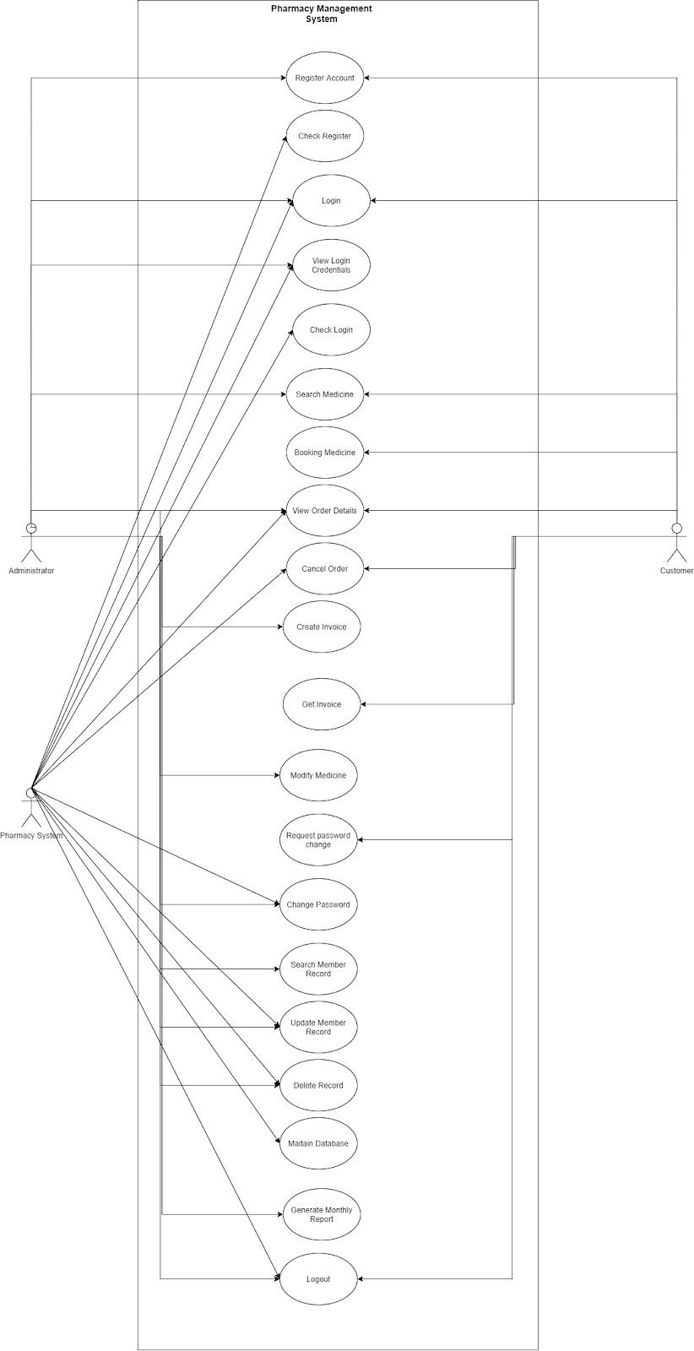

### 3.1.2 Use Case Description

​**UC-1: Register Account**

|  |  |
| --- | --- |
| Summary | The interface for users can register an account before login to the software. Information of the users at that session will be stored in the database. |
| Rationale | This is the first thing if you want to order medication with PMA. At the same time, this will also help users easily manage their own information |
| Users | All users |
| Preconditions | Don't have any account on the system yet |
| Basic Course of Event | 1. The user clicks the “Sign Up” button in the Navigation Page. 2. Then, the user is redirected to the account registration page. 3. The user enters full name, username, password & password again. 4. The user clicks the “Sign Up” button 5. If the information entered is valid, the system will display the user's profile page |
| Alternative Paths | Step 3: if duplicate usernames, then the System display and notify “This username already exists” to the right of the username. The user enters another username.  Step 3-4: The user can enter the “Cancel” button to return the navigation page. |
| Post conditions | Print out notify “Sign Up Successful” or “Sign Up Failed” after sign up |

**UC-2: Login to System**

|  |  |
| --- | --- |
| Summary | The interface for users can login to access the software. And the information of the users at that session |
| Rationale | This is the very first thing to make sure the user is Customer or Manager. And the security gate for anonymous users cannot access the database. |
| Users | All users |
| Preconditions | - The old login session is expired |
| Basic Course of Event | 1. The user clicks the “Login” button in the Navigation Page. 2. Then, the user is redirected to the login page. 3. The user enters username & password 4. The user clicks the “Login” button 5. If the information entered is valid, the system will display the homepage. |
| Alternative Paths | Step 3: if the user forgot the username of password   1. Choose “Forgot password” 2. Enter a request to the manager 3. Renew the username or password     Step 5: if the information entered is not correct   1. the software displays an notify “Error message”. 2. the user re-enter username & password     Step 3-4: The user can enter the “Cancel” button to return the navigation page. |
| Post conditions | Username & password is validated |

**UC-3: Logout to System**​

|  |  |
| --- | --- |
| Summary | The interface allows the user to terminate access to the application. |
| Rationale | Logout ensures that user access and user credentials are secure after the login session. |
| Users | All users |
| Preconditions | -The user signing in |
| Basic Course of Event | 1. In the homepage, the user clicks “Logout” button 2. The system displays a notification “Do you want a logout ?” 3. The user clicks “Yes” button 4. The system returns the Navigation page. |
| Alternative Paths | Step 3: if the user clicks the “No” button. The system returns the homepage. |
| Post conditions |  |

​**UC-4: Change Login Password**

|  |  |
| --- | --- |
| Summary | The interface allows the user change password |
| Rationale | Security information, avoid data loss |
| Users | Manager |
| Preconditions | Logged in as Manager user |
| Basic Course of Event | 1. Login with the Manager Account 2. Select navigate settings 3. Select “change password” 4. The app displays change password form 5. Enter old password 6. Enter new password 7. Re-Enter new password 8. Select “Ok” button |
| Alternative Paths | Step 6: old password duplicate with new password   1. The system displays “!” and notify: “The new password is the same as the old password”.Forcing users to re-enter 2. The user re-enter password 3. Click “Ok”     Step 4-8: The user can click “Cancel” to return the homepage. |
| Post conditions | Password is changed |

​**UC-5: Modify Medicine Data**

|  |  |
| --- | --- |
| Summary | The interface allow user update, add, delete medicine in system |
| Rationale | -Because of supplier change it’s necessary to update medicine  -Because of the medicine is out of date. |
| Users | Manager |
| Preconditions | Logged in as Manager user |
| Basic Course of Event | 1. ​ Login with the Staff account.​  2. ​ Select Menu from dashboard and click the “edit” tab.​  3. Select a medicine type and choose “edit”.​ |

​

|  |  |
| --- | --- |
|  | 4.​ Update information of a medicine type by filling​  information into the table.  5.​ Click the “update” button to save.​ |
| Alternative Paths | When manager want to delete a medicine type so in step  3:  1.​ Choose “delete” instead of “edit”.​  2.​ Choose “confirm” when the alert dialog appears.​  When manager want to add a medicine type so in step 2:  1.​ Choose the “add new medicine” button.​  2.​ Fill information of a medicine into the table.​  3. Click the “add” button to save. |
| Post conditions | -The medicine information is fully displayed on the homepage if add or update medicine.    -The medicine is disappear on the homepage if delete medicine |

**UC-6: Search for Medicine Information**

|  |  |
| --- | --- |
| Summary | The interface allows users to find information about the medicine which they need such as: name, id,type, amount, expired day... |
| Rationale | Convenient for buying, selling as well as updating medicines |
| Users | All Users |
| Preconditions | The User is signing |
| Basic Course of Event | 1. Enter the name of the drug to look up in the search bar 2. Select “search” or press “Enter” 3. Show a list of medicines to find |
| Alternative Paths | Step 3: if the system doesn't have information about that medicine . The system display notify “The medicine which you are looking for are not in the store” |
| Post conditions |  |

**UC-7: Booking Medicine**​

|  |  |
| --- | --- |
| Summary | The interface allows users order medicine |
| Rationale | This is a main function of the software, making the order with software help easy to track the order history, which kind of items is best sold, who was responsible for the order. |
| Users | Customer |
| Preconditions | -Logged in  -No order forms are currently in process |
| Basic Course of Event | 1. Customers choose the type medicines to order 2. Click directly on that medicine on the home page 3. The system displays product details page 4. Press "+" or "-" to increase or decrease the amount of the drug 5. Click "add to cart" on the product details page to proceed with adding to cart      1. Select the icon "basket" of the upper right corner of the product 2. The software will calculate the total price and show all information of the orders to the secondary monitor. 3. Customer selects "checkout" to complete the checkout process |
| Alternative Paths | Step 5: Customers can choose to "buy now" to initiate a direct payment for that medicine    Step 8: Customer can select “Cancel payment” if the customer does not want to buy that medicine. The system returns the homepage. |
| Post conditions | After checkout the system display “Payment successful” or “Payment failed” |

**UC-8: Make report**​

|  |  |
| --- | --- |
| Summary | Make the monthly report about working hours history and business status. |
| Rationale | The report is very important for reviewing past profit.  Making the report will help the manager easily track the |
|  | business, labor working state, and have a suitable improvement for the set of goods . |
| Users | Manager |
| Preconditions | * Logged in as Manager user. * The software is in the Report interface. |
| Basic Course of Event | 1. The​ manager enters the beginning and end date for getting data, monthly, annually or weekly. 2. The​ software fetch data in a selected time range and calculate the summary, plot the chart.   3. ​ The manager can enter the item filter condition.​  4. ​ The software re-fetch with filtered data and​  re-summary. |
| Alternative Paths | Step 1, if the manager chooses monthly, annually or​  weekly, the software will automatically set an end date with corresponding start date. |
| Post conditions | The report is made and shows the option for sending to the mail |

### ​3.2 Object Model

**3.2.1 ERD**

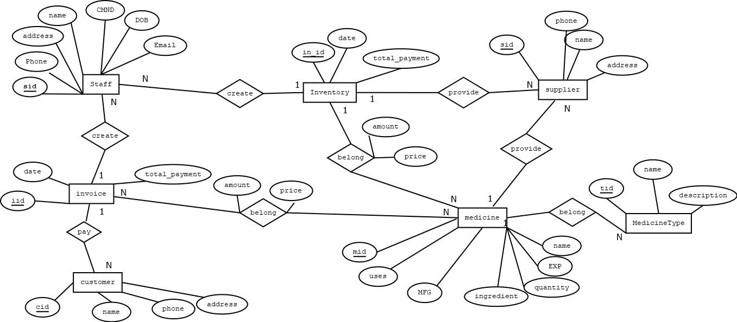

#### 3.2.2 Class Diagram

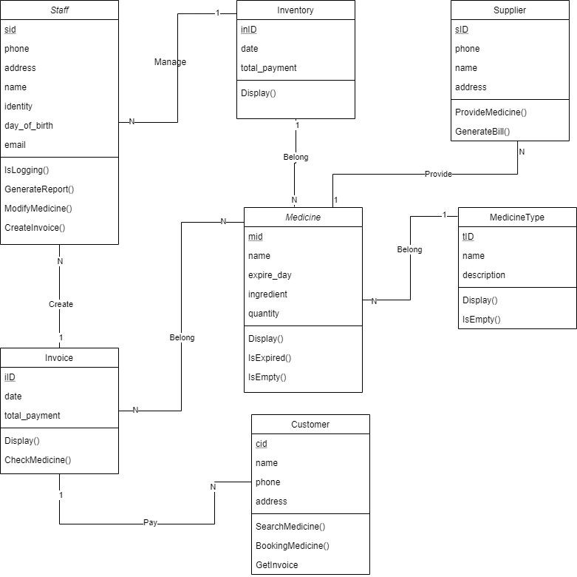

**3.3 Dynamic Model (Sequence Diagram)**

#### Register and Login Account

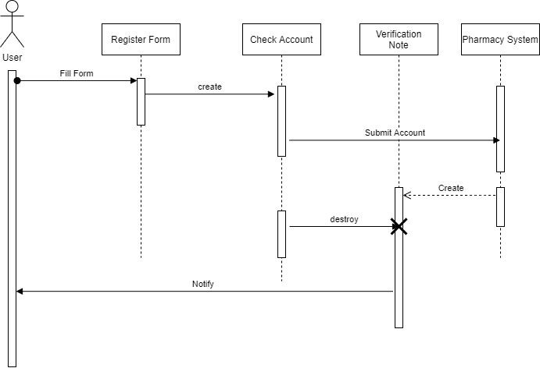

#### Booking Medicine​

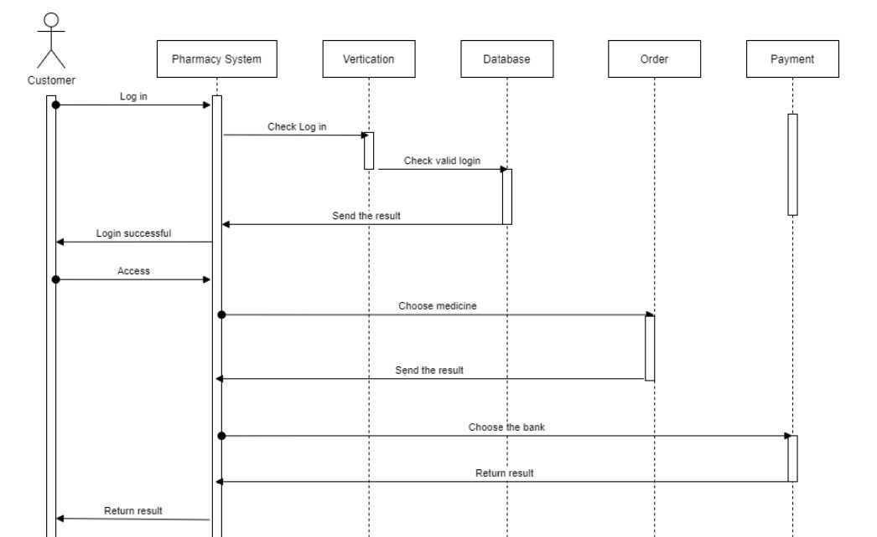

#### Search Medicine​

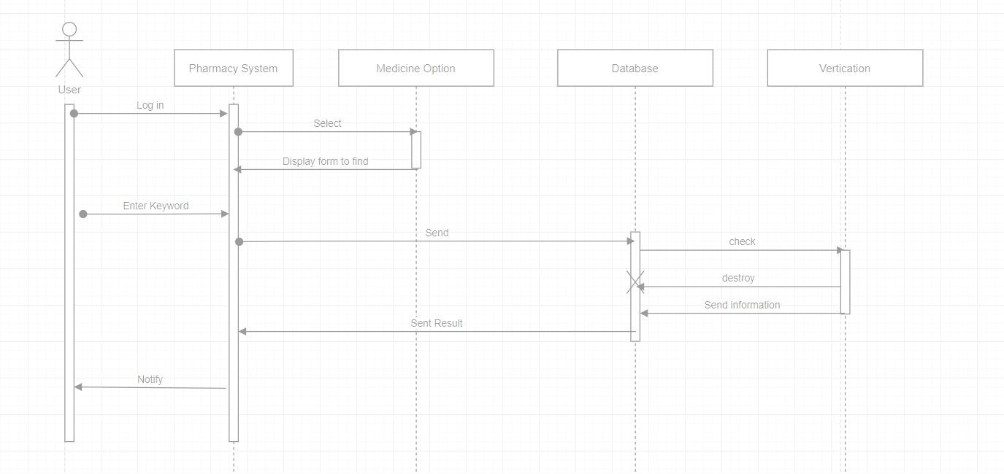

#### ​ Modify Medicine

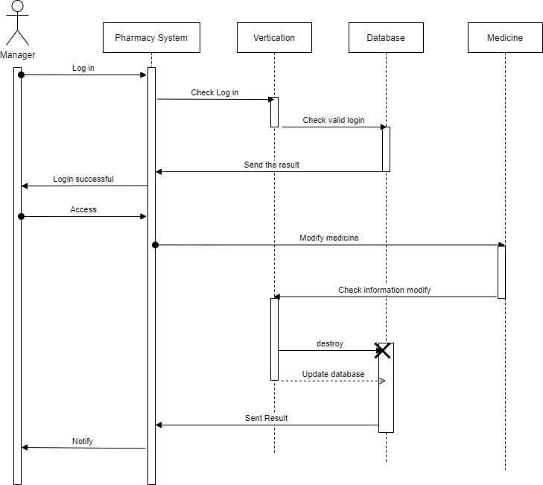

#### ​ ​Make report

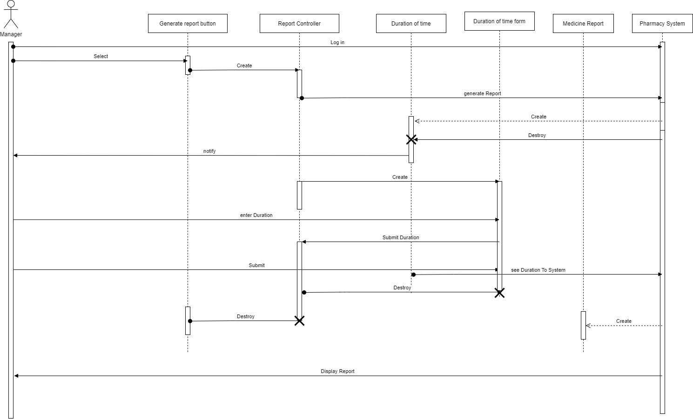

​**3.4 User Interface**

#### 3.4.1 Navigation Page

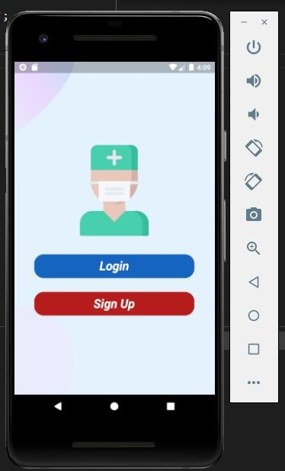

#### 3.4.2 Register Form

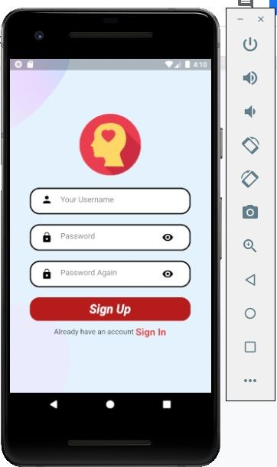

#### 3.4.3 Login Form

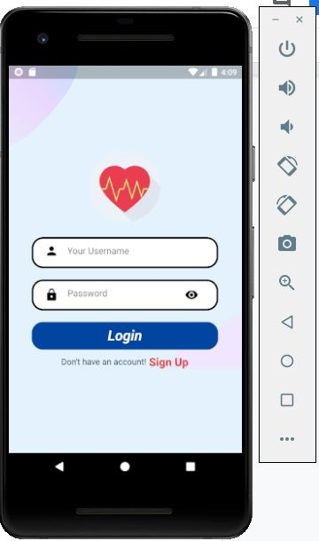

#### 3.4.4 HomeScreen

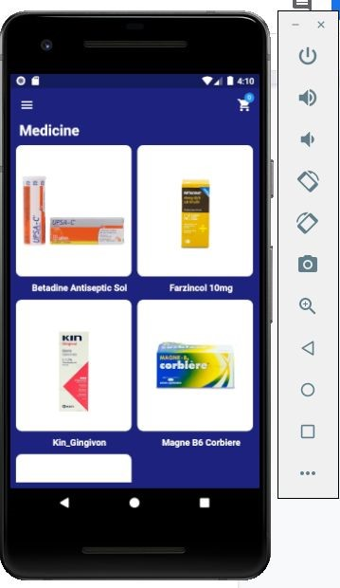

​ **3.4.5**​  **Product Details:**

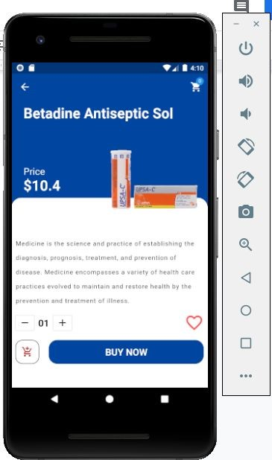

#### 3.4.6 Admin Main Page

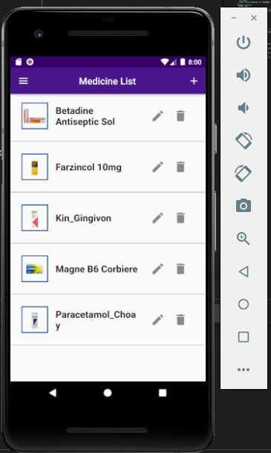

1. **Testing System**

|  |  |  |
| --- | --- | --- |
| **Procedure** | **Pass/Fail (P/F)** | **Actual Result/Comment** |
| **Login validation** | **P** | **Detecting user name and password correctly** |
| **Data validation** | **P** | **All text and numbers input are responding correctly** |
| **Handles editing** | **P** | **All of them are** |
| **functions** |  | **functioning** |
| **Delete/ Update and**  **Insert** | **P** | **All data can be deleted, updated, inserted**  **correctly** |
| **Responsive** | **P** | **Already repsonsive** |
| **Basic Application Testing** | |  |

|  |  |  |
| --- | --- | --- |
| **Procedure** | **Pass/Fail (P/F)** | **Actual Result/Comment** |
| **Coding Standards & Practices** | |  |
| **Code should be readable and easy to follow** | **P** | **All code are clean and they have comment attached** |
|  |  |  |

1. **Summary**

**5.1**​  **Challenges & Problems:**

### Challenge

This product is a part of the project for a one-semester University course. Due to the constraints in time (around 2 months) and human resources (3 members), it is impossible for us to deliver a complete product with all great functionalities as we want to. Therefore, we only aim at implementing some basic services of a management application, and leave some of them for the future development.

Aside from the costs for hardware resources and domain server used to develop and run the system, which our team decides to take care of by ourselves, we intend to distribute the final product absolute free for everyone. Any comments from the community are strongly appreciated, but are not required.

|  |  |
| --- | --- |
| **Time Delivery** | The Start Day: About 1​st ​5​th​ October 2020  The End Day: About 28​th​ December 2020 |
| **Duration** | Approx. 2 months |

**Some of the difficulties our team encountered:**

1. Problem with the platform of the framework when we had been working in the version​ source control and collaboration. Since our members may install this framework in separate time, or because of the hardware requirement we can not install the same versions of framework. So, the differences between the versions of the framework may occur. We have to make a migration between these versions. This is belong to the technical problems
2. Besides, our team faces with the limit of time. Cause we have not get well with the Dart language or Flutter before. We developed this app while we had been learning Dart and Flutter. In addition, there are some impacts from outside like we not only have one project, the delay in the last stage of this semester due to covid-19.

**5.2 Orientation in the future**

In this Pharmacy Application there are some features, some functions that we want to improve and

develop them. In the future our team plans to public this app on Google Play Store and App Store. We also need to develop some features like searching or ordering online. Last but not least, our team want to develop a Pharmacy Web App.